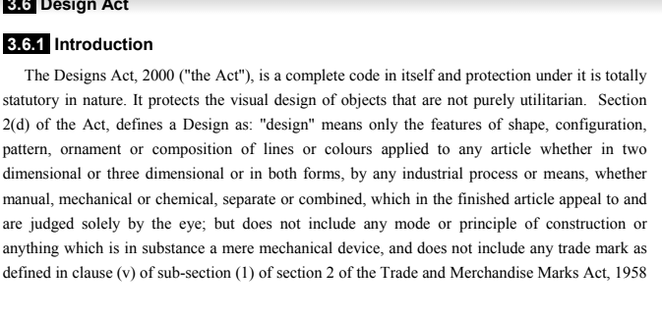

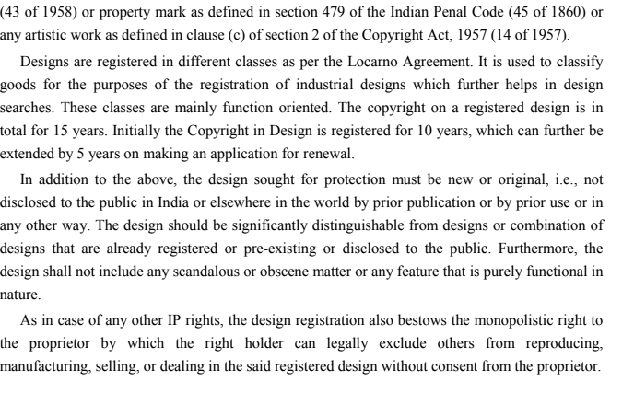

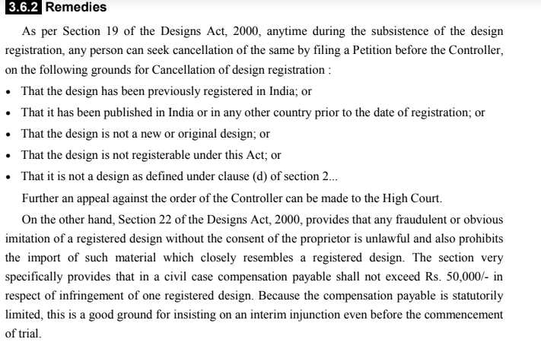

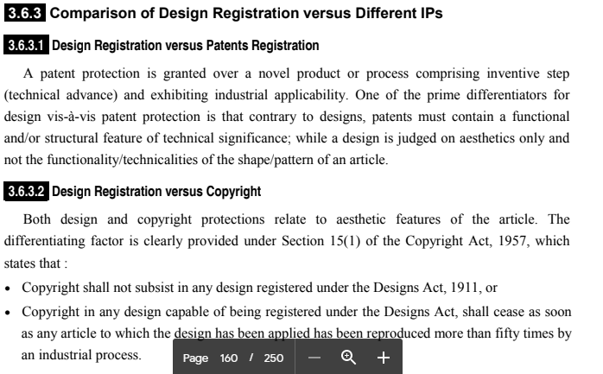

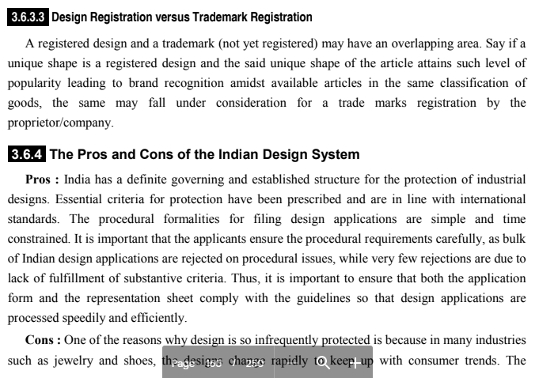

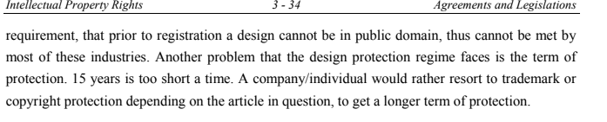

**TRADEMARK**

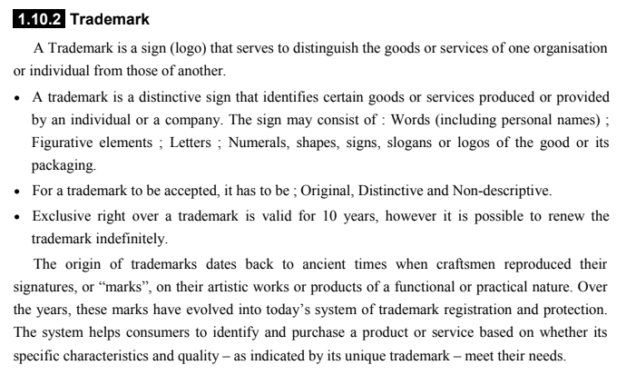

**What Cannot Be Registered As Trademark In India?**

Updated on :  Oct 12, 2021 - 12:36:56 PM

12 min read.

Trademarks in India are registered under the Trademarks Act, 1999 (“Act”). An application is filed to the Registrar of Trademarks (“Registrar”) for registration. The Registrar may accept the application and proceed to register the trademark. He can also reject the application if he finds any fault in it. The Act also provides a list of trademarks which cannot be registered.

**Absolute Grounds For Refusal Of Registration**

Section 9 of the Act lists down the absolute grounds for refusal of registration. If any trademark comes under the grounds listed in this section, it cannot be registered. The absolute grounds for refusing registration are –

* Trademarks which do not possess any distinctive character. Distinctive character means trademarks which are not capable of distinguishing the goods or services of one person from those of another.
* Trademarks which exclusively contain marks or indications which serve in trade to define the kind, quality, quantity, intended purpose, values or geographical origin of goods or services rendered.
* Trademarks which exclusively contain marks or indications which have become customary in the current language or the established practices of the trade.
* Trademarks are of such a nature which deceives or cause confusion to the public.
* Trademarks which contain or comprise matter likely to hurt the religious susceptibilities of any class or sections of citizens of India.
* Trademarks which contain or comprise scandalous or obscene matter.
* If the usage of the trademark is prohibited under the Emblems and Names (Prevention of Improper Use) Act, 1950.
* Trademarks which consist of marks of the shape of goods which result from the nature of goods themselves.
* Trademarks which consist of marks of the shape of goods which is necessary to obtain a technical result.
* Trademarks which consist of marks of the shape which gives substantial value to the goods.

The Act provides for an exception with regard to the first three points, i.e. where the trademarks lack distinctiveness or which contain exclusive marks which sever in the trade to define kind, quality etc. or contains marks which have become customary in the trade practices. The exception is that the trademarks that come under the first three points shall not be refused registration if the trademark has acquired a distinctive character as a result of the use or is a well-known trademark before applying for registration.

**Relative Grounds For Refusal Of Registration**

Section 11 of the Act provides relative grounds for refusal of registration. This section provides exceptions to the grounds of refusal. If the exceptions are complied with, then the trademarks under section 11 can be registered.  
Section 11(1) states the following grounds for refusal –

* Trademarks which confuse the public as it is identical with an earlier similar trademark of goods or services.
* Trademarks which confuse the public as it is similar with an earlier identical trademark of goods or services.

An exception to this section is if there is an honest concurrent use of the trademark, the Registrar of Trademarks may allow the registration.  
Section 11(2) states the following grounds for refusal –

* Trademarks that would take unfair advantage of a similar or identical earlier well-known trademark in India.
* Trademarks that would be detrimental to the distinctive character or repute of a similar or identical earlier well-known trademark in India.

Section 11(3) states the following grounds for refusal –

* The usage of the trademark is bound to be prevented by the law of passing off protecting an unregistered trademark used in the course of trade.
* The usage of the trademark is bound to be prevented by the law of copyright.

The trademarks mentioned in Section 11(2) and 11(3) shall not be refused registration unless an objection is raised in opposition proceedings by the proprietor of the earlier trademark.  
Section 11(4) provides an exception to all the grounds mentioned above. It states that the trademarks that fall under Section 11 can be registered if the proprietor of the earlier trademark consents to the registration. If the proprietor of the earlier well-known trademark gives his consent to register the latter trademark, the Registrar can register it.

**Names Which Cannot Be Registered**

Section 13 and 14 of the Act provides that trademarks containing specific names cannot be registered. Trademarks which have a word that is commonly used of any single chemical element or chemical compound in relation to a chemical substance or preparation cannot be registered.

Trademarks that falsely suggest a connection with any living person can be declined registration by the Registrar unless the consent of a such living person is obtained. Similarly, trademarks that falsely suggest a connection with any dead person within twenty years of submitting the application for registration can be declined by the Registrar unless the consent of legal representatives of such person is obtained.

**Illustrations Of Refusal Of Registration**

A few illustrations of the words which were rejected registration on the basis of the above grounds are given below –

* Words like ‘Himalayan’ or ‘Shimla’ were rejected registration as they indicate geographic origin.
* Words like ‘Janta’ or ‘Rasoi’ were not registered as they were common expressions.
* The word ‘Saffo’ was not registered for cleaning power and liquid as being too close to the word ‘Saff’ meaning clean. This word indicated the character of the goods.
* The word ‘Ombrella’ for shower baths curtains was not registered as it was descriptive of umbrella-like shower bath curtains.
* The word ‘Heavenly’ for cosmetics was not registered as it is a word which is in common use.
* The word ‘Electrix’ for electric vacuum cleaners was rejected registration on the ground of it being similar to the common term ‘Electric’.
* A mark consisting of representation of parts of chain wheel and chain and a blank space was refused registration on the ground of chains and chain wheels as being not distinctive.

**PATENTS :**

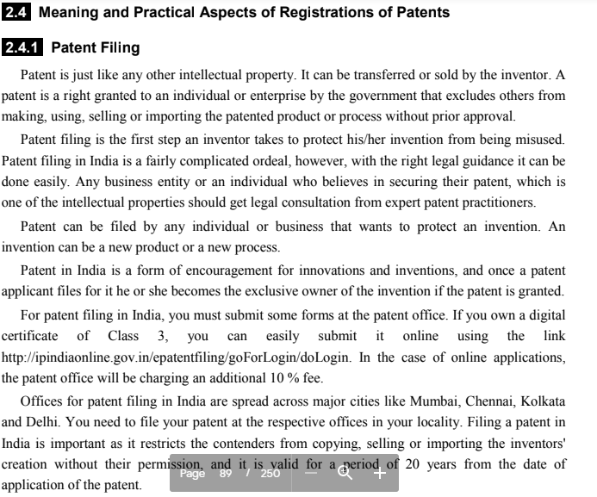

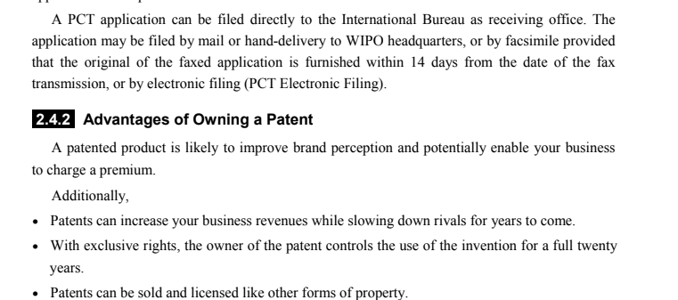

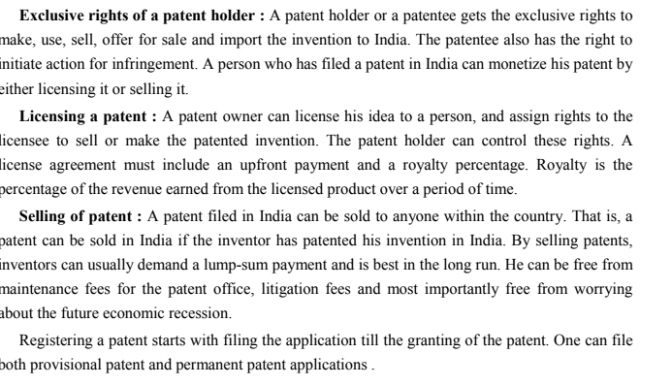

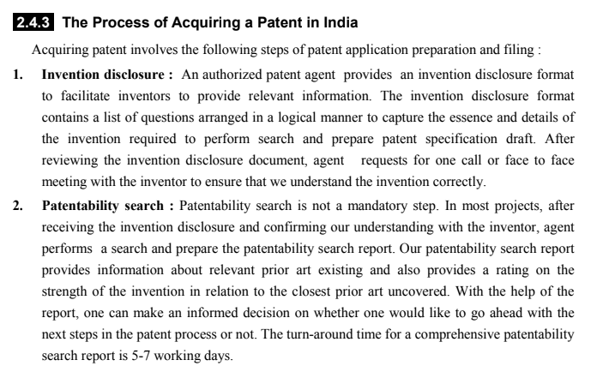

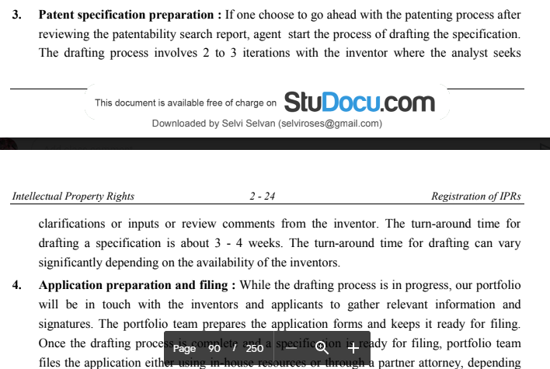

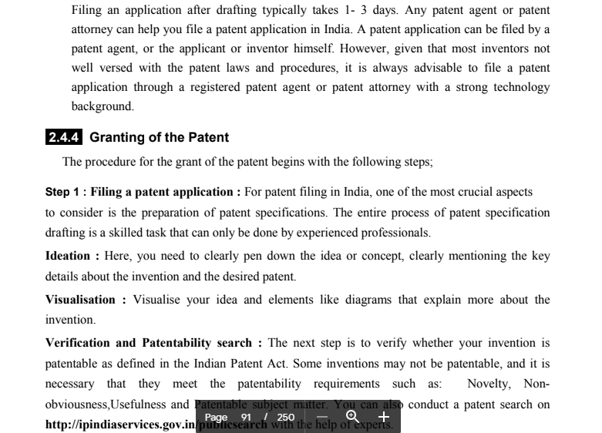

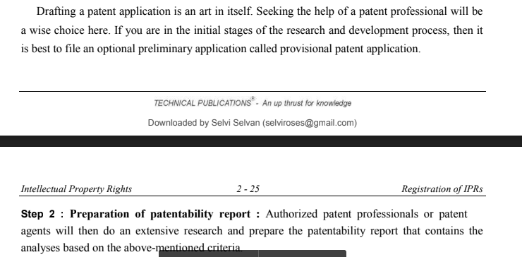

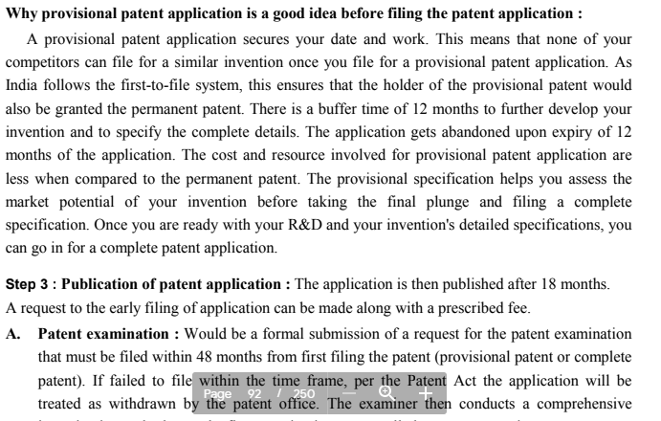

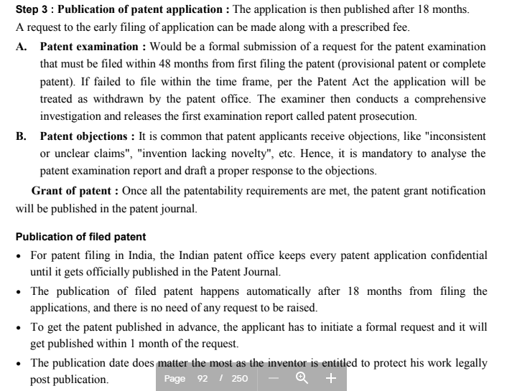

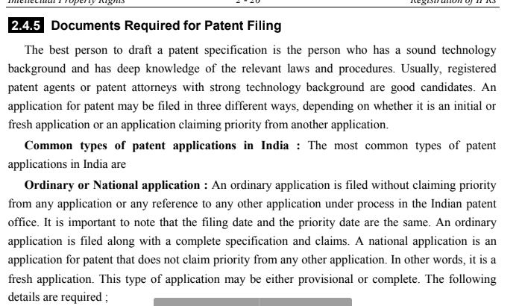

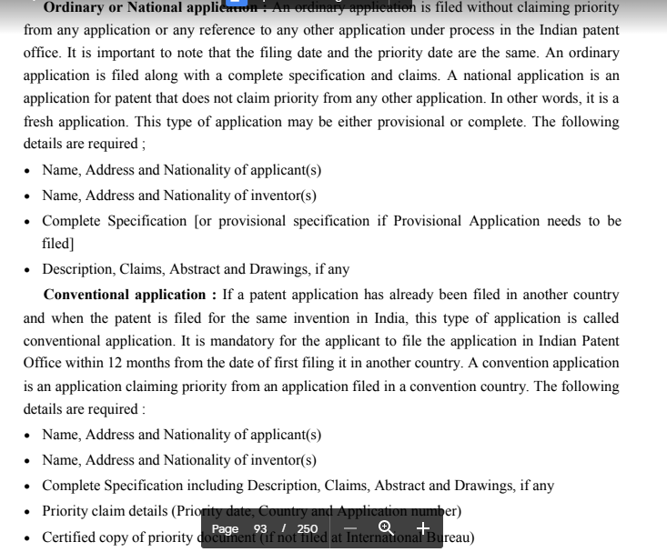

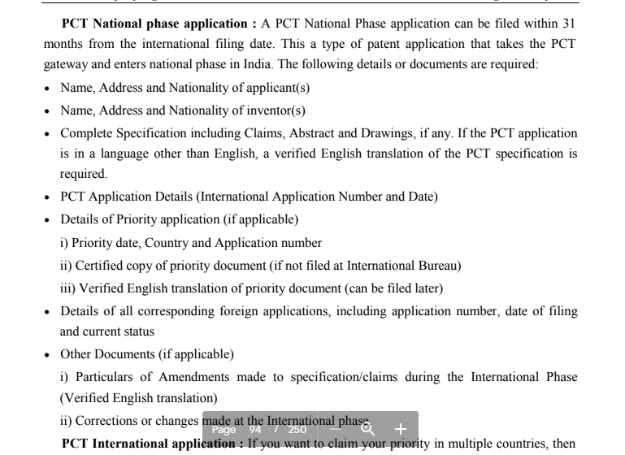

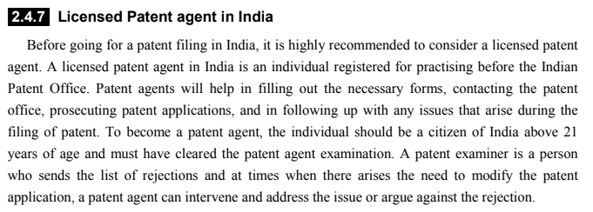

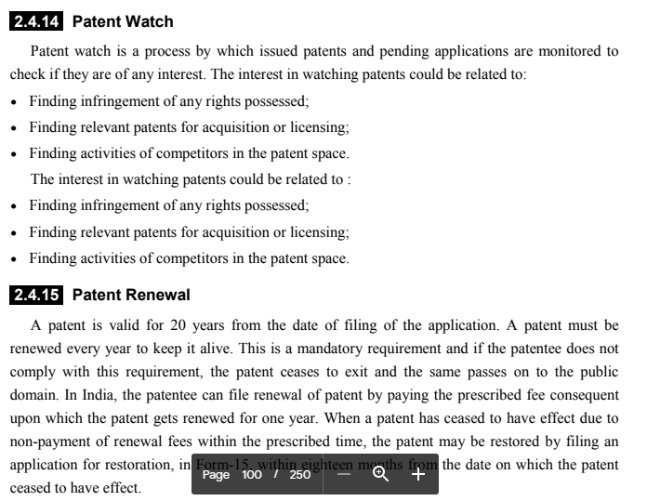

**INTERNATIONAL TREATIES AND CONVENTIONS**

