<?php

$num = 12;

echo "<h3>Fibonacci series using recursive function:</h3>";

echo "\n";

function series($num){

if($num == 0){

return 0;

}else if( $num == 1){

return 1;

} else {

return (series($num-1) + series($num-2));

} }

for ($i = 0; $i < $num; $i++){

echo series($i);

echo "\n";

}

Output:

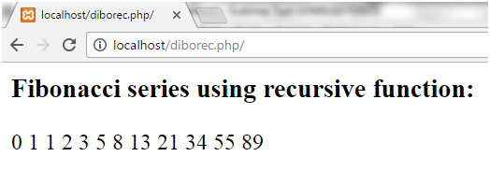

PHP is_int() function

By using this function, we can check the input variable is integer or not. This function was introduced in PHP 4.0.

Syntax

1. bool is_int (mixed $var)

Return type

This function returns true if var_name is an integer, Otherwise false.

Example :

<?php

$x = 56;

$y = "xyz";

if (is_int($x))

{

echo "$x is Integer \n" ;

}

else

{

echo "$x is not an Integer \n" ;

}

if (is_int($y))

{

echo "$y is Integer \n" ;

}

else

{

echo "$y is not Integer \n" ;

}

?>

