**Proactive routing protocols**

Proactive routing protocols **maintain information on all routes throughout the network, even if they are not required**, so each node registers routes to all other nodes in the network. These protocols exchange control information between nodes on a regular basis, which keeps updated routes for each node in the network.

Proactive routing algorithm **maintains the route information to the other nodes in its routing table so minimum delay to transmit data packets.**

Examples:

In a proactive routing scheme, each node maintains an up-to-date routing table by frequently querying its immediate neighbors for routing information. An example of such a scheme is the **Destination Sequenced Distance Vector (DSDV) routing protocol.**

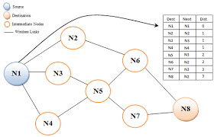

**Reactive routing protocols**

Reactive routing protocols: These are also known as **on-demand routing protocol**. In this type of routing, the route is discovered only when it is required/needed. The process of route discovery occurs by flooding the route request packets throughout the mobile network.

Examples:**Ad-hoc on demand vector distance vector (AODV), Dynamic MANET On demand (DYMO) and Dynamic source routing (DSR)** are the examples of reactive routing protocols.

An **Ad Hoc On-Demand Distance Vector** (AODV) is a routing protocol designed for wireless and mobile ad hoc networks. This protocol establishes routes to destinations on demand and supports both unicast and multicast routing.

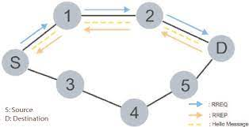

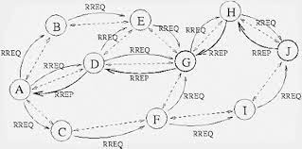

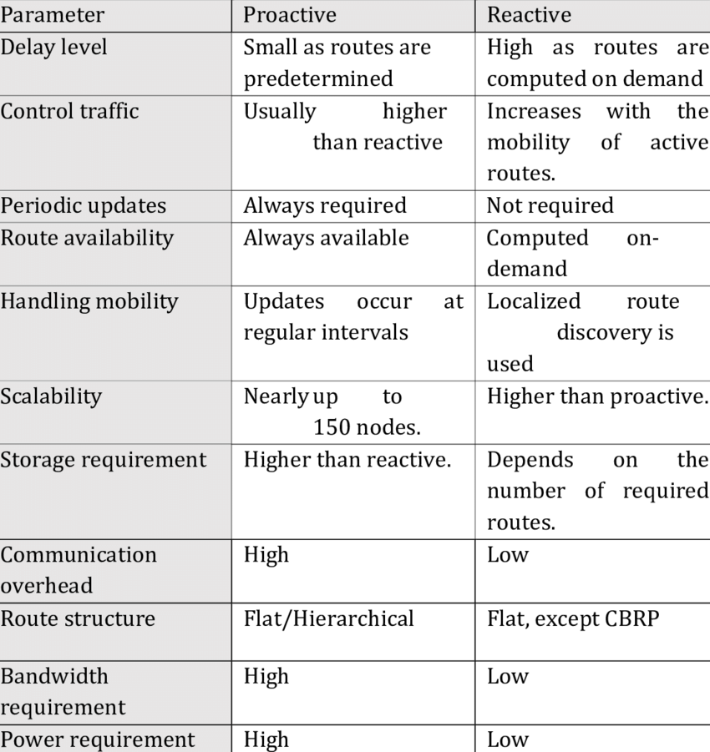

**DHCP**

**Dynamic Host Configuration Protocol** (DHCP) is a client/server protocol that automatically provides an Internet Protocol (IP) host with its IP address and other related configuration information such as the subnet mask and default gateway.

The Dynamic Host Configuration Protocol is a network management protocol used on Internet Protocol networks for automatically assigning IP addresses and other communication parameters to devices connected to the network using a client–server architecture.

**AD-HOC**

A wireless ad hoc network or mobile ad hoc network is a decentralized type of wireless network. The network is ad hoc because it does not rely on a pre-existing infrastructure, such as routers or wireless access points. Instead, each node participates in routing by forwarding data for other nodes.