**WEKA**

**Filename: - topic-0.arff**

**Preprocess 🡪**

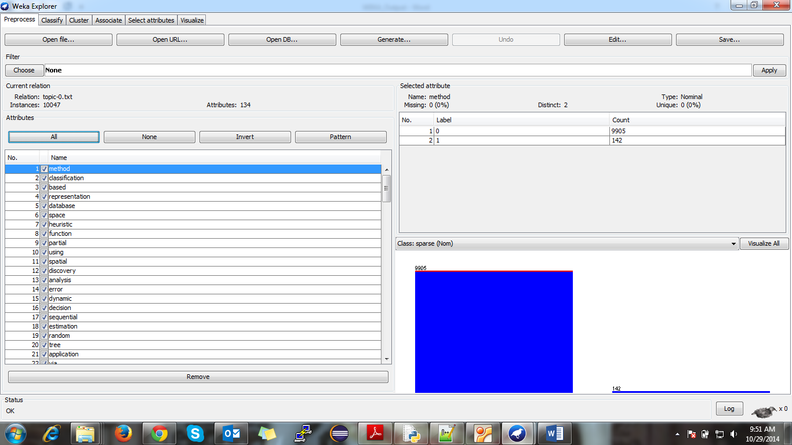

**Associator Choose 🡪 FP GROWTH**

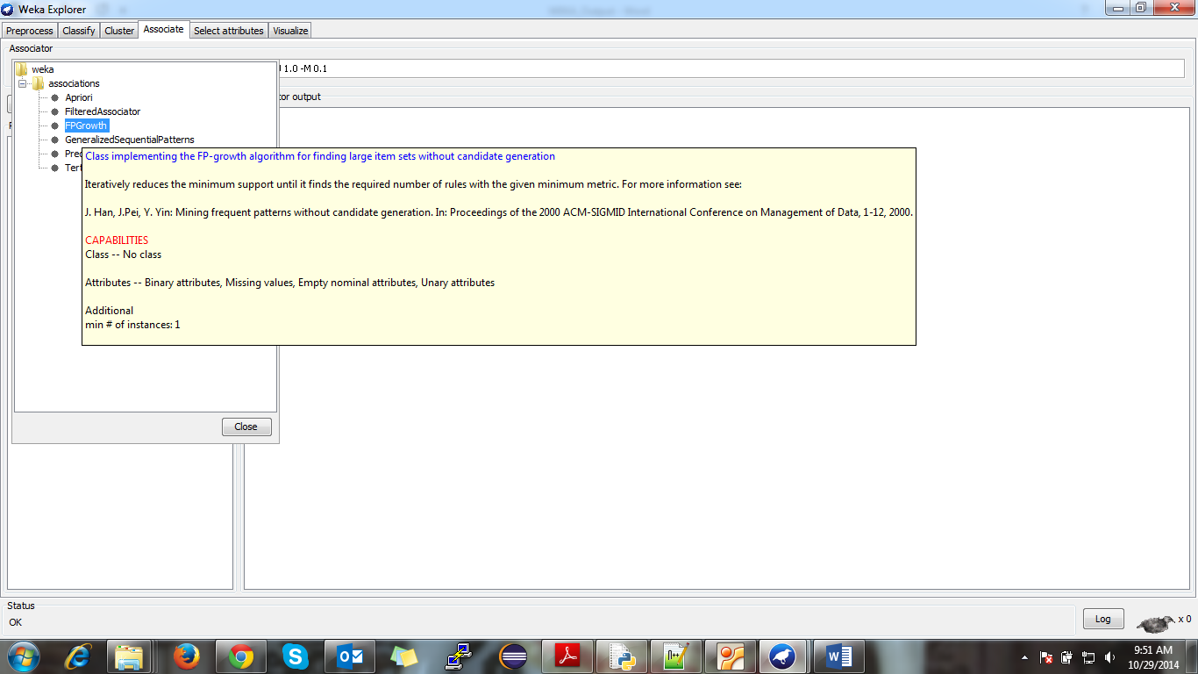

**Parameter Settings 🡪**

**lowerBoundMinSupport 🡪 0.001**

**minMetric 🡪 0.9**

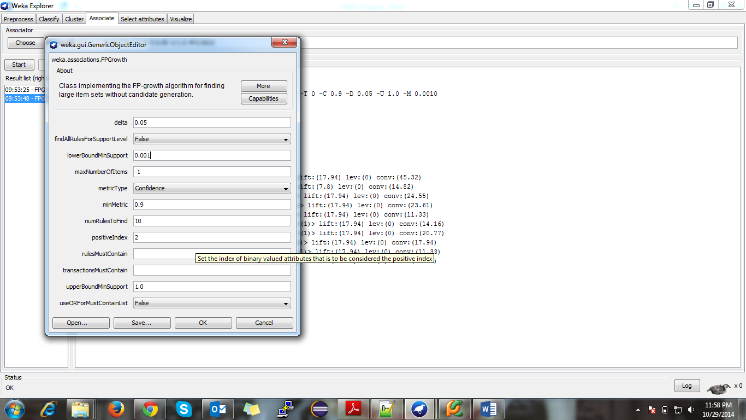

**Association Rules 🡪**

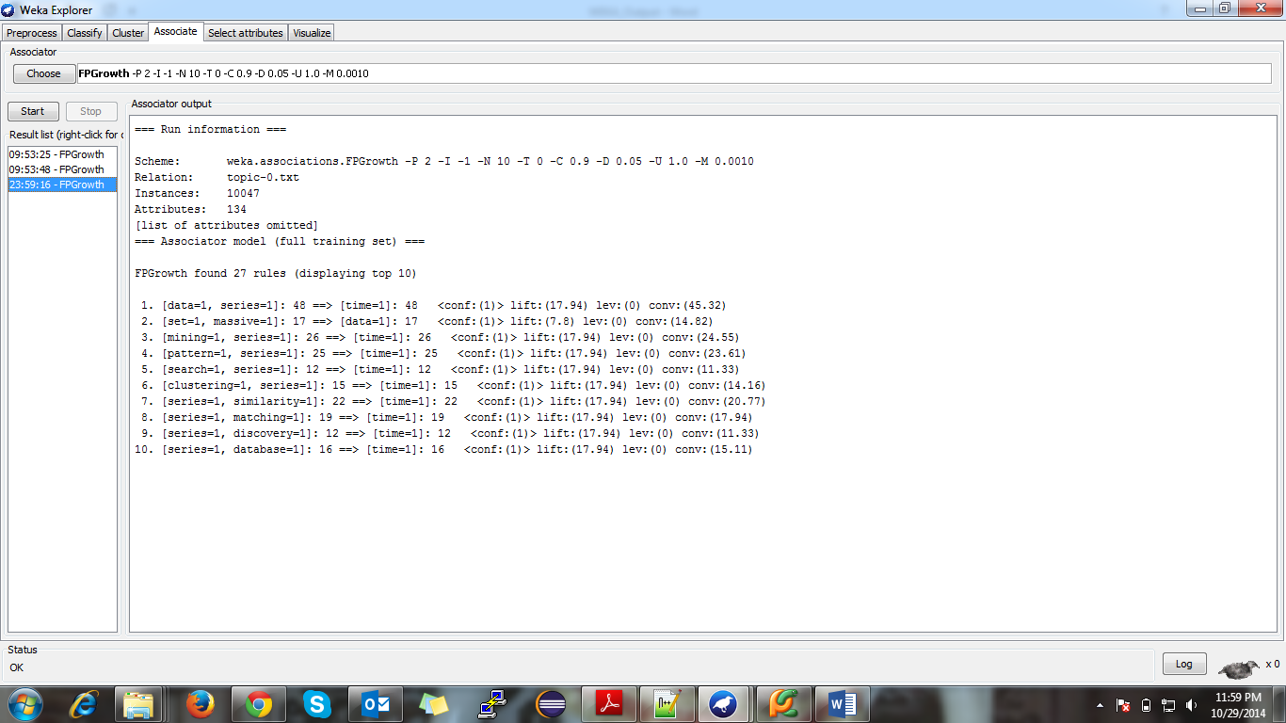

**Filename: - topic-1.arff**

**Preprocess 🡪**

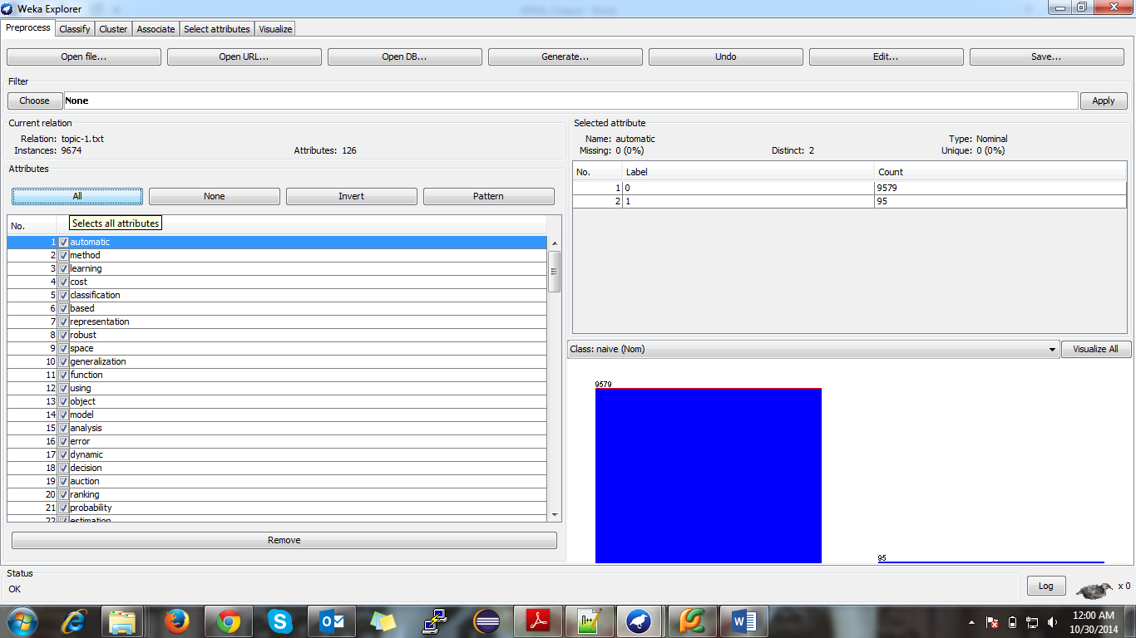

**Parameter Settings 🡪**

**lowerBoundMinSupport 🡪 0.002**

**minMetric 🡪 0.8**

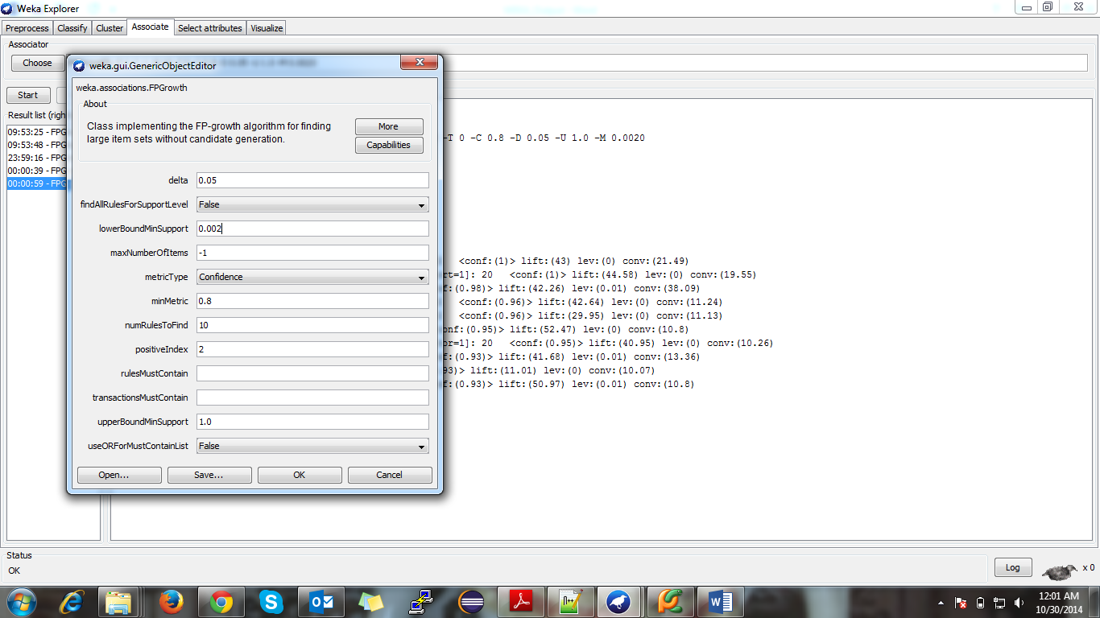

**Association Rules 🡪**

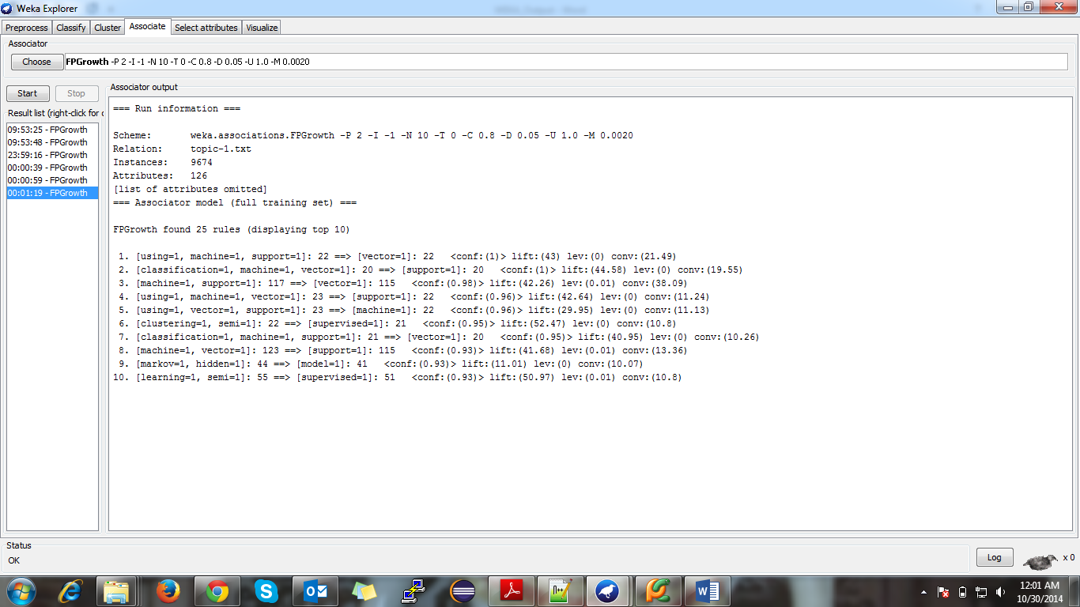

**Filename: - topic-2.arff**

**Preprocess 🡪**

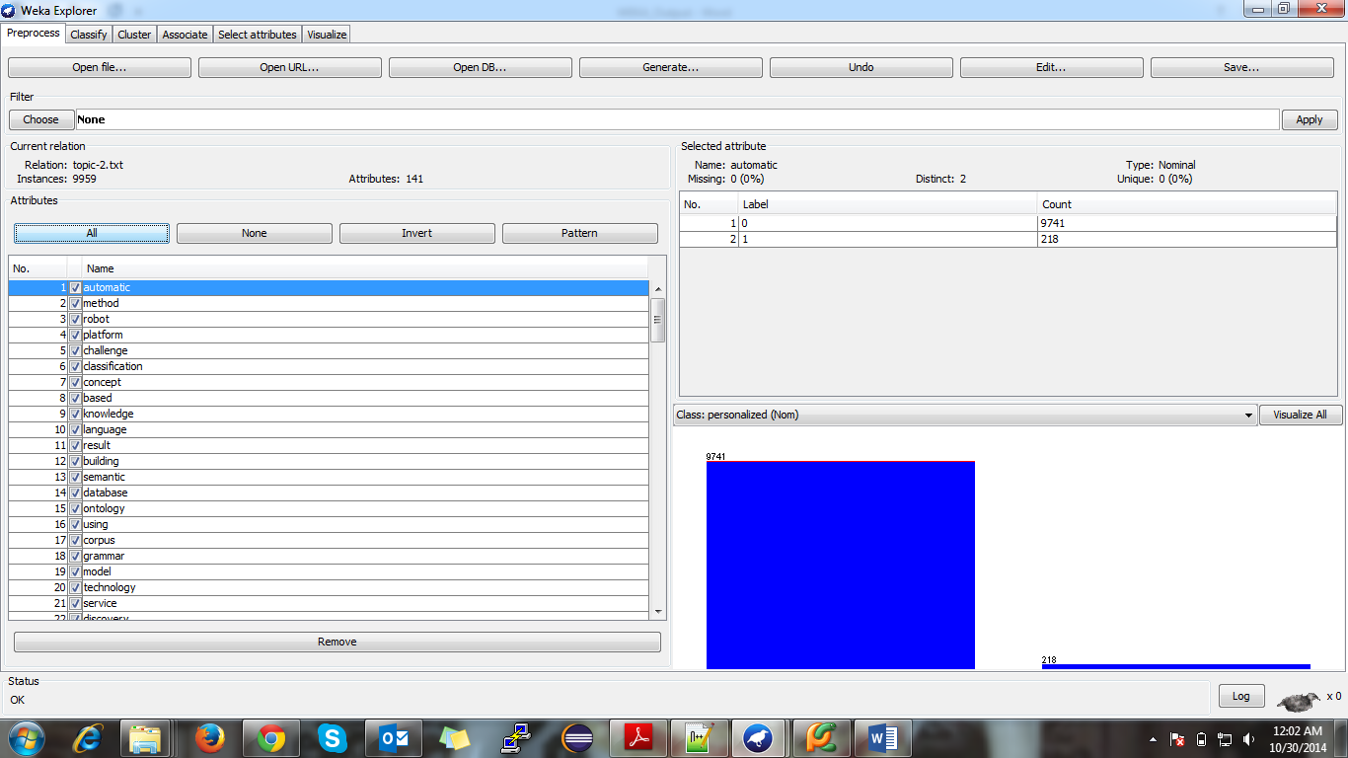

**Parameter Settings 🡪**

**lowerBoundMinSupport 🡪 0.002**

**minMetric 🡪 0.8**

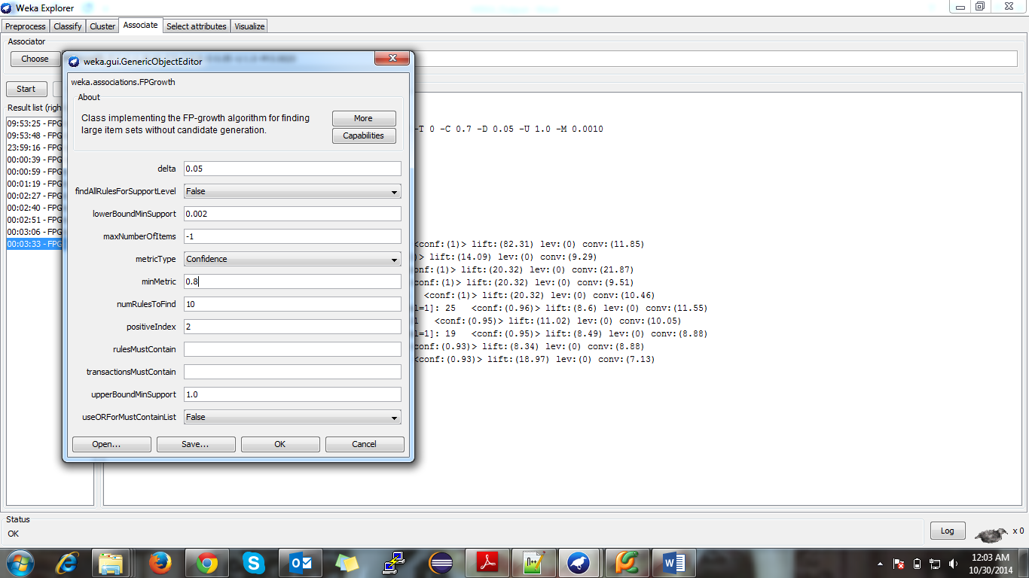

**Association Rules 🡪**

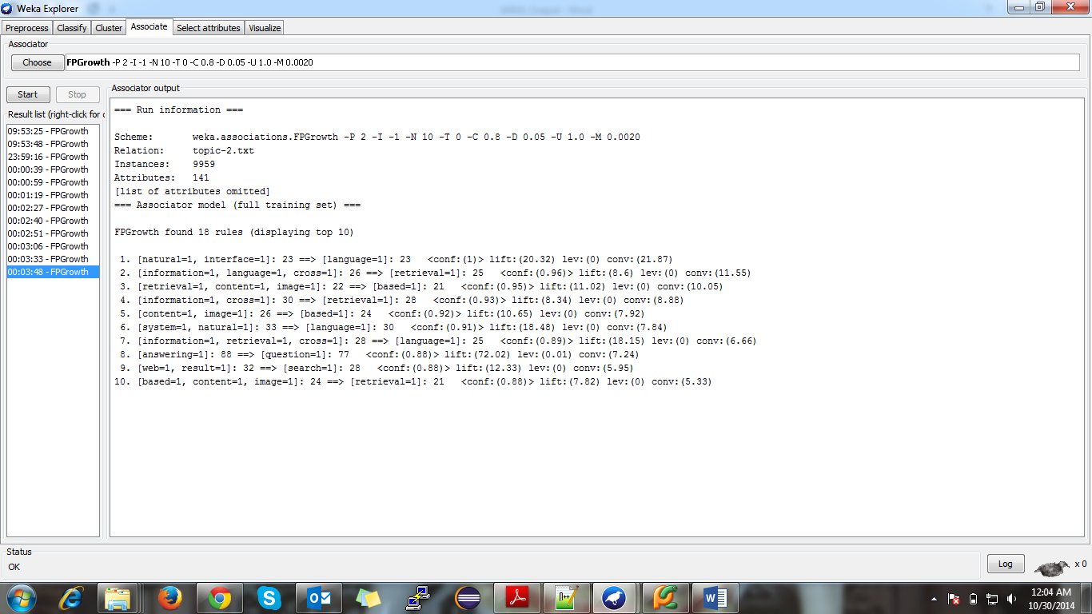

**Filename: - topic-3.arff**

**Preprocess 🡪**

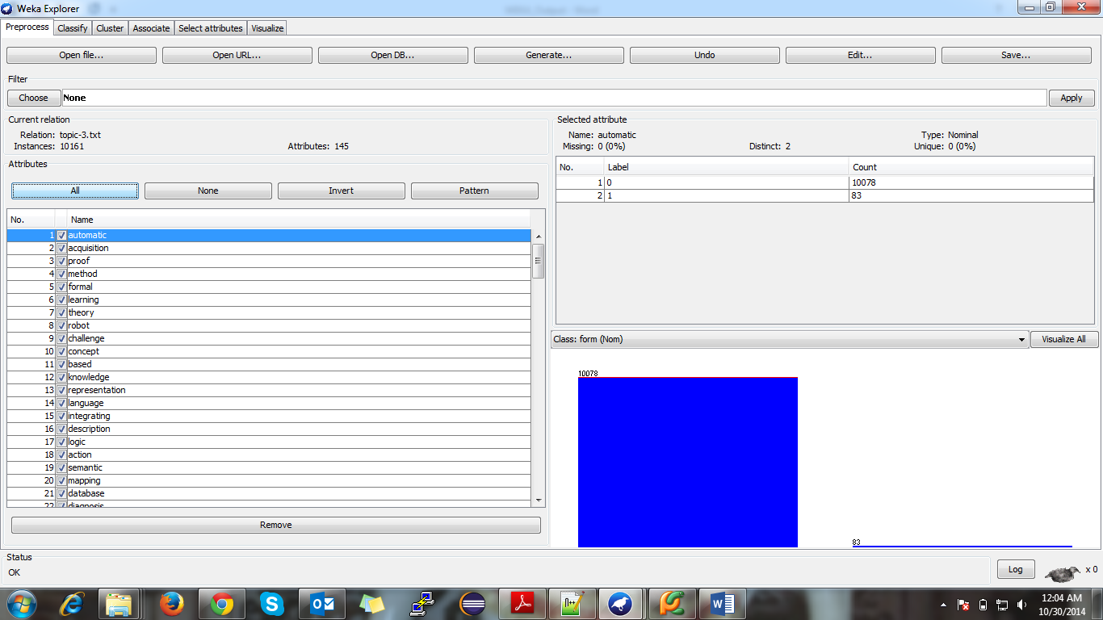

**Parameter Settings 🡪**

**lowerBoundMinSupport 🡪 0.001**

**minMetric 🡪 0.8**

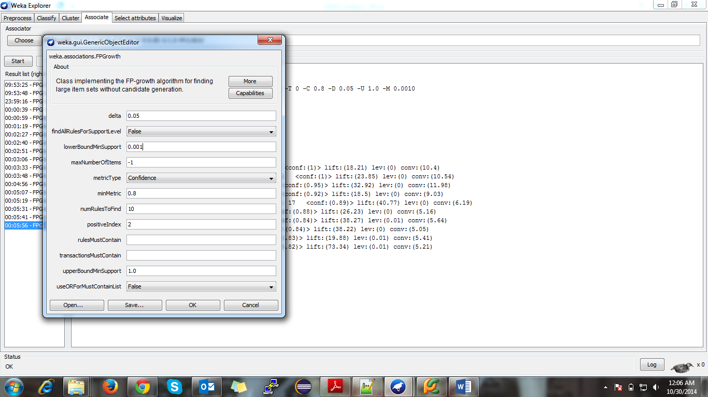

**Association Rules 🡪**

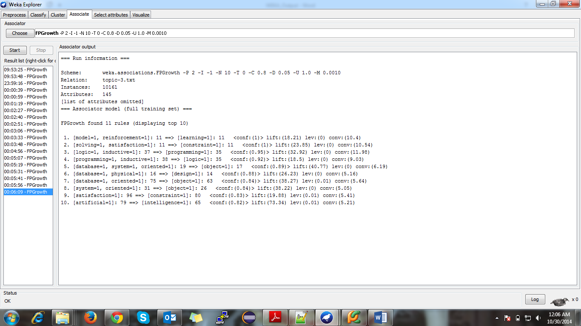

**Filename: - topic-4.arff**

**Preprocess 🡪**

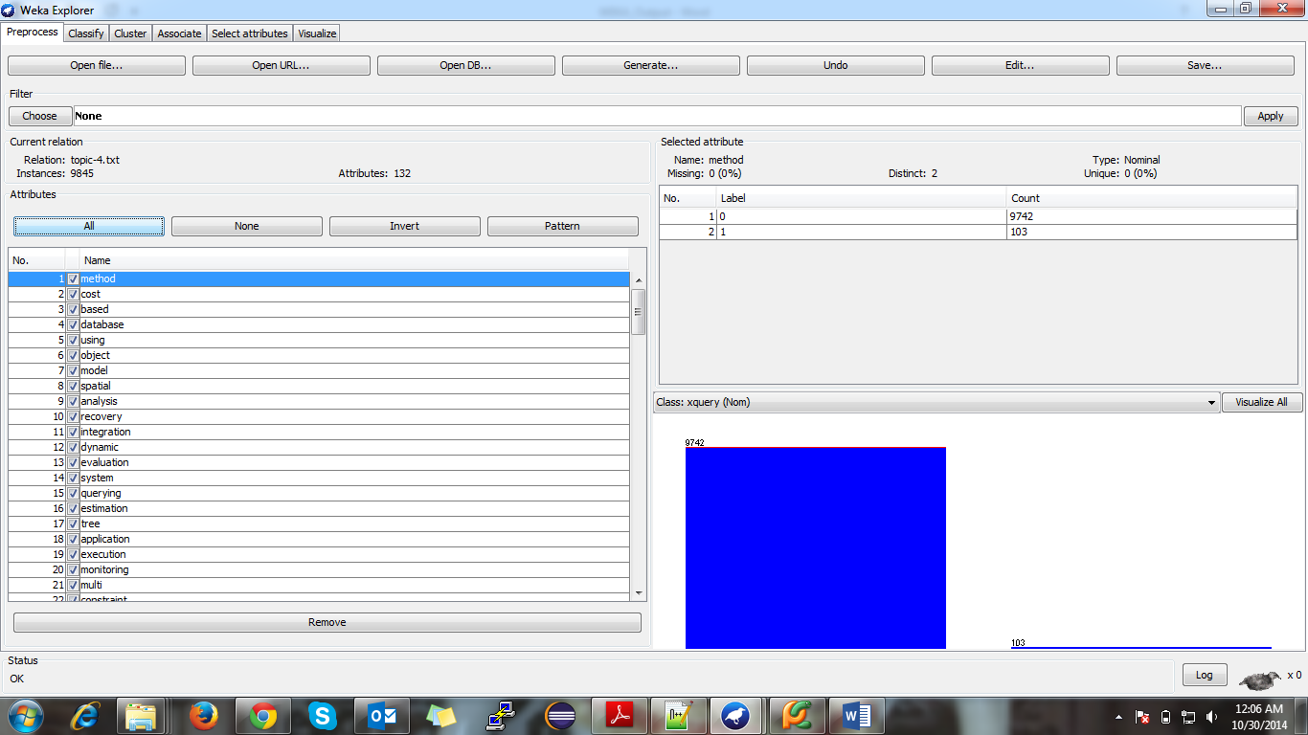

**Parameter Settings 🡪**

**lowerBoundMinSupport 🡪 0.002**

**minMetric 🡪 0.8**

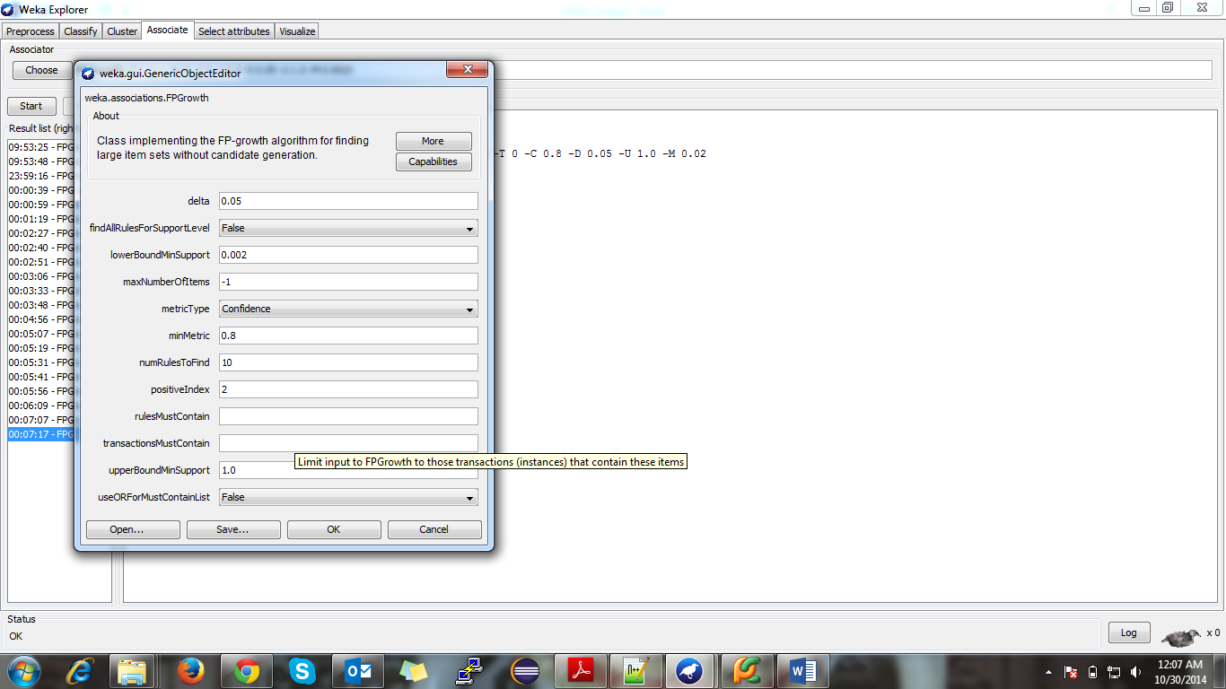

**Association Rules 🡪**

