**CheckStyle Correction Tool**

**Problem Statement:-**

**=============================================================================**

PMDis static ruleset based Java source code analyzer that identifies problems like empty try/catch blocks, unused local variable, empty if/while statement etc. It basically helps to improve code quality which is very important as per our enterprise standard. So manually correcting the changes is tedious and also there are chances of mistake.

**About the Tool:-**

**=============================================================================**

The check style correction tool helps to correct the checkstyle errors which are very tedious and error prone if solved manually. The tool is very handy to use and requires no configuration apart from some command line argument. It is developed using PERL language. The reasons for using PERL are as follows:-

1. It is practical, easy-to-use, efficient programming language.
2. It’s best suitable for perform incremental, iterative development and testing as we don’t have to go through a create/compile/test/debug/fix cycle.
3. It is optimized for text processing and, therefore, is very efficient at many tasks which require formatting, searching etc.
4. It runs on every popular operating system, is tuned for information processing (free form text) and is excellent at data processing (numbers and raw, binary data).

**Working: -**

**=============================================================================**

Parameters for HTML_Parser.pl

1. **checkstyle_report.html**
2. **CheckStyle.config file name along with path**
3. **CheckStyle_Error_List.txt**

HTML

Parser

<html>

<body>

…………..

</body>

</html>

**calls**

**generates**

**Input**

**checkstyle_report.html**

PMD

Solution

Tool

**(Report generated by PMD)**

**uses**

**KEY, VALUE**

Line No, Error

.java

.

.

.

.

**Output**

**Input**

**CheckStyle.config file**

**Input Directory**

**(Source files are placed**

**On which tool is to be run)**

.java

.

.

.

.

**PMD_Output**

**(Processed files from Input dir. are placed at PMD_Output dir.)**

**Environment Setup:-**

**=============================================================================**

In order to run any Perl program in windows operating system, you have to install ActivePerl.exe. You can find the setup at <http://www.activestate.com/activeperl/downloads>

After installing ActivePerl check whether it is installed successfully or not check by typing following command at command prompt

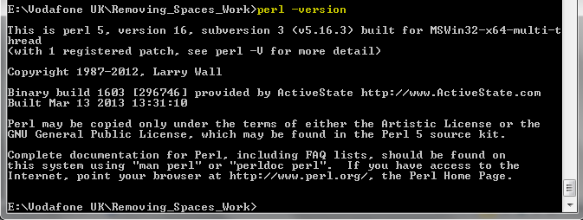

If the output display the version of Perl installed then it is successfully installed or else check whether it is included in PATH variable.

**Important Files and Folders:-**

**=============================================================================**

**PMD_Output**:- Folder includes the files that are modified by the PMD Solution Tool. It contains the output files with all the check style modifications done. Compare the output file with your current revision file and check whether the changes are done or not

**NOTE:-**PMD_Output folder if not exist in current working directory then it will automatically be generated by the tool

**Tool_Script:-** Folder contains files that are required by PMDSolutionTool.pl

Do not modify any of the files placed under Tool_script

**PMD_SolutionTool.pl**:- Main program that helps to correct the Check Style errors.

**CheckStyle_Error_List.txt**:- File that is required by PMD_SolutionTool.pl and should always be placed under **Tool_Script** folder. **DO NOT MODIFY IT**

**HTML_Parser.pl**:- File that is required by PMD_SolutionTool.pl and should always be placed under **Tool_Script** folder. **DO NOT MODIFY IT**

**How to Run the Tool?**

**=============================================================================**

In order to run the tool for PMD Check style error resolution follow the below mentioned steps at **command prompt**

1. Go to the folder location where the script is present.
2. Run the Command at Command prompt:-

**perl**<space> **PMDSolutionTool.pl**<space>**"C:\PM**

**DTool\pmdreport\checkstyle_report.html"**<space>**"C:\PMDTool\pmdsrc"** >> log.txt

**NOTE: -** Always give absolute path to files within double quote

1. The log will be redirected to log.txt and modified files are in **PMD_Output** folder.