Romans 6b – Freed From Sin, Slaves to Righteousness
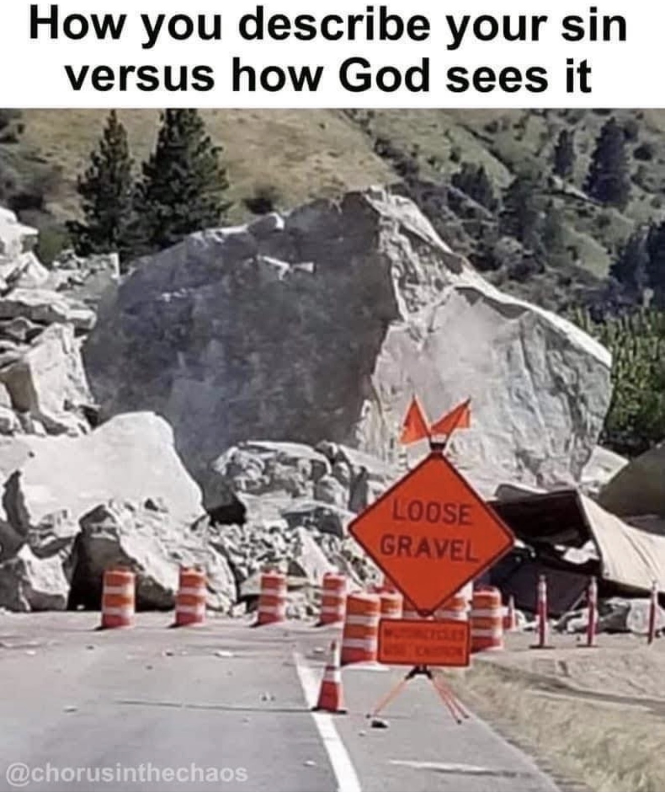
This is how most people talk about their sin—like it’s a little loose gravel on the road. But God sees it for what it is—a massive boulder blocking the way. A boulder you can’t move, can’t get around, and can’t ignore. And unless it’s removed, it will keep you from the destination He’s called you to.
INTRODUCTION
Before we dive into Romans 6, I want us to remember why this matters for the nations. Just as that boulder blocks a road, sin blocks the way to God for every people group still in darkness...
Point 1 – Grace Exposes Your Master
Grace doesn’t hand you a broom for the gravel—it sends the demolition crew for the boulder. When Christ saves you, He removes not just the penalty of sin, but the master you once served.
CONCLUSION
So the question is this—are you still camped at the foot of the boulder, pretending it’s just a minor inconvenience? Or have you followed the King who shattered it and brought you under His banner?

