JOHN S. STRITZINGER
FIGMA COMPLETE TASK
CSCE242 SPRING 2026

FOR THIS ASSIGNMENT WE HAVE INTRODUCED SOME NEW FEATURES IN OUR DESIGN MODEL WHILE UPDATING THE ORIGINAL LAYOUT WE DID. WE USED A SIDE BAR NAVIGATION ON THE LEFT WHICH IS NON-STANDARD FOR US BUT LOOKS NICE.

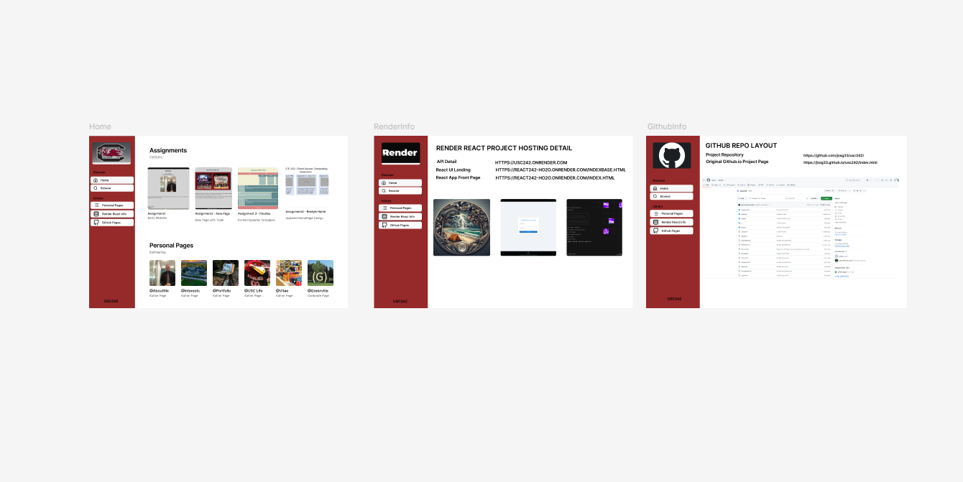
AFTER THE ORIGINAL MOCK UP IN THE DESIGN VIEW, WE WANTED TO SEE FIGMAS NEW “MAKE UTILITY” WHICH PASSES PARAMETERS TO CLAUDE AND GENERATES A DESIGN INCLUDING REACT DESIGN UPDATES WHICH ACTUALLY GENERATES FULL WORKING REACT CODE WHICH NEEDS TO BE TWEAKED A BIT. FIGMA VIA CLAUDE THEN ADDED A FEW NEW PAGES IN IMPERFECT MODE.

USING AI WE GOT A FEW NEW SUB PAGES CREATED AND A WORKING NAV BAR BEFORE WE RAN OUT OF AI CREDITS. WE INTEND TO IMPROVE THE DESIGN OVER TIME BUT ITS CONCERNING THAT THE “TECH IS BEING TAKEN OUT OF THE BUSINESS” AND MOVING TO ART ONLY. WILL IT GET RID OF THE ARTISTS TOO?
