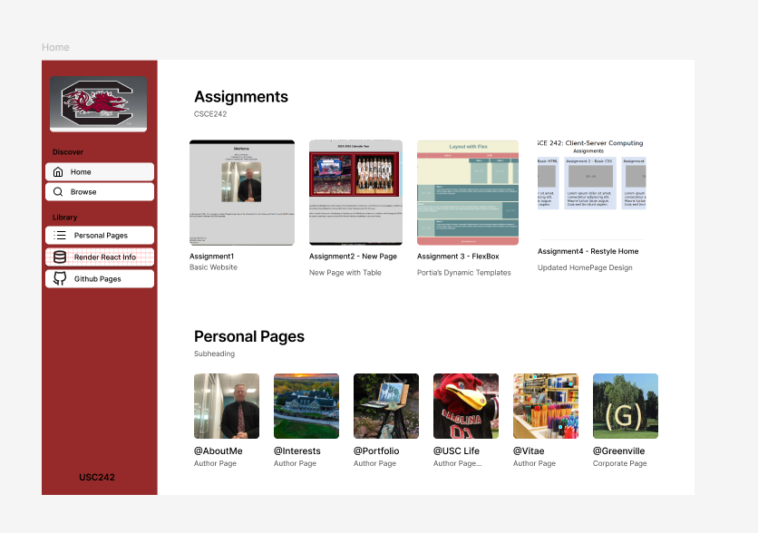
HOME PAGE -> WITH LINKS TO ALL PERSONAL PAGES
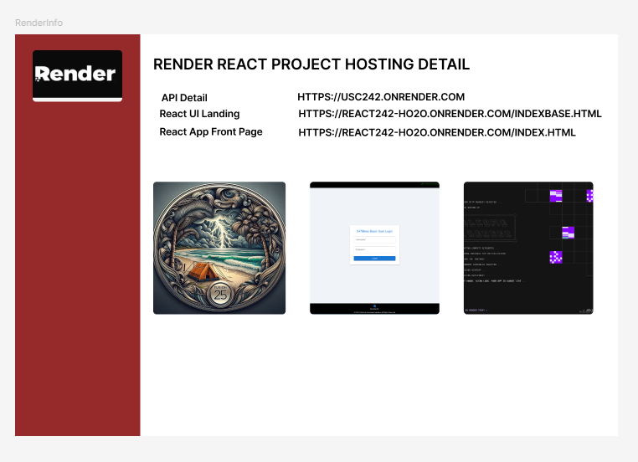RENDER PAGE WITH LINKS TO THE REACT PROJECT FOR FINAL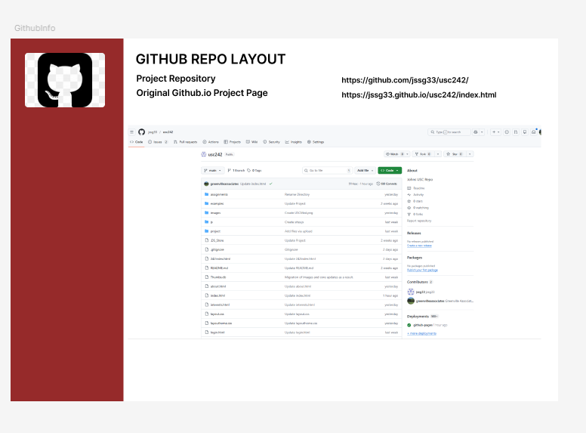
GITHUB REPO WITH BUILD INFORMATION
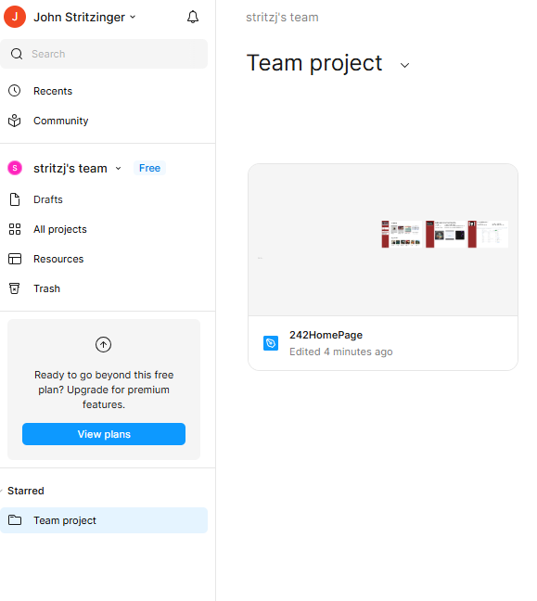
RENDER HOME PAGE FOR PROJECT

