**18. Create a car with function for payment simulation (Gpay) with the function name called "pay" which return 1 or 0.**

**1. Success payment**

**2. Failure**

**Step1:**

1. File →New → Java project →project name(junit→Finish

2) Right click on created java project → New → class → Name(Gpay) → Fini h

3) Content Inside that class (Gpay-java)

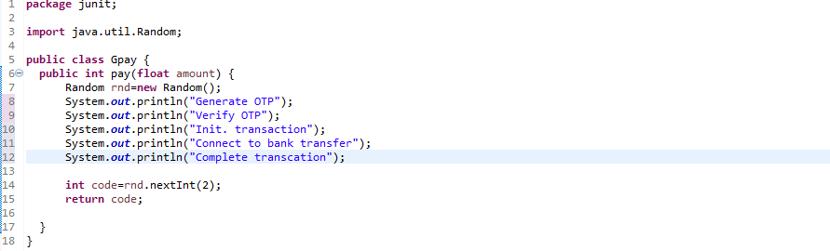

5) Right click on created java project→ New →other → Junit Test Class → Name: (PaymentText) ,New Junit Jupiter text (select this) →select this( Add Junit 5 Library to the build path) → ok

6) Remove this: fail ("Not yet implemented “)

7)Content Inside that Junit Test class (payment Text)

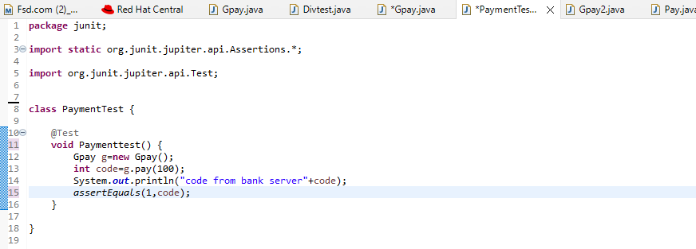

7) Right click on Junit Test class (PaymentTest.java) → Run As→ 2.JUnit Test → Ok

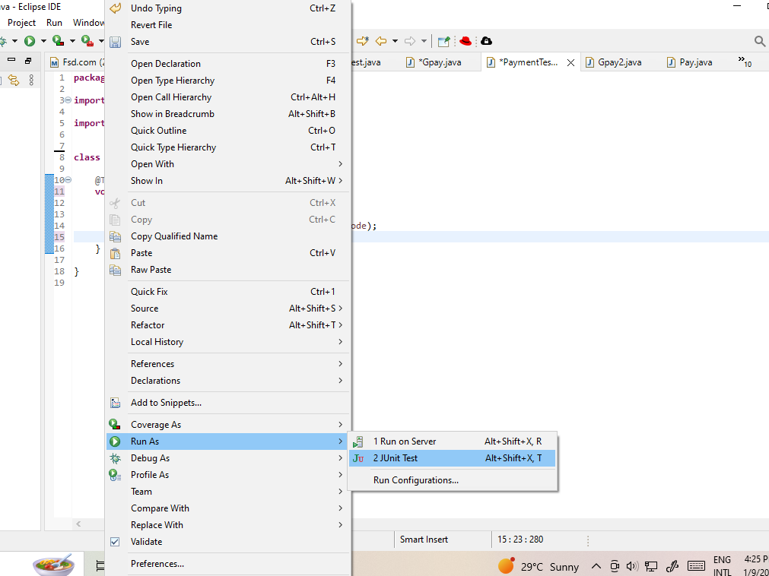

**Passed:** 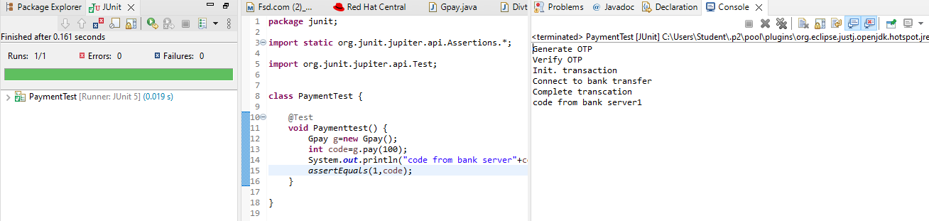

**Failed:**