GIT HUB

# PREREQUISITES :

* Download and install the git bash
* Create an account in github

# Steps to push file from local repository to remote repository

Step 1: Create a new folder(named as GitDemo)

Step 2: Open your github account and create a new repository

* Click on new repository and repository window will appear as shown below

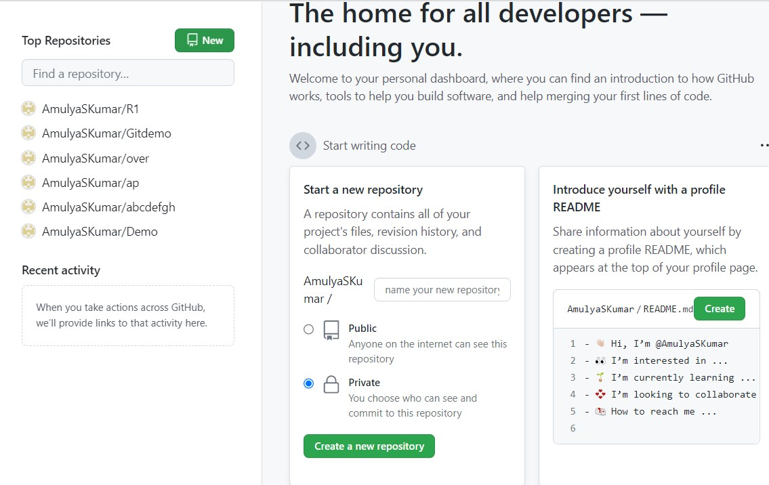

* Enter the name and description of the repository
* Select public and Readme file
* Click on create button

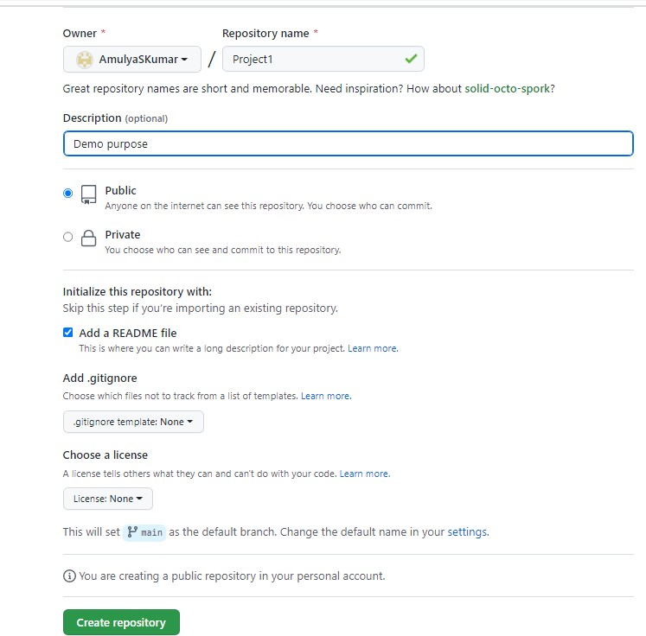

Step 3: Open GitBash and execute the following commands

* Get into the new folder i.e GitDemo
* Initialise the Git

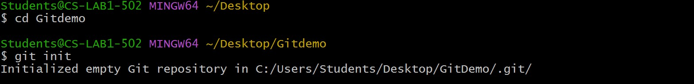

* Clone or download the central/remote repository
* Get into the cloned repository
* Create a file inside the repository

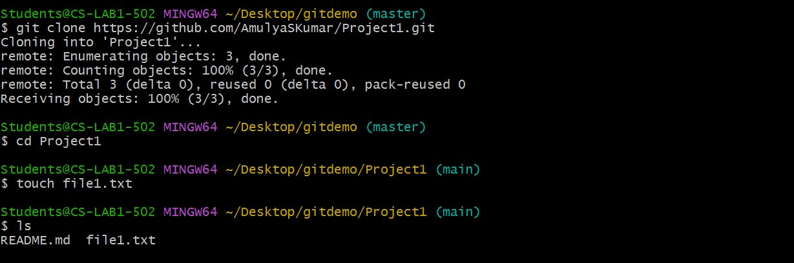

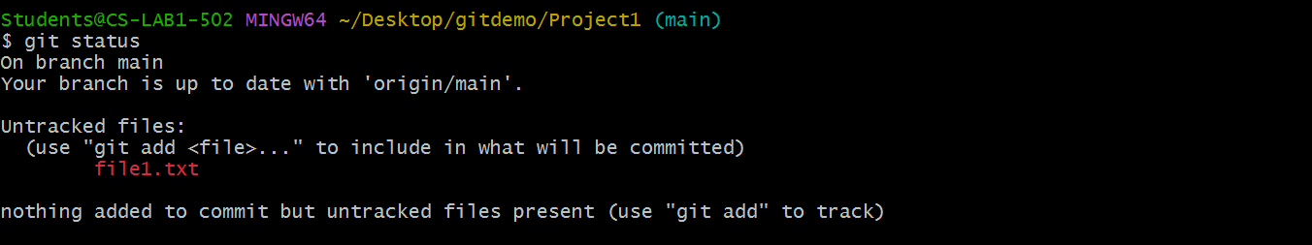

* Add the file (file1.txt) to the repository
* Commit the File and check the git status

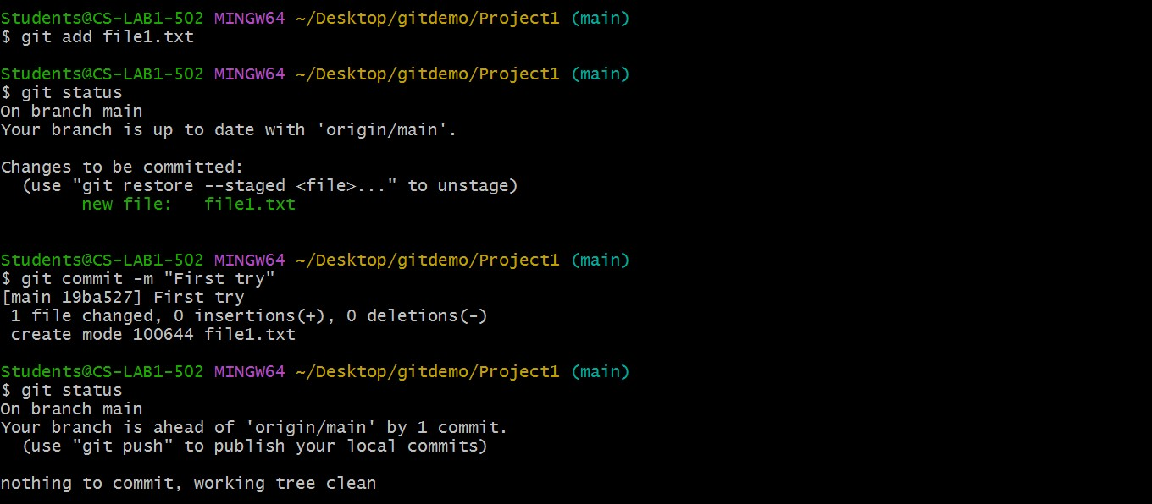

* Establish connection between Remote and Local repository

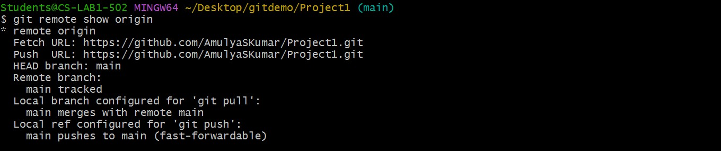

* Push the file to the remote/central repository

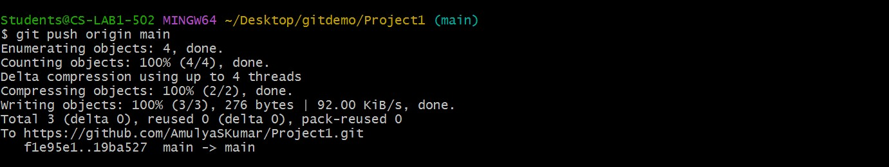

# Note:

* Cd command :to change from current directory to specific directory
* Git init:initialise the git and creates .git file
* Git clone:creates a copy of the main repository to the working/local repository
* Touch:to create new new empty file
* Ls:lists files and directories within in the file system
* Git status:displays the state of the working directory and staging area
  + If the file name displays in red colour,then the file is still in the working copy
  + If the file name displays in green colour,then the file is in staging area

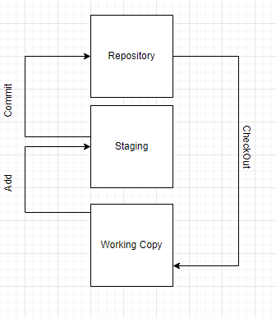

# Git Clone

In Git, cloning is the act of making a copy of any target repository. The target repository can be remote or local. You can clone your repository from the remote repository to create a local copy on your system. Also, you can sync between the two locations.

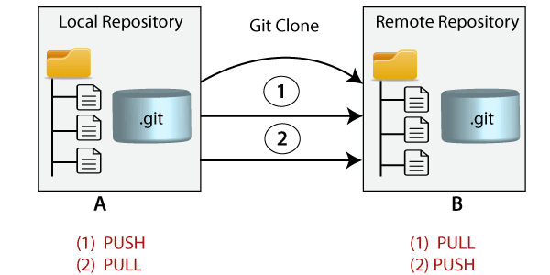

Use the git clone command with repository URL to make a copy of the remote repository. See the below command:

1. $ git clone https://github.com/ImDwivedi1/Git-Example.git

Now, Press Enter. Hence, your local cloned repository will be created. See the below output:

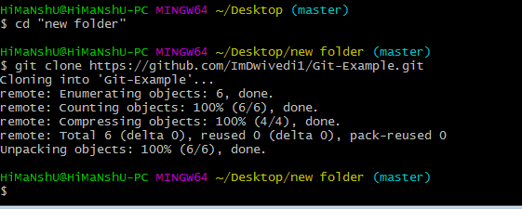

**Git Branching:**

In Git, a branch is a new/separate version of the main repository.

Let's say you have a large project, and you need to update the design on it.

You can create a branch in your local repository and also in you remote repository.

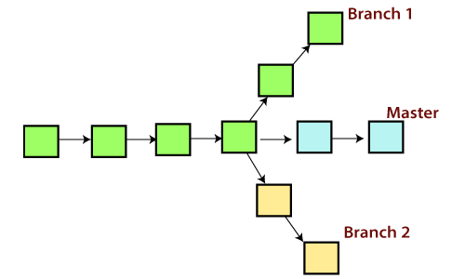

* **Creating branch in your local :**

You can create a new branch with the help of the **git branch** command. This command will be used as:

**Syntax:**

1. $ git branch  **<branch** name**>**

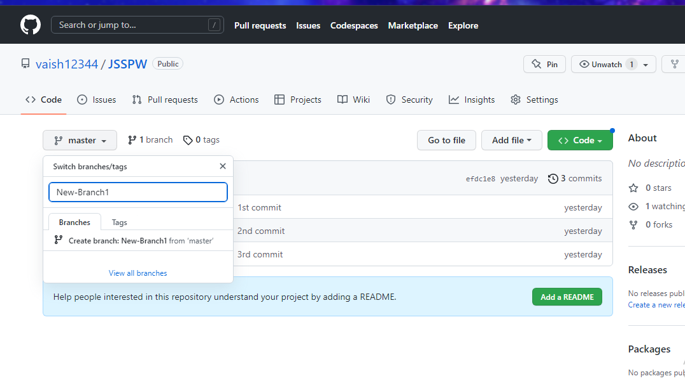

* **Creating branch in Remote:**

View the Branches:

$git branch

Move to another branch we will use command:

$git checkout <branch_name>

* Whenever you create a new branch the files in the new branch it will create all files which were present in main branch
* And if you are working on a new branch and you add a new file , it will not be added to main branch
* To add it to a main branch you should get the approve from your supervisors of your branch and you should send a request.
* If he/she checks the code and approves it it will be added to your main branch this term is called **merging .**

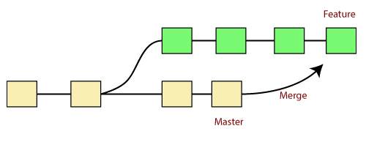

* Creating branch in local:

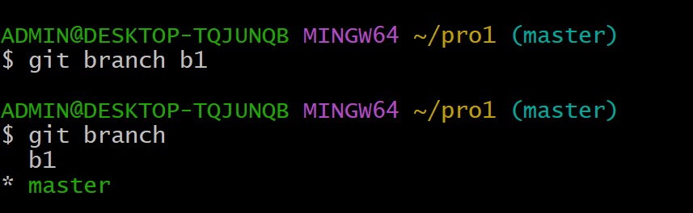

* Entering to that branch which you have created :

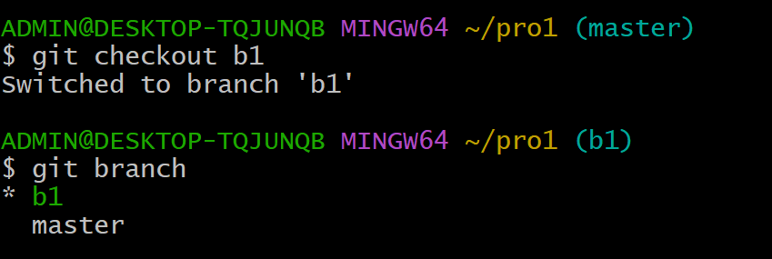

* After creating the branch you can pull all your work/code files into that branch .
* After pushing some files to your creates branch you should create a pull request to your supper wiser to approve your work and merge it into your main project(main branch).

Crete a pull request:

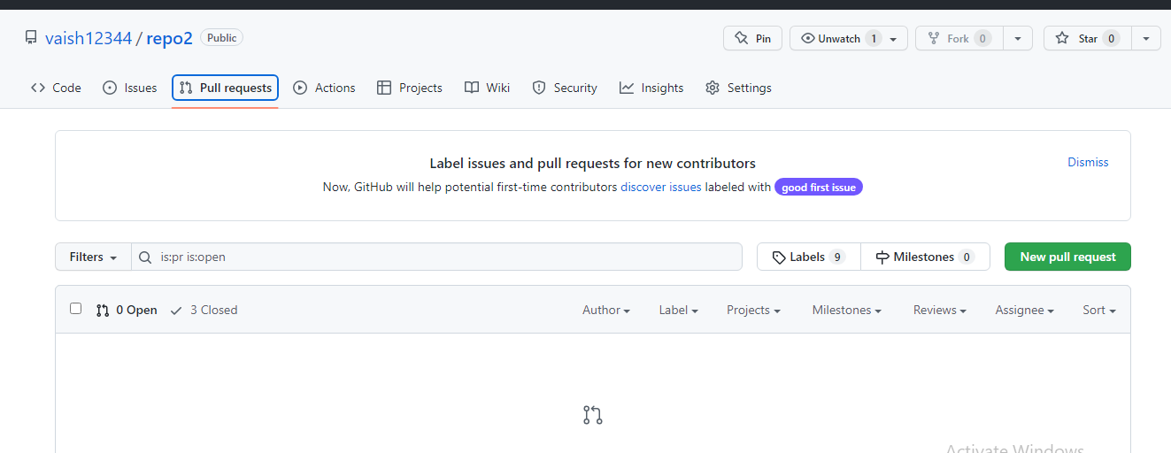

Merging:

