**13.Create JPA class using maven**

**Tools used:**

* Eclipse
* Mysql
* Sqlyog

**Prerequisites**

* Install Eclipse
* Install Mysql
* Install Sqlyog
* Install Jboss on Eclipse

**Steps to create a maven project:**

* Open Eclipse
* Click on File → New → Project → Select Maven Project.
* Select an archetype for your maven project (Set internal as catalog and maven-quickstart as filter)
* Add MySQL and Hibernates in pom.xml

| <dependency>  <groupId>org.hibernate</groupId>  <artifactId>hibernate-core</artifactId>  <version>5.6.14.Final</version>  dependency> |
| --- |
| <dependency>  <groupId>mysql</groupId>  <artifactId>mysql-connector-java</artifactId></  <version>5.1.49</version>  </dependency> |

* Open SqlYog
* Enter the required Details i.e username ,password,address of mysql
* Right click on new connection tab → click on create database → Enter database name (For eg:Student_db)
* Double tap on database created → right click on tables
* Enter table fields(attributes) → click on create table – Enter table name (For eg:Student_details)

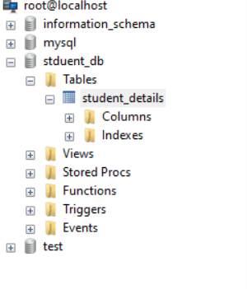

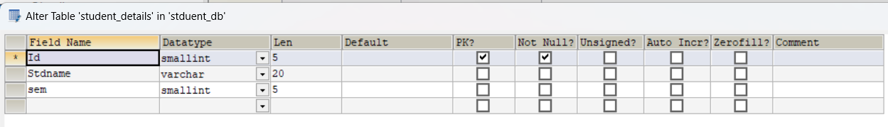

* Create a JPA class in Eclipse(Student.java)

| package com.demo.demo;  import javax.persistence.Id;  import javax.persistence.Column;  import javax.persistence.Entity;  import javax.persistence.Table;  @Entity  @Table(name="student_details")  public class Student1 {  @Id  @Column(name="Id")  private int id;    @Column(name="Stdname")  private String sname;    @Column(name="sem")  private int sem;  public int getId() {  return id;  }  public void setId(int id) {  this.id = id;  }  public String getSname() {  return sname;  }  public void setSname(String sname) {  this.sname = sname;  }  public int getSem() {  return sem;  }  public void setSem(int sem) {  this.sem = sem;  }  } |
| --- |

* Edit the existing App.java

| package com.demo.demo;  import org.hibernate.SessionFactory;  import org.hibernate.Transaction;  import org.hibernate.cfg.Configuration;  import org.hibernate.Query;  import org.hibernate.Session;  import java.util.List;  import java.util.Scanner;  public class App  {  public static void main( String[] args )  {  Configuration con=new Configuration().configure().addAnnotatedClass(Student1.class);  SessionFactory sf=con.buildSessionFactory();  Scanner scan=new Scanner(System.in);  Student1 obj=new Student1();  while(true) {  System.out.println("Enter 1 for Insertion ,2 for Deletion and 3 to Exit");  int i=Integer.parseInt(scan.next());  if(i==1)  {  Session s=sf.openSession();  Transaction tx=s.beginTransaction();  System.out.println("Enter the StudentID,StudentName and Sem");  obj.setId(Integer.parseInt(scan.next()));  obj.setSname(scan.next());  obj.setSem(Integer.parseInt(scan.next()));  s.save(obj);  tx.commit();  }  else if(i==2)  {  Session s=sf.openSession();  Transaction tx=s.beginTransaction();  System.out.println("Enter StudentId for deleting");  int pri=Integer.parseInt(scan.next());  obj =(Student1) s.get(Student1.class, pri);  s.delete(obj);  tx.commit();  }  else  {  break;  }  }  scan.close();  }  } |
| --- |

| Inputs | Outputs |
| --- | --- |
|  |  |
|  |  |