1. Estimate a simple logistic regression model where the binary outcome of grad school admission (**\*admit*)** is regressed on GRE score (**\*gre\***)
2. Use the **_LogRegR2()_** function to evaluate whether the simple logistic regression model does a better job than the null model of predicting whether a person is a case
3. Save the logit predictions, odds predictions, and probability predictions back into the data and create a **_ggplot_** to visualize the results of the logistic regression model
4. Using 0.4 as the threshold for predicting whether a person is a case, compute the accuracy of predictions of the model (i.e., compute number of true positives, false positives, true negatives, and false negatives) and use these counts to create summary accuracy metrics (overall accuracy, positive accuracy, negative accuracy, sensitivity, and specificity)
5. Write up a brief APA style report that details your findings and your interpretations of the simple logistic regression model and the accuracy metrics (see example write up on next page for additional detail).

(Reminder: Steps 1-4 can all be done by completing the template R script)

**Example APA write up for logistic regression analysis**

A logistic regression model was constructed where students’ GPA was used to predict their admission into graduate school. The deviance of the model was significantly lower than the deviance of the null model, χ2 (1, *N* = 400) = 13.01, *p* < .001, suggesting that adding GPA as a predictor provided additional predictive power above and beyond modeling only an intercept. Further, GPA was a significant predictor of a student’s admission to graduate school – for each one unit increase in GPA, the logit of a person’s likelihood of being admitted to graduate school increased by 1.05 (Wald = 3.52, *p* < .001). Converted to a probability, for each one unit increase in GPA the model predicted roughly a 74% multiplicative increase in graduate admission success [(exp(*B*)/ 1 + exp(*B*)) = .741]. The logistic regression model is depicted in *Figure 1.* Additionally, when using a binary classification rule of 40% (i.e., predicted probabilities greater than 40% were predicted to be successful cases of admission) the model performed with relatively good accuracy (overall accuracy = 64.25%), but struggled to identify true positives (positive accuracy = 40%; sensitivity = 25.20%), suggesting that GPA is a more useful predictor for determining true negative cases of graduate school admission.

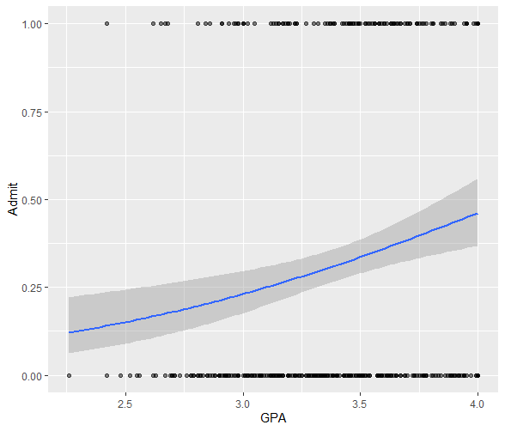

*Figure 1.* Results of the simple logistic regression model where admission to graduate school was predicted by students’ GPA.