Session 10

**Scipy:**

We have the min and max temperatures in a city In India for each months of the year.

We would like to find a function to describe this and show it graphically, the dataset

Given below.

Task:

1. Fitting it to the periodic function

2. Plot the fit

Data

Max = 39, 41, 43, 47, 49, 51, 45, 38, 37, 29, 27, 25

Min = 21, 23, 27, 28, 32, 35, 31, 28, 21, 19, 17, 18

Code

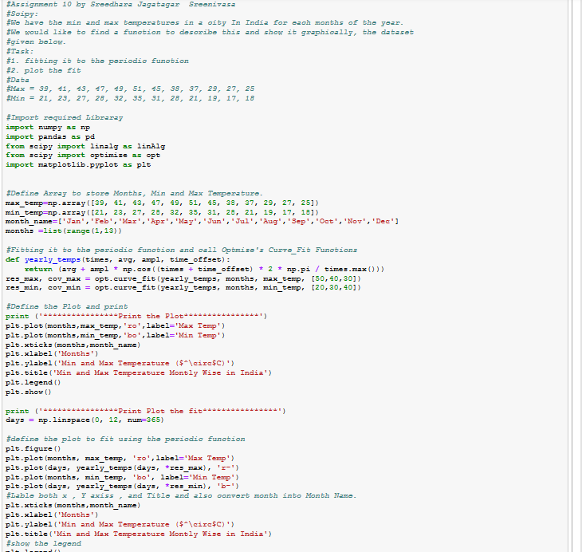

Output

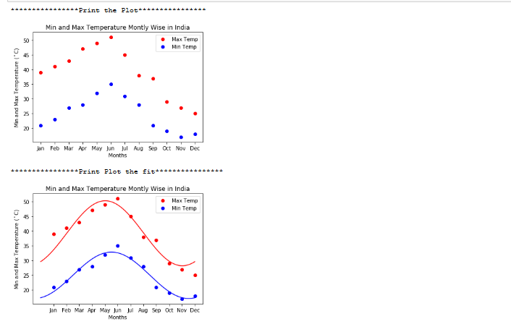

**Matplotlib:**

This assignment is for visualization using matplotlib: data to use:

url=https://raw.githubusercontent.com/Geoyi/Cleaning-Titanic-Data/master/titanic_original.csv

titanic = pd.read_csv(url)

Code

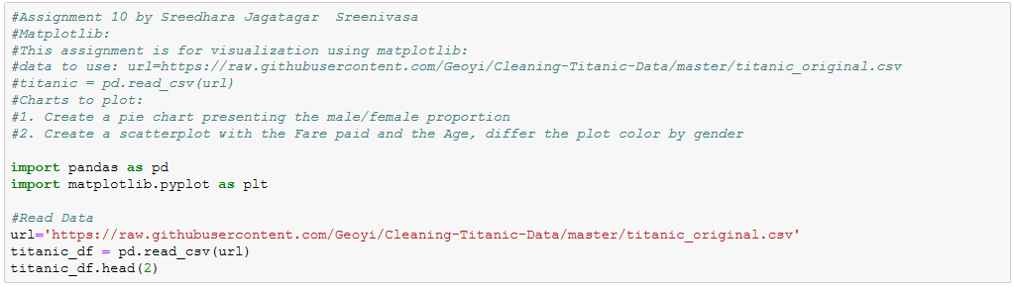

Output of the data

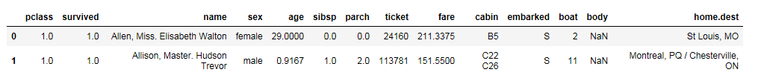

Charts to plot:

#1. Create a pie chart presenting the male/female proportion

Code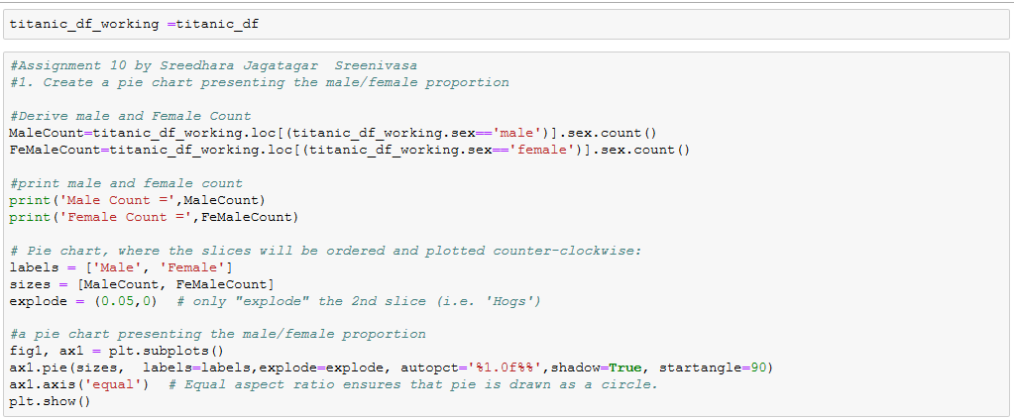

Output

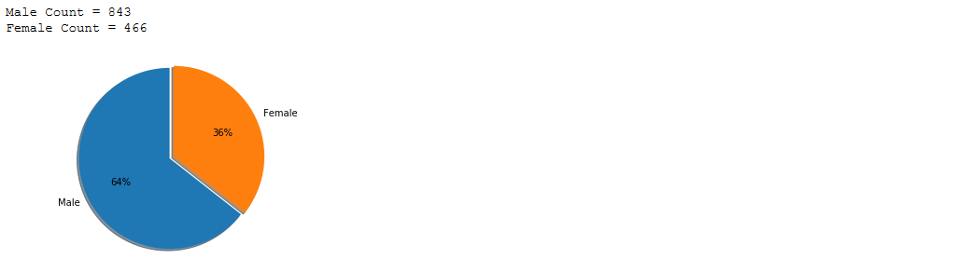

2. Create a scatterplot with the Fare paid and the Age, differ the plot color by gender

Code

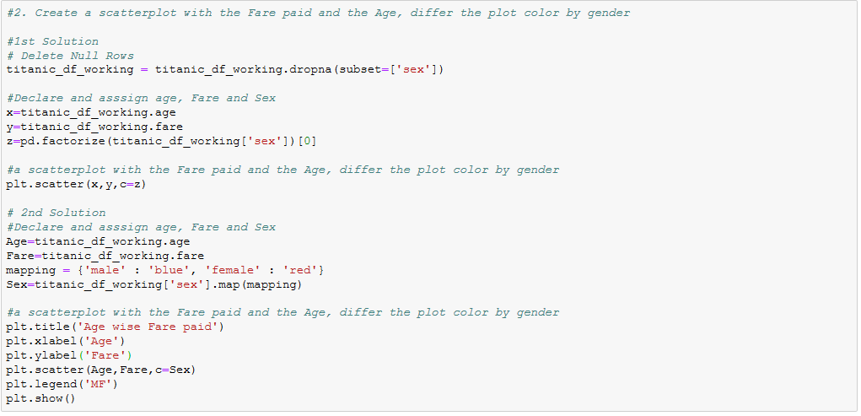

Output

