Session 12

Read the following data set:

https://archive.ics.uci.edu/ml/machine-learning-databases/adult/

Rename the columns as per the description from this file:

https://archive.ics.uci.edu/ml/machine-learning-databases/adult/adult.names

Task:

Create a sql db from adult dataset and name it sqladb

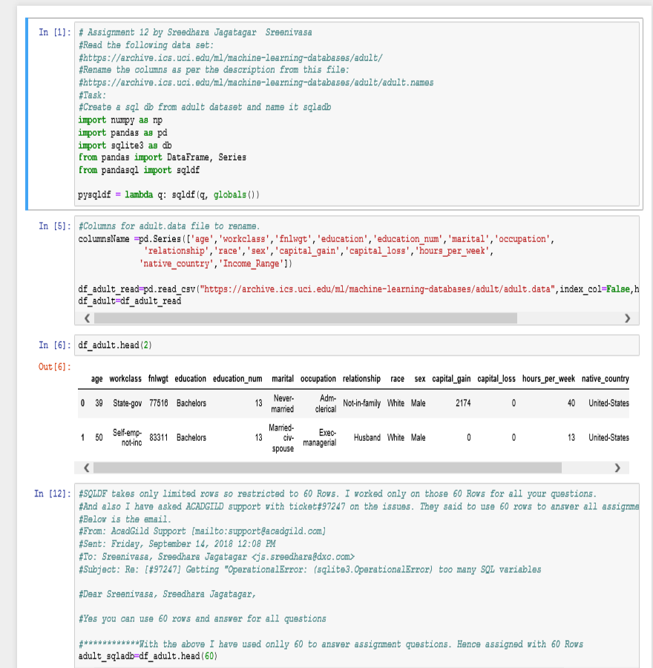

1. Select 10 records from the adult sqladb

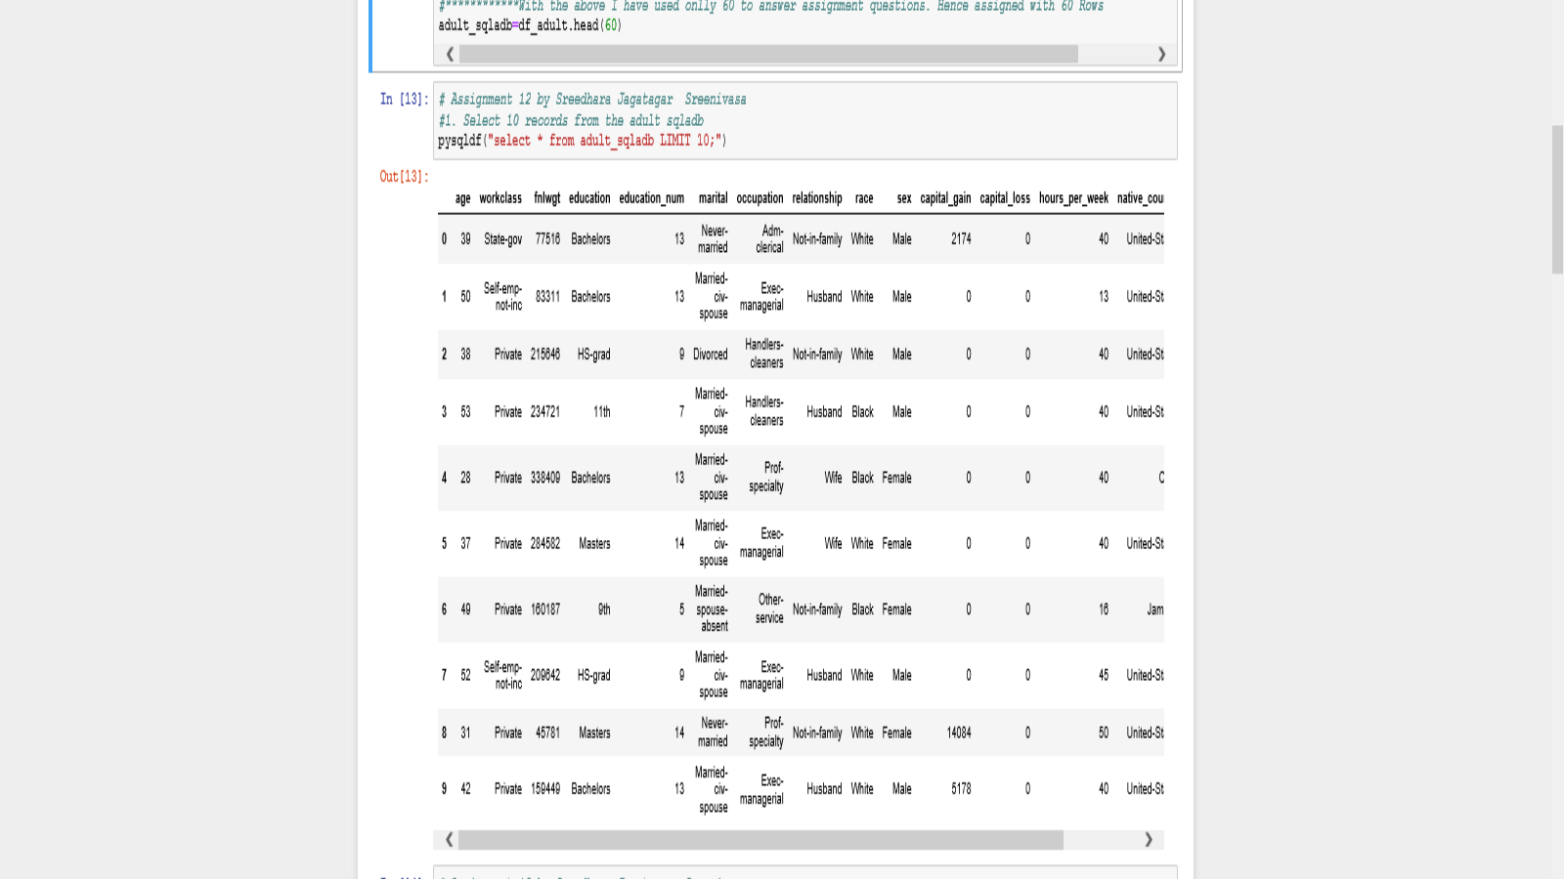

1. Show me the average hours per week of all men who are working in private sector

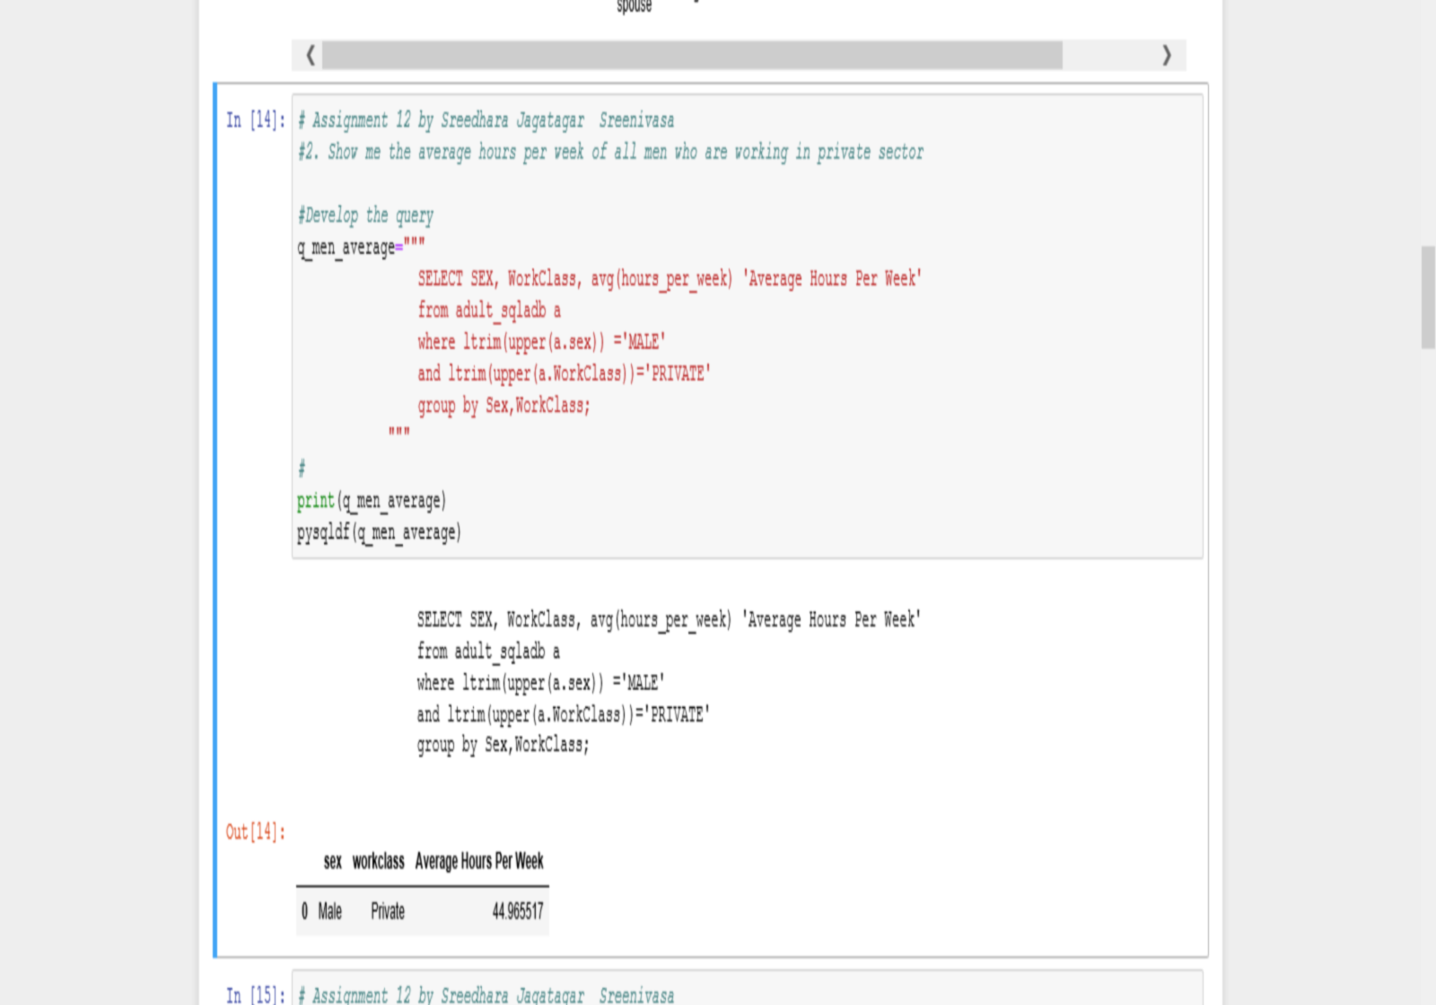

1. Show me the frequency table for education, occupation and relationship, separately

Education

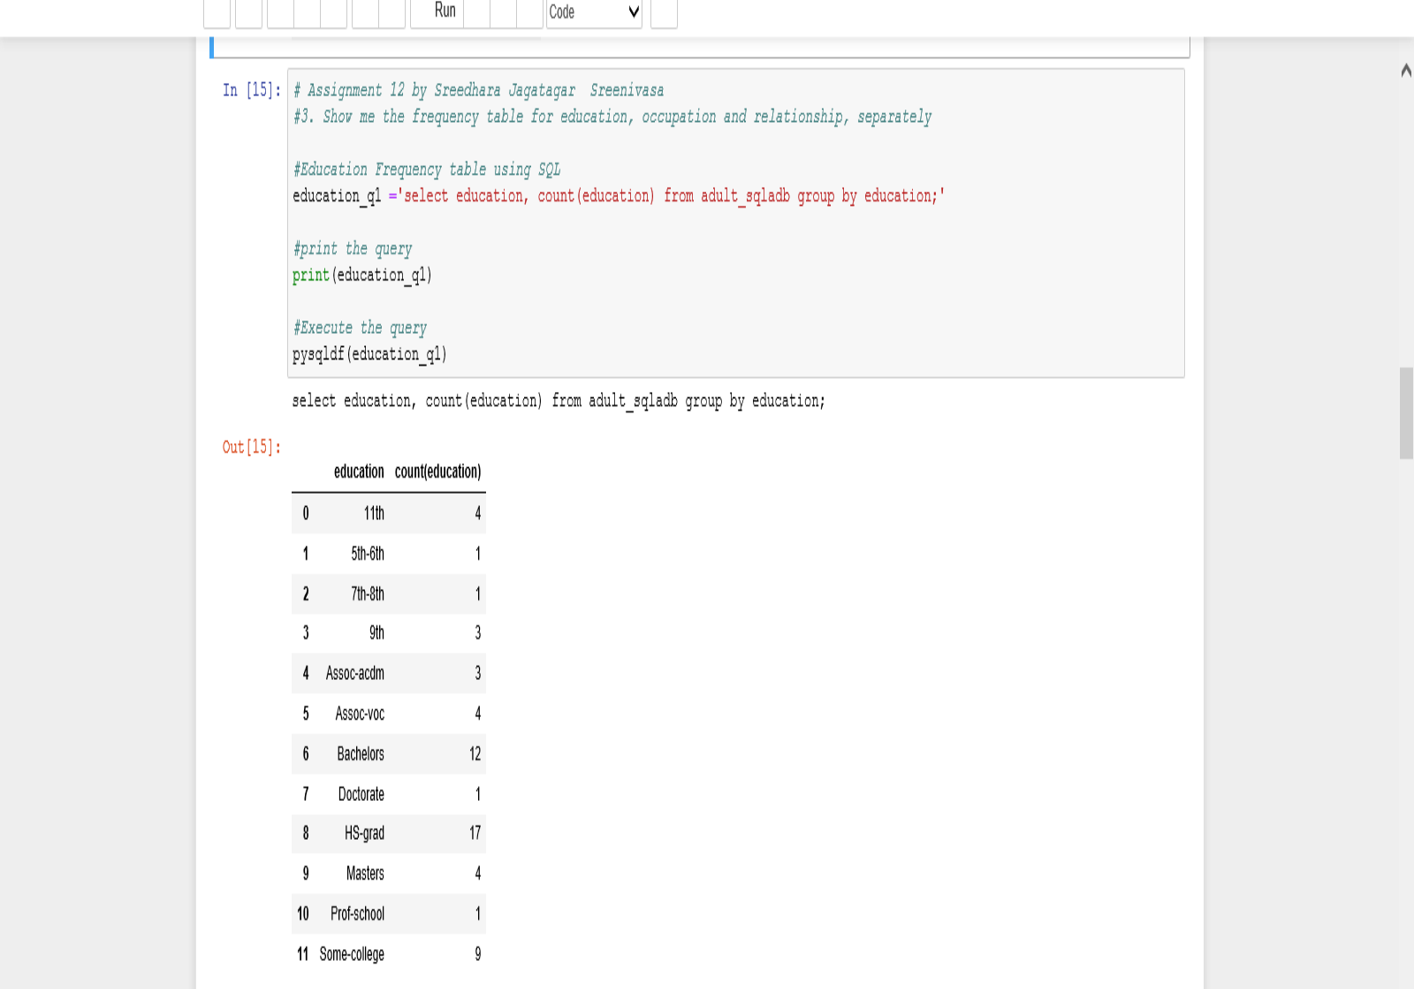

Occupation

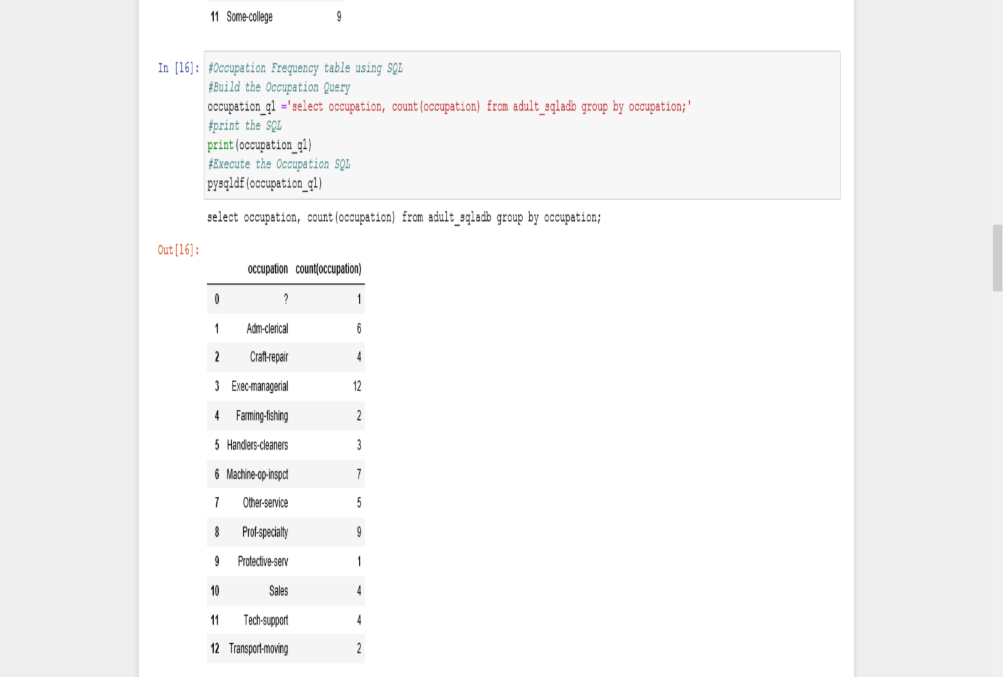

Relationship

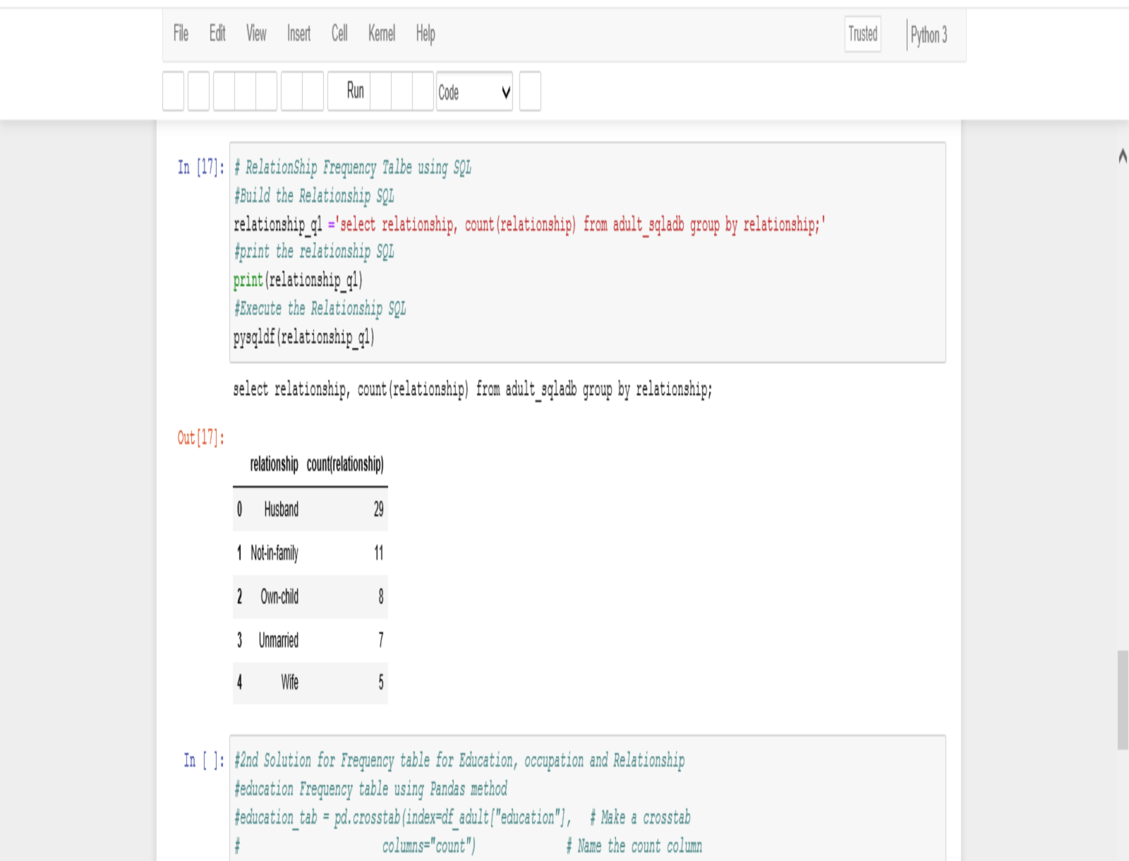

4. Are there any people who are married, working in private sector and having a masters

Degree

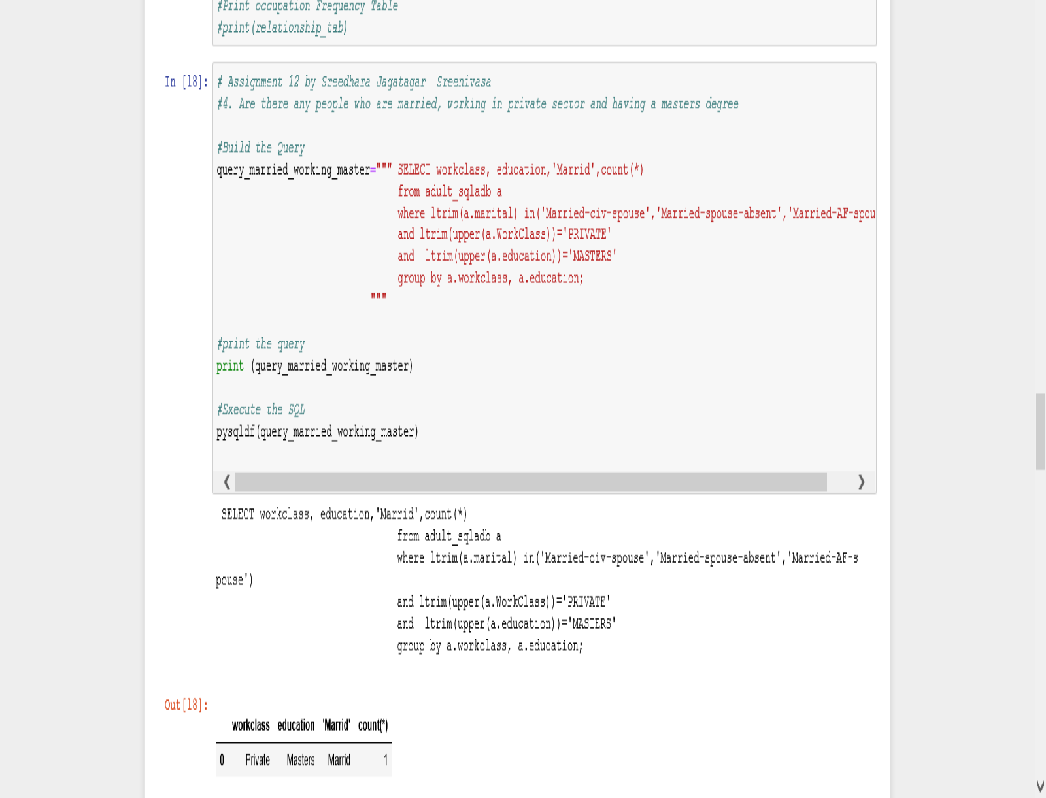

5. What is the average, minimum and maximum age group for people working in Different sectors

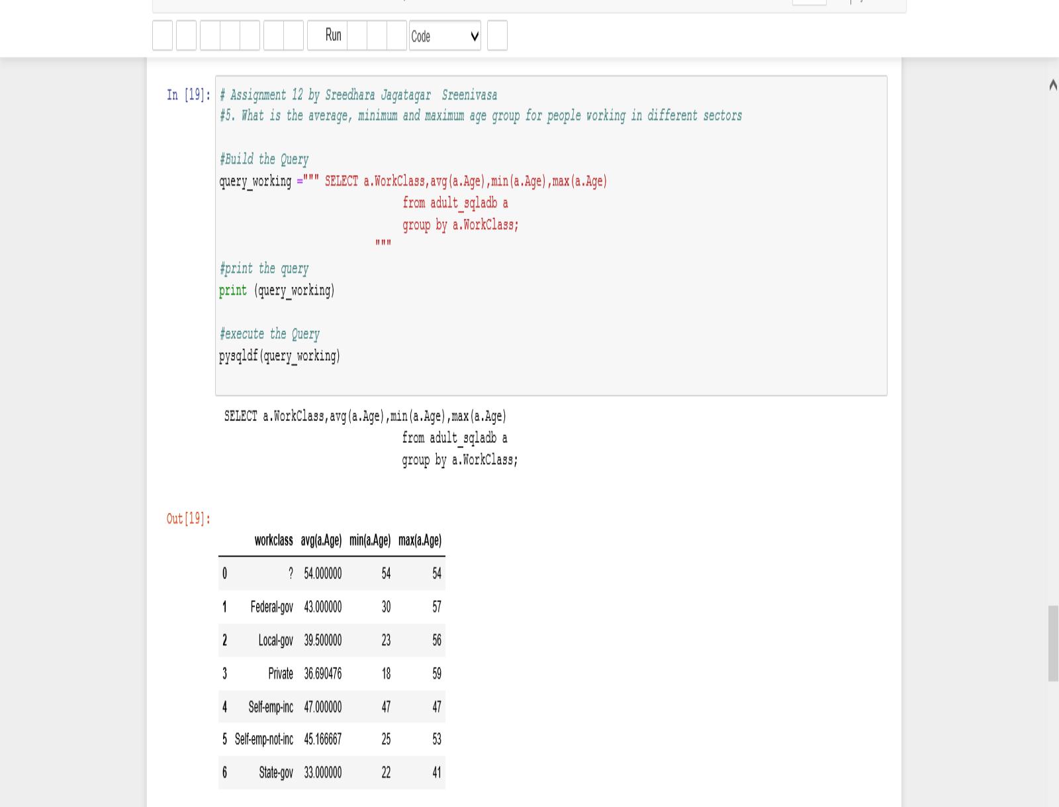

6. Calculate age distribution by country

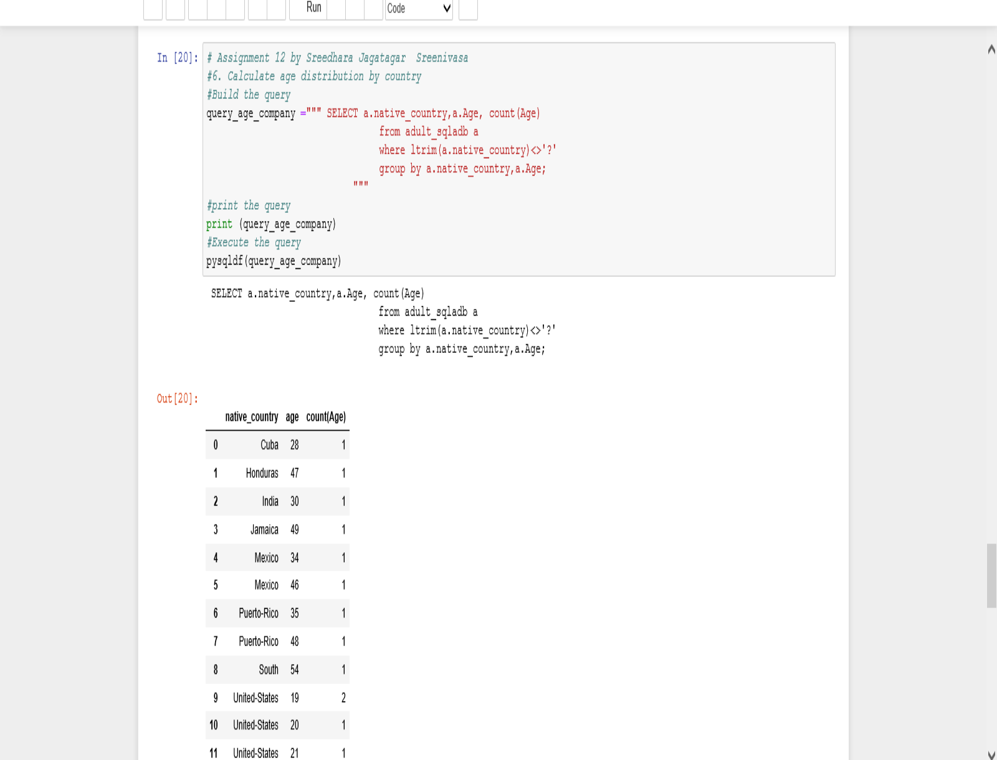

7. Compute a new column as 'Net-Capital-Gain' from the two columns 'capital-gain' and

'capital-loss'

