Session 2

1. Write a program which accepts a sequence of comma-separated numbers from console and generate a list.

Code Screenshot

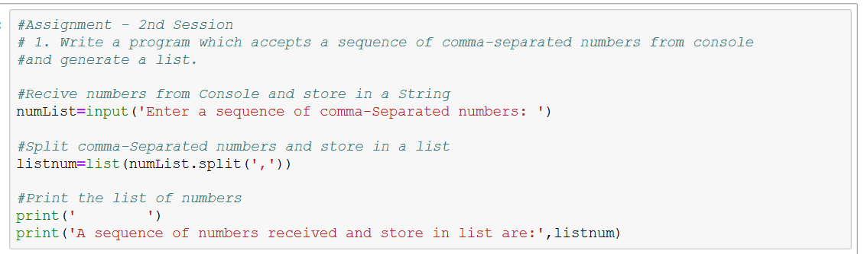

Output Screenshot



2. Create the below pattern using nested for loop in Python.

*

* *

* * *

* * * *

* * * * *

* * * *

* * *

* *

*

Code Screenshot

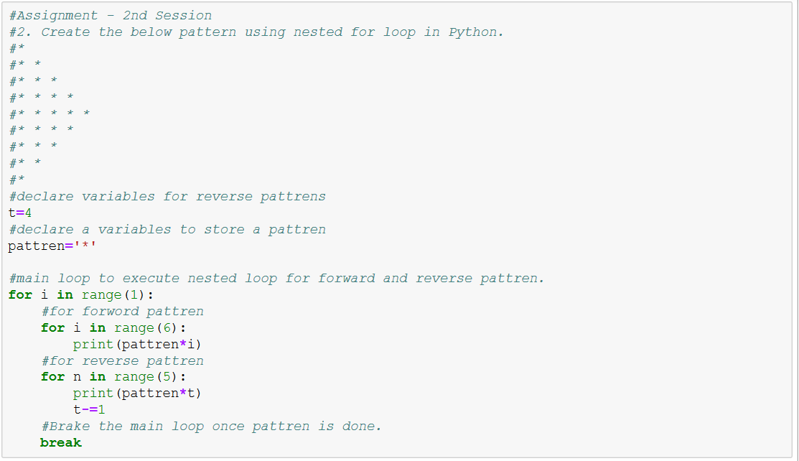

Output Screenshot



3. Write a Python program to reverse a word after accepting the input from the user.

**Sample Output:**

Input word: AcadGild

Output: dilGdacA

Code Screenshot

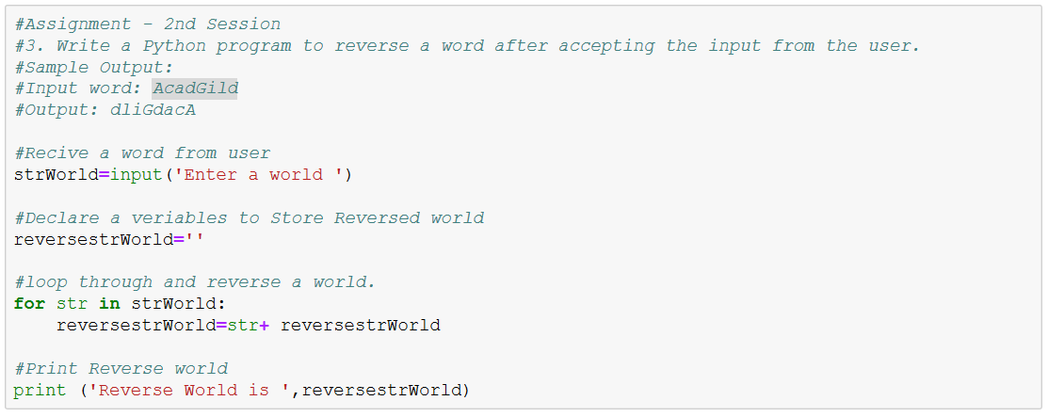

Output Screenshot



4. Write a Python Program to print the given string in the format specified in the **sample output.**

WE, THE PEOPLE OF INDIA, having solemnly resolved to constitute India into a SOVEREIGN,

SOCIALIST, SECULAR, DEMOCRATIC REPUBLIC and to secure to all its citizens

**Sample Output:**

WE, THE PEOPLE OF INDIA,

having solemnly resolved to constitute India into a SOVEREIGN, !

SOCIALIST, SECULAR, DEMOCRATIC REPUBLIC

and to secure to all its citizens

Code Screenshot

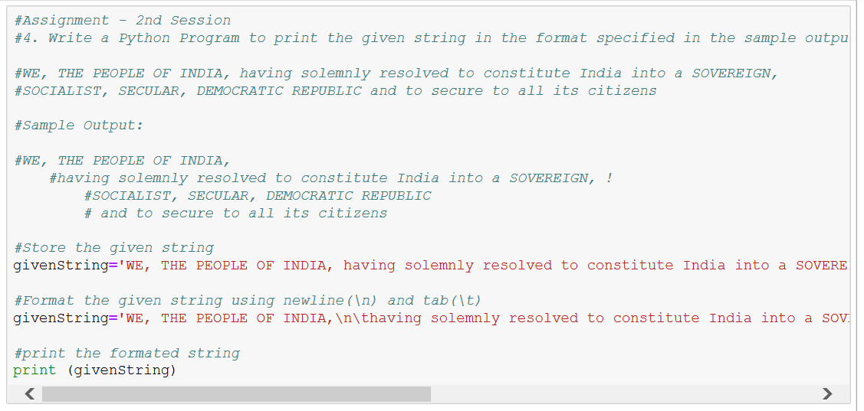

Output Screenshot

