Session 5

1. Write a function to compute 5/0 and use try/except to catch the exceptions.

Code

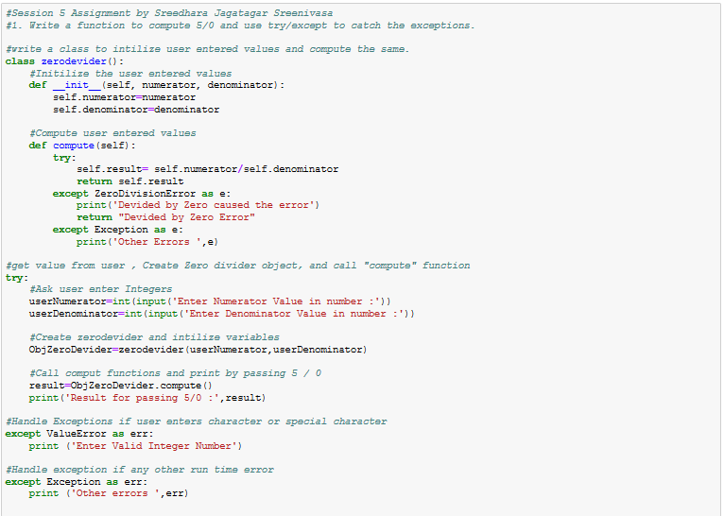

Output



1. Implement a Python program to generate all sentences where subject is in ["Americans","Indians"] and verb is in ["Play", "watch"] and the object is in ["Baseball","cricket"].

Hint: Subject,Verb and Object should be declared in the program as shown below.

subjects=["Americans ","Indians"]

verbs=["play","watch"]

objects=["Baseball","Cricket"]

**Output should come as below:**

Americans play Baseball.

Americans play Cricket.

Americans watch Baseball.

Americans watch Cricket.

Indians play Baseball.

Indians play Cricket.

Indians watch Baseball.

Indians watch Cricket.

