Session 8

1) How-to-count-distance-to-the-previous-zero

For each value, count the difference of the distance from the previous zero (or the start of the Series, whichever is closer) and if there are no previous zeros,print the position

Consider a DataFrame df where there is an integer column {'X':[7, 2, 0, 3, 4, 2, 5, 0, 3, 4]}

**The values should therefore be [1, 2, 0, 1, 2, 3, 4, 0, 1, 2]. Make this a new column 'Y'.**

import pandas as pd

df = pd.DataFrame({'X': [7, 2, 0, 3, 4, 2, 5, 0, 3, 4]})

Code

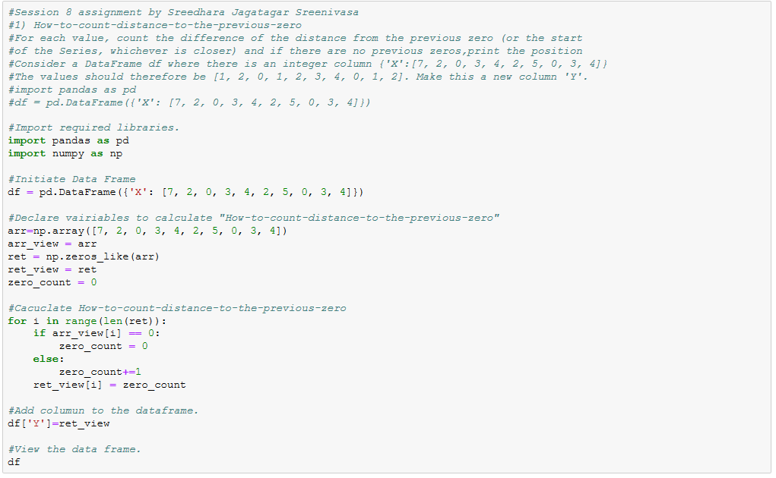

Output

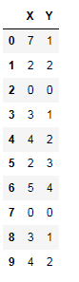

2) Create a DatetimeIndex that contains each business day of 2015 and use it to index a Series of random numbers.

Code

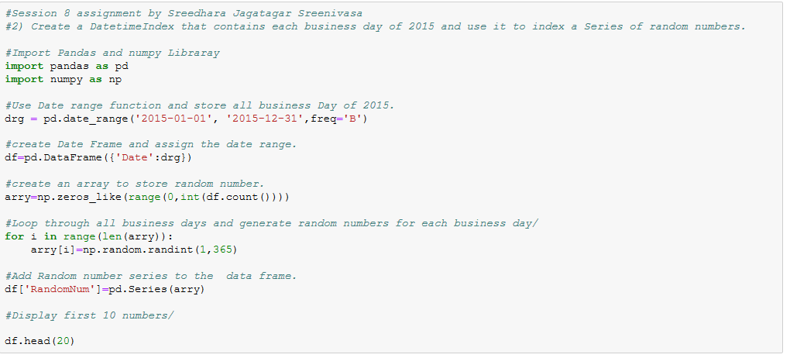

Output

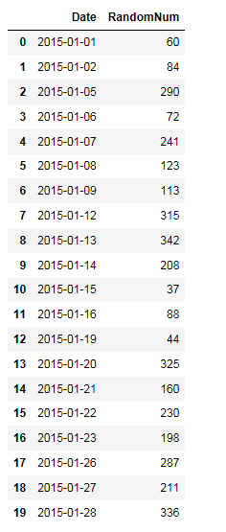

3) Find the sum of the values in s for every Wednesday

Code

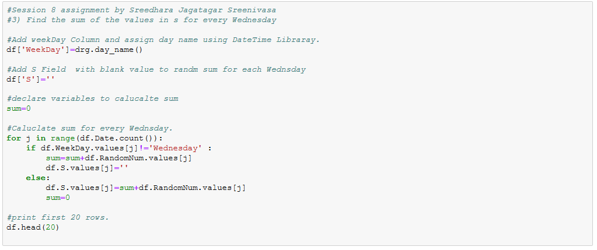

Output

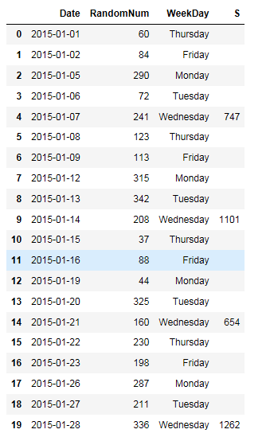

4) Average For each calendar month

Code

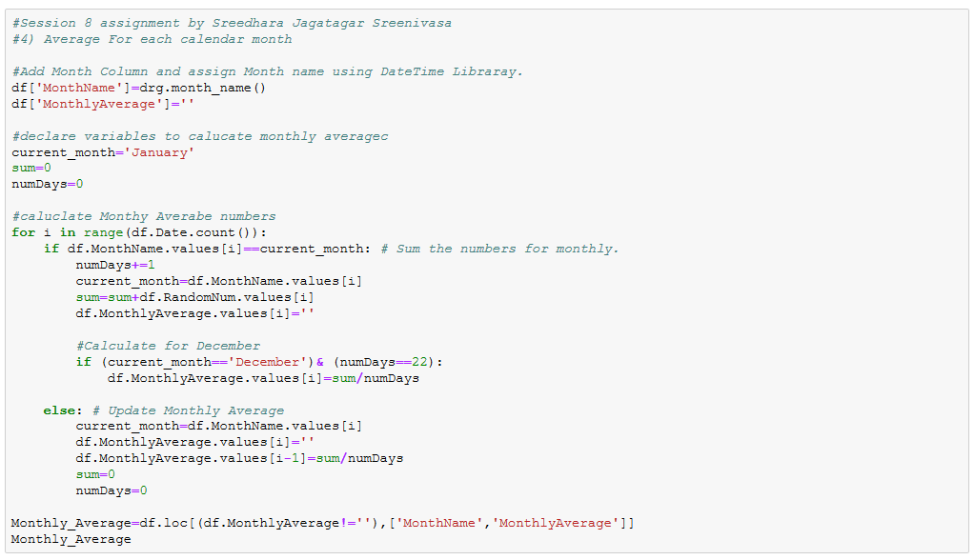

Output

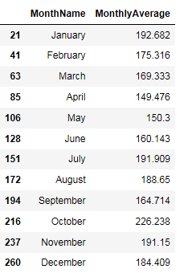

5) For each group of four consecutive calendar months in s, find the date on which the highest value occurred.

Code

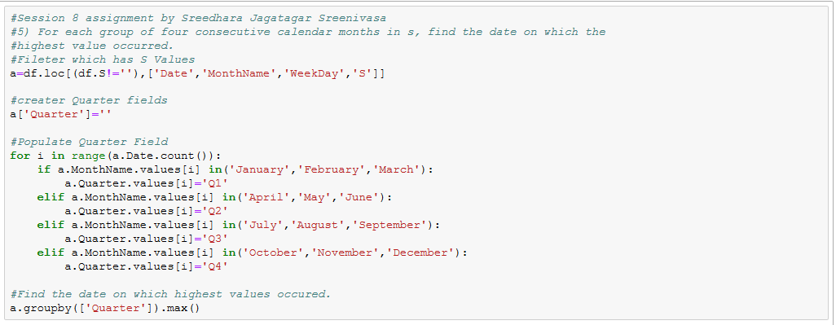

Output

