Session 9

Read the dataset from the below link

https://raw.githubusercontent.com/guipsamora/pandas_exercises/master/06_Stats/US_Baby_Names/US_Baby_Names_right.csv

Code

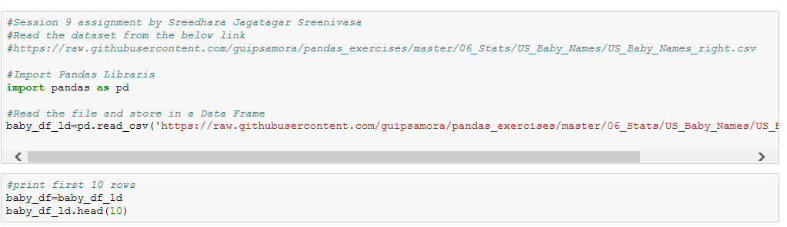

Output

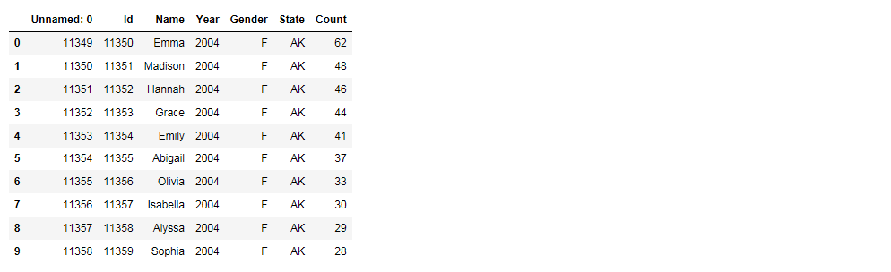

Questions:

1. Delete unnamed columns

Code

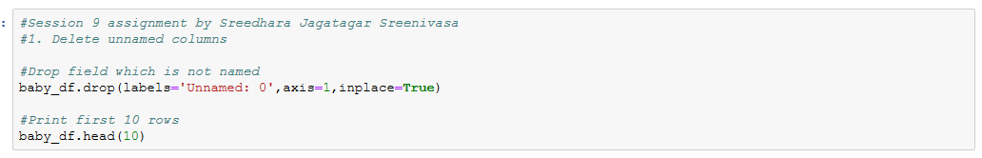

Output

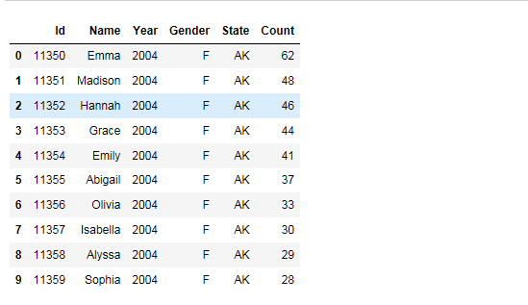

2. Show the distribution of male and female

Code

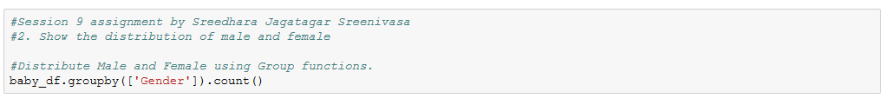

Output

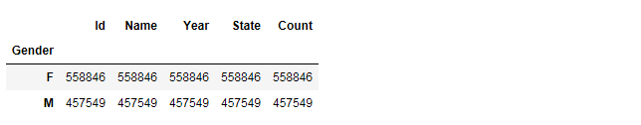

3. Show the top 5 most preferred names

Code

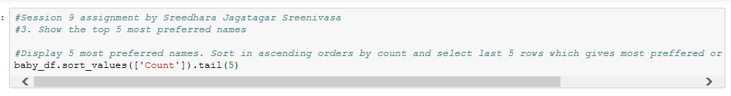

Output

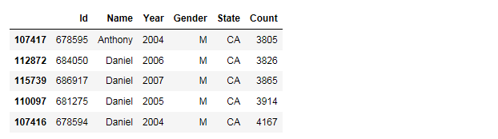

4. What is the median name occurrence in the dataset

Code

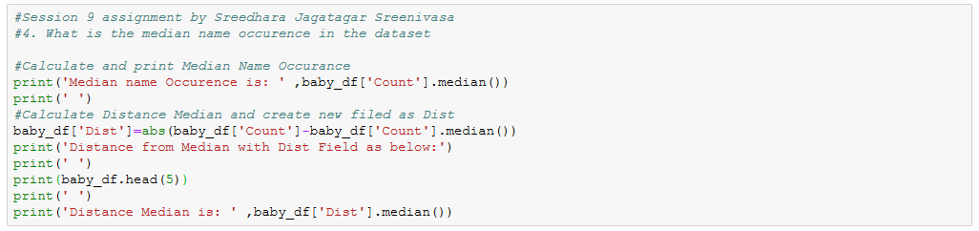

Output

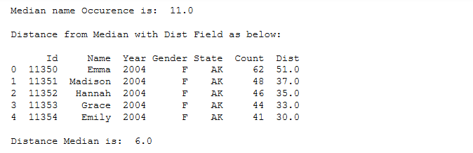

5. Distribution of male and female born count by states

Code

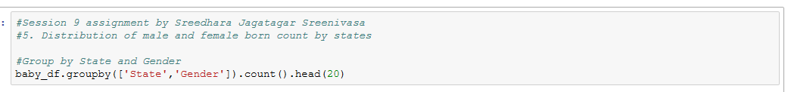

Output

