**PPL Lab sheet-2**

**Name : J.Sampat Srivatsav**

**Roll Number : AM.EN.U4CSE19125**

**Batch : C.S.E - B**

**Q1)**

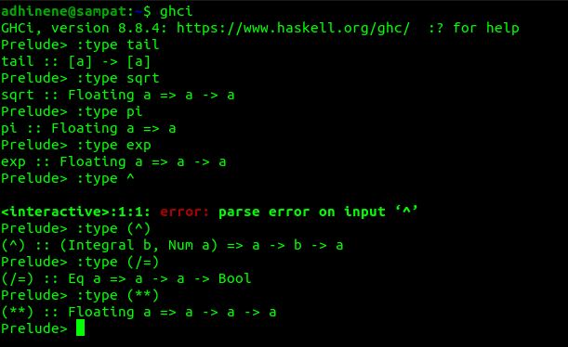

**We need not have to specify the type in the program . Haskel can understand what is the type and how to be used .**

**Q2)**

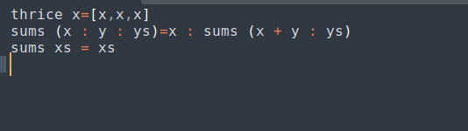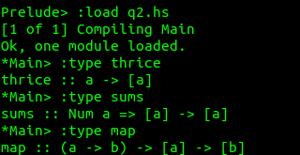

**Q3)**

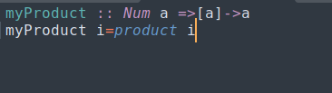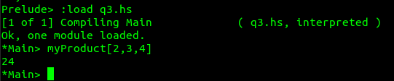

**Q4)**

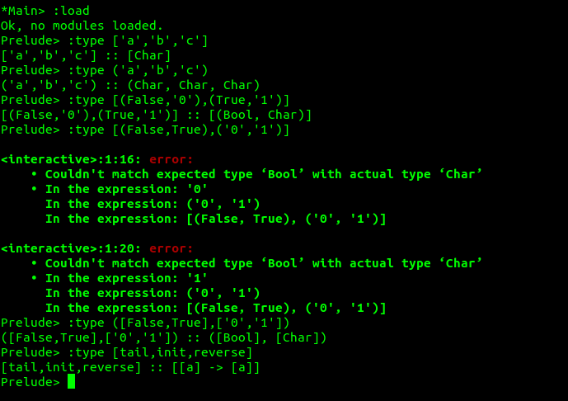

**Q5)**

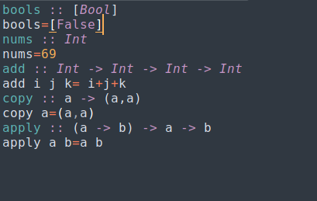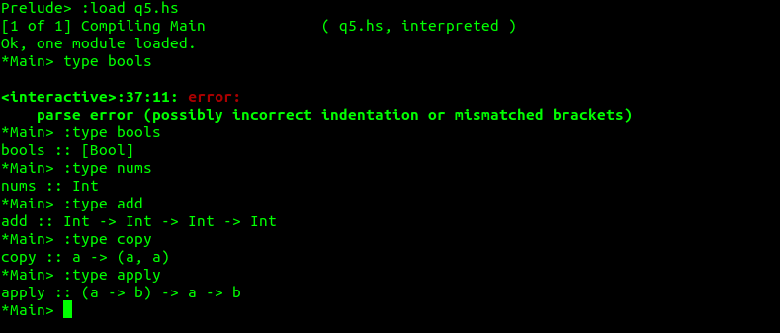

**Q6)**

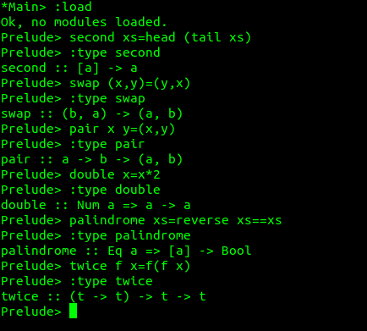

**Q7)**

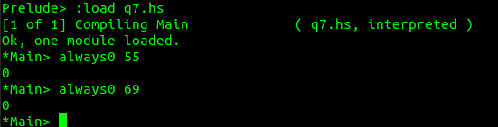

**Q8)**

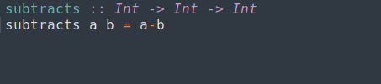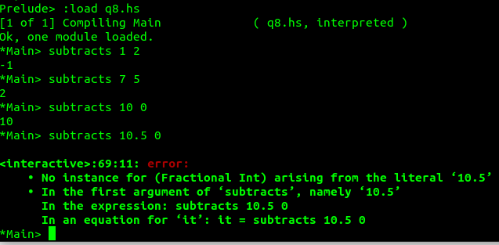

**It doesnot work for float .**

**Modified :**

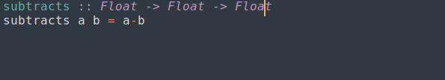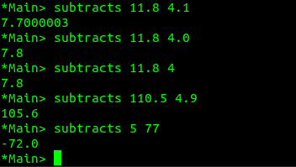

**Q9)**

