Introduction
In creating vast numbers of more-or-less-redundant genes, polyploidization events give evolution a monumental canvas for experimentation. The results of this experimentation can be exceptionally important. So it is with legumes. The evolution of nitrogen-fixing nodules in plants seems to be the alignment of a perfect storm of several successive evolutionary steps, and not all of these can be tracked to recent whole genome duplications (WGDs). A latent capacity for novel-symbiont-interaction seems to date to the ancestor of all eudicots, derived from the pre-existing mycorrhizal machinery.^{[1, 2]} The diversity of nodulating lineages suggests the existence of some deep common ancestor, one bearing some intermediate form of nodulation or of a near precursor state to nodulation, a trait which was preserved in sufficient independent lineages to give rise to the present day.^{[3]} Still, the importance of the post-Cretaceous legume-specific WGD events has been affirmed in multiple studies as responsible for the generation of the elaborated nodule types found in the major legume clades.^{[1, 4]} Any lens by which we may peer into the evolutionary past thus provides us with a valuable model for understanding the impact of large-scale genomic events on not just individual gene families, but also on the whole-process development of novel complex phenotypic features such as elaborated root nodules as such traits evolve either alone or in parallel over diverse and diversified families and genera.
We here present evidence that Cercis canadensis, a non-nodulating member of the legume clade which diverged earliest from the papilionoid lineage, has two features that make it valuable as a genomic model legume. The first is that unlike all other legume tribes, Cercideae lacks a post-Cretaceous polyploidization, suggesting that Cercis may be a representative genomic model for that of the ur-legume. The second is that Bauhinia tomentosa, of tribe Bauhinieae, sister tribe to Cercideae, seems to have evolved not from an autoploidization WGD, but from an ancient alloploid hybridization WGD; and that, moreover, Cercis appears to be descended from one of its parents. While both tribes of the Cercidoideae subfamily are non-nodulating, the existence of this relationship structure so evolutionarily-near to the known instances of autoploid WGDs in the other legumes further-affirms Fabaceae as an excellent model clade for studying the evolutionary effects of all forms of WGDs.

Methods:
Ks-ratio analysis
Peptide and DNA coding sequence transcripts based on RNA transcript data were obtained from lab sources. BLAST protein databases were made, using the configuration for hash indexing. An all-by-all BLAST comparison was performed, with each gene in each species being used as a query against the databases of each species. Only BLAST hits of e-value 1e-5 or lower were reported from the BLAST package. Pairs of genes bearing less than or equal to 90% identity were filtered out. Pairs were then sorted by query gene and by e-value, and the pairs with the lowest e-value for each query gene were separated into lists of top matches per species pair. The Ka/Ks ratio was then calculated using Haibao Tang’s script “synonymous_calc.py”, available via BSD license at Github^{[5]}, which in turn makes use of the software clustalw2^{[6]}, pal2nal^{[7]}, and PAML^{[8]}. A histogram of Ks values was created for the top populations of gene pairs, with Ks peak values observed manually and recorded for each species-pair. (See fig. 1 for an example Ks-histogram.)
To infer a species tree from these Ks peak values, a doubled triangular matrix was recorded, with each species being recorded twice, once for each main branch of the legume ancestral whole genome duplication. Under the assumption that for any given species, a query gene would be most likely to top-match with a gene from that species with which it diverged via speciation, should such a gene exist, the mode Ks peak values from top-match populations of inter-species gene pairs were assumed to represent the mode distance between genes from the same branch of the legume ancestral whole genome duplication. For gene pairs within a single species, only top matches were used; these were assumed to represent mode distances between genes that diverged as of the most recent whole genome duplication. To convert this distance matrix data into a tree, neighbor-joining analysis was performed via the Neighbor utility from the free software package Phylip^{[9]}.
To infer the depth of the Bauhinia polyploidization event, the above procedure was followed, except that the Bauhinia species was doubled, with the depth of the Ks-peak of the Bauhinia polyploidization event serving as the distance between these doubled Bauhinia species.

Aggregated gene families (AGF) phylogenetic analysis
To obtain topology counts, trees for legume gene families were obtained from lab sources. Trees were filtered first by the number of genes in each species, with trees retained only if they bore the gene count expected by previously known polyploidization events for all those non-Cercideae species that were included in the analysis. Trees were filtered out unless they bore a monophyletic clade of at least three genes, all from Cercis and Bauhinia and at least one from each. All observed monophyletic clades of three-or-more members were categorized into various topology classes.
To obtain consensus branch lengths for our two hypothesized genome-formation topologies, trees for legume gene families were obtained from lab sources. Trees were filtered out unless they bore a clade of at least three genes from Cercis or Bauhinia. Trees bearing CB triples were then pruned to eliminate all non-CB branches, giving rooted subtrees of all CB genes in the family. Subtrees were filtered out unless they bore exactly three leaves, one from Cercis and two from Bauhinia. Rooted subtrees remaining were divided into two topology populations – c(b₁b₂) and (cb_{c})b_{x} – and the lengths of all branches were averaged. For the c(b₁b₂) population, b₁ represents the shorter of the two branch lengths; b₂, the longer.

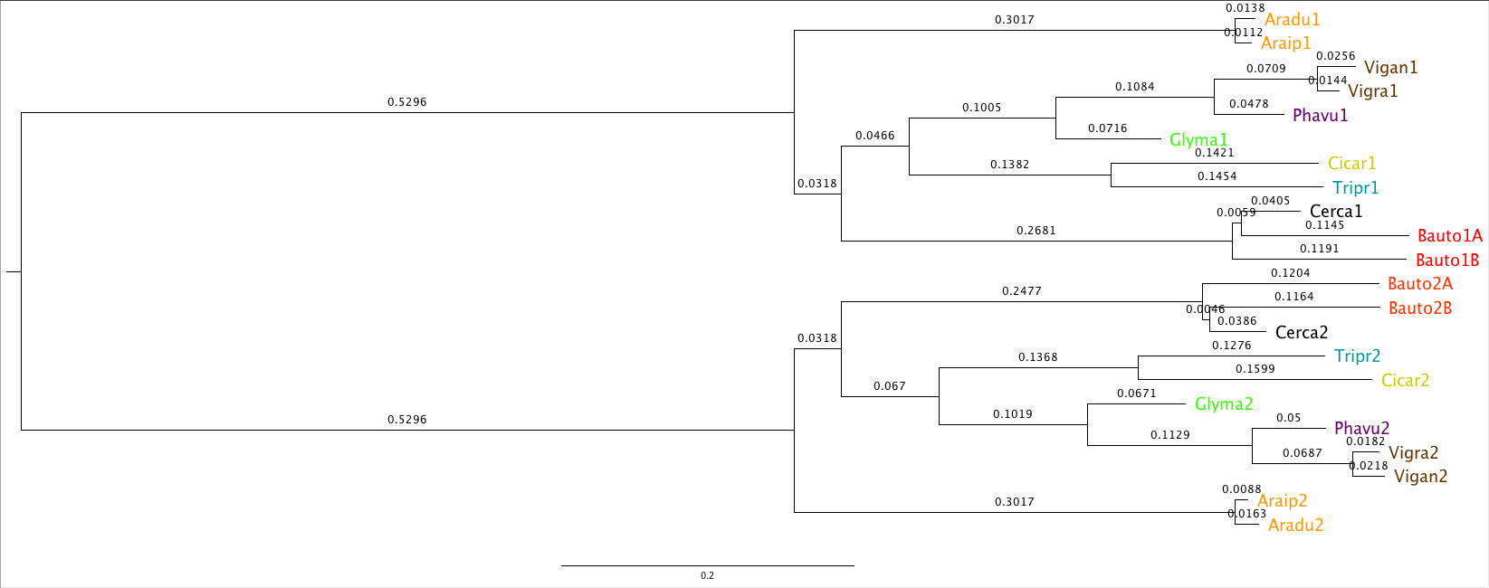Fig. 1: Tree was generated using the neighbor utility of the free Phylip bioinformatics package.^{[9]} Species charted included in our analysis were: Arachis duranensis (aradu), Arachis ipaensis (araip), Vigna angulata (vigan), Vigna radiata (vigra), Phaseolus vulgaris (phavu), Glycine max (glyma), Cicer arietinum (cicar), Trifolium pratense (tripr), Bauhinia tomentosa (bauto), and Cercis canadensis (cerca). Bauto was included twice in order to estimate the timing of its own internal whole-genome duplication.
Results
The histogram of Ks values for Bauhinia tomentosa displayed the distinctive double-peak pattern common to legumes whose genetic history includes recent polyploidization events. The histogram of Ks values for Cercis canadensis, meanwhile, displays no near-term peak, indicating that it lacks a whole genome. The neighbor-joining-derived speciation tree for both Cercis and two Bauhinia clades showed Cercis as more-closely related to one Bauto clade than to the other (fig. 1). Mean branch lengths for both halves of the mirrored tree were 0.00525 for the segment between the Cercis-Bauhinia speciation point and the Bauhinia polyploidization event, 0.03955 from the CB speciation to Cercis, 0.11785 from the CB speciation to Bauhinia_{Cercis}, and 0.11965 from the CB speciation to Bauhinia_{X}.
Topology counts from the ##,### trees of our original dataset showed that 100 trees fell in the c(b₁b₂) topology class and 160 trees fell in the (cb_{c})b_{x} topology class (fig. 2).

For the c(b₁b₂) topology class, consensus branch lengths for our two hypothetical topology classes were: 0.0333 for the root-c branch, 0.0395 for the root-join branch, 0.0398 for the join-b₁ branch, and 0.0607 for the join-b₂ branch (fig. 3a). For the (cb_{c})b_{x} topology class, consensus branch lengths were: 0.0993 for the root-b_{b} branch, 0.0142 for the root-join branch, 0.0327 for the join-c branch, and 0.0977 for the join-b_{c} branch (fig. 3b). Sum root-Cercis and root-Bauto distances were comparable in both topologies.
BauhiniaC

0.097 BauhiniaX

Cercis 0.099

0.032

0.014
BauhiniaLong
BauhiniaShort 0.061
0.039
Cercis
0.039
0.033

Fig. 3: Trees were averaged from unpublished lab tree sets. Older versions of these same tree sets may be obtained at the LegumeInfo database. Starting sets before filtering included all available families: https://legumeinfo.org/

Discussion
One of the great unsolved problems in bioinformatics is: how do we validly extrapolate what we know of the function of the genes of one species to predict the function of genes of related species? While there can be no doubt in the value of sequence-based analyses that strive to tie gene form to gene function, it seems equally obvious that many of the most important biochemical relationships in biology – hormone and receptor, effector and enzyme – are tautological in nature. Among the vast panoply of possible lock-key relationships with high capacity to pass specific signals between signaling molecules, it is whichever one that develops first that is discarded or retained by evolution; and not by evolutionary judgment on the particularities of its form, but by evolutionary judgment on the appropriateness of the pairing it creates between perception and response. Reality is no doubt more complicated than this paragraph, but we can surely not assume that form alone will be sufficient to enable us to predict the function of every type of gene in every genome in every species.
The lack of a whole genome duplication in Cercis, coupled with rather short branch lengths since the Bauhinia hybridization event, gives it far greater claim than many to description as an “evolutionary fossil”. Our evidence is not unassailable in its details*; for exmaple, our Ks-peak derived neighbor-joining tree showed not Cercis and Bauhinia, but Arachis as the outgroup among legumes. This is known by prior research not to be true. As the data was, the Arachis peaks for the WGD event that we used to root our tree really did appear at a lower Ks-value than for other legume species, Cercideae included; however, that may have been simply an artifact of our mode-based measurement process. Nevertheless, it can be seen that Cercis is considerably closer than Glycine to the branch on which the root is known to be placed. It doesn’t take much of a correction to the rooting of the two subtrees under consideration to place Cercis firmly as the legume which has evolved most slowly on average since the time of the ur-legume. It is also worth noting that since the time of the ur-legume Glycine has undergone two whole-genome duplication events, where Cercis has undergone none.
Relying on whole-genome analysis alone would force us into an impossible conjunction of conclusions: that either Bauhinia and Cercis somehow share a whole genome duplication evidence for which has been totally erased in Cercis, or else that Bauhinia and Cercis formed out of a hybridization event too ancient to be sure of having observed, given the likelihood of statistical noise in our data. It is here that our aggregation of individual gene trees resolves our solution. When subtrees for well-behaved families are extracted, divided by topology, and then analyzed in aggregate they tell a coherent message. The trees of topology (cb_{c})b_{x} recapitulate in full the tree derived by neighbor-joining, with Cercis slightly-more-closely related to one set of Bauhinia genes than to the other. The remaining trees of topology c(b₁b₂) fall in the same general branch-length structure, except replacing the Bauhinia genes from one cryptic hybridization parent with a later locally-duplicated copy. This line of evidence supports the allotetraploid model over the cryptic autotetraploid one.

* I will likely remove the Arachis data for the final draft for precisely these following reasons. However, I’m already late and don’t have time to redo this figure. Sorry!

Citations

[1] Young ND et al. 2011 The Medicago genome provides insight into the evolution of rhizobial symbioses. Nature 480, 520–524. (doi:10.1038/nature10625)
[2] Kiers ET, Rousseau RA, West SA, Denison RF. 2003 Host sanctions and the legume–rhizobium mutualism. Nature 425, 78–81. (doi:10.1038/nature01931)
[3] Cannon SB, Ilut D, Farmer AD, Maki SL, May GD, Singer SR, Doyle JJ. 2010 Polyploidy did not predate the evolution of nodulation in all legumes. PloS ONE 5, e11630. (doi:10.1371/journal.pone.0011630)
[4] Li QG, Zhang L, Li C, Dunwell JM, Zhang YM. 2013 Comparative genomics suggests that an ancestral polyploidy event leads to enhanced root nodule symbiosis in the Papilionoideae. Mol. Biol. Evol. 30, 2602–2611.(doi:10.1093/molbev/mst152)
[5] https://github.com/tanghaibao/bio-pipeline/blob/master/synonymous_calculation/synonymous_calc.py
[6] Clustal W and Clustal X version 2.0. (2007 November 01) Bioinformatics (Oxford, England) 23 (21) :2947-8
[7] Suyama M, Torrents D, and Bork P (2006) PAL2NAL: robust conversion of protein sequence alignments into the corresponding codon alignments. Nucleic Acids Res. 34, W609-W612.
[8] Yang Z, 2007 PAML 4: a program package for phylogenetic analysis by maximum likelihood. Molecular Biology and Evolution 24 : 1586-1591
[9] Felsenstein J, 1989 PHYLIP - Phylogeny Inference Package (Version 3.2). Cladistics 5: 164-166.

