nexus_readme.doc

July 20, 2001

Nexus Telescope: Integrated Modeling and Simulation

What is NEXUS?

NEXUS was planned as an in-space technology risk-reduction experiment and as a precursor to NGST (now JWST = James Webb Space Telescope) with an anticipated launch date of 2004. Due to lack of funding the NEXUS program was cancelled in December of 2000. Nevertheless, in the course of the project a detailed integrated model of the precursor space telescope was developed. The innovative technology areas for this project are light-weight optical telescope assembly (OTA) fabrication and verification, cryogenic instrument and actuator development, deployable sunshield technology and image-based wavefront sensing and control. A graphical representation of the launch and on-orbit configurations of NEXUS is shown in Figure 1.

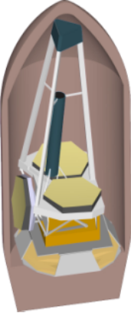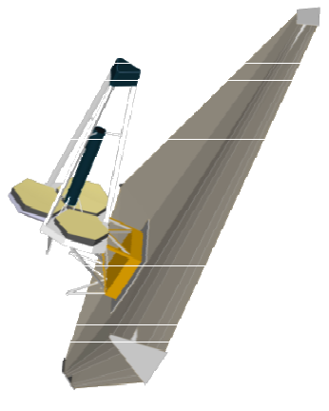
Fig.1: Nexus Spacecraft Concept: (left) stowed configuration, (right) on-orbit deployed configuration

NEXUS features a 2.8 m primary mirror, consisting of three one meter primary mirror (PM) petals. Two of these are fixed and one is deployable as shown in Figure 1 (left). The total estimated mass of the spacecraft is nominally 810 [kg] at an estimated cost of $105.88 million (FY00), which included launch and mission operations. The expected power consumption is 225 [W] and the target orbit is the Lagrange point L2 of the Sun-Earth system with a projected launch date of 2004. The optical telescope assembly (OTA) also features a 3-legged spider (tower), which supports the secondary mirror (SM). The instrument module contains the optics downstream of the tertiary mirror and the camera (detector). The sunshield is large, deployable and accounts for the first flexible mode of the spacecraft structure around 0.2 Hz.

The challenge at a systems level is to find a design that will meet optical performance requirements in terms of pointing and phasing of the science light. This has to be done taking into account the flexible dynamics of the system, the control loops for attitude and pointing as well as the on-board mechanical and electronic noise sources. An integrated model of NEXUS was built to simulate the performance of the telescope and to investigate these interactions, subject to a number of disturbance sources acting during steady state observations.

What is the Structure of the Integrated Model?

The easiest way to explain the structure of the integrated model is to consider the block diagram shown in Figure 2. This figure shows the top-level of the Nexus Simulink model (nexus_block.mdl). Each block is color-coded according to the subsystem it represents. Signal lines are shown with the number of channels above the arrow, as well as the units of each signal, e.g. [N] = newtons, below the arrow..

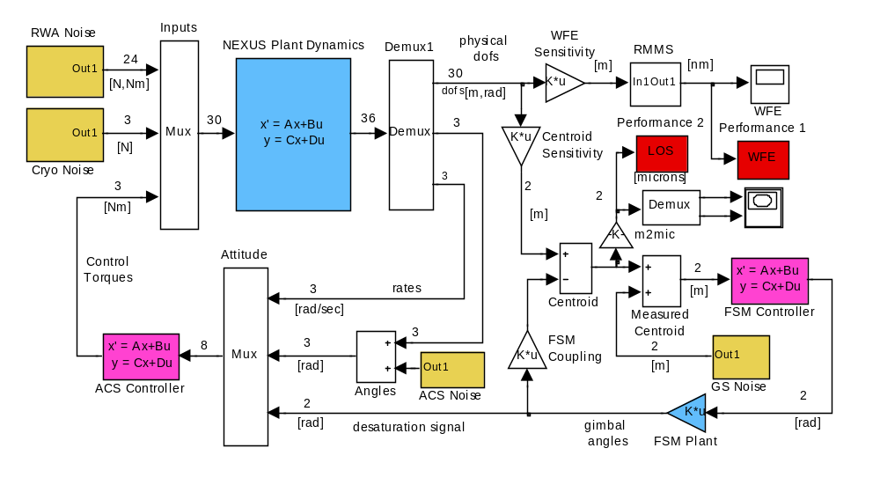

Fig.2: Integrated Simulink model of NEXUS spacecraft: 4 disturbance sources (brown: reaction wheel assembly imbalance noise, cryo-cooler mechanical noise, attitude control system noise, guide star photon noise), 2 plants (blue: NEXUS structural dynamics, fast steering mirror), 2 control loops (magenta: attitude control system (ACS) controls spacecraft rigid body modes and provides coarse pointing, fast steering mirror (FSM) controller provides fine pointing), 2 performance metrics (red: RMS wavefront error, RSS line-of-sight pointing).

There are a large number of design parameters associated with the different subsystems of NEXUS. For the purposes of the research 25 parameters were investigated in some detail (see references shown below).

How can I run this model?

Here are the step-by-step instructions for running the NEXUS integrated model:

- create a new directory on your hard drive
- download the ZIP file nexus.zip into that directory
- extract all files from nexus.zip
- Open Matlab [Note: the model was tested on MATLAB Version 7.0.1.24704 (R14) Service Pack 1, including Simulink Version 6.1 (R14SP1) – Sept. 2004 and ran without problems]
- Change your working directory to the “nexus” directory where all the extracted files reside
- type “nexus_runnom” and hit Enter
- The simulation will execute automatically. Note that first the integrated model is assembled and all the parameters are set. This takes about 5 seconds on a PC Pentium 4. Next, two different methods are used to simulate the system
  - Lyapunov Equation Method
  - Time Domain Simulation using Simulink.
- Inspect the results

What are the results telling me?

The simulation predicts the RMS WFE (wavefront error) and the LOS jitter as follows:

Total Runtime: 40.5783 [sec]

Lyapunov simulation results
RMMS_WFE_lyap = 25.4919
RSS_LOS_lyap = 15.5134

Time-domain simulation results
RMMS_WFE_time = 16.8868
RSS_LOS_time = 18.0231

The RMMS_WFE is in units of [nm], i.e. 10⁻⁹ meters. The nominal observational wavelength of the telescope is λ=1000 [nm] = 1 [μm], so the WFE caused by dynamic disturbances is roughly λ/40. A time domain representation of the WFE, averaged from 134 rays for traced through the optical train can be shown with the following command:

>> plot(tout,WFE)

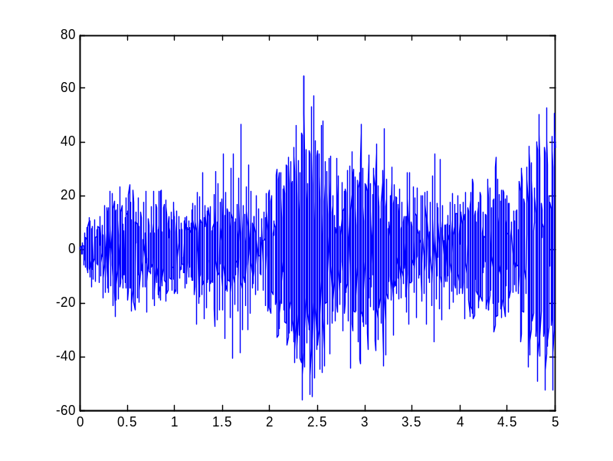
Fig.3: WFE as a function of time (average of 134 ray traces): x-axis in [sec], y-axis in [nm]

The LOS jitter is expressed as the size of the motion traced out by the image centroid on the focal plane in units of [μm]. This trace is generated by the Simulink time domain simulation (see Figure 4) and shows the simulated motion of the image centroid for a time period of 5 seconds.

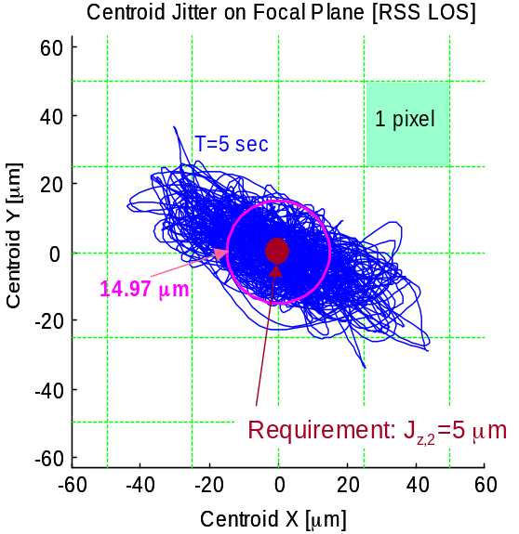
Fig.4: LOS pointing as a function of time

It is important to note that the answers given by the two methods are not exactly identical. This is because slightly different assumptions are used for ray tracing and the frequency content of time domain simulation is incomplete, due to limitations in the time step size and length of simulation. The answer provided by the Lyapunov analysis tends to be more accurate because it is independent of time step. On the downside, the Lyapunov analysis does not provide any insights into the time domain evolution of the signals or frequency content.
Where can I learn more?

A number of publications have been generated that explain the model in greater detail, as well as how it can be used for design analysis and improvement.

- de Weck Olivier L. , “Multivariable Isoperformance Methodology for Precision Opto-Mechanical Systems”, Ph.D. Thesis, Department of Aeronautics and Astronautics, Massachusetts Institute of Technology, SERC Report August 2001

URL Link:
http://ssl.mit.edu/publications/theses/PhD-2001-deWeckOlivier.html

- Miller, D. W., de Weck, O.L. and Mosier G.E., “Framework for Multidisciplinary Integrated Modeling and Analysis of Space Telescopes”, SPIE Proceedings: First International Workshop on Integrated Modeling of Telescopes, Vol. 4757, SPIE, pp. 1-18, July 2002

URL Link:
http://deweck.mit.edu/PDF_archive/3%20Refereed%20Conference/3_8_SPIE_DOCS_Lund.pdf

- de Weck O.L., Miller D.W., “Multivariable Isoperformance Methodology for Precision Opto-Mechanical System”, Paper AIAA-2002-1420, 43rd AIAA/ASME /ASCE/AHS Structures, Structural Dynamics, and Materials Conference, Denver, Colorado, April 22-25, 2002

URL Link:
http://deweck.mit.edu/PDF_archive/3%20Refereed%20Conference/3_10_AIAA-2002-1420.pdf

- A brief presentation (Powerpoint) is included in this package: nexus.ppt
- A mode shape animation showing a critical mode at 23Hz: mod23Hz.avi

For further questions and inquiries:

Olivier L. de Weck, Ph.D.
Robert N. Noyce Assistant Professor of Aeronautics
and Astronautics and Engineering Systems
33-410, Massachusetts Institute of Technology
77 Massachusetts Avenue, Cambridge, MA 02139, USA
phone: (617) 253-0255
email: deweck@mit.edu
web: http://deweck.mit.edu

