PRODUCT INTERN ASSIGNMENT
Subspace Product Teardown

SUMMARY
Subspace is not competing with Netflix, Spotify, or traditional subscription managers. It is competing against consumer inertia. The product's biggest challenge is not helping users find subscriptions; it is making savings tangible enough for users to change their existing purchasing behaviour.
After thoroughly exploring the platform as a real user in Chennai, five systemic issues emerged across activation, discovery, trust, marketplace health, and retention. Each observation below is tied to a specific screen, a clear business cost, and an actionable ship recommendation.

PRIORITY SUMMARY
Priority | Feedback | Business Impact
P1 | Cold start onboarding fix | Activation — reduces new-user churn
P1 | Intent-based discovery | Activation — reduces decision fatigue
P1 | Trust Score on sharers | Conversion — drives group join rate
P1 | Surface savings everywhere | Retention — reinforces core value prop
P2 | Refocus rental marketplace | Marketplace health — restores trust

P1 | Feedback 1 — New User Dashboard Has No Immediate Value

1A. OBSERVED
When a brand new user signs up and lands on the Home screen, they are greeted with an entirely empty state:
- No Active Subscriptions message with a generic icon
- ₹0 saved, ₹0 wallet balance, empty transactions, empty cart
- Four action shortcuts (Add Subscriptions, Bill Payments, Events, Sell Products) with no context on where to begin
- No indication of what the product can do for this specific user in their city
The entire onboarding experience is blank. There is no value visible until the user takes action themselves.
1B. THE PROBLEM
This is a textbook cold start problem. Subspace's entire value proposition is built on three pillars: saving money, sharing subscriptions, and discovering deals. Yet a new user sees zero evidence of any of these on their very first screen.
The business cost is high. Users who do not understand the value within the first 60 seconds of a product experience are far more likely to abandon. When the home screen shows only empty states, the implicit message to the user is: "you have to do work before you get value." That is the opposite of a strong activation hook.
Furthermore, the product is asking users to trust a platform for financial transactions (group subscription payments) without first demonstrating credibility, savings potential, or social proof.
1C. CURRENT SCREEN
The screenshot below shows the blank Home dashboard a new user encounters immediately after signing up.
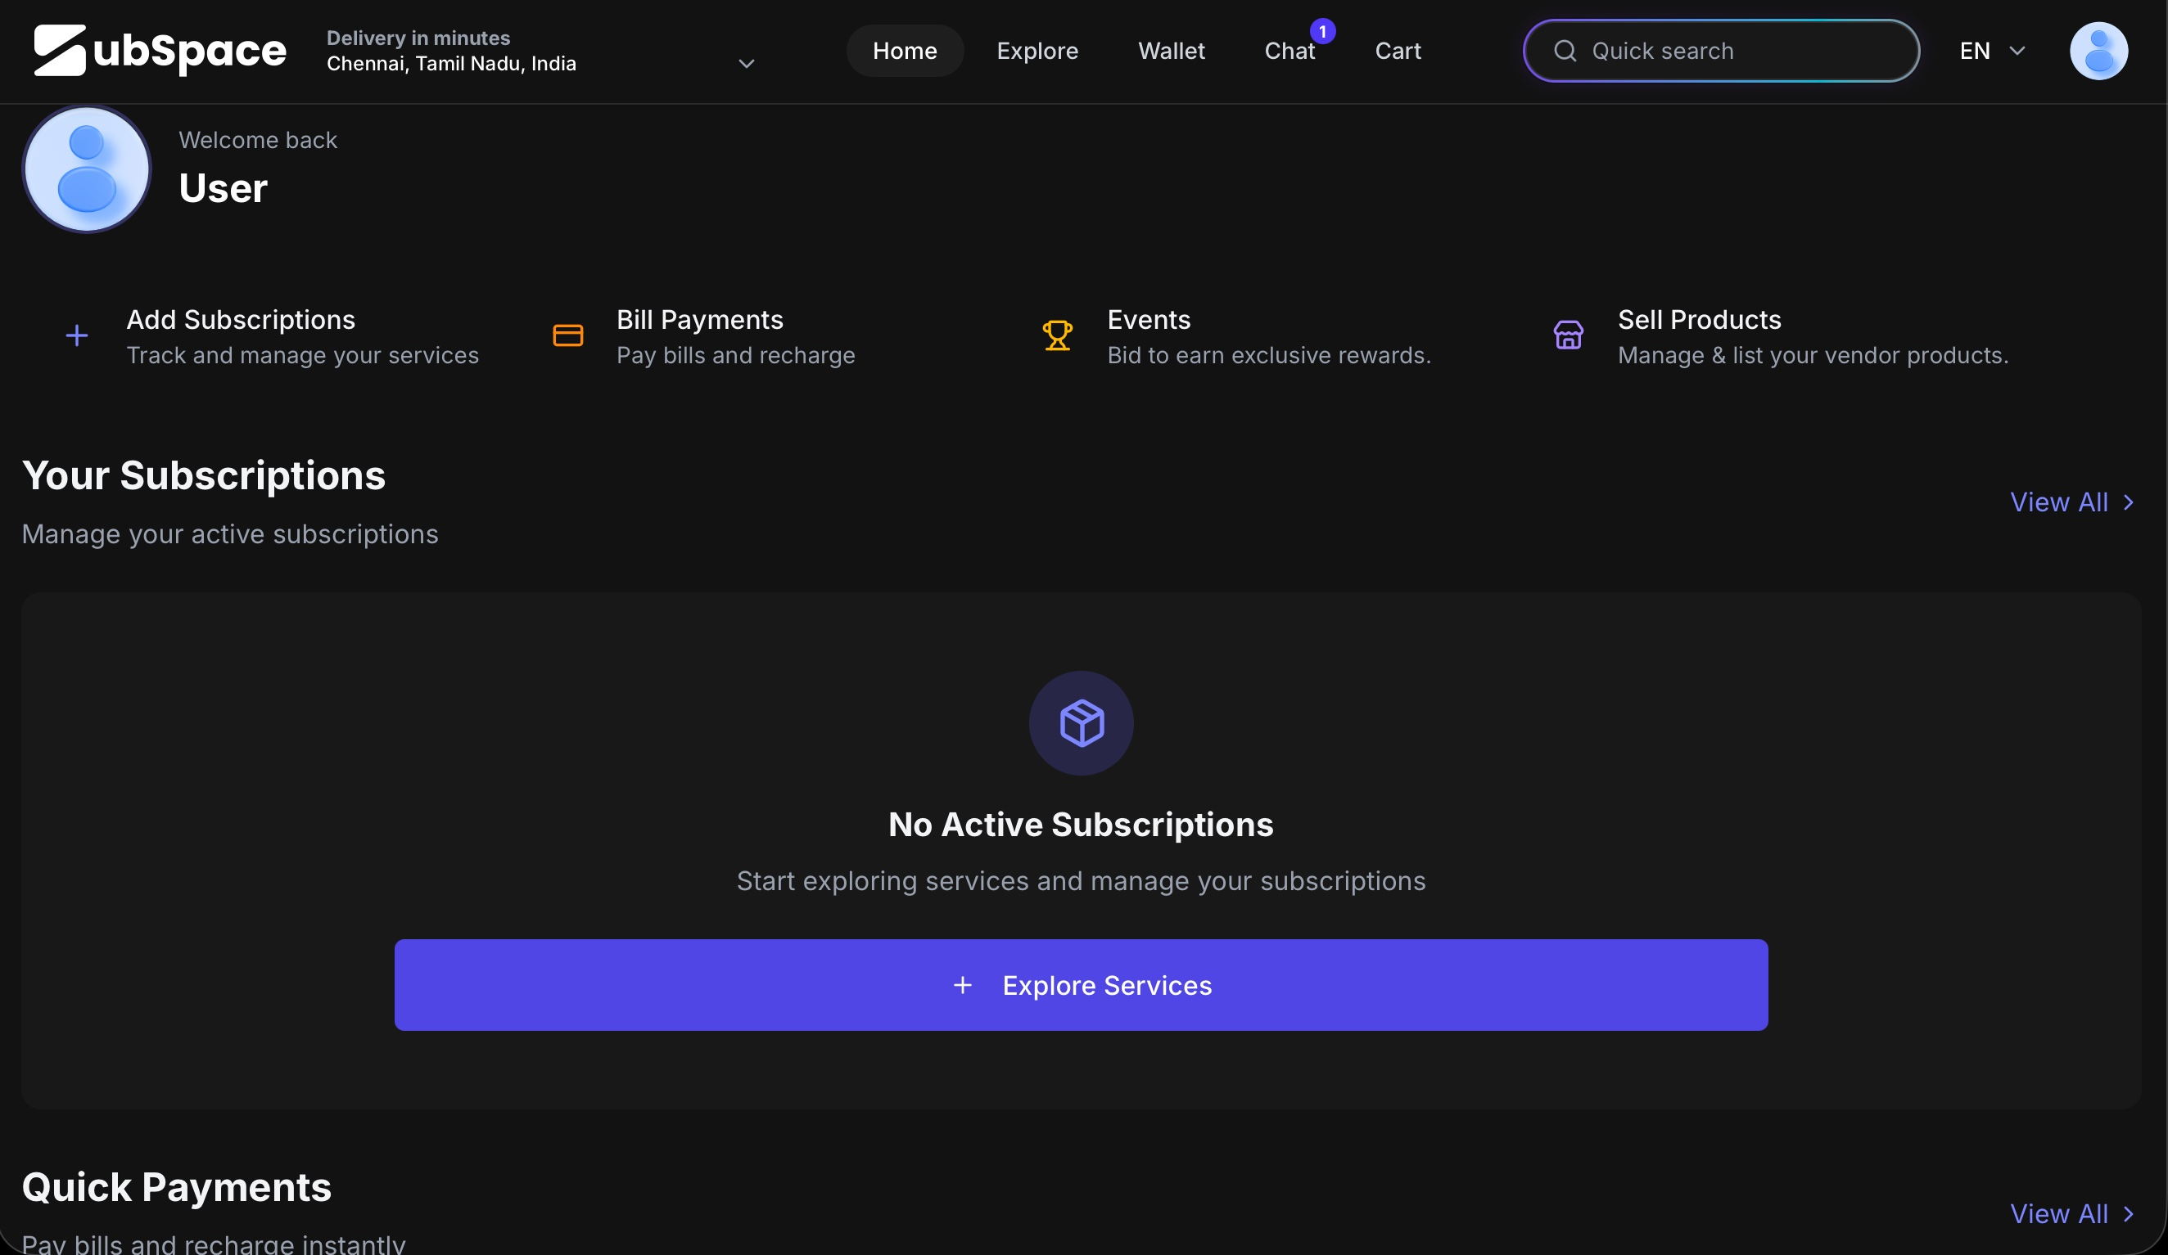
1D. SHIP INSTEAD — QUICK WINS ONBOARDING
Replace the blank state with a "Quick Wins" section that shows the user exactly how much money they could save today, before asking them to take any action. The key insight is: the product should sell value before asking for effort.
Specifically:
- Show a "Potential Savings Today" banner at the top — personalised by city (e.g. "Based on popular subscriptions in Chennai, you could save ₹510/month")
- Display 3–4 service cards (Netflix, Spotify, Prime, YouTube) showing the monthly saving and number of available groups
- Each card has a single "Join group →" CTA — the lowest-friction path to activation
- Keep the existing "Your Subscriptions" section below, now clearly secondary to the value demonstration above it
This pattern is proven: Splitwise shows you your balance before asking you to add friends; Zepto shows you nearby delivery time before asking you to search. Leading with the outcome converts better than leading with the empty state.
1E. REDESIGNED SCREEN
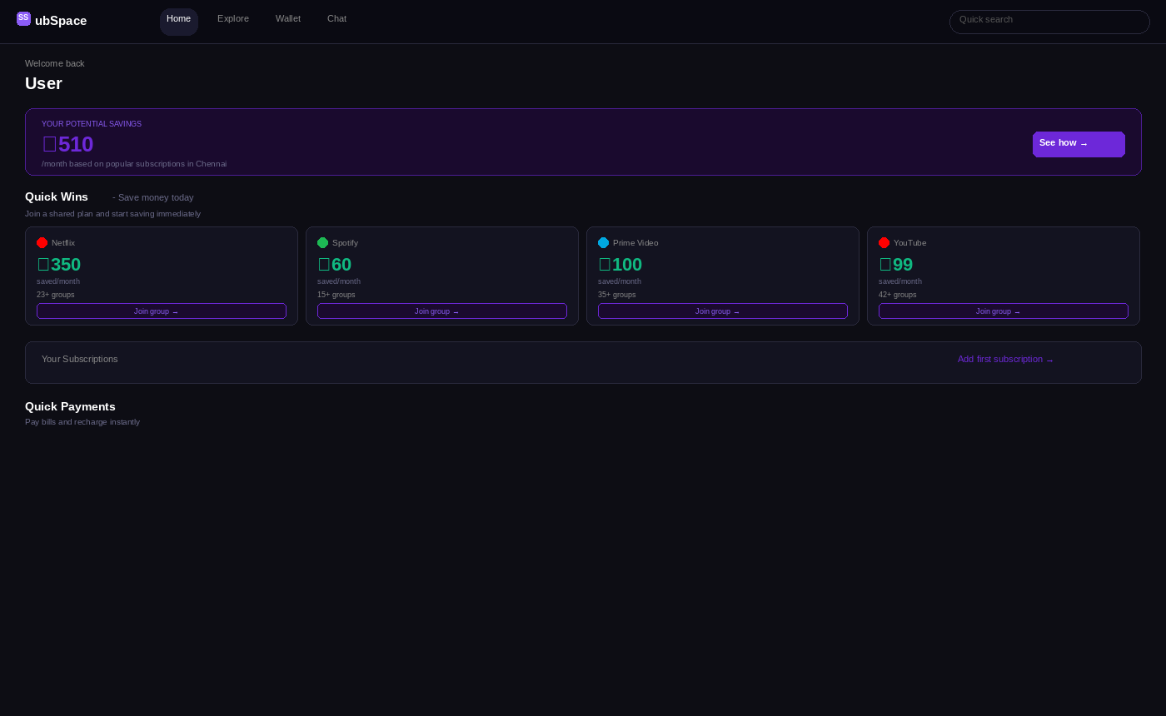
1F. EXPECTED IMPACT
Metric | Before | After (Expected) | Why It Matters
New user activation rate | Low — empty state creates confusion | Higher — savings shown upfront drive first click | First action within session = activation event
Time to first group join | 3+ sessions on average | 1 session — user sees value and clicks directly | Reduces drop-off before first transaction
User comprehension of product | Unclear — 4 parallel actions, no hierarchy | Clear — savings > sharing > explore | Reduces support tickets, improves NPS
P1 | Feedback 2 — Discovery Is Weak Despite Search Being Everywhere

2A. OBSERVED
The Explore page presents the user with all product lines simultaneously, without hierarchy:
- A scrolling ticker of discounts at the top (3–16% off various brands)
- Large banner carousel with promotional images
- Favourite Brands grid (unlabelled as to why these were "favourite")
- Gift Cards section, then Subspace Minutes (rentals), then Shared Subscriptions — all in one undifferentiated scroll
The global search bar appears on every single screen, yet there is no guided path for a first-time user who does not yet know what they are looking for.
2B. THE PROBLEM
Subspace is simultaneously a subscription marketplace, a rental marketplace, a gift card platform, and a savings platform. This breadth is a strength at scale but a weakness at activation - when a user does not understand the hierarchy of what to do first, they do nothing.
The design symptom is "feature soup": every capability is displayed at equal visual weight, leaving the user with decision fatigue. Research consistently shows that presenting too many choices at once reduces the probability of any choice being made (the paradox of choice).
A first-time user asking "what is the primary thing I should do here?" has no clear answer from the current Explore page.
2C. CURRENT SCREEN
The current Explore page as seen by a new user — all four product lines compete for attention simultaneously.
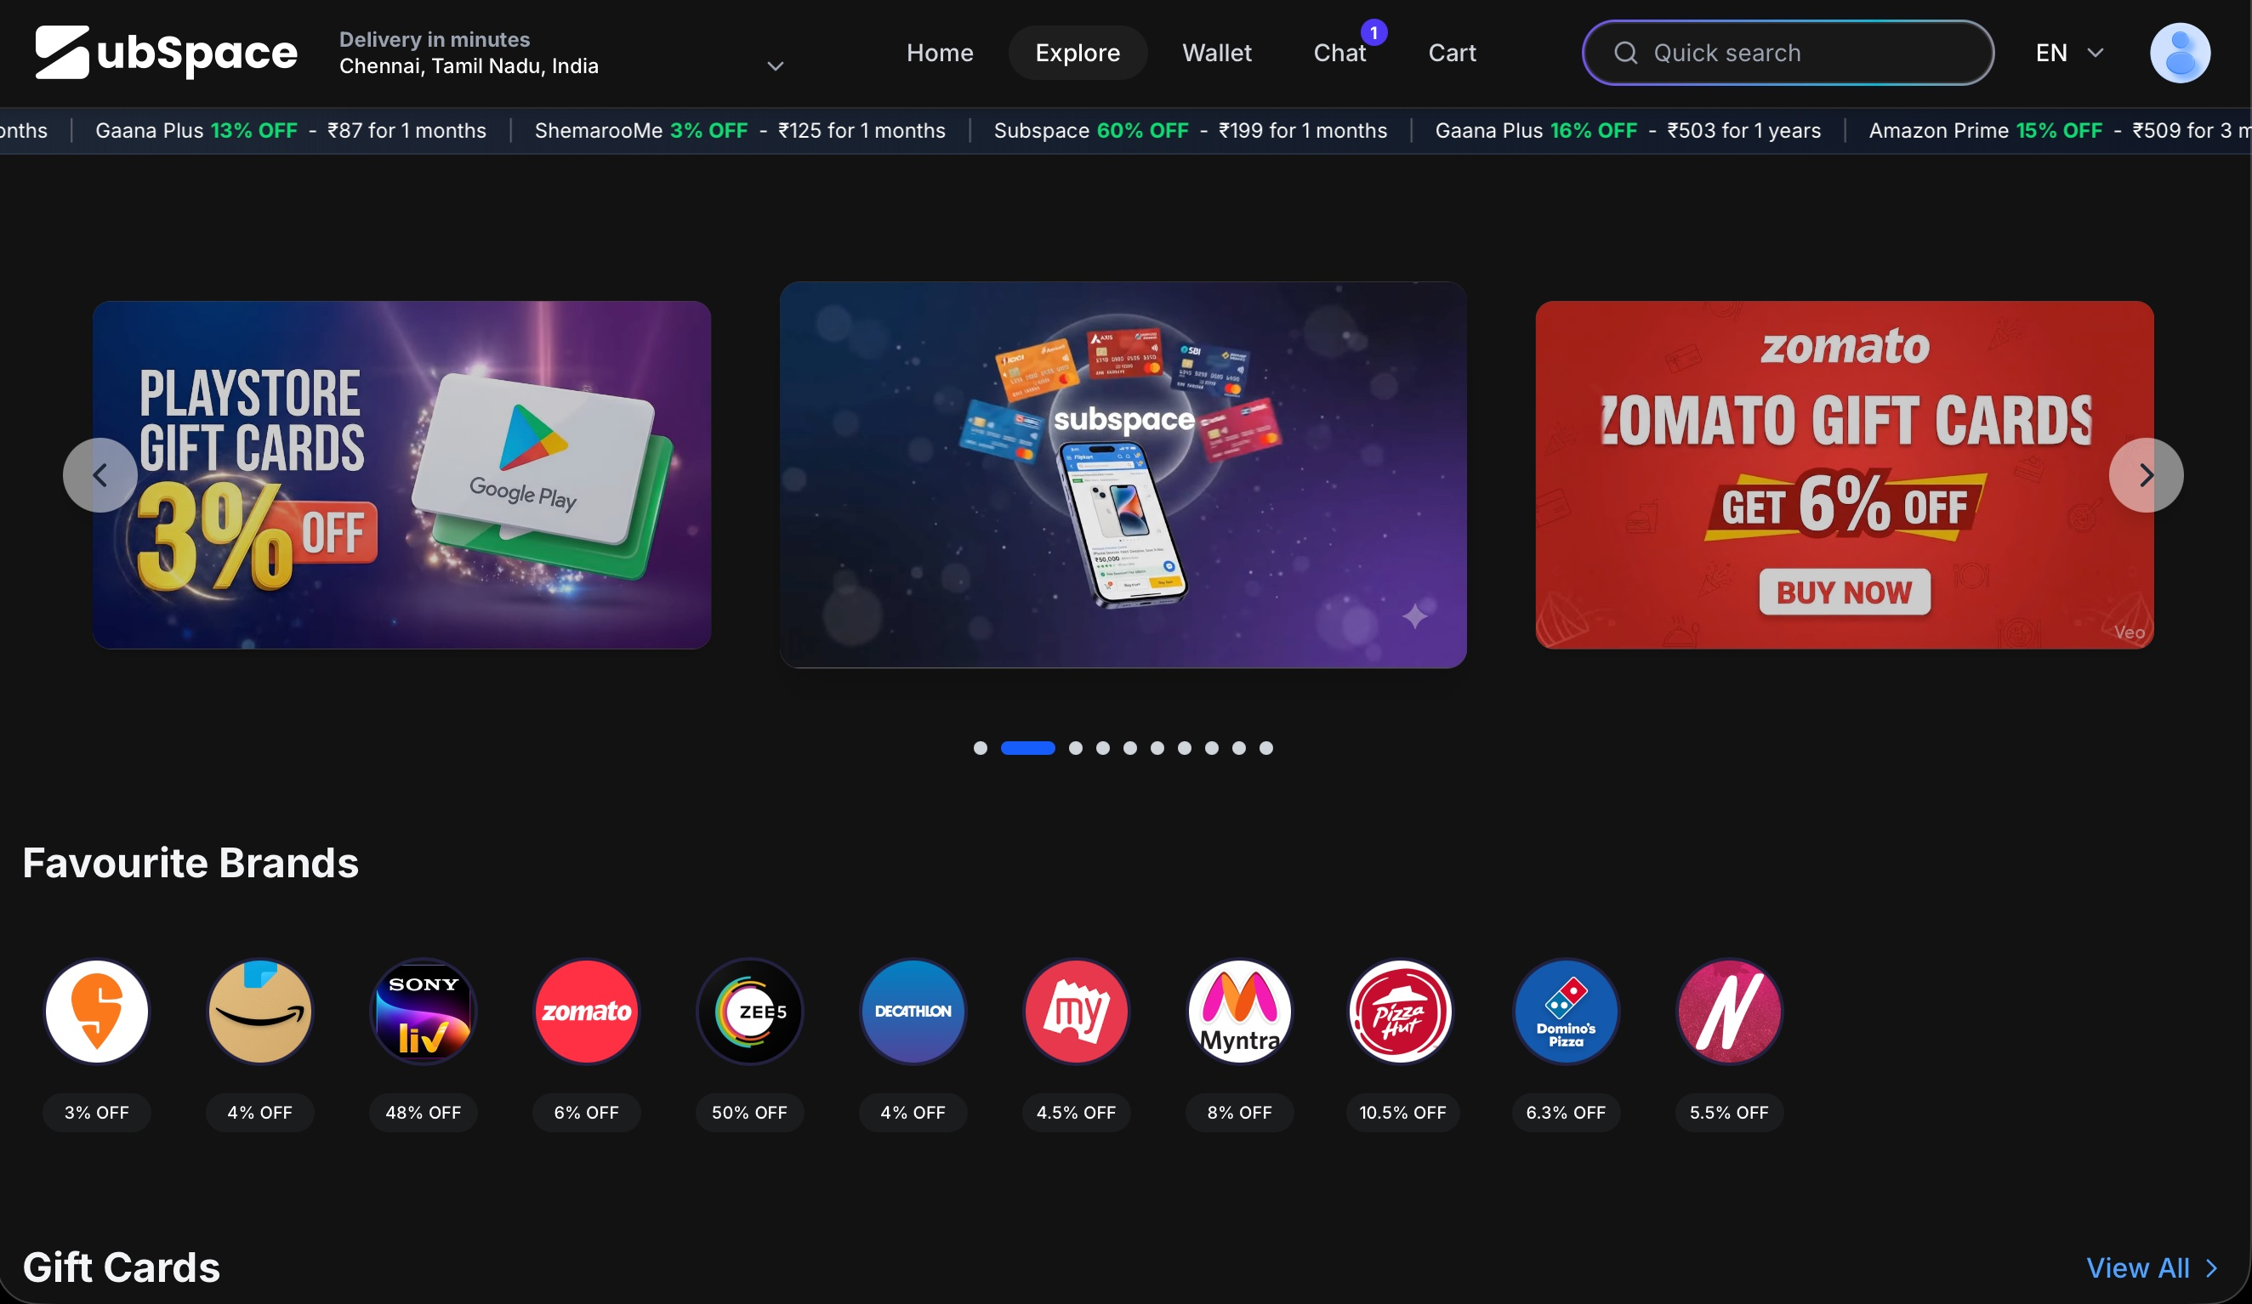
2D. SHIP INSTEAD — INTENT-BASED NAVIGATION
Add a three-option intent selector at the top of the Explore page. The user picks their primary goal, and the page dynamically surfaces the relevant product lines first.
- "I want cheaper subscriptions" → Prioritise shared subscriptions and OTT group listings
- "I want discounts & deals" → Prioritise gift cards, coupons, brand cashback
- "I want to earn money" → Prioritise rental listings and sharing opportunities
This is not an aggressive onboarding gate — the user can still scroll past to see everything. It is a soft personalisation signal that reorders content hierarchy. Preference should be remembered across sessions.
This pattern is used effectively by Swiggy (cuisine preferences), Cred (spend category filters), and Amazon (department-first browse). It reduces cognitive load by narrowing the decision tree before the user scrolls.
2E. REDESIGNED SCREEN
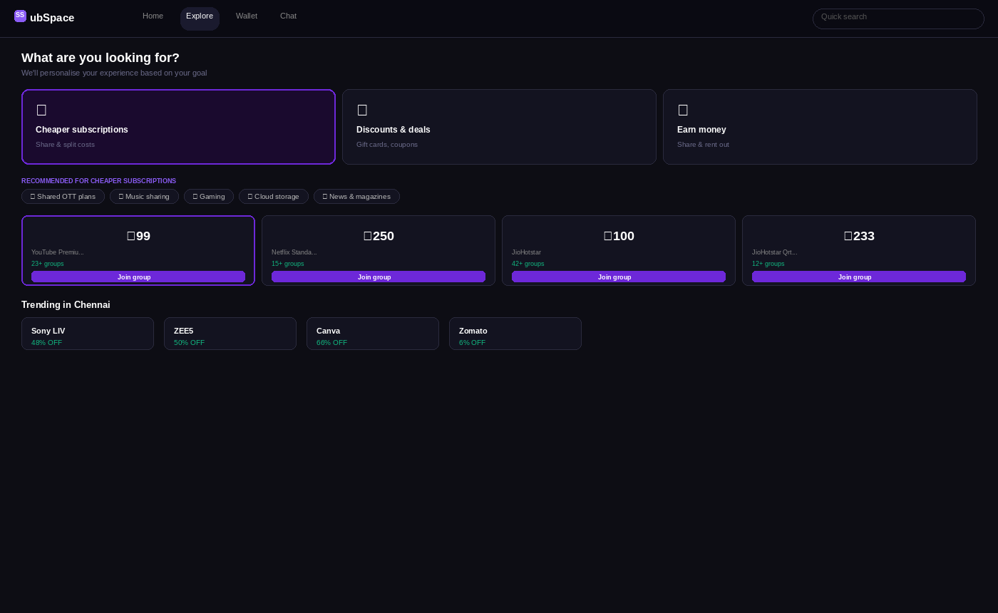
2F. EXPECTED IMPACT
Metric | Before | After (Expected) | Why It Matters
Explore-to-product-page conversion | Low high bounce from unstructured feed | Higher intent narrows to relevant listings | Fewer irrelevant impressions = higher CTR
New user comprehension | Subspace = unclear mixed platform | Subspace = the app for [my specific goal] | Drives word-of-mouth with a clear category peg
Session depth | 1-2 screens before exit | 3–5 screens intent-matched content sustains interest | More sessions = more opportunities to transact
P1 | Feedback 3 - Social Trust Is Underutilised Despite Being Core to the Product

3A. OBSERVED
The YouTube Premium sharing page — and other shared subscription listings — shows a grid of potential group owners. Each card includes:
- User name and profile photo
- Star rating (most show 5.0, which feels untrustworthy when universal)
- Last active timestamp
- Number of available slots
- Price (₹99/device/month) and group split structure
This is actually one of Subspace's most differentiated features — real human hosts, with ratings, activity signals, and peer-to-peer pricing. But the trust architecture is shallow.
3B. THE PROBLEM
Subscription sharing requires a higher degree of trust than most marketplace transactions. The user is agreeing to share a payment obligation with a stranger on a recurring basis. If the sharer stops renewing, the user loses access.
The current design does not answer the questions that matter most to a first-time buyer:
- Has this person actually renewed reliably, or did they join yesterday?
- What percentage of their previous members renewed with them?
- How quickly do they respond if something goes wrong?
- Have they been verified beyond just a profile photo?
A rating of "5.0" from 2 reviews and a rating of "5.0" from 45 reviews look identical in the current design. That is a significant trust signal failure.

3C. CURRENT SCREEN
The YouTube Premium listing page as it currently appears — rich with data but thin on trust signals.
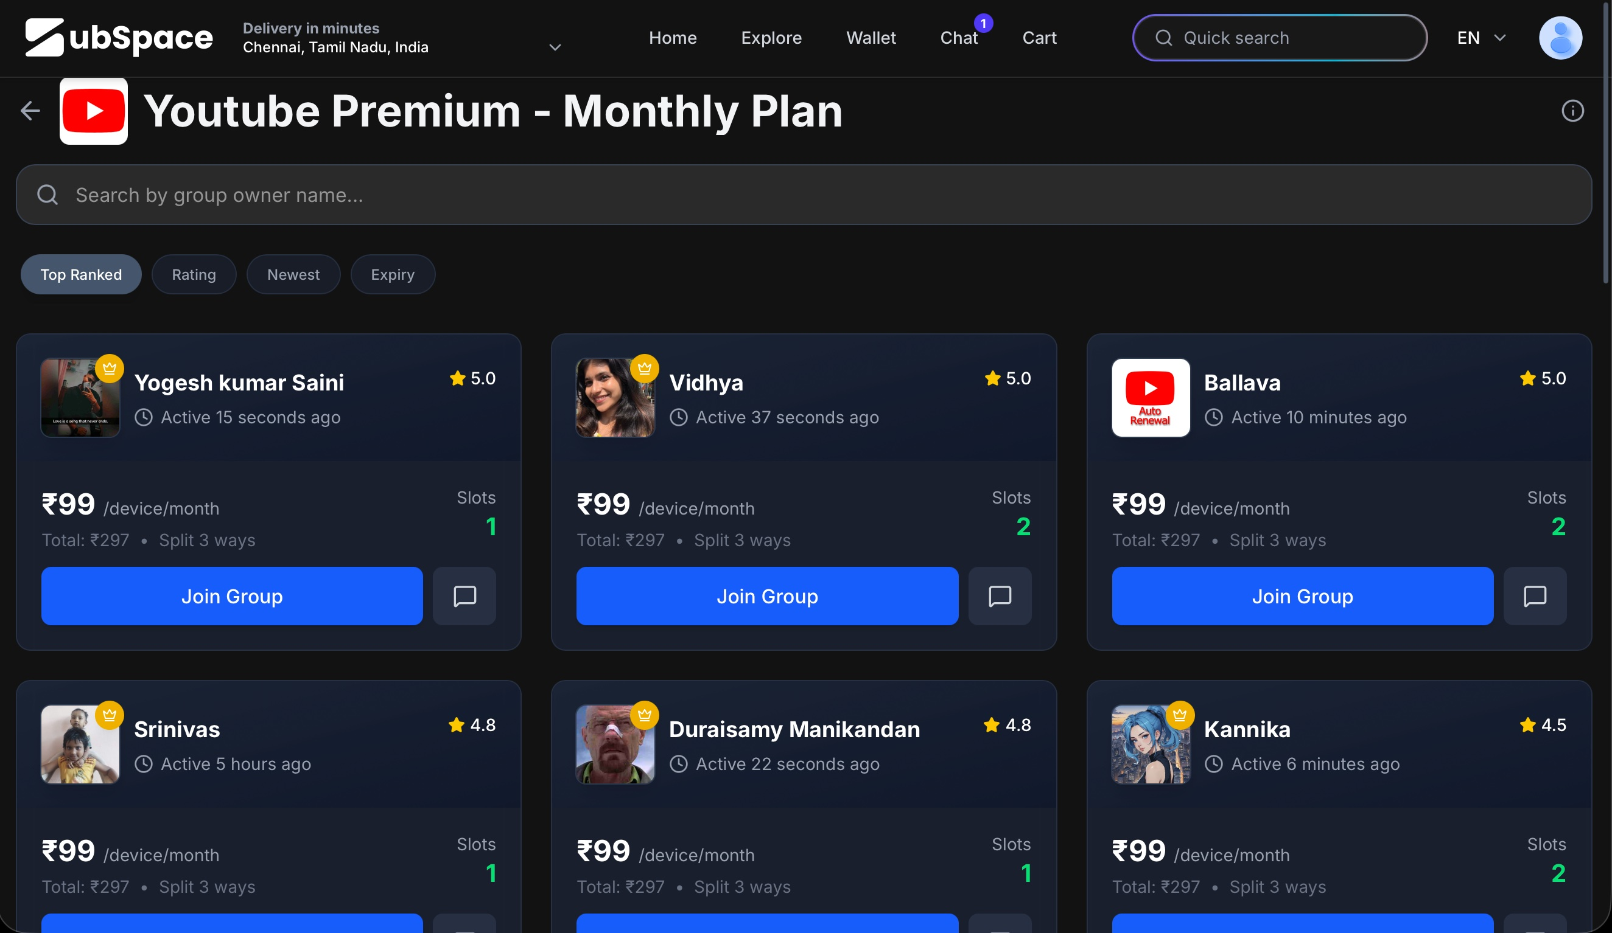
3D. SHIP INSTEAD — TRUST SCORE FOR SHARERS
Introduce a composite Trust Score (0–100) for each group owner, calculated from four weighted signals:
- Renewals completed (e.g. 45 successful renewals over 12 months)
- Renewal success rate (percentage of billing cycles completed without interruption)
- Response time (average time to respond to member messages)
- Verification level (KYC, phone verified, Aadhaar-linked, etc.)
Display the Trust Score on each card as a labelled progress bar, alongside a "Trusted Sharer" badge for those scoring above a threshold (e.g. 80+). Also show the community aggregate — "This community has saved ₹2.4 Lakhs this month" — at the top of each subscription listing page.
This builds trust at the exact moment of conversion, which is what drives liquidity. More trust → more group joins → more network density → harder for competitors to replicate.

3E. REDESIGNED SCREEN
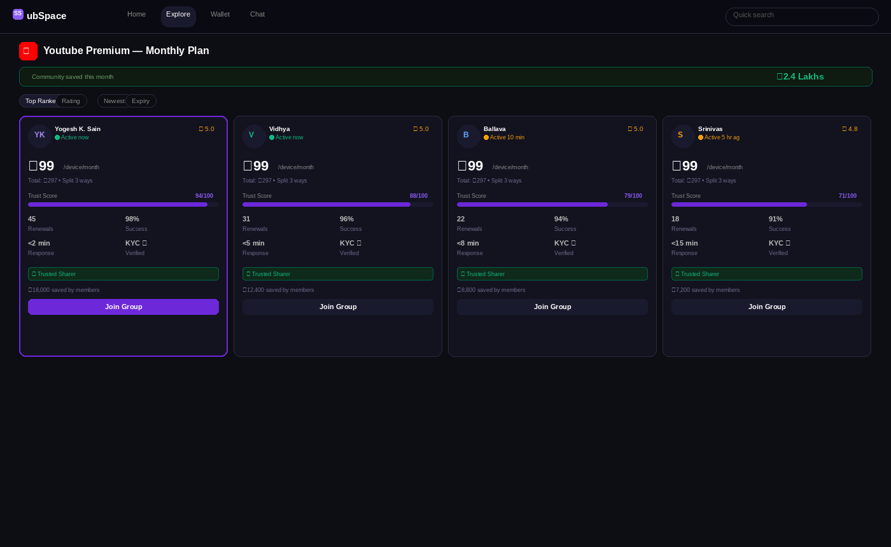
3F. EXPECTED IMPACT
Metric | Before | After (Expected) | Why It Matters
Group join conversion rate | Low for new users unfamiliar with sharers | Higher - trust score reduces perceived risk | Trust drives the single most important transaction
Average sharer quality | Invisible - all 5.0 ratings look equal | Differentiated - high-trust sharers win more slots | Marketplace selects for reliable hosts over time
Platform stickiness | User can switch to another platform | Higher switching cost - accumulated trust history | Verified sharer network is a durable moat

P2 | Feedback 4 — Rental Marketplace Appears Underdeveloped

4A. OBSERVED
The "Subspace Minutes" rental section within Explore contains a single vendor: KodeKloud (a DevOps learning platform). Under KodeKloud's rental listing, only two items appear:
- "Monthly Yoga Classes" — priced at ₹100/day, with a broken image placeholder
- "Ayurvedic Wellness Kit" — priced at ₹100/day, with a broken image placeholder
Neither item has an image, a description, or any content explaining what the rental covers. Both items are completely misaligned with KodeKloud's brand identity as a cloud/DevOps learning platform.
4B. THE PROBLEM
Broken images and sparse listings are the fastest way to destroy perceived platform quality. A user browsing Subspace for the first time who sees image error icons and empty cards will form an immediate negative impression not just of the rental feature but of the entire platform.
Marketplaces have a liquidity problem at launch: they need enough supply to create a credible browsing experience. Showing thin or broken inventory is worse than showing no inventory at all — it signals that the product is incomplete.
Additionally, "Monthly Yoga Classes" and "Ayurvedic Wellness Kit" listed under a cloud infrastructure company creates category confusion that undermines platform credibility further.
4C. CURRENT SCREEN
The rental listing as it currently appears - broken images and mismatched inventory under KodeKloud.
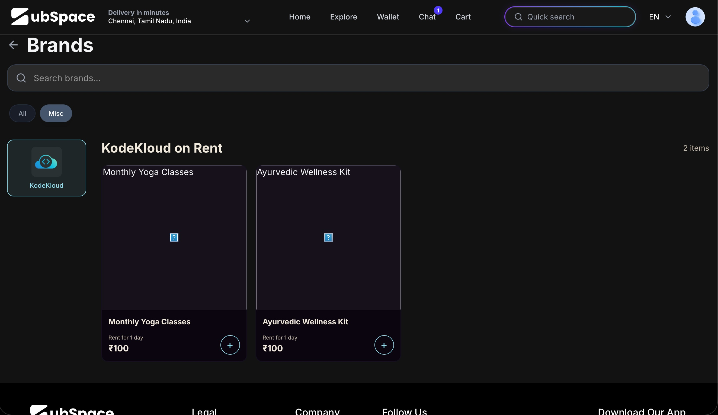
4D. SHIP INSTEAD — SUPPLY-MATCHED RENTAL CATEGORIES
Two options, in order of preference:
Option A (Recommended): Hide categories that do not yet have sufficient and functional inventory. Show only categories where images, descriptions, and pricing are complete. A "Coming soon" placeholder tile is more trustworthy than a broken listing.
Option B: Pivot the rental catalogue toward categories that are supply-compatible with Subspace's current user base (tech-forward, urban, 18–35):
- Professional courses (KodeKloud fits perfectly here — list DevOps labs, not yoga)
- Creator tools (Canva Pro, Adobe CC, Figma — day/week rentals)
- Productivity software (Notion, Grammarly — short-term access)
- Software subscriptions (JetBrains, GitHub Pro — professional tools)
For categories not yet ready: show a locked tile with "Coming soon — supply being built" and a "Suggest a category" CTA. This is honest and turns a trust failure into a community-building moment.
4E. REDESIGNED SCREEN
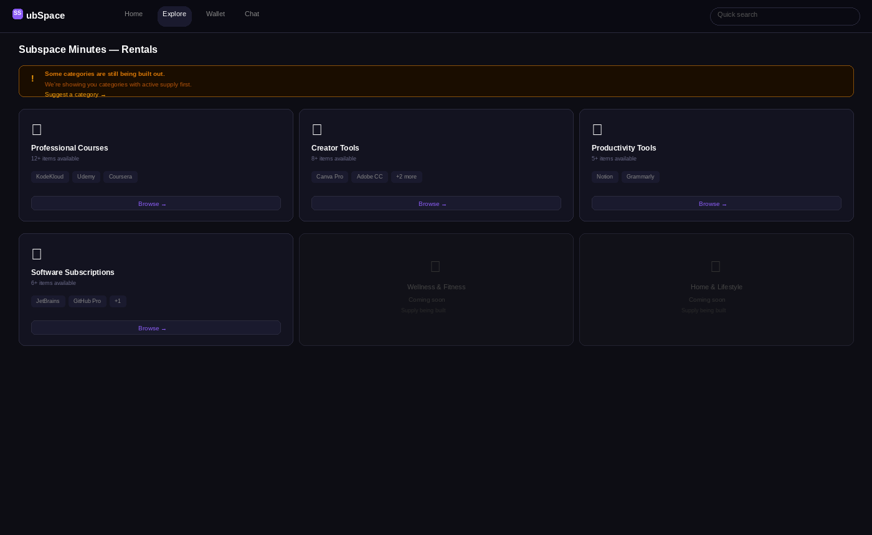

4F. EXPECTED IMPACT
Metric | Before | After (Expected) | Why It Matters
First impression of platform quality | Damaged by broken images and empty cards | Restored — only complete listings are shown | Trust is the foundation of any marketplace
Rental category GMV | Near zero — no usable inventory | Grows from focused, supply-matched categories | Concentration beats breadth at early stage
User perception of Subspace | "This product feels unfinished" | "This product curates well and is honest about limits" | Transparency is a brand asset, not a weakness
P1 | Feedback 5 — "Money Saved" Is Hidden in Profile Instead of Being the Hero Metric

5A. OBSERVED
Subspace has a dedicated "Money Saved" dashboard that shows:
- Total savings through Subspace (₹0 for a new user)
- Sharing savings, Sharing earnings, Purchase savings, Paid via Subspace — broken into four categories
- A friends section below
However, this dashboard is buried three levels deep: Profile icon → sidebar menu → "Money Saved" item. It is not visible from the Home page, the Explore page, or any product listing page.
5B. THE PROBLEM
Saving money is arguably the single most powerful emotional outcome Subspace delivers. Users do not buy "subscription management software" — they buy the feeling of being smart with their money. Yet the product hides its most compelling metric in a side menu most users will never find.
This is a significant retention failure. Users who can see their savings accumulate over time have a strong reason to return and engage more. Users who cannot see it have no visceral reminder of what the product is doing for them.
Consider the contrast: Swiggy shows you your total orders and savings on the profile page. CRED makes its cashback counter the centrepiece of the home screen. Zepto shows you how many minutes your delivery took. These are all retention hooks built on making the core value visible.

5C. CURRENT SCREEN
The Money Saved dashboard as it currently exists — buried in the profile sidebar, invisible during normal product usage.
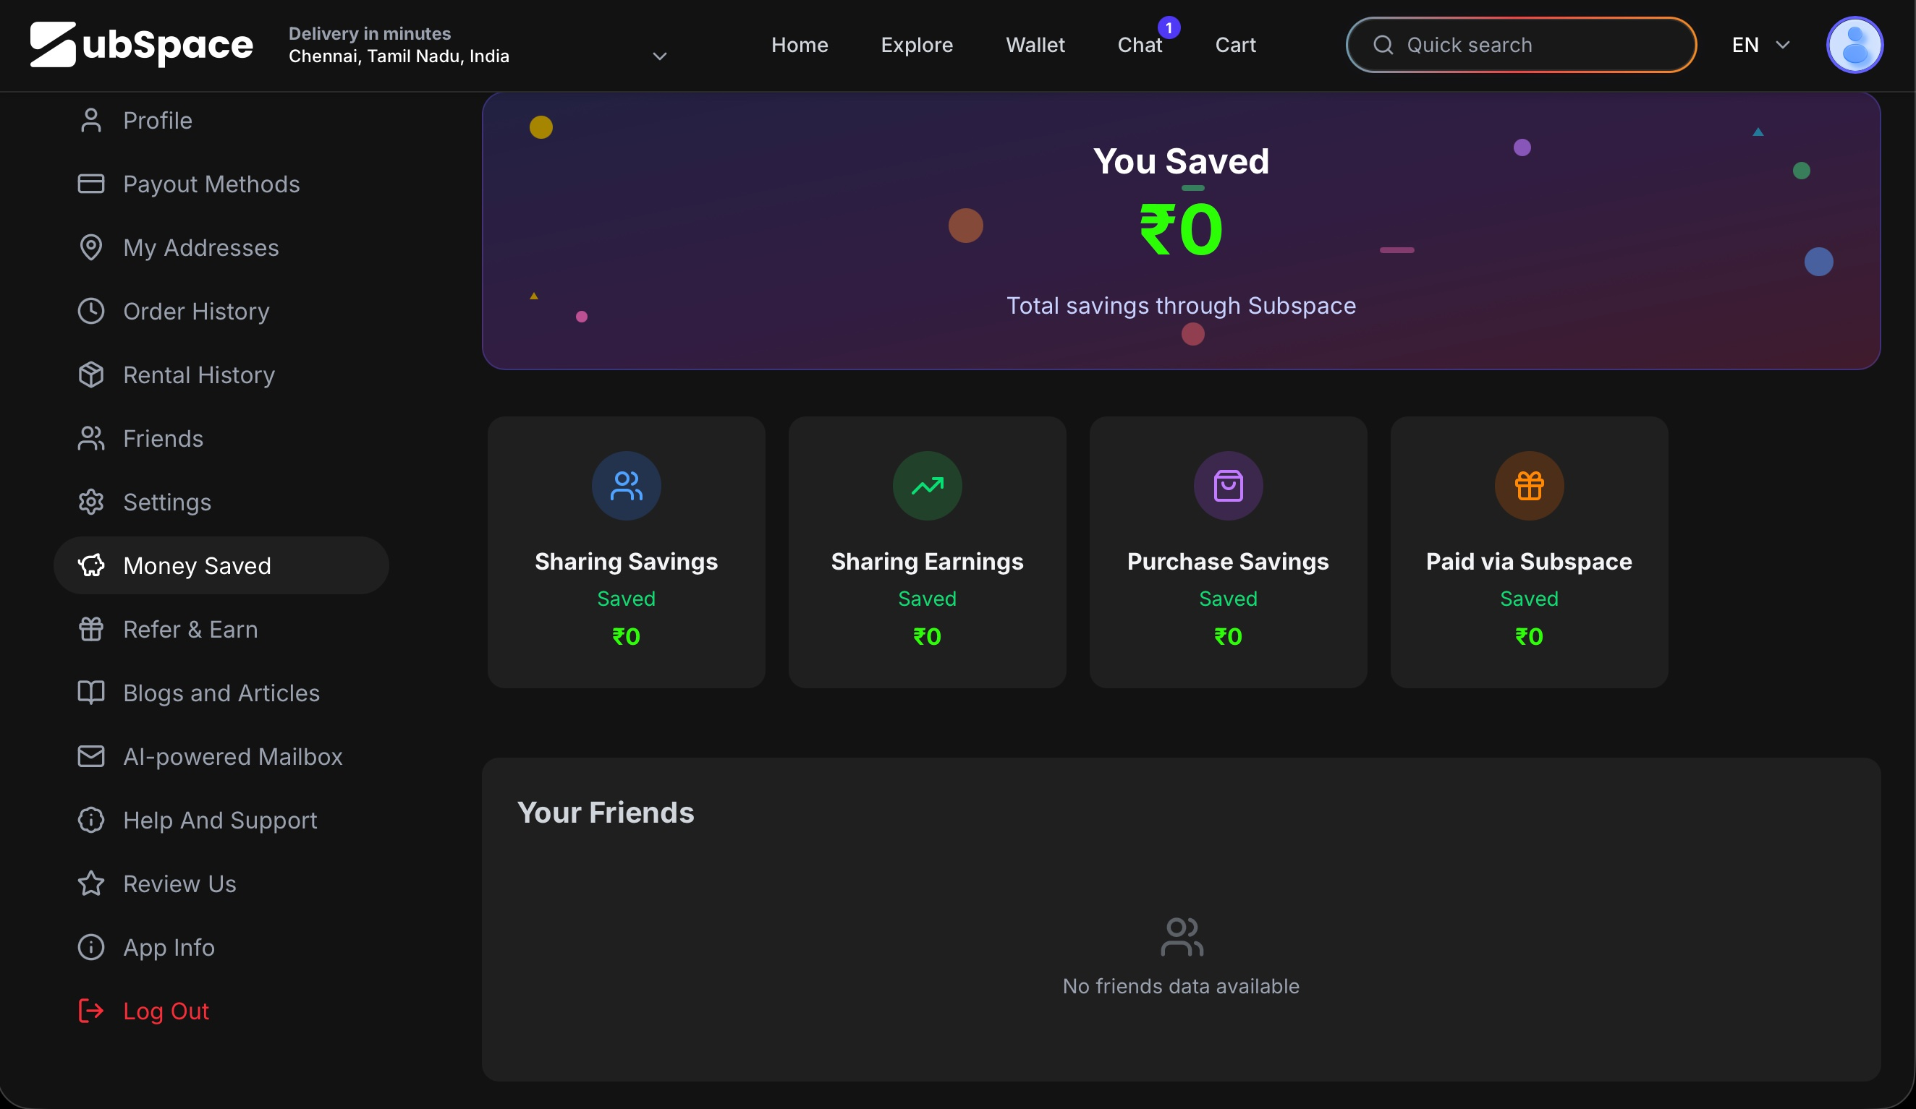
5D. SHIP INSTEAD — SURFACE SAVINGS EVERYWHERE
Make savings visible at three levels:
- Top navigation bar (all pages): A persistent green pill showing "You saved ₹1,284 this month" — always in peripheral vision, a constant positive reinforcement signal
- Home page hero card: A full-width savings summary card at the top of Home — total savings, breakdown by category, and month-on-month delta ("+₹350 from last month")
- Per-brand pages: Show "Average users save ₹220 here" on each brand's gift card or sharing page — this creates anticipation before the transaction
Additionally, introduce a community savings bar on shared subscription listing pages: "This community saved ₹24 Lakhs this month." This creates social proof at scale while reinforcing the individual savings narrative.
The goal is for every session to begin and end with the user knowing exactly how much money Subspace has saved them. That single number is the best retention hook the product has.

5E. REDESIGNED SCREEN
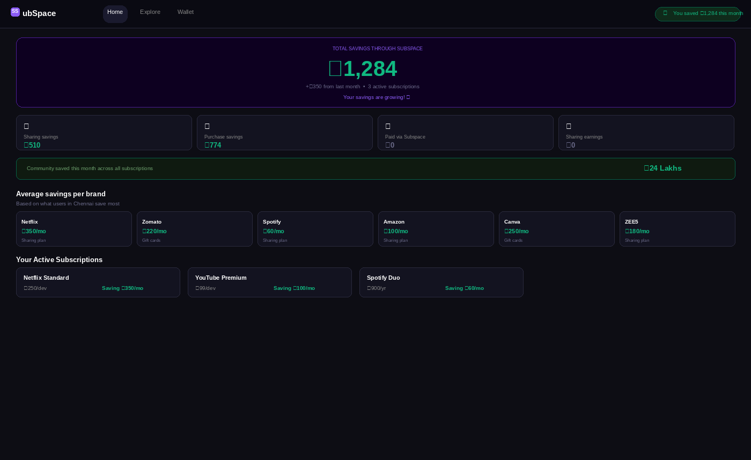
5F. EXPECTED IMPACT
Metric | Before | After (Expected) | Why It Matters
User retention (D30) | Low — no persistent value reminder | Higher — savings counter drives return visits | Money saved is the #1 reason to come back
Referral conversion | Hard to explain product value to friends | Easy — "I saved ₹1,284 this month on Subspace" | Shareable number = organic word-of-mouth
Session frequency | 1–2 sessions/month average | 3–4 sessions/month — users check their savings | More sessions = more transactions

CONCLUSION
The five feedbacks above address this core challenge from different angles: activation (Feedbacks 1 & 2), conversion (Feedback 3), marketplace health (Feedback 4), and retention (Feedback 5). Together they form a coherent product thesis: show value sooner, build trust more visibly, and make savings the emotional backbone of every session.

