December 2018

**R package glmGUI and GLM Toolbox**

**User’s Guide (Version 1.0)**

glmGUI Toolbox Version: 1.0

G:\DatenUNI_181018\Publikationen\Thomas\9_GLM_GUI\Manual\AS_difference_contourplot_WT21_Tho_Manual_frontpage.tiff 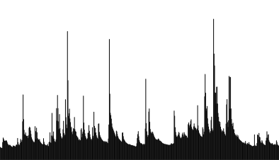

Authors: T. Bueche, M. Wenk, B. Poschlod & M. Vetter

Please cite the scientific description of the package Bueche et. al. (…)

# Start/Install GUI Toolbox

Two options are available to start the GUI:

1. Steps to open the GUI using the R package:

* Download the package *glmGUI\_1.0.tar.gz*
* <http://doi.org/10.5281/zenodo.2025865>
* Open R or Rstudio: Run the command *(this step is only required for the first use)*  
  install.packages("*<…path…>*/glmgui\_1.0.tar.gz", repos=NULL, type= "source")  
  🡪 the glmGUI package is installed and all additional required R packages are downloaded an installed
* Run the command *glmgui::glmGUI()*

1. Steps to open the GUI using the R-code (development version)

* Download R-code in the most recent version

<http://doi.org/10.5281/zenodo.2025865>

* Open the R-code (.R file) with a supporting software (R or RStudio). The first rows of the code specify also the steps to open the GUI (the r-code has to be run)(Figure 1)
* Run entire code:

🡪 Select total code (Crtl+A) and run (for R Ctrl+R, for RStudio Ctrl+ENTER)

🡪 all required R packages are downloaded and installed

🡪 The GUI - main menu opens (Figure 2)

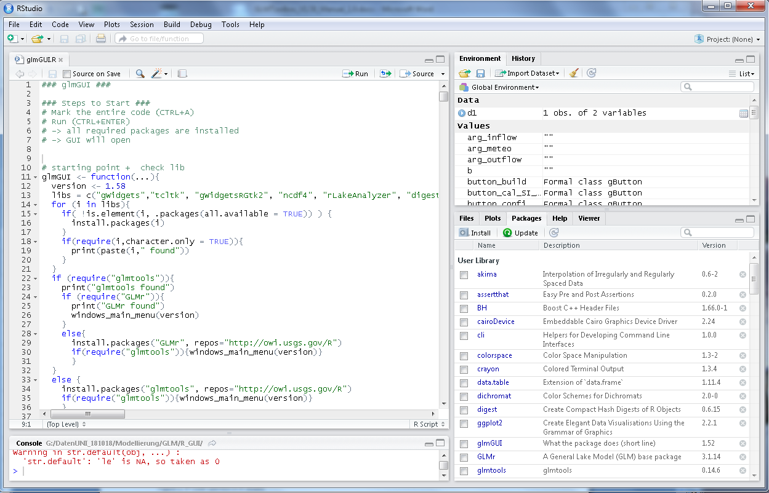

Figure 1: R-Code opened in R-Studio

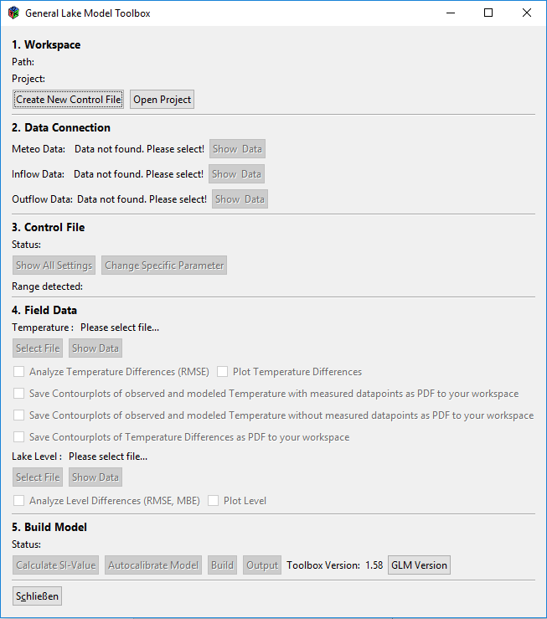

Figure 2: Main menu window of the GLM Toolbox

# Set/Create Workspace

Main required file for a GLM simulation is a control file (.nml) with the pre-defined file name *glm2.*nml. In Section **1. Workspace** either a new control file can be created, or an existing file can be loaded.

A new created control file will have the settings, model version [compatibility](https://www.dict.cc/englisch-deutsch/compatibility.html) and format is according the nml-file created by the R packages GLMr   
 (<https://github.com/GLEON/GLMr/blob/master/inst/extdata/glm2.nml>). The lake specific parameters are on default as suggested by Hipsey et al. (2017). All environmental settings and information, like lake morphometry (&morphometry) and description of initial boundary conditions (&init\_profiles) are recommended to be adjusted for the site before to enable a correct simulation. The template nml defines 2 inflows, which might be adopted (e.g. number of inflows), too.

To open an existing control file the folder (workspace) containing the.nml file (*must be named glm2.nml!*) has to be selected using the button *OPEN PROJECT.*

The further processing of the control file (view and the adjustment) and its parameter is described in chapter IV of thus User’s Guide.

*Problems/Solutions:*

* *nml-files must not contain German ä, ö, ü, ß (even if commented out by “!”*
* *no hanging lines allowed (Figure 3) 🡪 no lines with only blacks are allowed*

**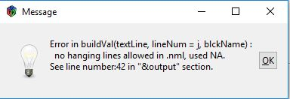**

Figure 3: Warning message for hanging lines (given line number does not include commented out lines)

*🡪 delete lines without content or the blanks (example for hanging line see red box in Figure 4.*

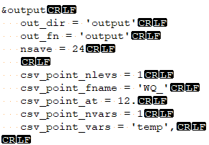

Figure 4: hanging line (blanks in red box), CRLF mark line terminators

# Input parameter

Section **2. Data Connection**:

Meteorological and hydrological input data have to be provided in separate .csv data sets. The names of the files are specified within the control file (parameters *meteo\_fl*, *inflow\_fl, outflow\_fl*). Specifications and units of required input data are described by Hipsey et al. (2014, comment: discharge values have to be given in the unit m³/s). The files have to be stored in the workspace directory and will be found automatically.

To be able to display the data with the GUI toolbox the data requires a header row and all have to be separated by “,” (Figure 6). Files must not have empty lines in the end. No values (data gaps) have to be given as “NA” (Figure 6, do not leave blank or use zero).

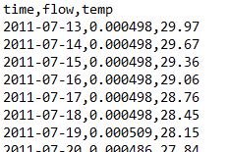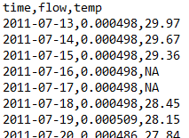

Figure 5: Example for input (inflow) file and missing values (NA)

Data can be viewed selecting SHOW DATA. If there are sections with missing values (Figure 7) the data can be analyzed to find out the number of missing data. Data gaps can be filled through interpolation (see Scientific Manual) after ANAYSIS DATA is done (🡪 REPAIR button is now active). A warning pops up, reminding that interpolation may not make sense in some cases. Measured and repaired data will be shown in a new graph (). Even though interpolation of gaps may not be shown, check the CSV file if it was interpolated.

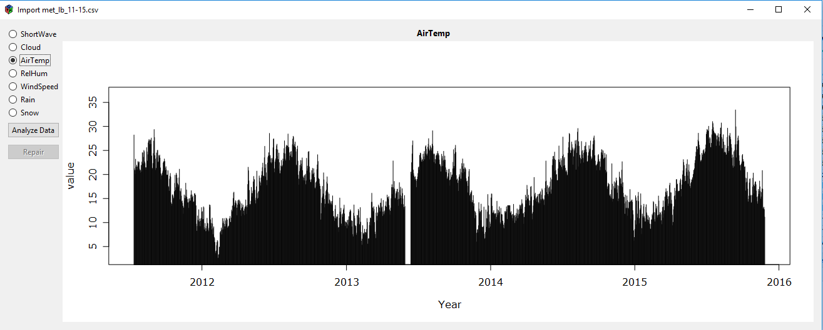

Figure 6: Show Data specifying missing input values

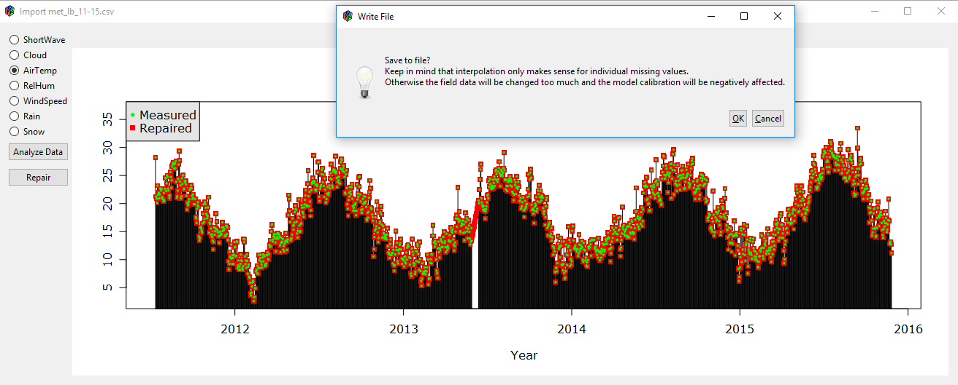

Figure 7: ... with interpolated values and message regarding ...

*Problems/Solutions:*

*Input files cannot be shown although in the correct directory  
🡪 Check if number of inflows/outflows is set to the correct amount  
🡪 if not, change it with “Change Specific Parameter”*

Otherwise the source has to be specified manually by the user.

# View and adjust simulation parameter

The settings of the control file can be shown in The GUI section **3. Control File** and any adjustable parameter can be changed by the user using the provided feature (Figure 8)

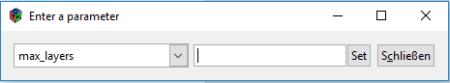

Choose parameter to adjust

Enter new value

Press to complete

Figure 8: Adjust/enter a parameter

# Field Data

In section **4. Field Data,** observed water temperature and lake level have to be provided in order to be able to plot differences of the lake simulations to the field data and calculate the model error. Field data are also required for the function of sensitivity analysis (*Calculate SI-Values*) and automated model calibration (*Autocalibrate Model*, see chapter VI.). The field data have to be provided in a csv-file containing a header (see Figure 9). For each depth of observed lake water temperature, a new row is required. Use “NA” for missing values.

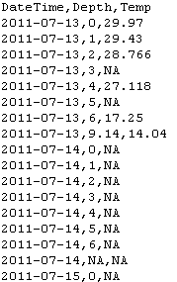

Figure 9: Format of field data file - lake water temperature

# Run Model (BUILD)

A sensitivity analysis can be done for preselected lake specific model parameter chosing the menu *Calculate SI-Values*. The parameters to be considered for the sensitivity analysis can be selected and the increase/decrease (in %) of the respective parameter have to be set (more details see scientific R package description, Bueche et al. 2018, submitted). The analysis can be made for the sensitivity of the model output variables water temperature and lake level. Two calculation methods of the SI-Value (Sensitivity Index) can be chosen: based on the root mean square error (RMSE) or on the respective model output (water temperature or lake level). *Calculate SI-Values* (Figure 10) starts the analysis and files with the results (Sensitivity\_Level.csv or Sensitivity\_Temp.csv) including the SI-Values and a bar plot (Figure 11) are created. The status will switch to “DONE” when analysis is finished.

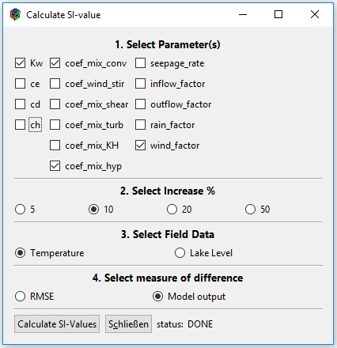

Figure 10: Window Calculate SI-value

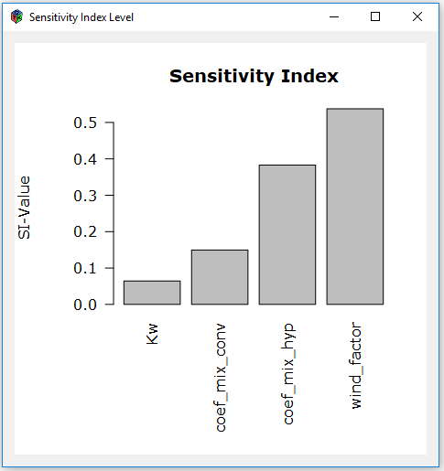

Figure 11: Bar plot visualizing the result of calculation of the sensitivity index

*Save plots:*

*right click on plot 🡪 save🡪 give file name and select location*

***file name has to include the file extension to be saved properly*** *(e.g. test-plot.****tiff****)*

After defining model input data, control file and field data, the model can be run (*build*). This can take a few minutes depending on the R version. By clicking on *output* two new windows open to plot the output variables stored in the csv file (lakename\_overview, Figure 12) and the NetCDF (.nc) file (Figure 13).

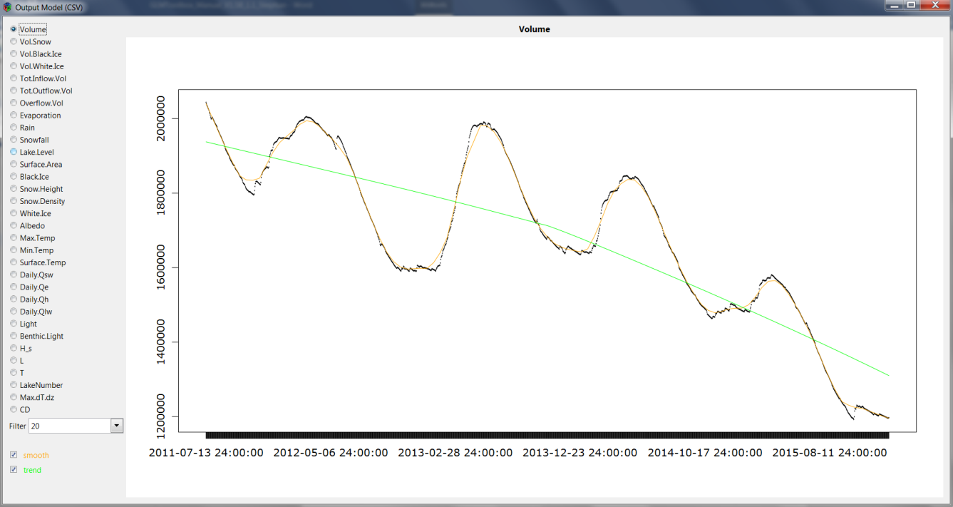

Figure 12: Visualized model output (CSV)

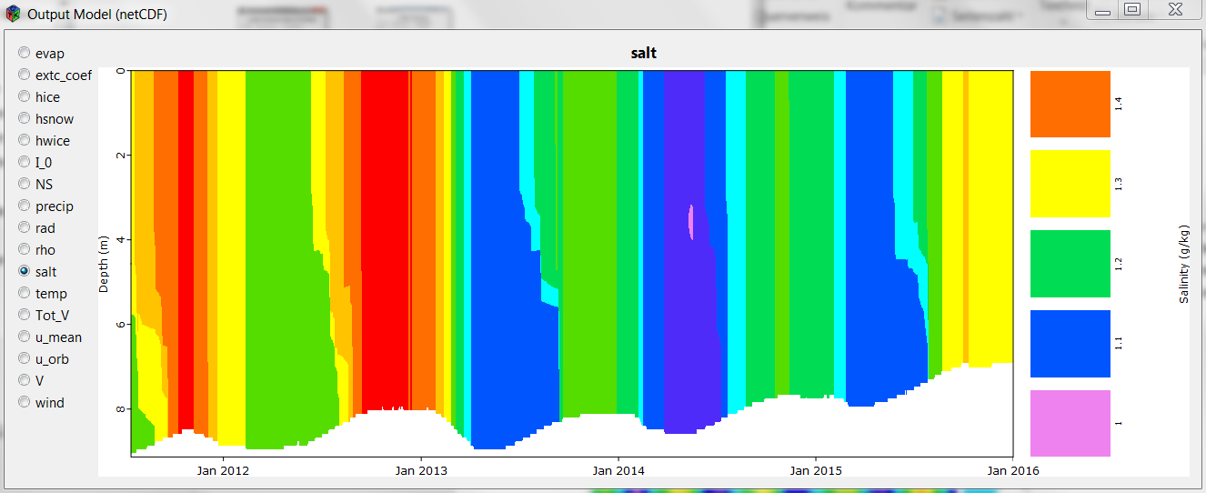

Figure 13: Visualized Output Model (netCDF)

Several plot options can be selected in section **4. Field Data**. For each selected plot a separate R-window will be opened. Three different options of contour plots can be created. Upper ones show observed data and simulated data, which can be plotted with and without indications of available field data observations (Figure 14). For a better visualization of the spatial and temporal pattern of the model error, the differences between model and observed data can be plotted into one contour plot (Figure 15). All plots are saved as PDF files directly into the workspace path. The option of plotting the simulated and observed water temperatures (RMSE, no figure shown here) and lake level (Figure 16) after running (*build*) the model can also be selected in this section of the GUI.

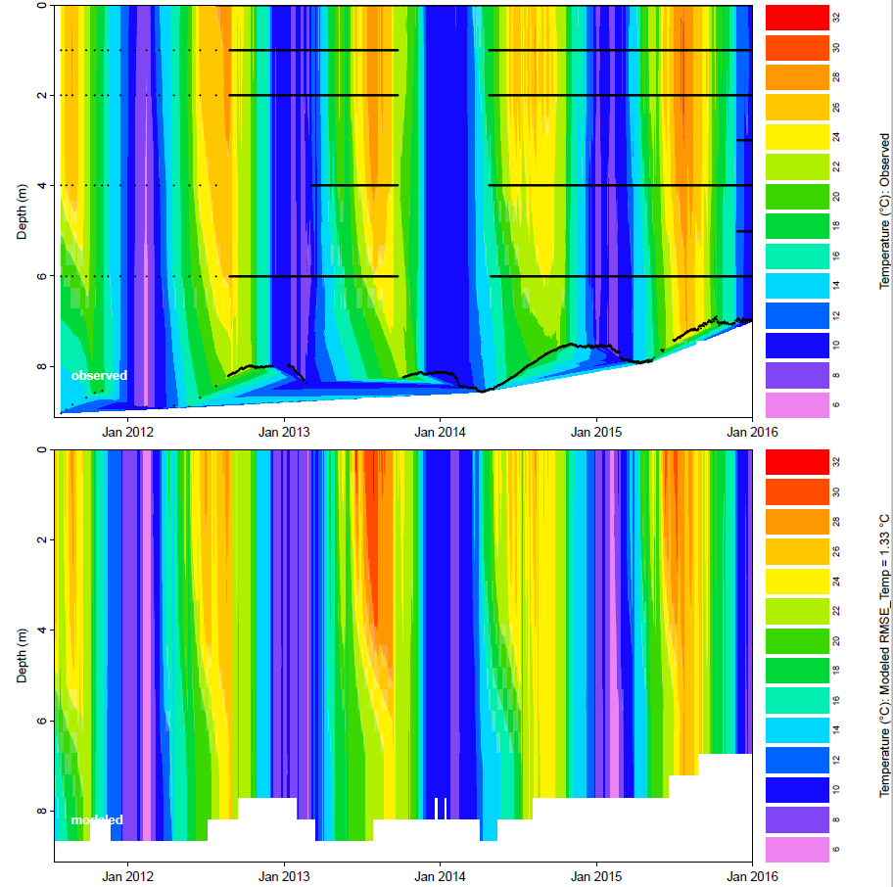

Figure 14: Observed temperature (with datapoints) and simulated (modeled) temperature

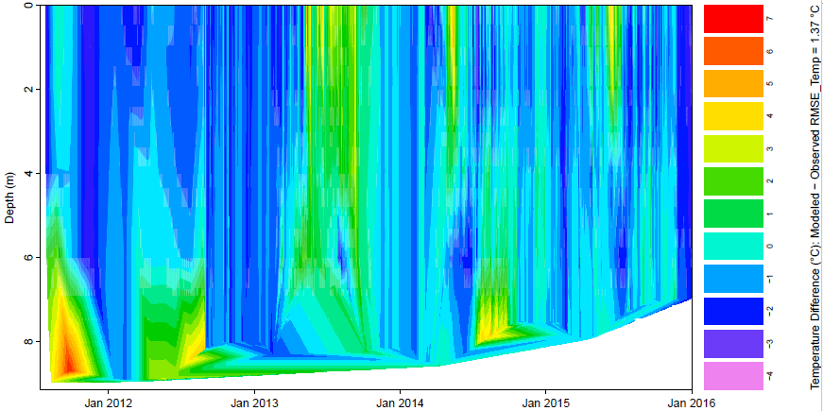

Figure 15: Temperature differences between model and field data

G:\DatenUNI_181018\Modellierung\GLM\R_GUI\LB_2011-2016_03_final_set\plots\71_lake_level.tiff

Figure 16: Comparison of field (red) and model (blue) values for lake level

The GUI includes a tool to autocalibrate the model. A selection of lake-specific, meteorological, and hydrological parameters can be chosen for the calibration (Figure 17). If multiple inflows are defined in the nml.file the parameters *inflow\_factor* for all inflows are considered.

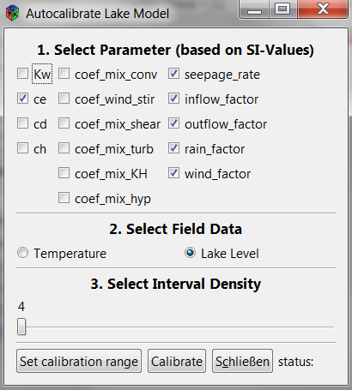

Figure 17: Autocalibration of selected parameters

In the window for setting the autocalibration (Figure 17) 3 options has to be defined:

* the parameter to be involved in the calibration process,
* the simulation output, for which the model criteria (= RMSE) will be calculated, and
* the interval density of the calibration parameters (number of parameter values).

For each parameter the calibration range can be defined by a percentage of the start value (Figure 18). The calibration range is divided into intervals (Interval Density) with equal lengths defined by the user (step 3 in autocalibration window, Figure 17), and the model criteria (RMSE) will be calculated for all limits of the intervals. In Figure 19 an example is shown of the considered parameter values (coef\_mix\_conv) in the calibration process for a defined calibration range of 50% and an interval density of 6. The start value is 0.2, the upper limit (0.3) and lower limit (0.1) and in total 7 parameter values are considered. The calculated RMSE values as a result of the calibration process are stored in the files AutoCal\_LL.csv or AutoCal\_WT.csv depending on either water temperature or lake level was chosen. The results will also be outputted in the R-script marking the parameter combination with the best model fit criteria in the last row.

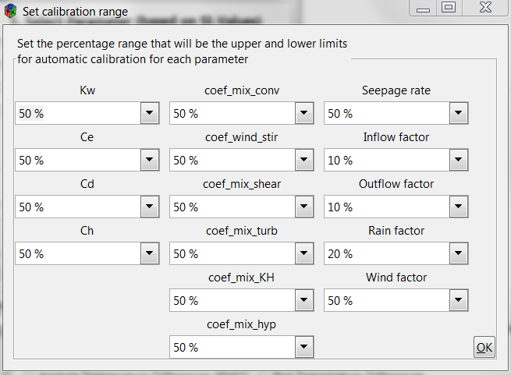

Figure 18: Setting of the calibration range for each parameter

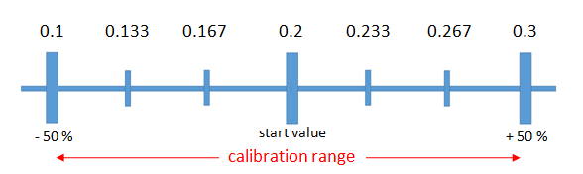

Figure 19: Simulated values of a parameter with a start value of 0.2 (e.g. default value of coef\_mix\_conv), a calibration range of 50 %, and an interval density of 6.

# Literature

Hipsey, M. R., Bruce, L. C., Boon, C., Busch, B., Carey, C. C., Hamilton, D. P., Hanson, P. C., Read, J. S., de Sousa, E., Weber, M., and Winslow, L. A.: A General Lake Model (GLM 2.4) for linking with high-frequency sensor data from the Global Lake Ecological Observatory Network (GLEON), Geoscientific Model Development Discussions, 1-60, 10.5194/gmd-2017-257, 2017.