Forecasting Tomorrow’s Symptoms Today: Using AI-Driven Symptom Prediction to Empower Patients with Chronic Illness
Jimmy Tabet^{1*}, Chelsea Li¹, Greg Alspaugh¹
¹UNC School of Medicine, Chapel Hill, NC
*Corresponding Author: Jimmy Tabet, jimmy_tabet@med.unc.edu

Abstract
Background: Chronic illnesses, such as diabetes, cardiovascular disease, and autoimmune conditions, affect millions of individuals worldwide and are characterized by unpredictable symptom fluctuations that complicate day-to-day management. Illness uncertainty (the inability to anticipate symptom severity or disease progression) contributes to stress, reduced quality of life, and diminished self-efficacy among patients. Advances in artificial intelligence (AI) and machine learning offer the potential to mitigate these challenges by leveraging large-scale patient-generated data to predict symptom trajectories and support proactive disease management.
Methods: In this study, we analyzed the Flaredown chronic illness dataset, comprising over 7.9 million user entries capturing daily symptoms, treatments, food, weather, and user-assigned tags. We constructed features including daily metrics and demographic information to predict next-day symptom worsening using a Random Forest classifier.
Results: Our model achieved 62.7% accuracy with an AUROC of 0.66, demonstrating that short-term symptom prediction is feasible. Feature importance analysis revealed that overall symptom severity, neurological symptoms (e.g., headache, brain fog, dizziness), specific foods, lifestyle tags (e.g., sleep, alcohol), and common treatments (e.g., ibuprofen, paracetamol) were among the top predictors. Notably, several influential features can be considered more modifiable (food, tags, and treatments), highlighting actionable factors patients can monitor to potentially reduce symptom severity.
Conclusions: While model interpretability and predictive performance remain limited by computational constraints, this work establishes a baseline for AI-driven symptom forecasting and underscores its potential to empower patients with chronic illness. By providing predictive insight, such tools can reduce illness uncertainty, support personalized daily management, and transform chronic disease care from reactive to proactive.
Keywords: Chronic Illness, Artificial Intelligence, Machine Learning, Symptom Prediction

Introduction
Burden and Epidemiology of Chronic Illness
Chronic illnesses—such as diabetes, heart disease, stroke, and cancer among others—are currently the leading cause of death worldwide(Hacker, 2024). In the United States alone, approximately 57 million people live with chronic conditions(Tu, 2004). According to the Centers for Disease Control and Prevention (CDC), chronic illness encompasses a broad range of conditions that often last one year or more, require ongoing medical attention, and limit activities of daily living. For many patients, symptoms can fluctuate unpredictably, making day-to-day life difficult: negatively affecting quality of life, mental wellbeing, or work productivity. Providing better resources for individuals with chronic illnesses is vital. Because these conditions are long-lasting, complex, and require ongoing self-management, patients need personalized support that can allow for improved autonomy and quality of life.
Trends such as population growth and aging contribute to the rising number of individuals who are living with chronic conditions and in many cases, co-occurring illnesses (Rolland, 2025). In 2018, it was estimated that 27% of adults in the US had multiple chronic conditions (Boersma et al., 2020; Hacker, 2024). Prevalence is especially high among older adults. According to the CDC, in adults 65 and older, 90% have at least one chronic condition; in adults 35-64, 75% have at least one chronic condition; and in young adults 18-34, 60% have at least one condition. In addition to adults, there is an increasing number of children and adolescents living with chronic conditions(Yeo & Sawyer, 2005),. Over 85% of children with congenital or chronic conditions now survive into adolescence and these conditions can affect physical, cognitive, social, and emotional aspects of growing up(Yeo & Sawyer, 2005), highlighting the need for age-appropriate support and resources. Chronic illnesses are not only widespread and debilitating, but also costly. On an individual scale, especially for uninsured, chronically-ill individuals, the financial burden often leads to delayed or forgone health care(Tu, 2004). On a national scale, chronic illness burden to the US healthcare system has an estimated cost of approximately $1 trillion per year(Hacker, 2024).
Illness Uncertainty
Chronic illness profoundly affects individuals as they navigate managing symptoms day-to-day. For many conditions, symptoms are frequent and unpredictable; there can be flare-ups without clear signs and it is hard to anticipate “good” or “bad days,” directly impacting how individuals balance managing a chronic illness with other responsibilities and their wellbeing. Illness-related events that are hard to assign meaning to or being unable to predict outcomes because there are limited cues often result in illness uncertainty(Johnson Wright et al., 2009). This can not only be a cognitive stressor, but also can lead patients to feel a loss of control and negatively impact coping with a chronic illness(Johnson Wright et al., 2009). With chronic illnesses especially—such as fibromyalgia, rheumatoid arthritis, and pelvic pain—illness uncertainty influences how individuals adapt to chronic pain conditions(Johnson Wright et al., 2009). Reich and colleagues showed that for fibromyalgia patients, high levels of illness uncertainty even affected relationships and feelings of partner’s supportiveness(Reich et al., 2006). Affleck et al. showed that for rheumatoid arthritis patients, decreased predictability of illness was related to decrease in positive mood and psychosocial adjustment(Affleck et al., 1987; Johnson Wright et al., 2009). Furthermore, LeFort found that with various types of pain and musculoskeletal conditions, illness uncertainty reduced self-efficacy, resourcefulness, and life satisfaction (LeFort, 2000).
This work on illness uncertainty identifies the need for providers to address uncertainty with patients as they navigate their chronic condition. Moreover, it motivates research that can assist patients in coping and managing uncertainty. Existing methods of tracking symptoms rely on retrospective reporting that may not provide predictive insight. Thus, there is a need to provide patients with the right tools to better reduce uncertainty and manage fluctuations with symptoms.
Current Role of Artificial Intelligence (AI) in Supporting Patients with Chronic Illnesses
AI and machine learning offer a promising opportunity to fill this gap with resources that can identify patterns to help patients act proactively. Current advancements focus on monitoring and early warning of chronic illness disease progression(Dong et al., 2025) and precision-based care that focuses on tailoring interventions directly to the individual(Dong et al., 2025). By leveraging AI with large datasets or wearable devices, it can be used to detect patterns in symptoms, disease progression, or treatment response.
Wearable devices equipped with sensors, Internet of Things, and AI technologies have greatly expanded relatively non-invasive monitoring across a range of chronic illnesses including cardiovascular, respiratory, and metabolic disease(Dong et al., 2025; Sharma et al., 2021; Xie et al., 2021; Yang et al., 2019; Zheng et al., 2024). While there remains concerns regarding accessibility, regulation on how they will be used for clinical decision-making, and effectiveness of wearable devices, integration with AI algorithms can identify health risks and may uncover mechanisms of chronic illness(Dong et al., 2025). Following data acquisition and storage, machine learning and deep learning can generate predictions and knowledge reasoning that inform personalized care that assists patients with various applications including food and exercise recommendations(Dong et al., 2025).
In addition to improved monitoring, AI-powered chatbot interventions, especially for chronic illnesses(Kurniawan et al., 2024), have become increasingly common. Greer et al. showed that the Vivibot chatbot can provide positive psychology support to young adults post-cancer treatment (Greer et al., 2019). Gong and fellow colleagues utilized an app-based conversational program, My Diabetes Coach (MDC), and found that this improved health-related quality of life (HRQoL) for the individuals with type 2 diabetes that used the app(Gong et al., 2020).
Overall, AI applications in chronic illness management have the potential to support clinicians in providing more effective care while simultaneously empowering patients to play an active role in managing their health.
Purpose
There is a need to improve care for those that are diagnosed with chronic illnesses. Because of the unpredictable nature of many chronic conditions, patients may struggle to manage fluctuating symptoms and complex treatments. In order to better understand chronic illness, it is essential to evaluate its dynamic process and utilize this knowledge to support patients and their families.
AI and machine learning are powerful tools for analyzing large and complex health datasets to uncover trends in symptom fluctuation and predict flare-ups. These predictive models can be applied on a day-to-day basis and allow patients to anticipate and prepare for symptom changes.
The ability to forecast symptoms in advance has meaningful implications for patient empowerment and their quality of life. Predictive insights can transform chronic illness management from a reactive to a proactive approach, empowering patients to reduce illness uncertainty and make informed decisions despite the unpredictable nature of chronic illness.
Aims
Using the Chronic Illness Dataset, we aim to explore the patterns in daily symptom fluctuations and identify modifiable behaviors that can help empower patients to proactively manage chronic illnesses.
Aim 1: Evaluate the predictive potential of daily symptom tracking.
Hypothesis 1: Users’ symptom data from a given day can provide signal to predict whether their symptoms will worsen the next day.
Aim 2: Identify the most influential features for next-day symptom prediction.
Hypothesis 2: Symptoms, food intake, user-assigned tags, and treatments contribute differently to the model’s predictions, with certain features driving stronger predictive signals. Feature importance analysis will reveal which factors are most strongly associated with symptom changes.
Aim 3: Highlight modifiable behaviors to inform symptom management.
Hypothesis 3: Food, tags, and treatment-related features, being somewhat more modifiable, will emerge as actionable predictors. Paying attention to these factors may help patients reduce symptom severity, identify potential triggers, and personalize daily management strategies.

Methods
Overview
In an effort to empower patients with AI-driven insight, we analyzed the Chronic illness Dataset from Kaggle (Kaggle). This dataset consists of user data from the Flaredown app which is used to help patients with chronic diseases track their symptom severity along with treatments and potential triggers. The dataset contains 7,976,223 user entries. Demographic informatics like age, sex, and country are recorded along with “trackables”: condition, symptom, treatment, food, weather, and user-inputted tags. A visual overview of the data is provided below.
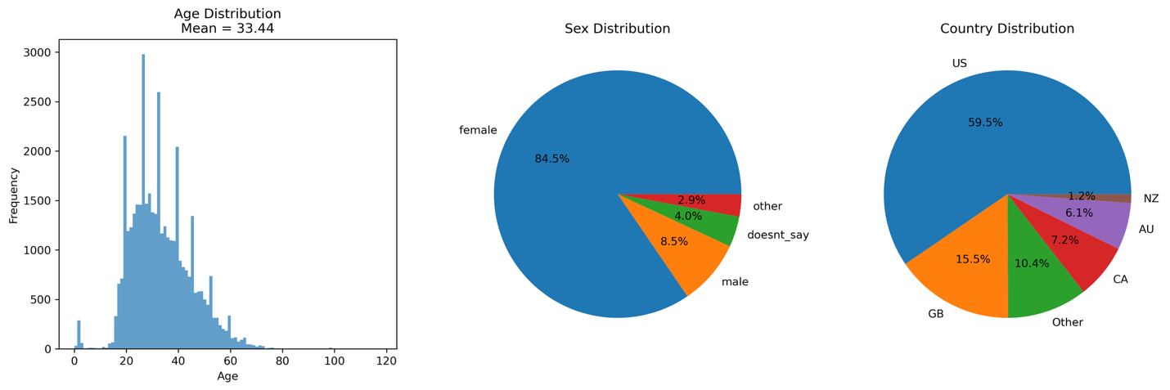Figure 1: Overview of Flaredown users age, sex, and country distribution.

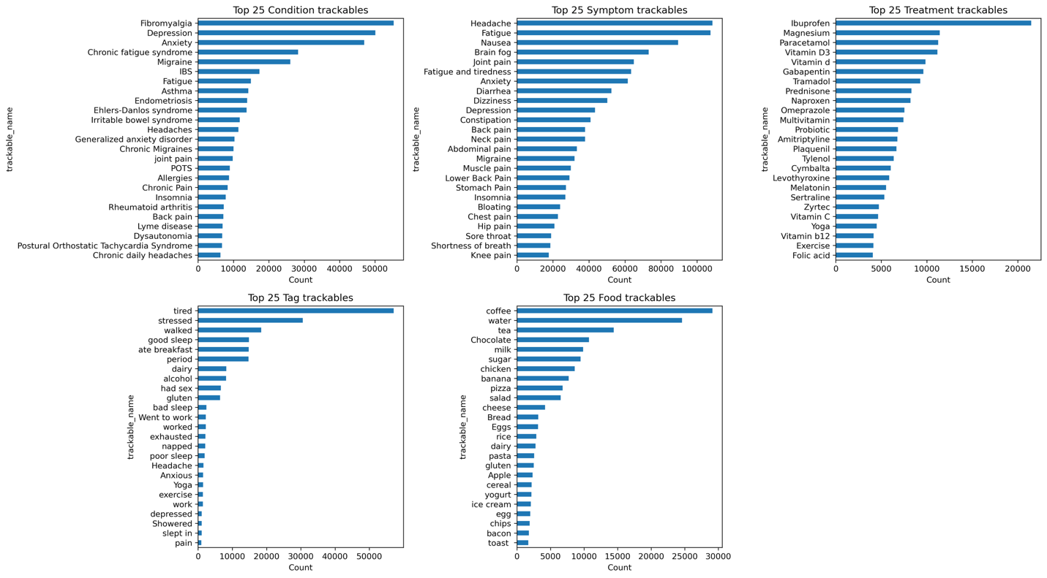Figure 2: Top 25 most frequent entry categories for condition, symptom, treatment, tag, and food trackables.
Preprocessing
The data was preprocessed by loading the Flaredown dataset and standardizing key text fields (trackable names, types, sex, and country) to normalized, lowercase strings. Outlier ages (i.e., less than 0 or greater than 120) were removed as they were most likely due to input error. For each user and each calendar day, an overall symptom severity score was calculated by averaging the severity of all logged symptoms and conditions. To capture more granular information, we constructed separate daily metrics, per user, for symptoms, conditions, tags, foods, treatments, and weather by retaining only the top 100 most commonly reported items in each category. To construct the feature matrix, we merged the overall severity score with the daily metrics and demographic (age, sex, country) information. To construct our outcome of interest, we computed the change in overall symptom severity score between consecutive calendar days, per user. We binarized the outcome as follows: 1 if the if the next day’s severity was higher (i.e., worse), and 0 otherwise (same or better). We imputed any missing values based on column means. We one-hot encoded categorical features to end with a final dataset of 223,865 samples and 671 features, plus our outcome variable. The data was split 70/30 between train and test sets, stratified by outcome. A standard scaler was fit on the training data and applied to both training and test sets.
Modeling
We trained a Random Forest (RF) classifier to predict whether a user experienced a worsening of their symptoms the following day based on our binarized score (i.e., 1 indicating worsening symptoms, and 0 otherwise). Due to the size of the dataset and compute constraints, we were only able to train a default RF classifier with 100 trees. Code was developed to perform extensive hyperparameter tuning using 10-fold cross validation with the train set and to compare performance between several model types (logistic classification, Random Forest, XGBoost, LightGBM, simple multi-layer perceptron, and TabPFN model), however these experiments were not able to be performed again due to time and compute constraints.
Feature Importances
To further investigate the modeling capabilities, we analyzed feature importances from our trained RF model. Although Shapley values offer rich global and local interpretability, we were unable to apply SHAP reliably due to computational constraints stemming from the high dimensionality and sample size. These limitations caused repeated kernel crashes even when using aggressive subsampling strategies. As an alternative, we relied on the model’s built-in feature importance scores. While feature importances do not provide the same individualized explanations or fully account for feature interactions in the way Shapley values do, they still offer meaningful insight into which variables the model relies on most when making predictions. These feature importances allow us to highlight influential predictors, identify potential risk-increasing and protective factors, and retain a degree of interpretability for population-level analysis.

Results
Using the held-out test set, we evaluated our RF model with several metrics. Overall accuracy was 62.7% with an AUROC of 0.66 (Figure 3). The full classification report is shown in Table 1. Feature importances from the trained model were analyzed and the top 25 features were collected across all feature types. To provide insight into more “modifiable” features that may allow for greater user control, we also collected top features from tag, food, and treatment trackables (Figure 4).
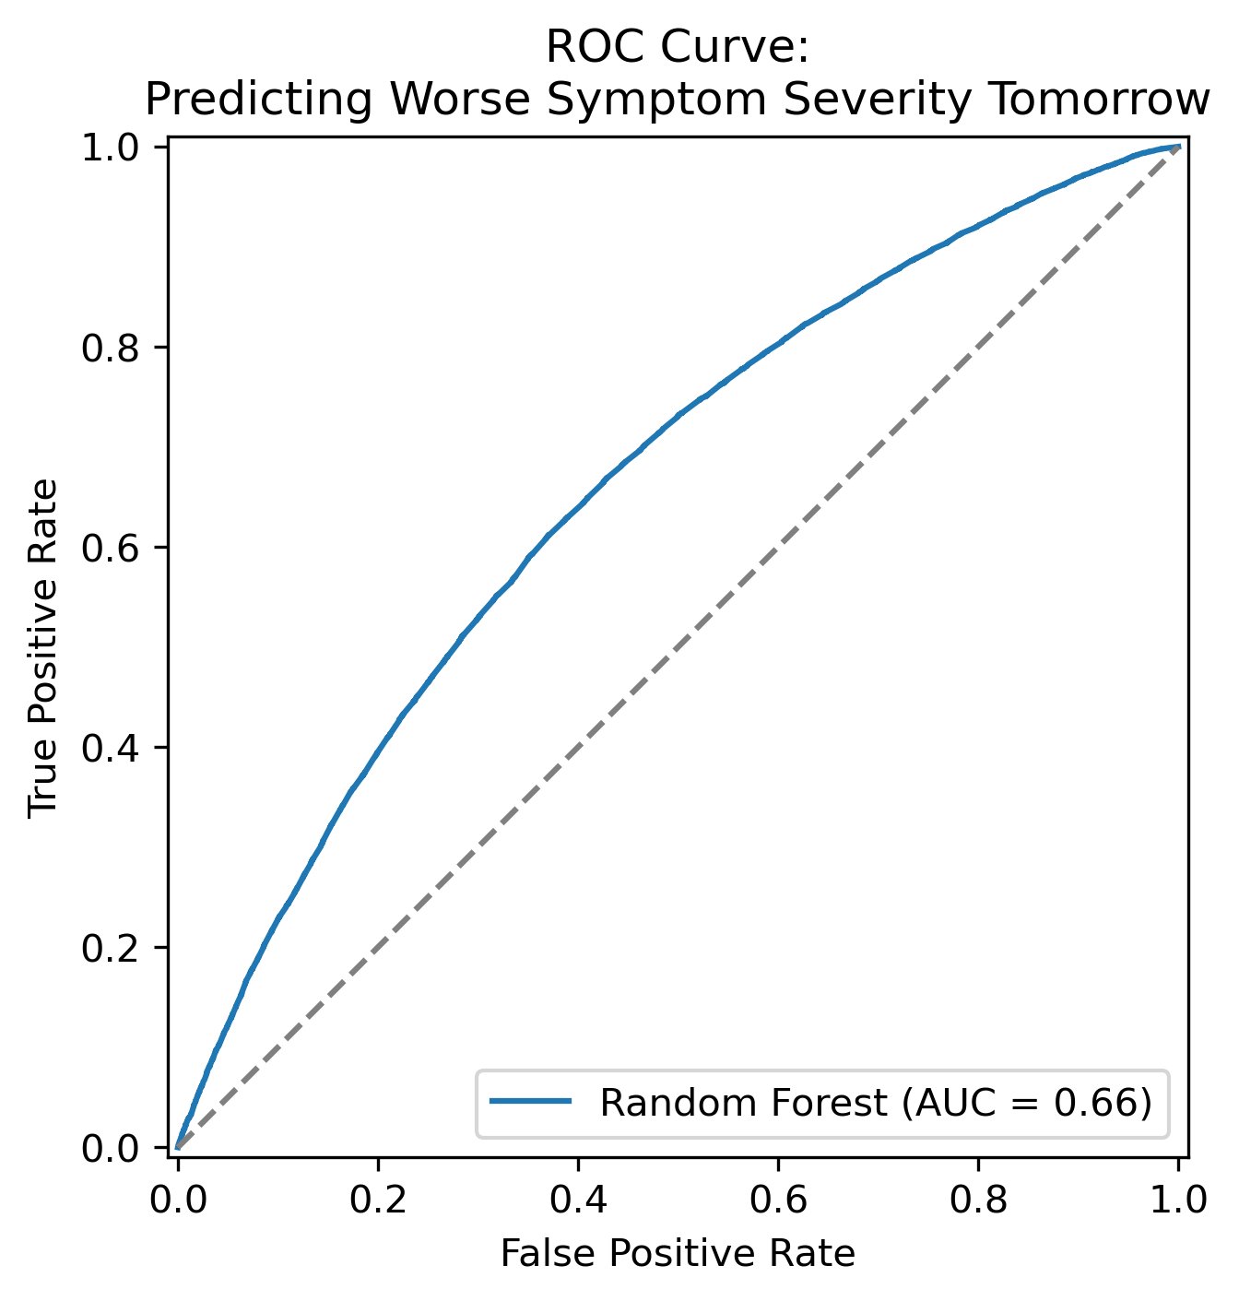
Figure 3: Receiver operating characteristic
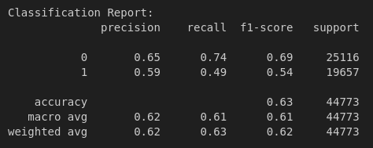
Table 1: Full classification report from trained Random Forest model.
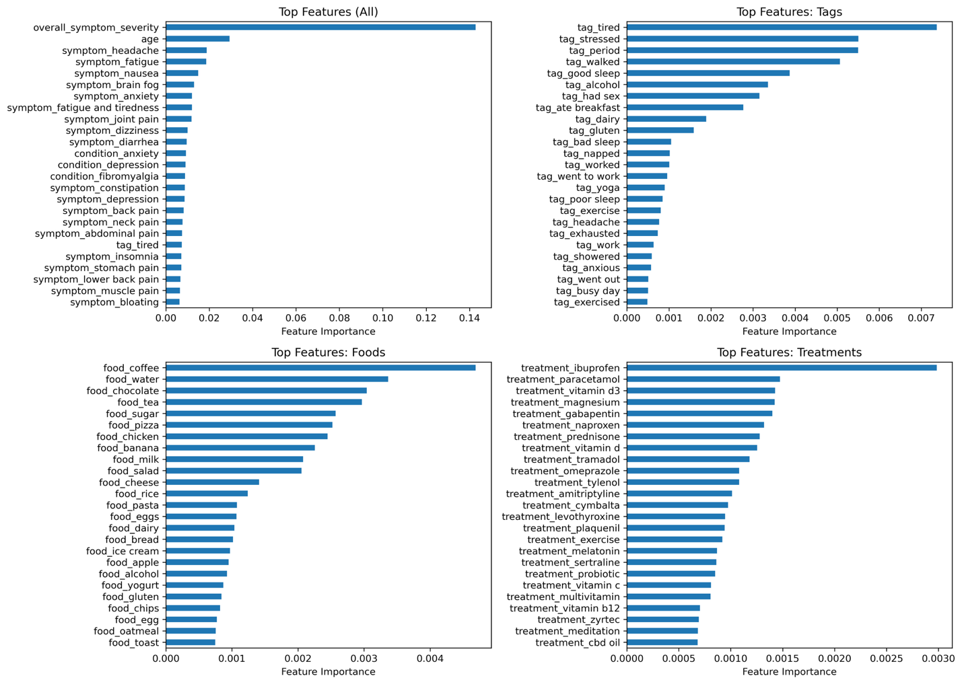Figure 4: Top 25 features based on feature importances from trained Random Forest model. Top left: all features, top right: tag trackables, bottom right: food trackables, bottom left: treatment trackables

Discussion
While the model results (accuracy, AUROC) are not fantastic, they provide a solid baseline and demonstrate the potential for AI to digest large datasets and provide individual insights. We hope our intended combination of hyperparameter tuning and algorithm comparisons (including more recent transformer-based architectures) would allow the model to better learn patterns and increase overall accuracy to an appropriate level for consumer confidence. Our strategy for empowering patients with AI hinges on interpretable and explainable aspects of a well-trained model. Improving the predictive power of our model would be a critical step towards providing more consistent and reliable insights.
In addition, the ideal method of interpretability for our model is Shapley values are they are (1) model agnostic and (2) provide both global and individual decision insights. For example, Shapley values would allow users to see exactly which features, or class of features, lead to an individual/single model prediction of worsening symptoms on the following day. However, in lieu of Shapley values, we decided to rely on more global insights into general trends across the data that contributed, either positively or negatively, to the model’s decision-making process. Analyzing feature importances yielded some obvious results (i.e., overall symptom severity today is the single most important feature in predicting worsening symptoms tomorrow). Almost all of the remaining top features consisted of symptoms, though some trends may be inferred. For example, headache, brain fog, and dizziness all rank in the top 10. These neurological symptoms may be more specific cues or indicators for individuals that could be isolated from other symptoms like joint pain and constipation. The top user-inputted tags were alcohol, breakfast, dairy, and bad sleep. These represent discrete triggers, but their identification could serve as reminders for those with chronic illness to pay particular attention to individual decisions during the day. In a similar vein, the top two food features are coffee and water. For a given individual, a reminder that drinking coffee or not drinking enough water may contribute greatly to worsening symptoms the following day could provide additional incentive and/or insight. Finally, medications like ibuprofen and paracetamol were the top treatment features. This insight into model decision making could cue users into which medications work consistently for their symptoms, and which treatments may be less effective for them.

Conclusion
Chronic illnesses place a sustained burden on patients, and much of that burden stems from the unpredictability of day-to-day symptom changes. In this project, we examined whether next-day symptom worsening could be forecasted using real-world data from the Flaredown platform. By constructing a detailed daily dataset and training a baseline Random Forest model, we showed that short-term symptom prediction is feasible, even if current accuracy remains modest. In addition, the model’s feature-importance patterns highlighted several symptoms, behaviors, and lifestyle factors that align with patient-reported triggers, suggesting that even simple models can reveal meaningful trends. Although computational constraints prevented us from generating individual-level Shapley explanations, global feature importances still offered useful insight into the variables most associated with symptom fluctuations. Overall, this work illustrates both the promise and current limitations of applying AI to support patients with chronic illness. Further refinement through improved modeling, hyperparameter tuning, and scalable interpretability methods will be important for translating these insights into patient-facing tools that can help anticipate symptom changes, make informed decisions, and ultimately reduce the uncertainty that shapes the chronic illness experience. As such, our findings point toward a future in which predictive models contribute to empowering patients through AI, offering greater clarity and agency in day-to-day disease management.

References
Affleck, G., Tennen, H., Pfeiffer, C., & Fifield, J. (1987). Appraisals of control and predictability in adapting to a chronic disease. Journal of Personality and Social Psychology, 53(2), 273–279. https://doi.org/10.1037//0022-3514.53.2.273
Boersma, P., Black, L. I., & Ward, B. W. (2020). Prevalence of multiple chronic conditions among US adults, 2018. Preventing Chronic Disease, 17, E106. https://doi.org/10.5888/pcd17.200130
Dong, C., Ji, Y., Fu, Z., Qi, Y., Yi, T., Yang, Y., Sun, Y., & Sun, H. (2025). Precision management in chronic disease: An AI empowered perspective on medicine-engineering crossover. IScience, 28(3), 112044. https://doi.org/10.1016/j.isci.2025.112044
Flaredown. (2021, February 2). Chronic illness: Symptoms, treatments and triggers. Kaggle. https://www.kaggle.com/datasets/flaredown/flaredown-autoimmune-symptom-tracker
Gong, E., Baptista, S., Russell, A., Scuffham, P., Riddell, M., Speight, J., Bird, D., Williams, E., Lotfaliany, M., & Oldenburg, B. (2020). My Diabetes Coach, a Mobile App-Based Interactive Conversational Agent to Support Type 2 Diabetes Self-Management: Randomized Effectiveness-Implementation Trial. Journal of Medical Internet Research, 22(11), e20322. https://doi.org/10.2196/20322
Greer, S., Ramo, D., Chang, Y.-J., Fu, M., Moskowitz, J., & Haritatos, J. (2019). Use of the Chatbot “Vivibot” to Deliver Positive Psychology Skills and Promote Well-Being Among Young People After Cancer Treatment: Randomized Controlled Feasibility Trial. JMIR MHealth and UHealth, 7(10), e15018. https://doi.org/10.2196/15018
Hacker, K. (2024). The burden of chronic disease. Mayo Clinic Proceedings. Innovations, Quality & Outcomes, 8(1), 112–119. https://doi.org/10.1016/j.mayocpiqo.2023.08.005
Johnson Wright, L., Afari, N., & Zautra, A. (2009). The illness uncertainty concept: a review. Current Pain and Headache Reports, 13(2), 133–138. https://doi.org/10.1007/s11916-009-0023-z
Kurniawan, M. H., Handiyani, H., Nuraini, T., Hariyati, R. T. S., & Sutrisno, S. (2024). A systematic review of artificial intelligence-powered (AI-powered) chatbot intervention for managing chronic illness. Annals of Medicine, 56(1), 2302980. https://doi.org/10.1080/07853890.2024.2302980
LeFort, S. M. (2000). A test of Braden’s Self-Help Model in adults with chronic pain. Journal of Nursing Scholarship, 32(2), 153–160. https://doi.org/10.1111/j.1547-5069.2000.00153.x
Reich, J. W., Olmsted, M. E., & van Puymbroeck, C. M. (2006). Illness uncertainty, partner caregiver burden and support, and relationship satisfaction in fibromyalgia and osteoarthritis patients. Arthritis and Rheumatism, 55(1), 86–93. https://doi.org/10.1002/art.21700
Rolland, J. S. (2025). Chronic illness and disability: A multisystemic practice model. Journal of Family Nursing, 31(2), 63–74. https://doi.org/10.1177/10748407251329694
Sharma, A., Badea, M., Tiwari, S., & Marty, J. L. (2021). Wearable biosensors: an alternative and practical approach in healthcare and disease monitoring. Molecules, 26(3). https://doi.org/10.3390/molecules26030748
Tu, H. T. (2004). Rising health costs, medical debt and chronic conditions. Issue Brief (Center for Studying Health System Change), 88, 1–5.
Xie, Y., Lu, L., Gao, F., He, S.-J., Zhao, H.-J., Fang, Y., Yang, J.-M., An, Y., Ye, Z.-W., & Dong, Z. (2021). Integration of artificial intelligence, blockchain, and wearable technology for chronic disease management: A new paradigm in smart healthcare. Current Medical Science, 41(6), 1123–1133. https://doi.org/10.1007/s11596-021-2485-0
Yang, G., Pang, G., Pang, Z., Gu, Y., Mantysalo, M., & Yang, H. (2019). Non-Invasive Flexible and Stretchable Wearable Sensors With Nano-Based Enhancement for Chronic Disease Care. IEEE Reviews in Biomedical Engineering, 12, 34–71. https://doi.org/10.1109/RBME.2018.2887301
Yeo, M., & Sawyer, S. (2005). Chronic illness and disability. BMJ (Clinical Research Ed.), 330(7493), 721–723. https://doi.org/10.1136/bmj.330.7493.721
Zheng, N. S., Annis, J., Master, H., Han, L., Gleichauf, K., Ching, J. H., Nasser, M., Coleman, P., Desine, S., Ruderfer, D. M., Hernandez, J., Schneider, L. D., & Brittain, E. L. (2024). Sleep patterns and risk of chronic disease as measured by long-term monitoring with commercial wearable devices in the All of Us Research Program. Nature Medicine, 30(9), 2648–2656. https://doi.org/10.1038/s41591-024-03155-8

