James Stanbridge 0000247763

Date: 6 Feb 2014

Class Number: 201402 Section: 01 (Online)

Problem Solving

A Cat, A Parrot, and a Bag of Seed

1) Define the Problem

In this scenario, the man must transport three things across a river in a boat that can only carry himself and one of the things. Meaning that he has to take them one at a time. The added catch is that, when left alone together, some of the things will destroy other things. So the man has to figure out what order to take the things safely across in.

2) Break the Problem Apart

In this problem we have to successfully get a cat, a bird, and a bag of seed across a river one at a time while ensuring that each object not being taken across is safe. This applies to both sides of the river, as I’m sure the cat will eat the bird on either side and the bird will eat the seed on either side. We have to work within the constraints presented while thinking outside the box in areas where constraints are not present.

3) Identify Potential Solutions

The man could:

a) Put the animals into cages to prevent them from eating each other or the seed.

b) Figure out the correct order to take them across the water in.

c) Abandon one of the objects to get the other two across.

d) Try to find a bigger boat or get help from someone.

4) Evaluate Each Potential Solution

a) This solution would work as the man would be able to eliminate the constraint of worrying about the safety of his cat, bird, and bag of seed while transporting them.

b) This would be the optimal solution, provided that there is actually a way to get everything across the river safely without any additional equipment or help.

c) This solution is not optimal as the man would lose one of his things during the transporting and the goal is to get all three things across safely.

d) This solution has potential, but it is working outside of the context of the problem itself. I’m sure that if there were a source of help readily available the man would not be faced with this problem to begin with.

5) Choose a solution and develop a plan to implement it.

For this problem we are going to attempt solution B. At first, this problem seems simple: take the bird across first, and the cat and bag of seed will be left on the shore, safe from harm. But, no matter which object you take across next, be it cat of seed, you will lose that item when you return for the third. The cat will eat the bird if you take it across next, and the bird will eat the seed if you take that across next. So how do we solve the problem? We have to take items back and forth on most of the trips. This will require a total of four trips.

For trip #1, the man takes the bird across, leaving the cat and seed behind, safe. For trip #2, the man takes the cat across but returns with the bird, leaving the cat alone and the bird and seed on his side of the river, resulting in a safe situation for all. For trip #3, the man takes the seed across the river and brings nothing back, leaving the bird alone on one side and the cat and seed together on the other, safe. For the final trip the man brings the bird over, resulting in all three objects being together with him on the opposite side of the river.

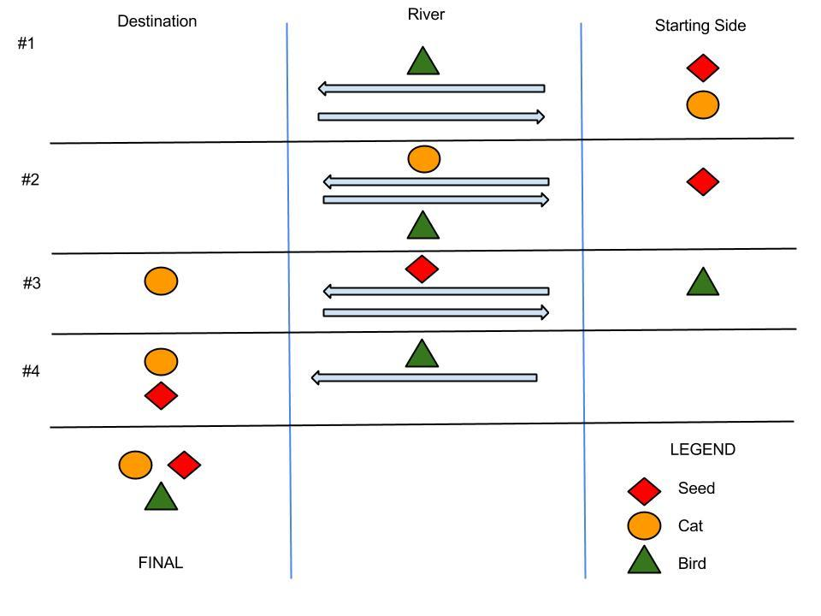

Socks in the Dark

1) Define the Problem

The main problem here is that you must correctly select pairs of socks that only differ in color while not being able to see them.

2) Break the Problem Apart

For this problem we have two goals: find the minimum number of socks you must select in order to get at least one matching pair of socks, then do the same for a result of one matching pair of each color. The constraint is that we are in the dark, unable to see the color of the socks in the drawer. So the key here is to focus on the number of individual socks, not the pairs themselves. In order to have a pair of socks, you have to have two socks. So how many socks do we have to pull from the door to make sure that we have two of the same color, and then two of each of the colors?

3) Identify Potential Solutions

a) We could find a light, and then be able to pick socks with accuracy instead of randomly.

b) We could pick two socks at random and wear them as a pair without regard to color.

c) We could break things down mathematically to determine what number of socks would meet each of our goals.

4) Evaluate Each Potential Solution

a) This solution is viable if there is a light around. However, given the parameters of the problem we should assume that there is not one around, making this solution unusable.

b) This solution is great if you don’t mind winding up in a potentially embarrassing fashion situation.

c) This is the optimal solution (however unrealistic) for this problem because we can keep within the constraints of the problem and find a guaranteed solution to our goals.

5) Choose a solution and develop a plan to implement it.

For this problem we will use solution C, as it falls within the constraints of the problem. The first goal of the problem is simple:

* There are three colors of sock in the drawer.
* We need two socks of a single color to get one matching pair of socks.
* In the worst case scenario, our first three socks from the drawer will all be different colors.
* Even in that scenario, the fourth sock that will pull from the drawer is guaranteed to match one of the three socks we already have.
* We must pull four socks from the drawer to guarantee ourselves at least one matching pair.

The second goal is a little more complicated than that, but follows the same principles:

* Once again, we focus on the worst case scenario - drawing all the pairs of two colors, before the pull a pair for the third - and drawing the colors with the most pairs of socks first.
* There are five pairs of black socks, or ten individual black socks. So we start there, ten socks.
* The next largest group is the brown socks, with three pairs, or six individual brown socks. That brings our total up to 16 socks, the worst case scenario.
* At this point, in order to pull a pair of the remaining socks, we would need two socks, as two socks make one pair. That brings our total up to 18 socks out of a total of 20 socks.
* So 18 socks is the minimum needed to absolutely guarantee that we will pull a pair for each color of sock.

Predicting Fingers

1) Define the Problem

The key to this problem is figuring out the mathematical pattern so that you do not have to literally count to 1000 in order to find out what finger the girl would stop on when counting to 1000, or any other number.

2) Break the Problem Apart

The problem with this problem is that the girl does not use a method of counting that utilizes each finger equally. If she counted 1-5 from thumb to pinky and 6-10 from pinky to thumb (or thumb to pinky again), we could easily divide each number by 5 and figure out which finger the number would land on. Instead we have to figure out what equation will work in the same manner with her odd counting style. If we can figure this out on a small scale, we should then be able to apply it on a larger scale.

3) Identify Potential Solutions

a) We could develop an equation that would tell us which figure any given number will fall on.

b) We could manually count to each number using the same method as the girl.

c) We could guess and hope for the best.

4) Evaluate Each Potential Solution

a) This solution is great because it will allows to determine the placement of any number, not just the ones that are given in the problem.

b) This solution would work, but has three major downsides. The first is that it would only give us answers to the number given in the problem. The second is that high numbers, such as 1000 (one of our goal numbers) would take a long time to count to. Finally, there is a lot of room in this solution for human error.

c) This solution does not fit with our goals at all, as we want a guaranteed correct result.

5)