Overview

1. Create script on local machine

2. Ensure script functions and has correct permissions

3. Upload script to Github repository
=========================================================================

1. Creating the script
1A. Use the touch command to create a script shell file.
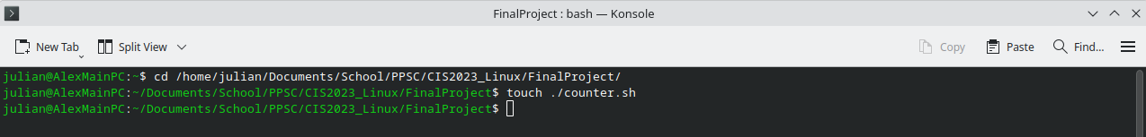
1B. Use a text editor like vim or nano to edit the file.
Script used:
#!/bin/bash
# Echoes variable "i" and increments from 1 to 50
for i in {1..50}
do
echo "$i"
done
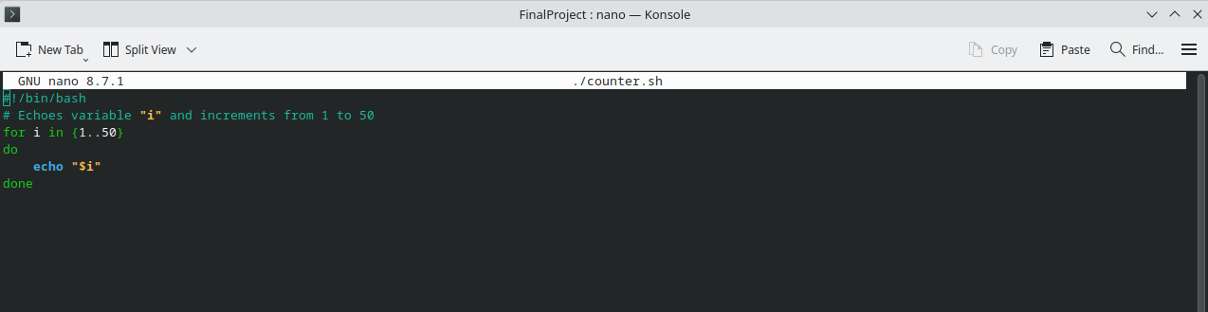
1C. Save changes (ctrl+O) and exit (ctrl+X).

2. Give script execute permission and test functionality
2A. Use chmod to give the script execute permission. (Optional: Use ls -la to verify the permission change.)
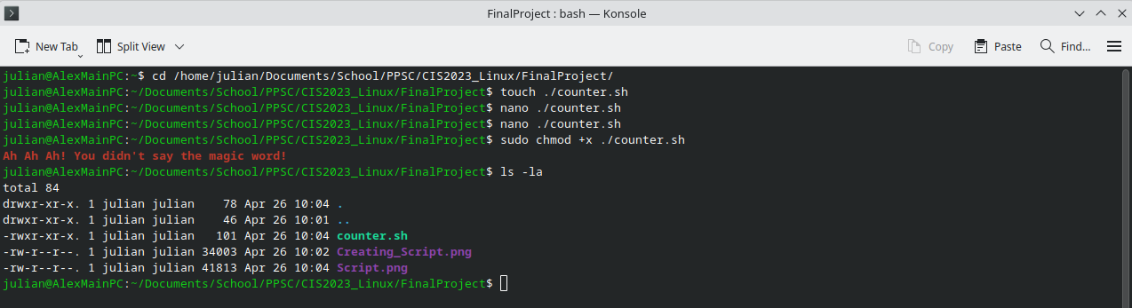
2B. Test the script.
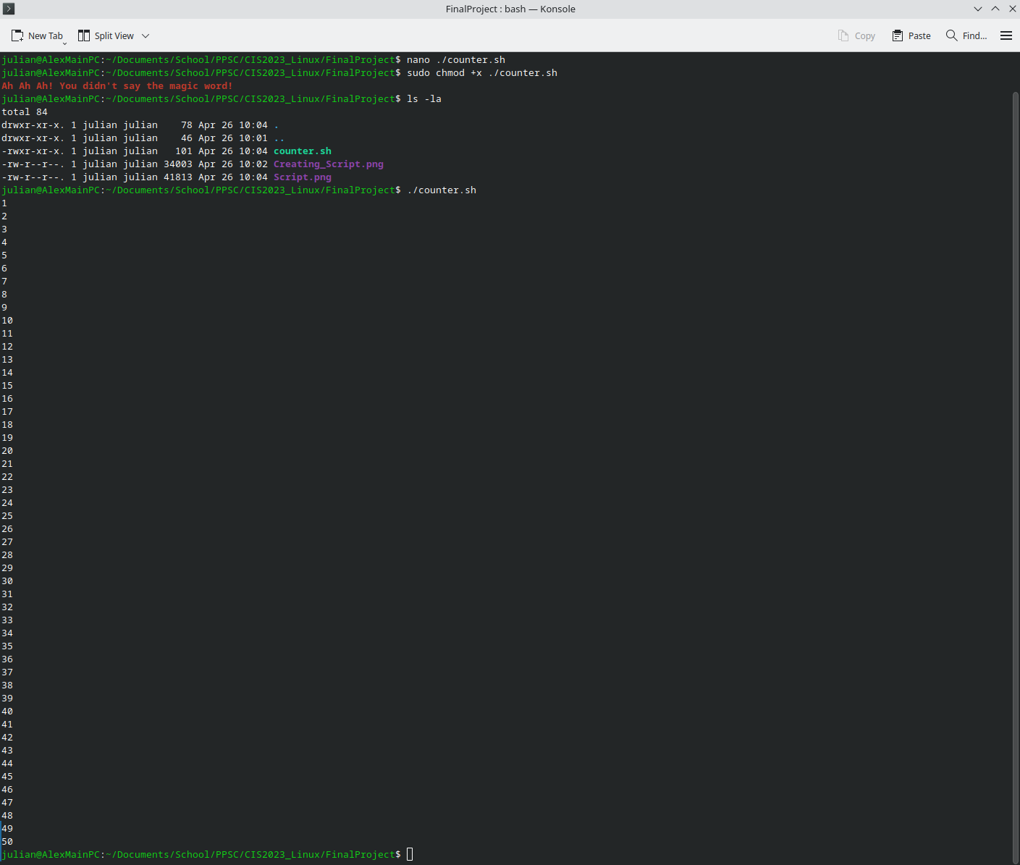

3. Upload the script to the Github repository
3A. Follow the instructions on Github to create a new repository.
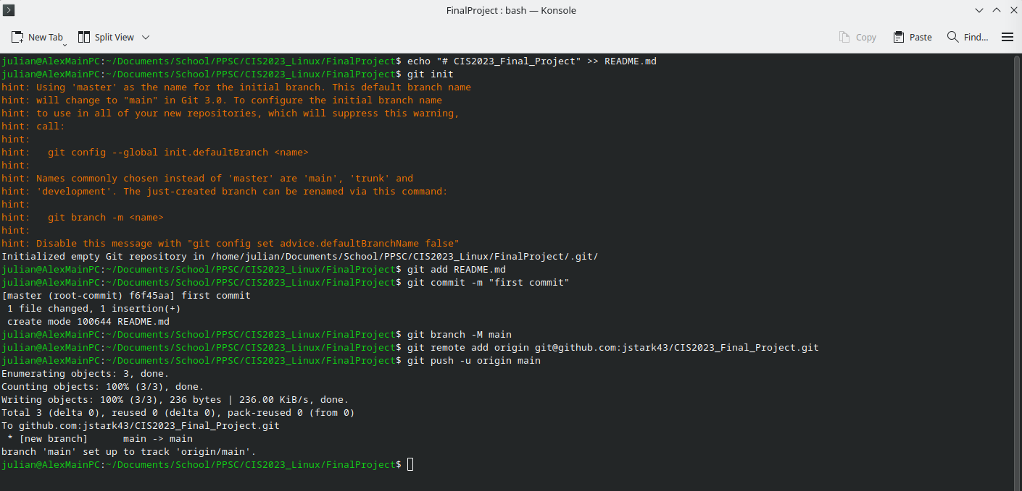
https://github.com/jstark43/CIS2023_Final_Project
3B. Commit and push files to the repository.
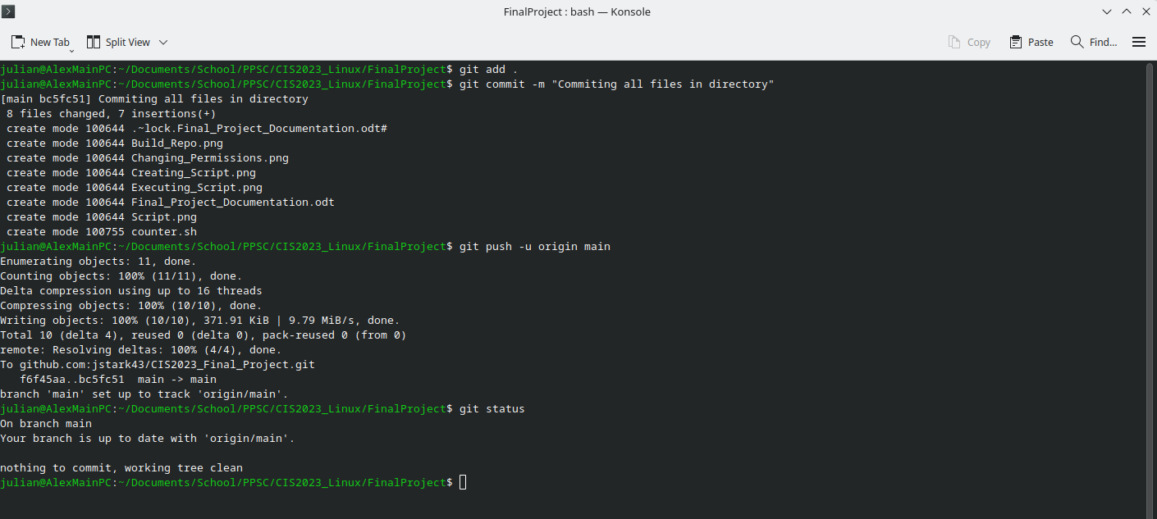
3C. Complete! See repo here:
https://github.com/jstark43/CIS2023_Final_Project

