Overview

1. Create script on local machine

2. Ensure script functions and has correct permissions

3. Upload script to Github repository
=========================================================================

1. Creating the script
1A. Use the touch command to create a script shell file.
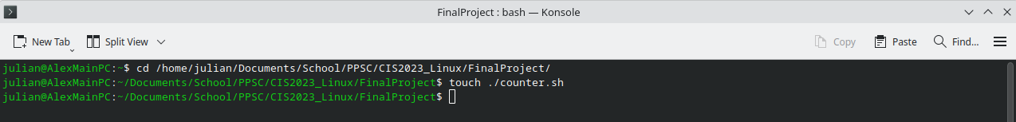
1B. Use a text editor like vim or nano to edit the file.
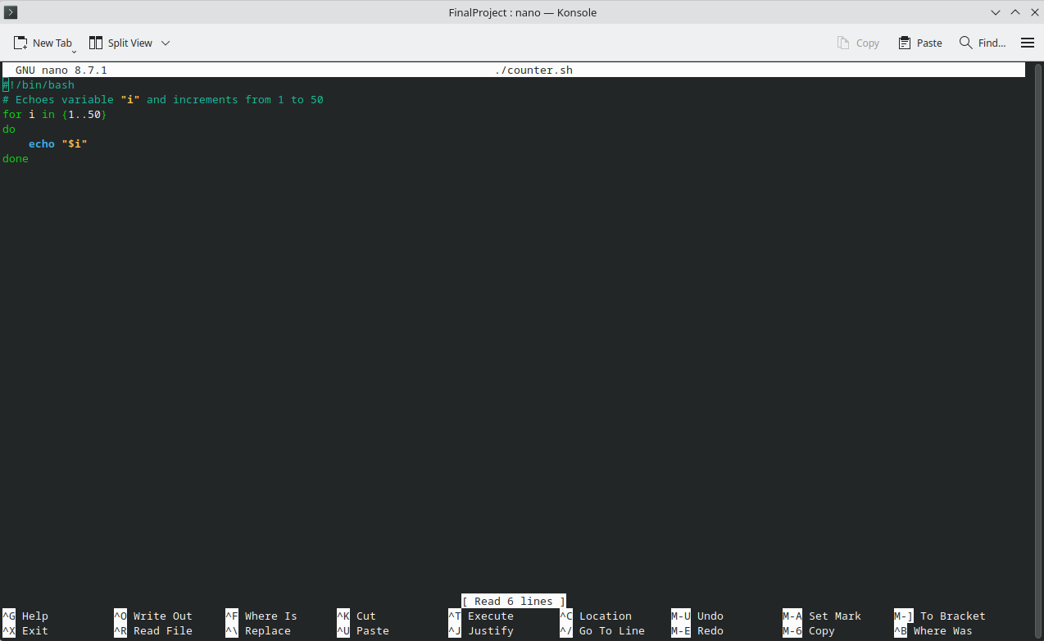
1C. Save changes (ctrl+O) and exit (ctrl+X).

2. Give script execute permission and test functionality
2A. Use chmod to give the script execute permission. (Optional: Use ls -la to verify the permission change.)
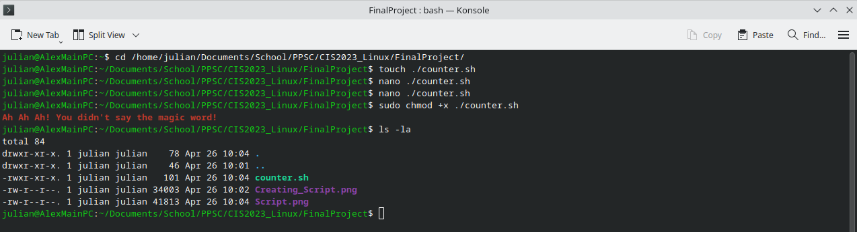
2B. Test the script.
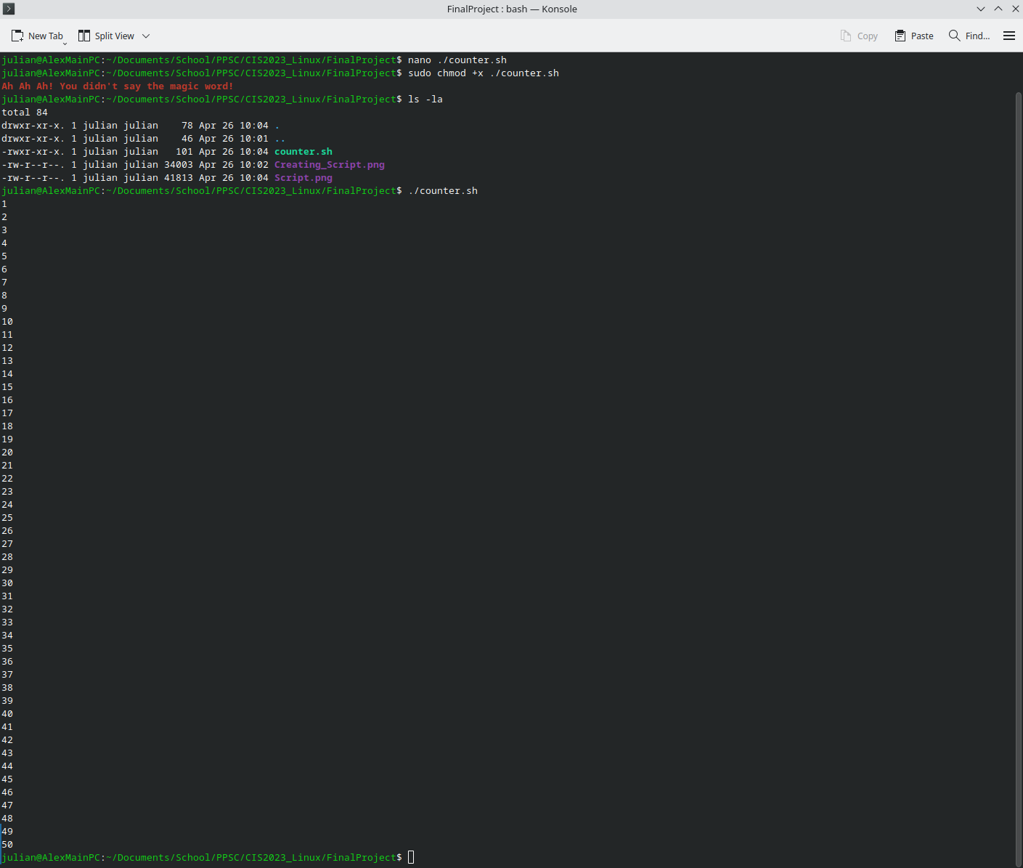

3. Upload the script to the Github repository

