Reliable Heating & Air  Monthly Financial Clarity Report · May 2026 | POWERED BY  EchoFrame  Business intelligence, not accounting.

REVENUE  $52,000  ▲ 18.2% vs last month | NET INCOME  $12,636  24.3% margin | HEALTH SCORE  80/100  Excellent

FINANCIAL OVERVIEW

MONTH-OVER-MONTH REVENUE  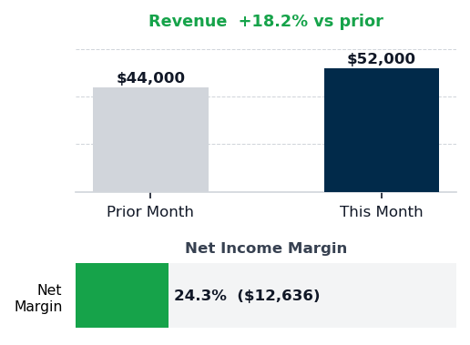 | EXPENSE MIX  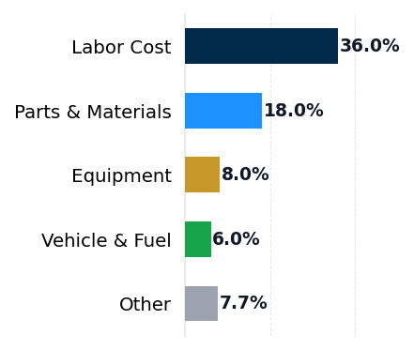 | HEALTH SCORE  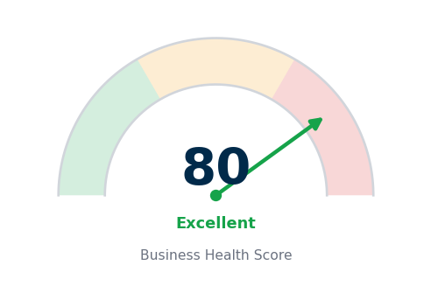  80/100 — Excellent  Revenue 25pts · Margin 35pts · Compliance 40pts

SUMMARY

$52,000 in May revenue represents an 18.2% increase over April, driven by spring AC tune-up season and strong service demand. Net income reached $12,636 at a 24.3% margin, a solid result, but the business is caught in a strategic contradiction: labor costs and utilities are consuming an additional $624 per month above industry benchmarks while marketing spend remains $1,820 below peer HVAC operations, restraining customer acquisition precisely when the business is growing. Reliable Heating & Air is over-investing in payroll to handle peak-season demand while under-investing in the demand-generation infrastructure needed to sustain growth beyond the seasonal peak. Without a deliberate reallocation from operational overhead to customer acquisition, the competitive position will weaken as spring demand softens and the business retreats toward its smaller peer base.

EXPENSE LEAKS

Category | This Month | % Revenue | Benchmark | Variance
Labor Cost | $18,720 | 36.0% | 35.0% | +1.0pp ($520)
Parts & Materials | $9,360 | 18.0% | — | —
Vehicle & Fuel | $3,120 | 6.0% | — | —
Equipment | $4,160 | 8.0% | — | —
Rent | $1,560 | 3.0% | — | —
Marketing | $780 | 1.5% | 5.0% | -3.5pp ($1,820)
Utilities | $624 | 1.2% | 1.0% | +0.2pp ($104)
Misc | $1,040 | 2.0% | 3.0% | -1.0pp ($520)
EXPENSE vs BENCHMARK · Source: IBISWorld Industry Averages

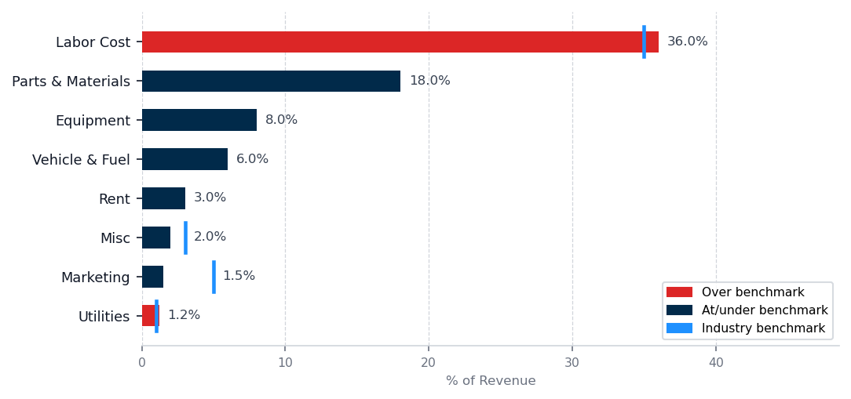
GROWTH GAPS — UNDERINVESTMENT vs BENCHMARK

▲ Marketing — Growth Opportunity  Current: 1.5% ($780/mo) · Industry avg: 5.0% ($2,600/mo) · Gap: $1,820/mo below peers  Marketing underinvestment directly constrains new customer acquisition. Peers at the 5.0% benchmark are investing $2,600/mo — $1,820/mo more than you are currently spending.  Action: Determine your current cost per acquired customer, then evaluate whether a $1,820/mo increase in acquisition channels would generate a positive return within 12 months given your average customer lifetime value. | ▲ Misc — Growth Opportunity  Current: 2.0% ($1,040/mo) · Industry avg: 3.0% ($1,560/mo) · Gap: $520/mo below peers  Spending 2.0% vs the 3.0% industry average means $520/mo less investment than comparable businesses. Review whether this reflects a deliberate strategic choice or an unexamined constraint.  Action: Document the rationale for the current spend level. If it is not a strategic decision, model the return on closing the gap to benchmark over 90 days.

LEAK ANALYSIS

#1 Labor Cost  36.0% rev · 35.0% avg · +$520/mo over  Labor cost sits at $18,720 or 36.0% of revenue, running $520 per month above the 35.0% HVAC industry benchmark. The second technician hire for peak season is necessary for capacity but has not been paired with a defined seasonal staffing plan or performance target. | #2 Utilities  1.2% rev · 1.0% avg · +$104/mo over  Utilities expense reached $624 or 1.2% of revenue against a 1.0% benchmark, an overage of $104 per month. The facility may have increased HVAC usage due to the second technician occupying shop space, or thermostat settings may not reflect seasonal conditions. | #3 Parts & Materials  18.0% of revenue · No benchmark  Parts and materials cost $9,360 or 18.0% of revenue. No industry benchmark exists for this category, and the data provided does not indicate variance from prior months.

THE ONE THING TO FIX THIS MONTH

Labor cost is the single highest-leverage pressure on Reliable Heating & Air's profitability and the only expense leak with both a quantified benchmark and a specific dollar recovery pathway.
1. Pull the May and June payroll register and list every employee by name, role, scheduled hours per week, and loaded hourly cost including burden.
2. Divide total billable hours per technician by total paid hours per technician to calculate individual utilization rate, then identify which technician or shift operates below eighty percent utilization.
3. Model a revised schedule in your POS or scheduling system that reduces the lowest-utilization technician to seasonal-only status (off-peak months at ten hours per week) and confirm coverage against average daily customer calls for July through February.
4. Present the revised schedule to your service manager and customers over the next five business days, obtain commit-to feedback on response time impact, and execute the change by month-end if no service degradation is flagged.
Full recovery of the $520 per month labor cost overage returns $520 per month to net income based on current month run rate.
Risk: This assumes scheduling optimization can maintain service response time and customer satisfaction scores during peak season — evaluate customer satisfaction metrics and average response time before reducing any customer-facing technician shifts or hours.

90-DAY NET INCOME OUTLOOK
Scenario | Net Income / Mo | Assumption
No Changes | $12,636 | Current trajectory
Top Leak Fixed | $13,156 | +$520 recovered
All Leaks Fixed | $13,260 | +$624 recovered
Assumes consistent revenue base and full implementation of labor and utility interventions within 60 days. Partial recovery scenarios available on request.
NEXT STEPS

THIS WEEK  Request demand charge analysis and time-of-use rate schedule comparison from your electricity provider within five business days. | THIS MONTH  Finalize the seasonal staffing plan and confirm the second technician's tenure before June payroll closes. | NEXT 30 DAYS  Evaluate the highest-return customer acquisition channel for HVAC service in Columbus, Georgia — referral incentives, local Google service ads, or trade sponsorships — and allocate an additional $1,820 per month to the highest-performing channel.
The June report, delivered July 1, 2026, will track labor cost %, utility spend, and marketing allocation against the targets set here.

