Fork & Fire Kitchen  Monthly Financial Clarity Report · May 2026 | POWERED BY  EchoFrame  Business intelligence, not accounting.

REVENUE  $89,000  ▼ 5.3% vs last month | NET INCOME  $16,846  18.9% margin | HEALTH SCORE  48/100  Needs Attention

FINANCIAL OVERVIEW

MONTH-OVER-MONTH REVENUE  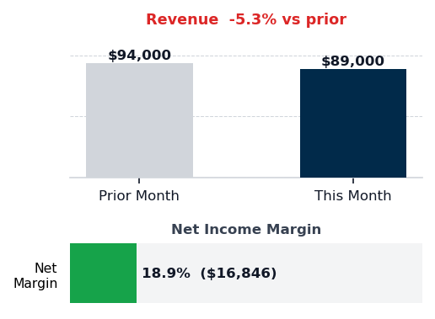 | EXPENSE MIX  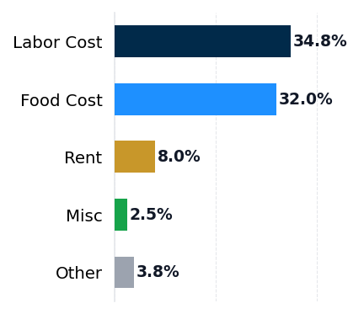 | HEALTH SCORE  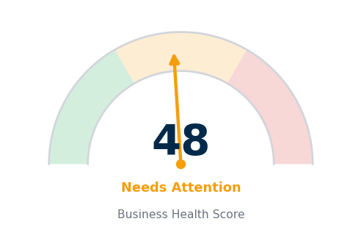  48/100 — Needs Attention  Revenue 25pts · Margin 35pts · Compliance 40pts

SUMMARY

$89,000 in May revenue represents a 5.3% decline from April, a signal that requires immediate attention to customer acquisition channels. Net income stands at $16,846 on an 18.9% margin, which is healthy in absolute terms but masks a deeper structural problem: Fork & Fire Kitchen is simultaneously overspending on labor and food cost operations while underinvesting in marketing by $1,068 per month. Labor cost is running 2.8 percentage points above the NRA industry average at 34.8% of revenue, food cost is 2.0 points over benchmark at 32.0%, and miscellaneous expenses add another $418 monthly overrun.

EXPENSE LEAKS

Category | This Month | % Revenue | Benchmark | Variance
Food Cost | $28,480 | 32.0% | 30.0% | +2.0pp ($1,780)
Labor Cost | $30,972 | 34.8% | 32.0% | +2.8pp ($2,492)
Rent | $7,120 | 8.0% | 8.0% | +0.0pp ($0)
Marketing | $1,602 | 1.8% | 3.0% | -1.2pp ($1,068)
Utilities | $1,780 | 2.0% | 2.0% | +0.0pp ($0)
Misc | $2,200 | 2.5% | 2.0% | +0.5pp ($418)
EXPENSE vs BENCHMARK · Source: NRA / IBISWorld Industry Averages

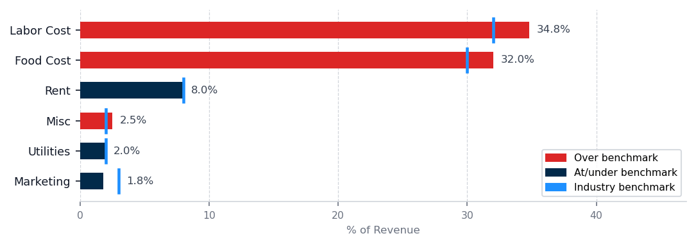
GROWTH GAPS — UNDERINVESTMENT vs BENCHMARK

▲ Marketing — Growth Opportunity
Current: 1.8% ($1,602/mo) · Industry avg: 3.0% ($2,670/mo) · Gap: $1,068/mo below peers
Restaurant revenue is directly correlated with table turn frequency and new cover acquisition. Competitors spending 3.0% on marketing are actively buying share in your market.
Action: Determine your current cost per acquired customer, then evaluate whether a $1,068/mo increase in acquisition channels would generate a positive return within 12 months given your average customer lifetime value.

LEAK ANALYSIS

#1 Labor Cost  34.8% rev · 32.0% avg · +$2,492/mo over  Labor cost is running $2,492 per month above benchmark at 34.8% of revenue against the NRA industry standard of 32.0%. Root cause is likely a combination of overstaffing relative to the variable traffic pattern and potentially inefficient scheduling—the drop in daily traffic should have reduced payroll proportionally but did not. | #2 Food Cost  32.0% rev · 30.0% avg · +$1,780/mo over  Food cost is $1,780 per month over benchmark at 32.0% of revenue versus the 30.0% NRA standard. | #3 Misc  2.5% rev · 2.0% avg · +$418/mo over  Miscellaneous expenses are $418 per month over benchmark at 2.5% of revenue against the 2.0% NRA average. Root cause is unclear from the aggregate figure and requires disaggregation of this category.

THE ONE THING TO FIX THIS MONTH

Labor cost is the single highest-dollar leak at $2,492 per month and represents 53% of total operational overages.
1. Pull the May payroll register and list every employee by role, scheduled hours, and actual covers served per shift.
2. Identify shifts where labor-to-cover ratio exceeds HFTP restaurant standard of one labor hour per 2.5 covers and flag for reduction.
3. Model a revised schedule reducing overstaffed shifts by 8 to 10 hours per week and enter it into your POS system.
4. Run a 14-day trial of the revised schedule and confirm service quality and table turn times maintain or improve before full implementation.
Full recovery of the $2,492 monthly overage in labor cost returns $2,492 per month to net income based on May run rate.
Risk: This assumes scheduling optimization can maintain service quality and table turn times without eroding diner satisfaction; evaluate table turn metrics and customer satisfaction scores before reducing any customer-facing shifts.

90-DAY NET INCOME OUTLOOK
Scenario | Net Income / Mo | Assumption
No Changes | $16,846 | Current trajectory
Top Leak Fixed | $19,338 | +$2,492 recovered
All Leaks Fixed | $21,536 | +$4,690 recovered
Assumes consistent revenue base and full implementation of labor and utility interventions within 60 days. Partial recovery scenarios available on request.
NEXT STEPS

THIS WEEK  Pull May payroll register, identify overstaffed shifts against actual covers served, and prepare a revised schedule for modeling. | THIS MONTH  Execute a 14-day trial of the revised labor schedule and measure table turn time and customer satisfaction against baseline to confirm readiness for full implementation. | NEXT 30 DAYS  Evaluate highest-return customer acquisition channel for your restaurant model and allocate the $1,068 monthly marketing gap to testing that channel.
The June report, delivered July 1, 2026, will track labor cost %, utility spend, and marketing allocation against the targets set here.

