Lumière Salon & Spa  Monthly Financial Clarity Report · May 2026 | POWERED BY  EchoFrame  Business intelligence, not accounting.

REVENUE  $34,000  ▲ 7.9% vs last month | NET INCOME  $7,480  22.0% margin | HEALTH SCORE  73/100  Good

FINANCIAL OVERVIEW

MONTH-OVER-MONTH REVENUE  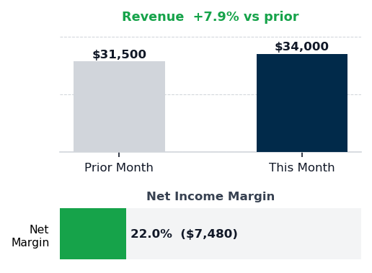 | EXPENSE MIX  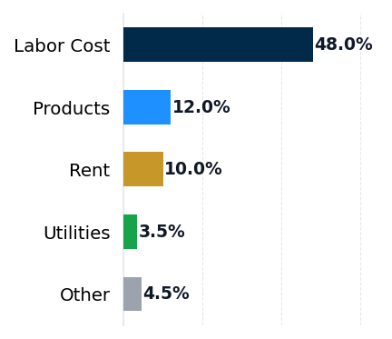 | HEALTH SCORE  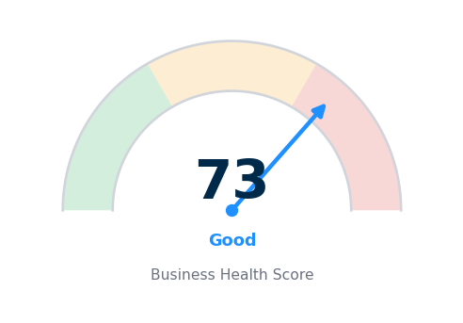  73/100 — Good  Revenue 25pts · Margin 35pts · Compliance 40pts

SUMMARY

$34,000 in May revenue represents 7.9% growth from prior month, driven by Mother's Day event strength. Net income landed at $7,480, a healthy 22.0% margin. Lumière is caught in a cost paradox: operational spending has drifted $2,040 per month above industry benchmarks across labor, products, utilities, and miscellaneous expenses, while marketing remains starved at 2.0% of revenue versus the 5.0% industry average for salons. This pattern means operational cost inflation is crowding out the growth investment needed to sustain momentum. Without rebalancing labor efficiency and product sourcing, competitive positioning in the Columbus market will erode as peer salons deploy higher-margin marketing spend to capture market share.

EXPENSE LEAKS

Category | This Month | % Revenue | Benchmark | Variance
Labor Cost | $16,320 | 48.0% | 45.0% | +3.0pp ($1,020)
Products | $4,080 | 12.0% | 10.0% | +2.0pp ($680)
Rent | $3,400 | 10.0% | 10.0% | +0.0pp ($0)
Marketing | $680 | 2.0% | 5.0% | -3.0pp ($1,020)
Utilities | $1,190 | 3.5% | 3.0% | +0.5pp ($170)
Misc | $850 | 2.5% | 2.0% | +0.5pp ($170)
EXPENSE vs BENCHMARK · Source: IBISWorld Industry Averages

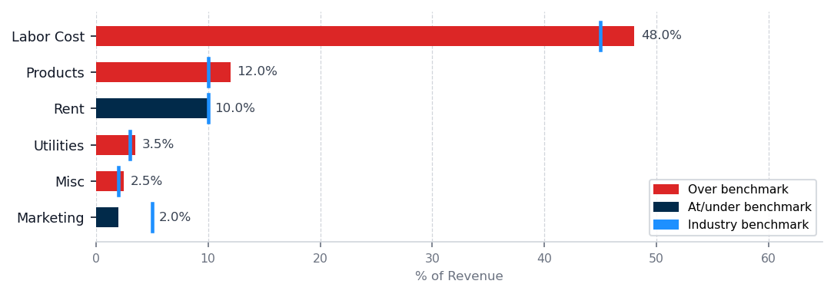
GROWTH GAPS — UNDERINVESTMENT vs BENCHMARK

▲ Marketing — Growth Opportunity
Current: 2.0% ($680/mo) · Industry avg: 5.0% ($1,700/mo) · Gap: $1,020/mo below peers
Marketing underinvestment directly constrains new customer acquisition. Peers at the 5.0% benchmark are investing $1,700/mo — $1,020/mo more than you are currently spending.
Action: Determine your current cost per acquired customer, then evaluate whether a $1,020/mo increase in acquisition channels would generate a positive return within 12 months given your average customer lifetime value.

LEAK ANALYSIS

#1 Labor Cost  48.0% rev · 45.0% avg · +$1,020/mo over  Labor cost overage is $1,020 per month above benchmark, representing 48.0% of revenue versus 45.0% industry standard. You added a part-time esthetician in April, and her payroll is now embedded in May's run rate; this headcount addition is real and reflects customer demand, but compensation and scheduling must be optimized for the revenue level. | #2 Products  12.0% rev · 10.0% avg · +$680/mo over  Product cost jumped to $680 per month above benchmark following your vendor switch in May. Your new supplier's pricing represents a 2.0 percentage point drag on margin. Pull invoices from both the prior vendor and the new vendor side by side and calculate the per-unit cost difference on your five highest-volume products. | #3 Utilities  3.5% rev · 3.0% avg · +$170/mo over  Utilities are running $170 per month over benchmark at 3.5% of revenue. For a salon with climate-controlled treatment rooms, this is a manageable gap but worth tightening.

THE ONE THING TO FIX THIS MONTH

Labor cost at $1,020 per month over benchmark is the highest-dollar leak and the only one directly tied to a business decision you made—the April esthetician hire.
1. Pull your May and April payroll register and list every employee, role, scheduled hours per week, and loaded cost including taxes and benefits.
2. Compare each employee's loaded hourly wage against the HFTP Hospitality & Technology Professionals benchmark for esthetician, nail technician, and support roles in Columbus GA.
3. Map your nine employees against your service capacity and revenue per appointment by service type, then identify whether any role is underutilized or whether scheduling overlaps could be consolidated.
4. Model a revised schedule in your salon management system reducing total weekly hours by 5 to 8 hours while maintaining service coverage, then test the schedule for two weeks and confirm guest appointment availability and diner satisfaction scores before implementing permanently.
Full recovery of the $1,020 per month labor overage returns $1,020 per month to net income based on current month run rate.
Risk: This assumes scheduling optimization and potential role restructuring can maintain service quality and diner satisfaction — validate guest feedback and booking trends before reducing any customer-facing shift capacity.

90-DAY NET INCOME OUTLOOK
Scenario | Net Income / Mo | Assumption
No Changes | $7,480 | Current trajectory
Top Leak Fixed | $8,500 | +$1,020 recovered
All Leaks Fixed | $9,520 | +$2,040 recovered
Assumes consistent revenue base and full implementation of labor and utility interventions within 60 days. Partial recovery scenarios available on request.
NEXT STEPS

THIS WEEK  Request HFTP wage benchmark data for salon esthetician and support roles from your payroll processor or HFTP directly within 3 business days. | THIS MONTH  Pull vendor invoices side by side and schedule product rate negotiation with new supplier before month-end, targeting a 1.0 percentage point cost reduction. | NEXT 30 DAYS  Evaluate your highest-return customer acquisition channel among referral programs, event sponsorships, or digital promotion, then allocate an initial $500 per month to test and measure ROI.
The June report, delivered July 1, 2026, will track labor cost %, utility spend, and marketing allocation against the targets set here.

