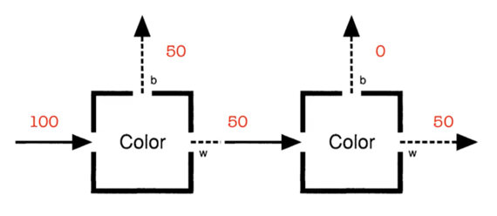
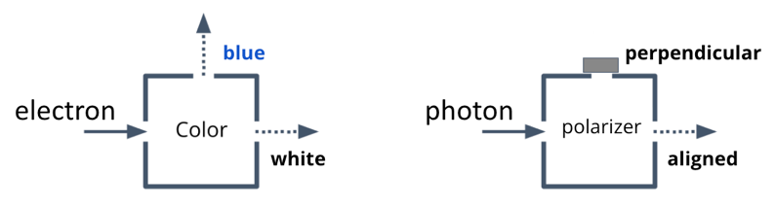
Splitters and polarizers have a lot in common.
With a polarizer, transmission is probabilistic, and the photon that emerges is in a definite polarization state. With a color (or hardness) splitter, splitting is probabilistic, and the electron that emerges is in a definite color (or hardness) state. The diagram at right illustrates some of the similarities. In what follows, we will explore these similarities further.

Color-color experiment

The color-color experiment is shown at right, illustrating that these kinds of measurements are repeatable.

To illustrate the repeatability of measurements for polarizers, draw a diagram of a pair of polarizers that would show the same experimental effect. Specify the orientations of the polarizers.

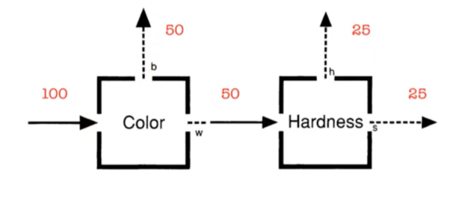
Color-hardness experiment

The color-hardness experiment is shown at right. Let’s explore what this experiment would be like with polarizers.

Draw a diagram of a pair of polarizers that shows the same pattern: half the photons emerge from the first polarizer, and half of those emerge from the second polarizer. Assume the first polarizer’s orientation is vertical (|θ⟩ = |0°⟩).

What can you conclude about the orientation of the second polarizer?

On the diagram, write the polarization state of the photon after each polarizer in two ways:

In terms of definite states of the first polarizer

In terms of definite states of the second polarizer

What effect does the second polarizer have on a transmitted photon? Express your response in terms of the polarization state (vector) of the photon.

Let’s use what we know about polarizers to help us interpret the color-hardness experiment. We will write the definite states of the color splitter as |white⟩ and |blue⟩, and the definite states of the hardness splitter as |soft⟩ and |hard⟩.

Write the state of the electrons that emerge from the white port of the color splitter in terms of definite states of the color splitter.

Now make a leap: Write what you think might be the state of the electrons that emerge from the white port of the color splitter in terms of definite states of the hardness splitter. If you aren’t sure, take a guess. Use the polarizer analogy as a guide.

Check your guess: The electrons that emerge from the hardness splitter are in either the |hard⟩ or |soft⟩ state, with 50-50 probability. Is this consistent with your guess? If not, find a way to make your guess match this known experimental outcome.

What effect does the hardness splitter have on an electron in the |white⟩ state? Express your response in terms of the state of the electron.

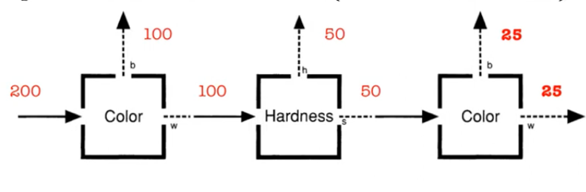
Color-hardness-color experiment
The color-hardness-color experiment is shown at right.

In the box, draw a diagram of a trio of polarizers that shows the same pattern: half the photons emerge from the first polarizer, half of those emerge from the second, and half again of those emerge from the third.

What is the orientation of the polarizers in this case?
(There is more than one option: choose the one in which the third polarizer is perpendicular to the first.)

On your diagram, write the polarization state of the photon after each polarizer, in two ways:

In terms of definite states of the previous polarizer

In terms of definite states of the next polarizer (if any)

Use your analysis above to respond to the question: Why are photons transmitted through the third polarizer, even though it’s perpendicular to the first one?



Now let’s interpret the color-hardness-color experiment.

On the diagram at right, write the state of the electrons that emerge from the white port of the first color splitter in two ways:

In terms of color states

In terms of hardness states

Next write the state of the electrons that emerge from the soft port of the hardness splitter in two ways:

In terms of hardness states

In terms of color states

Use your analysis above to respond to the question: Why do electrons go out of both the white and blue ports of the second color splitter, even though they previously all came from a white port?

When we first analyzed polarizers, we learned that definite states of one polarizer were superposition states of a differently oriented polarizer. Restate this relationship for color and hardness splitters.

Abstract vector spaces
white
blue
Just as we represent polarization states with vectors, we can represent color and hardness states with vectors. For example,
the state of the electron may be represented as a unit vector in a coordinate space whose axes are blue and white.

On the diagram at right, draw unit vectors representing the following:

|white⟩

|blue⟩

3/5 |white⟩ + 4/5 |blue⟩

A definite state for hardness

Add hard and soft coordinate axes to the diagram.

Explain how you know how to orient the axes.

Explain the physical significance of making the hard and soft coordinate axes perpendicular to each other.

Use the diagram to write the following states in terms of |blue⟩ and |white⟩:
|soft⟩ =

|hard⟩ =

Explain how the diagram illustrates that definite states for color are superposition states for hardness.

Reflection

Look back over your notes for this tutorial. What are the most important conclusions or findings from your work? Summarize them here in a couple sentences.

Are you concerned about any of the conclusions you have reached so far? What are your concerns?

What did you feel most prominently when working on this tutorial, including both physical sensations and emotions?

Explain in your own words what it means to you for an electron to be in a state that is a superposition of two colors (e.g., blue and white).

Spell out how your answer is the same as or different from your answer from last week, when you explained what superposition meant to you in the context of photons and polarizers.

"Be wary of the phrase 'definite value.' When I say 'An electron with a definite value of hardness doesn't have a definite value of color,' what I really mean is 'An electron with a value of hardness doesn't have color.' The second wording is more accurate and more clearly points out the difference between the quantum world and the classical world. But it is so stark that it makes most physicists uncomfortable. (It certainly makes me uncomfortable.) So usually I will employ the euphemism of 'definite value.' This is a personal failing of mine but I can't help it."
-- Adapted from D. Styer, “The Strange World of Quantum Mechanics”

What is your current feeling about the following questions in the context of color and hardness splitters? (You need not agree with the perspective quoted above.)

Should we say that an electron’s color is always defined? Or are there situations in which you think we should say that its color is not defined? What about its hardness? Explain.

Should we say that an electron’s color is always measured faithfully (i.e., that a color measurement reveals a pre-existing property of an electron and does not change its color)? Or are there situations in which you think we should say that its color is not measured faithfully? What about hardness? Explain.

Interpreting the color-hardness-color experiment
Below are the proposals from the class (A-K) and from the instructor (I-VIII) about what the color-hardness-color experiment might mean.

Are there any duplicates? If so, combine them. (But be picky: people might care about subtle differences.)

Are there any that we can rule out empirically based on experiments we already know about?

Are there any that we could test empirically by doing an experiment that you can imagine? What would that experiment be?

Proposals from the class:
- Maybe measuring softness randomizes color.
- Maybe measuring a property causes the electron to forget its former values of that property.
- Maybe the color of a soft electron cannot be known.
- Maybe a unicorn in the hardness box flips the color like a coin.
- Maybe an electron that goes through both color and hardness splitters is returned to its original state.
- Maybe you can’t know both color and hardness at the same time, so the hardness can’t stick.
- Maybe a hardness splitter changes an electron’s color.
- Maybe hardness is a superposition of blue and white, and superpositions can change.
- Maybe color and hardness are not really properties of electrons but are only probabilities, like how a coin has heads and tails.
- Maybe the act of measuring or knowing takes a snapshot of an electron’s color at a particular moment, but it could change after that.
- Maybe there’s a cool-down period during which an electron forgets its color.

Proposals from the instructor:
- Maybe an electron’s color gets changed by the hardness box.
- Maybe a soft electron doesn’t have a color.
- Maybe a soft electron has a color that fundamentally cannot be known.
- Maybe a soft electron has a color but its value is oscillating between blue and white and we’re catching it in each state half the time.
- Maybe it’s meaningless to talk about the color of a soft electron, like talking about whether the number 5 is an hour long.
- Maybe there’s some third property that would allow us to predict the color of soft electrons, if we could measure that third thing.
- Maybe the splitter is badly constructed (doesn’t work like we said).
- Maybe we shouldn’t try to say what’s going on with individual electrons.

