Traditionally, quantum states are represented with the letter $ψ$, like this: $|\left.ψ\right\rangle$

Normalization
The box at left shows a unit circle in a coordinate space whose axes are + and –, corresponding to the spin-up and spin-down states of a magnetic splitter oriented in the z-direction (z-splitter for short).

–

Draw a vector representing the state $|\left.ψ\right\rangle$ = ⅗ $|\left.+\right\rangle$ + ⅘ $|\left.-\right\rangle$.

What is the probability that an electron in this state would emerge from the + port of a z-splitter? Explain.
+

Explain why a vector representing the spin state of an electron must have unit length.

Suppose an electron is in the state $|\left.ψ\right\rangle =a|\left.+\right\rangle +b|\left.-\right\rangle$.

State the mathematical relationship between a and b.

What is the probability that this electron would be measured to be in the |+⟩ state? Explain.

A quantum state vector with unit length is said to be normalized. To normalize a quantum state is to adjust its coefficients so that their associated probabilities add to one, without changing the relative probabilities of the constituent states.

Normalize the following states:

$|\left.+\right\rangle +2|\left.-\right\rangle$

$3|\left.+\right\rangle -|\left.-\right\rangle$

$2|\left.+\right\rangle +6|\left.-\right\rangle$

Typically, we will ensure that quantum states are normalized. Cases in which we might not impose normalization include sequences of splitters, where we might want to compare probabilities at different points in the experiment.

Inner product, orthogonality, and projection

+
–
θ

The figure at right shows the quantum state $|\left.ψ\right\rangle =a|\left.+\right\rangle +b|\left.-\right\rangle$ as a unit vector, including the angle between the state vector and the + axis.
$$|\left.ψ\right\rangle$$

Write a and b in terms of θ and $\left|ψ\right|$, where $\left|ψ\right|$ is the length of vector $|\left.ψ\right\rangle$.

Show that the length a is equal to the dot product of $|\left.ψ\right\rangle$ and the unit vector $|\left.+\right\rangle$.

Show that the length b is equal to the dot product of $|\left.ψ\right\rangle$ and the unit vector $|\left.-\right\rangle$.

Dot products are one way of determining the extent to which two vectors are in the same direction. In quantum mechanics, this is called an “inner product” and is represented with a special bracket notation: the inner product of $|\left.ψ_{1}\right\rangle$ and $|\left.ψ_{2}\right\rangle$ is represented by $\left\langle ψ_{2} | ψ_{1}\right\rangle$. The first vector is called a “bra” and the second vector is called a “ket”; the notation is called “bra-ket notation,” or “Dirac notation” for the physicist who created it.

Write the inner product of $|\left.+\right\rangle$ and $|\left.-\right\rangle$ in bra-ket notation and calculate its value. Explain.

Explain why the inner product of any two different definite states for a given measurement will be zero.

For any normalized quantum state $|\left.ψ\right\rangle$, explain why the inner product $\left\langle ψ | ψ\right\rangle$ must equal one.

Like the dot product, the inner product has the distributive property: in other words, if $|\left.ψ\right\rangle =a|\left.+\right\rangle +b|\left.-\right\rangle$, then $\left\langle + | ψ\right\rangle =\left\langle +\right.| \left(a\left|\left.+\right\rangle +b\right|\left.-\right\rangle \right)=a\left\langle + | +\right\rangle +b\left\langle + | -\right\rangle .$ Similarly, for a scalar such as a, $\left\langle + | a | +\right\rangle =a\left\langle + | +\right\rangle$.

Given $|\left.ψ\right\rangle =a|\left.+\right\rangle +b|\left.-\right\rangle$, find the following inner products in terms of a and b:

$$\left\langle + | ψ\right\rangle =$$

$$\left\langle - | ψ\right\rangle =$$

The inner product expresses the extent to which two vectors are in the same direction: for example, $\left\langle + | ψ\right\rangle$ expresses how much of $|\left.ψ\right\rangle$ is in the $|\left.+\right\rangle$ direction. Check that your answers above align with this interpretation.

Quantum states whose inner product is zero are called orthogonal.

For a color splitter, are |blue⟩ and |white⟩ orthogonal? Explain.

Explain the physical significance of orthogonality for quantum states.

The inner product of two vectors is the magnitude of the projection of one vector onto another. The direction of the projection vector is the direction of the second vector. In other words, when we project $|\left.ψ_{1}\right\rangle$ onto $|\left.ψ_{2}\right\rangle$, the result has magnitude $\left\langle ψ_{2} | ψ_{1}\right\rangle$ and points in the direction of $|\left.ψ_{2}\right\rangle$. The projection of $|\left.ψ_{1}\right\rangle$ onto $|\left.ψ_{2}\right\rangle$ is written $|\left.ψ_{2}\right\rangle \left\langle ψ_{2} | ψ_{1}\right\rangle$.

Explain what “the projection of $|\left.ψ_{1}\right\rangle$ onto $|\left.ψ_{2}\right\rangle$” means in your own words, with a diagram.

Write the mathematical expression corresponding to “the projection of $|\left.ψ\right\rangle$ onto $|\left.+\right\rangle$.”

Write the mathematical expression corresponding to the following experiment: An electron prepared in the normalized state $|\left.ψ\right\rangle =a|\left.+\right\rangle +b|\left.-\right\rangle$ enters a z-splitter and emerges from the $|\left.+\right\rangle$ port.

Apply the concepts of normalization and orthogonality to simplify the resulting expression. Given that the initial state is $|\left.ψ\right\rangle$, what is the probability of the $|\left.+\right\rangle$ outcome?

Explain what experimental outcome is represented by each of the following terms, state the probability associated with this outcome, and sketch the corresponding vectors in the associated coordinate space.
One has been done for you.
State | Description of experimental outcome | Probability | Sketch
|+⟩_{z} _{z}⟨+|+⟩_{x} | An electron that had emerged from the + port of an x-splitter emerges from the + port of a z-splitter (with state spin-up in the z-direction) | ½ | 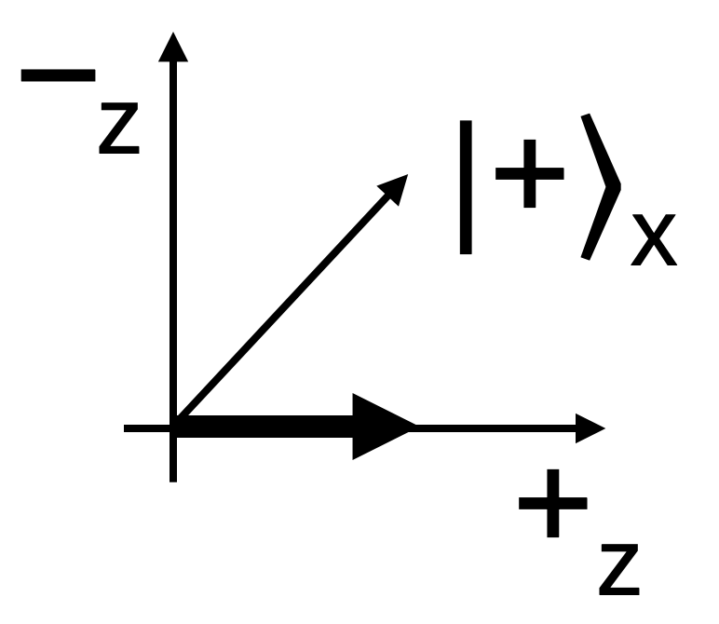
|+⟩_{z} _{z}⟨+|–⟩_{x}
|–⟩_{z} _{z}⟨–|+⟩_{x}
|–⟩_{x x}⟨–|+⟩_{z}
|–⟩_{x x}⟨–|–⟩_{z}

State the probability of an electron that emerges from either port of a magnetic splitter emerging subsequently from either port of a magnetic splitter that is perpendicular to the first.

(Bonus question) Describe a way to prepare a bunch of electrons in the state $|\left.ψ\right\rangle =a|\left.+\right\rangle +b|\left.-\right\rangle$.

Basis states

When we represent quantum states as vectors in a coordinate system, we often define coordinate axes in terms of the definite states for a given measurement. In such a system, the unit vectors that point along the coordinate axes are called basis states.

Justify the statement that |blue⟩ and |white⟩ are basis states for a color splitter.

Write the basis states for the following:

A hardness splitter

A vertical polarizer

A z-splitter
Recall that in the Splitters tutorial, you wrote |soft⟩ and |hard⟩ in terms of |blue⟩ and |white⟩. (Feel free to look back at your notes.)

Represent the normalized quantum state $|\left.ψ\right\rangle$ = a |hard⟩ + b |soft⟩ in the color basis. Show your work.

We will refer to the basis for the z-splitter as the “z-basis.” The diagram at right represents the coordinate system associated with
the z-basis.

–

Using the analogy between color and hardness splitters and magnetic splitters, add coordinate axes for the x-basis to the diagram. Label these axes +_{x} and –_{x}.
+

Use the diagram to represent the |+⟩_{x} and |–⟩_{x} states in the z-basis:
|+⟩ _{x} =

|–⟩ _{x} =

Check that your states are normalized; if they are not, normalize them.
Check that your states are orthogonal to each other. Show your work.

(This is a multi-step problem.) An electron in the state $|\left.ψ\right\rangle$ = $\frac{1}{\sqrt{5}}$|+⟩ _{x} + $\frac{2}{\sqrt{5}}$|–⟩ _{x} enters a z-splitter.
Calculate the probability of this electron emerging from the + port of the z-splitter. (Note that the electron state $|\left.ψ\right\rangle$ is represented in the x-basis.) Show your work and explain your reasoning.

Reflection

Look back over your notes for this tutorial. What are the most important conclusions or findings from your work? Summarize them here in a couple sentences.

Are you concerned about any of the conclusions you have reached so far? What are your concerns?

What did you feel most prominently when working on this tutorial, including both physical sensations and emotions?

- There will be a whole class discussion after this section.

