In what follows, you will analyze the time evolution of the state of an electron in an external magnetic field.

Energy operator

For a single electron in an external magnetic field $\overset{⃑}{B}$, the magnetic energy is $-\overset{⃑}{μ}∙\overset{⃑}{B}$, where $\overset{⃑}{μ}$ is the
magnetic dipole moment of the electron. Only energy differences are going to matter, so we can ignore
whatever kinetic energy might be present: this means the energy operator is $H=-\overset{⃑}{μ}∙\overset{⃑}{B}$.

An electron with spin $\overset{⃑}{S}$ has a magnetic dipole moment $\overset{⃑}{μ}=-\frac{e}{m_{e}}\overset{⃑}{S}$.

Write the energy operator H for a single electron in an external magnetic field in terms of $\overset{⃑}{S}$ and $\overset{⃑}{B}$.

Suppose the magnetic field is uniform and directed along the z-axis, such that $\overset{⃑}{B}=B_{0}\hat{z}$.

Write the energy operator in terms of $S_{z}$, the spin operator for the z-direction.

Show that the units of the coefficient of $S_{z}$ in the above expression are (time)⁻¹, allowing us to redefine this coefficient as an angular frequency $ω_{0}$.

Use the above to write the energy operator H in matrix form in terms of $ℏ$and $ω_{0}$.

Definite energy states

Write the definite states $\left.|E_{n}\right\rangle$ of the energy operator H for this system. How many are there?

Write the possible measured values of energy for this system, E_{n}, in terms of $ℏ$ and $ω_{0}$.

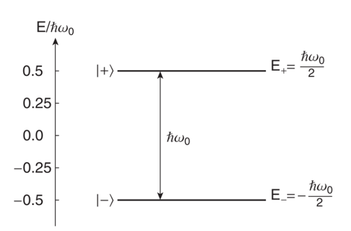
Use your findings to interpret the diagram at right, called an energy level diagram. For example, what is the energy difference between the two states? Which state has a higher energy? Why?

Time evolution of a definite state of the system
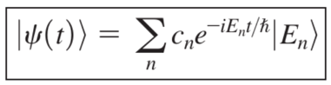
Suppose the initial state of the electron is spin-up along the z-axis: $\left.|ψ(0)\right\rangle =|\left.+\right\rangle$.

Use the general expression derived in class to find $\left.|ψ(t)\right\rangle$ in the energy basis in terms of $ω_{0}$ and t (and the initial state $|\left.+\right\rangle$).

We have said that for an electron in a definite energy state, the same energy would be measured at any time.

Is this $\left.|ψ(t)\right\rangle$a definite energy state for this system, or a superposition state?

Is the mathematical expression for $\left.|ψ(t)\right\rangle$independent of time?

Would the same energy be measured at any time? Explain how you can tell.

If you measure the z-component of the spin of this electron, what is the probability of the outcome being $|\left.+\right\rangle$, as a function of time? Show your work.

In general, when two states differ only by a term of the form $e^{iωt}$ (called a “phase”), no properties of those states are measured to differ.

Time evolution of a (specific) superposition state of the system
Suppose the initial state of the electron is $\left.|ψ(0)\right\rangle ={|\left.+\right\rangle }_{x}$.

Are the definite energy states the same as when the initial state of the electron was $|\left.+\right\rangle$? Why or why not?

Use the general expression (in the box on the previous page) to find $\left.|ψ(t)\right\rangle$ in terms of $ω_{0}$, t, and the definite energy states for this system.

Is this $\left.|ψ(t)\right\rangle$a definite energy state for this system, or a superposition state?

If you measure the x-component of the spin of this electron, what is the probability of the outcome being${|\left.+\right\rangle }_{x}$ as a function of time? Show your work.

What is the probability of the outcome being${|\left.-\right\rangle }_{x}$ as a function of time?

Calculate the average value of spin (e.g., the mean value of the outcome of many experiments) in each direction as a function of time and say why each of your answers makes sense.

$〈S_{z}〉$

$〈S_{x}〉$

$〈S_{y}〉$

Use your answers above to sketch a diagram showing what happens to the average spin in time. Explain.

Starting with an electron in an external magnetic field, for two different initial states of the system, we have calculated the average spin vector, and found that it orbits around the axis aligned with the external magnetic field. This is called spin precession.

Reflection

Look back over your notes for this tutorial and write a summary of the steps you took to determine what happens to the average spin vector over time. The first two steps have been written for you.

Write the energy operator H.

Find the definite states of the energy operator.

…

What do you think is the significance, if any, of calculating the average spin vector as a function of time? (You will explore the significance further in the homework.)

What did you feel most prominently when working on this tutorial, including both physical sensations and emotions?

- There will be a whole class discussion after this section.

