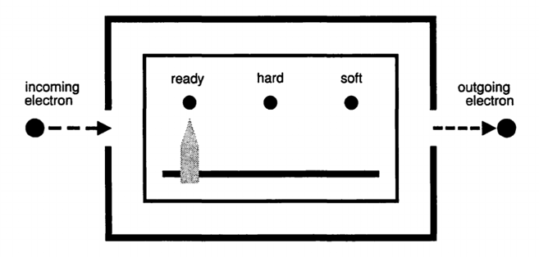
Pointer states

Let’s begin by supposing that everything in the world follows the time evolution equation, including whatever we use to measure the hardness of electrons. We will call such a measurement device a “pointer.” Before any measurement, the pointer is in its “ready state” (see figure).
When an electron is measured, we can represent the time evolution of this system as follows:
$$\left|\left.{ready}_{pointer}\right\rangle \right|\left.{hard}_{electron}\right\rangle →|\left.{"hard"}_{pointer}\right\rangle |\left.{hard}_{electron}\right\rangle$$

where the arrow represents time evolution, and the quotation marks represent a pointer reading.

Say what the above expression means in detail in words. (Start with, “The system starts out with the pointer in the ____ state and the electron in the _____ state. Then…”)

Write the equivalent expression for the system when the electron starts out in the state $|\left.soft\right\rangle$.

Say what that expression means in detail in words.

Justify the idea that the pointer states $|\left.{"hard"}_{pointer}\right\rangle$ and $|\left.{"soft"}_{pointer}\right\rangle$ are orthogonal.

Represent the time evolution if the incoming electron is in the state $|\left.blue\right\rangle$. (Hint: Since this pointer measures hardness, you’ll need to write $|\left.blue\right\rangle$ in the hardness basis.)

Note that the above depends only on the time evolution operator being linear.

The first-one-then-the-other proposal
If everything follows time evolution, the blue electron entering the pointer will time-evolve as follows:
$$\left|\left.{ready}_{pointer}\right\rangle \right|\left.{blue}_{electron}\right\rangle →\frac{1}{\sqrt{2}}(\left|\left.{"hard"}_{pointer}\right\rangle \right|\left.{hard}_{electron}\right\rangle +\left|\left.{"soft"}_{pointer}\right\rangle \right|\left.{soft}_{electron}\right\rangle )$$
However, what we observe is only ever $\left|\left.{"hard"}_{pointer}\right\rangle \right|\left.{hard}_{electron}\right\rangle$ or $\left|\left.{"soft"}_{pointer}\right\rangle \right|\left.{soft}_{electron}\right\rangle$ – never the superposition. One proposal to bring our formalism into line with our observations is the first-one-then-the-other proposal, which is as follows: When a microscopic object interacts with a macroscopic object,

Apply the time evolution operator when the interaction starts.

Then apply the relevant projection operator when the interaction finishes.

What is (are) the relevant projection operator(s) in this case? (Hint: What are the options for definite states?) Write the projection operator(s) in Dirac notation.

Apply each of the relevant projection operators to the relevant state of the system to show how this produces the expected readings of the pointer.

The first-one-then-the-other proposal suggests that we use time evolution except when a microscopic object finishes interacting with a macroscopic object. What does this mean to you? Record your ideas here.

The first-one-then-the-other proposal depends on the idea that pointers are macroscopic, meaning much bigger than electrons. What do you think should be considered “big enough” to call for a projection operator rather than time evolution? Record your ideas here.

The time-evolution-only proposal
In this section we will explore the possibility of only ever using time evolution, without any projection operator. Let’s continue to analyze the state
$$\left|\left.{ready}_{pointer}\right\rangle \right|\left.{blue}_{electron}\right\rangle →\frac{1}{\sqrt{2}}(\left|\left.{"hard"}_{pointer}\right\rangle \right|\left.{hard}_{electron}\right\rangle +\left|\left.{"soft"}_{pointer}\right\rangle \right|\left.{soft}_{electron}\right\rangle )$$

Justify the assertion that the result of the time evolution is a correlated state. Specify which systems are correlated (what is correlated with what).

Complete the following sentence with reference to this scenario:

“When the electron enters the pointer, a ___________ state is selected for the electron:
either ___________ or ___________. At the same time, a ___________ state is selected for the pointer:
either ___________ or ___________.”

Before the time evolution, were the electron state and the pointer state independent, or correlated? Explain how you can tell by looking at the expression above.

The electron was initially in a superposition of hardness states. In what sense does the time evolution “spread” or “amplify” the superposition?

In this time-evolution-only proposal, local interactions lead to correlated states and thus amplification of the composite state, changing the nature of each interacting object (in that they become correlated).

