Telecom knn  
{'n_neighbors': 5, 'p': 1}

[ 1 2 3 4 5 6 7 8 9 10 11 12]

[1 2]

knntune train res 0.9338207002693344

knntune test res 0.8950953678474114

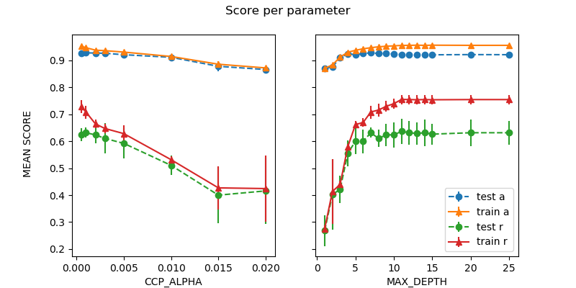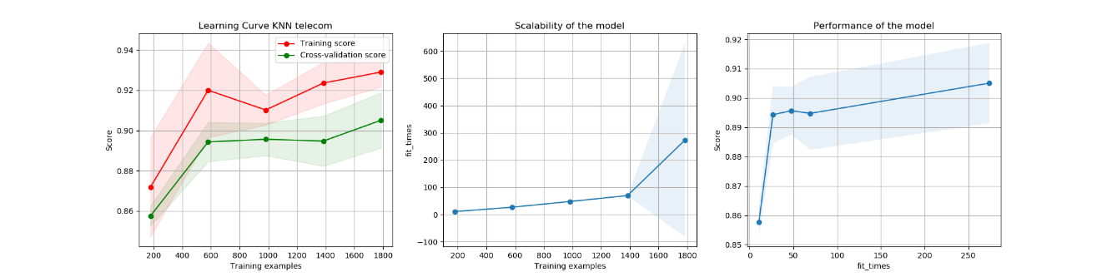

Default credit scalar data

svm train res 0.9903660886319846

svm test res 0.9795454545454545

svl train res 0.9492614001284522

svl test res 0.9340909090909091

boo train res 1.0

boo test res 0.9818181818181818

knn train res 1.0

knn test res 0.9795454545454545

dt train res 1.0

dt test res 0.9772727272727273  
{'C': 8, 'tol': 0.001}

{'C': 9, 'tol': 0.001}

{'learning_rate': 0.1, 'max_depth': 2, 'n_estimators': 150}

{'n_neighbors': 1, 'p': 1}

{'ccp_alpha': 0.0005, 'max_depth': 14}

Default credit reg data

svm train res 0.8631984585741811

svm test res 0.8409090909090909

svl train res 0.40141297366730894

svl test res 0.4113636363636364

boo train res 1.0

boo test res 0.9818181818181818

knn train res 0.8696210661528581

knn test res 0.8431818181818181

dt train res 0.9987154784842646

dt test res 0.9795454545454545

{'C': 0.1, 'tol': 0.001}

{'C': 4, 'tol': 0.5}

{'learning_rate': 0.1, 'max_depth': 2, 'n_estimators': 150}

{'n_neighbors': 12, 'p': 1}

{'ccp_alpha': 0.001, 'max_depth': 9}

Default credit norm data

svm train res 0.8631984585741811

svm test res 0.8409090909090909

svl train res 0.8631984585741811

svl test res 0.8409090909090909

boo train res 0.9441233140655106

boo test res 0.9136363636363637

knn train res 0.9415542710340398

knn test res 0.8454545454545455

dt train res 0.9402697495183044

dt test res 0.9159090909090909

{'C': 0.1, 'tol': 0.001}

{'C': 0.1, 'tol': 0.001}

{'learning_rate': 0.1, 'max_depth': 2, 'n_estimators': 50}

{'n_neighbors': 2, 'p': 1}

{'ccp_alpha': 0.0005, 'max_depth': 2}

Credit scalar knn

svm train res 0.9922928709055877

svm test res 0.9886363636363636

svl train res 0.9434810533076429

svl test res 0.9568181818181818

knn train res 0.9910083493898523

knn test res 0.9727272727272728

{'C': 10, 'tol': 0.8}

{'C': 0.1, 'tol': 0.8}

{'n_neighbors': 5, 'p': 2}

Telecom

{'n_neighbors': 5, 'p': 2}

knn train res 0.9292035398230089

knn test res 0.9196185286103542

dt train res 0.9426702577914583

dt test res 0.9196185286103542

{'ccp_alpha': 0.002, 'max_depth': 6}

credit

{'ccp_alpha': 0.0005, 'max_depth': 9}

dt train res 1.0

dt test res 0.9818181818181818

{'ccp_alpha': 0.0005, 'max_depth': 9}

Neural net credit

nn train res 1.0

nn test res 0.9931818181818182

{'activation': 'logistic', 'hidden_layer_sizes': (12, 1)}’

nn train res 1.0

nn test res 0.9977272727272727

{'activation': 'tanh', 'hidden_layer_sizes': (96, 2)}

nn train res 0.9993577392421323

nn test res 0.9954545454545455

{'activation': 'logistic', 'hidden_layer_sizes': (4, 3)}

Neaural Net Telecom

nn train res 0.8984224701808388

nn test res 0.9005449591280654

{'activation': 'logistic', 'hidden_layer_sizes': (4, 1)}

nn train res 0.951135051943055

nn test res 0.9168937329700273

{'activation': 'relu', 'hidden_layer_sizes': (12, 2)}

nn train res 0.9276644863409004

nn test res 0.9073569482288828

{'activation': 'relu', 'hidden_layer_sizes': (12, 3)}

Telecom sv

svm test res 0.9250681198910081

{'C': 5, 'kernel': 'rbf', 'max_iter': 400}