Neighborhood and Social Network Influences on Preschoolers’ Theory of Mind Development

Jordi Sterett1

1 The University of Chicago

Author note

Add complete departmental affiliations for each author here. Each new line herein must be indented, like this line.

Enter author note here.

The authors made the following contributions. Jordi Sterett: Conceptualization, Writing - Original Draft Preparation, Writing - Review & Editing.

Correspondence concerning this article should be addressed to Jordi Sterett, 5707 S. Harper Avenue, Chicago, IL 60637. E-mail: [jordansterett@uchicago.edu](mailto:jordansterett@uchicago.edu)

Abstract

Research has indicated that children develop the ability to understand and apply others’ mental states, emotions, and knowledge through a skill known as Theory of Mind. However, little is known about how this skill initially arises.This study seeks to study how a child’s home and external environment may influence development of Theory of Mind. Such factors include parental perceptions of their children’s social understandings, the makeup of children’s neighborhood and the size and make up of their social network. This research can provide a better understanding of how children acquire Theory of Mind abilities and what kind of environments either promote or hinder development.Here we show no statistically significant correlations between the majority of the factors considered and children’s Theory of Mind ability. However, scores on the behavioral task and the parent-report measure were correlated with statistical significance, suggesting that parents have an understanding of their children’s Theory of Mind abilities. Counter to the hypothesis, neighborhood violent crime rate was positively and significantly correlated with children’s performance on the parent-report measure, indicating that children in areas that experience more violent crime may actually have better developed Theory of Mind. The lack of statistically significant correlations may be due to the small sample size. However, it is also possible that factors within the home or characteristics of the child themselves may be the deciding factors in how Theory of Mind arises.

*Keywords:* Theory of Mind, Social Network, Neighborhood

*Word count:* X

Neighborhood and Social Network Influences on Preschoolers’ Theory of Mind Development

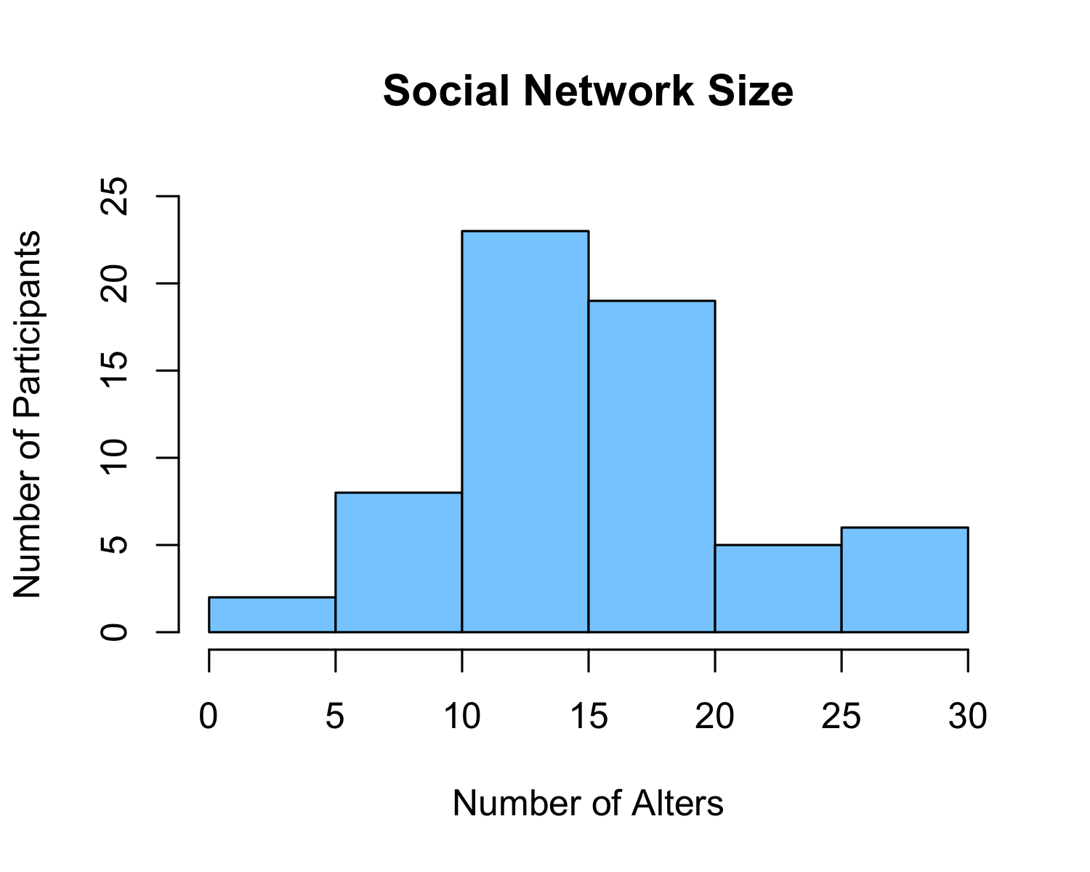

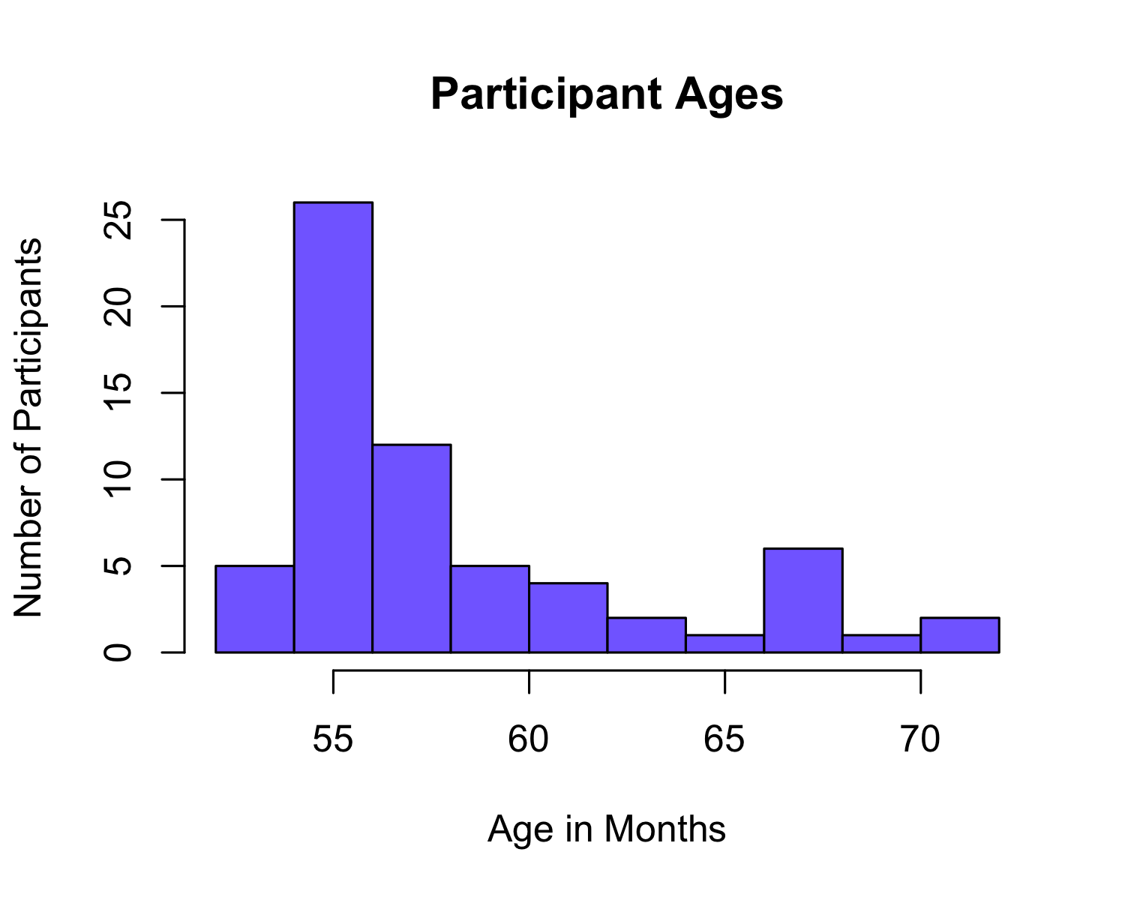

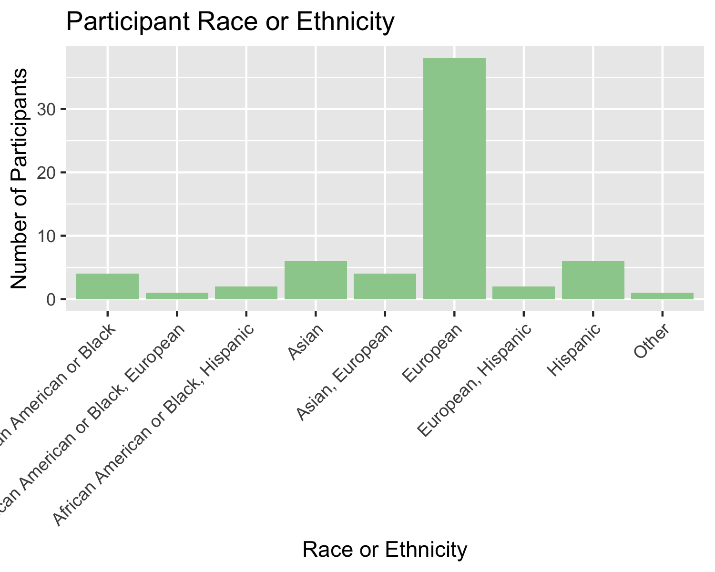

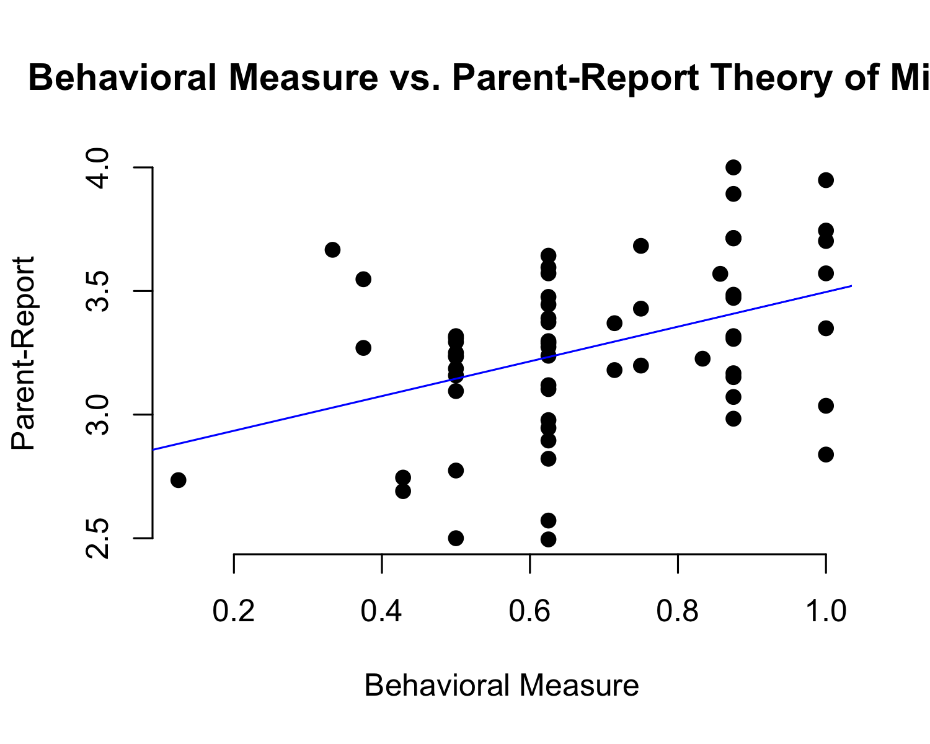

## NULL

# Methods

To address this question, I collected data on 64 participants recruited through the Infant Learning and Development Laboratory. This *n* was derived using a power analysis. Due to the ongoing COVID-19 pandemic, no in-person testing occurred. Instead, all behavioral tasks were conducted over Zoom. The parent-report measures were administered through Qualtrics, an online platform for anonymous surveys.

## Participants

Participant ages ranged from 54.0 months to 70.9 months with a mean age of 58.25 months or 4 years, 10 months.[1] Thirty-four females and 30 males participated in the study, of which 56 were enrolled in school or daycare at the time of the behavioral task. 38 participants were European, 6 were Hispanic/Latino, 6 were Asian, 4 were Black or African American, 9 reported more than one race or ethnicity, and 1 participant selected “Other.” Out of the 64 participants, 34 had at least one parent who had completed Post-Graduate education. All participants were native English speakers. The majority of participants reside in the Greater Chicago area although the study was conducted virtually and included participants throughout the United States.

## Material

## Procedure

## Data analysis

We used R (Version 4.1.0; R Core Team, 2021) and the R-packages *papaja* (Version 0.1.1; Aust & Barth, 2022), and *tinylabels* (Version 0.2.3; Barth, 2022) for all our analyses.

# Results

# Discussion

# References

Aust, F., & Barth, M. (2022). *papaja: Prepare reproducible APA journal articles with R Markdown*. Retrieved from <https://github.com/crsh/papaja>

Barth, M. (2022). *tinylabels: Lightweight variable labels*. Retrieved from <https://cran.r-project.org/package=tinylabels>

R Core Team. (2021). *R: A language and environment for statistical computing*. Vienna, Austria: R Foundation for Statistical Computing. Retrieved from <https://www.R-project.org/>

1. Participants were recruited using the University of Chicago’s online participant database.