Exercise5: Gestalt Laws (20 points)

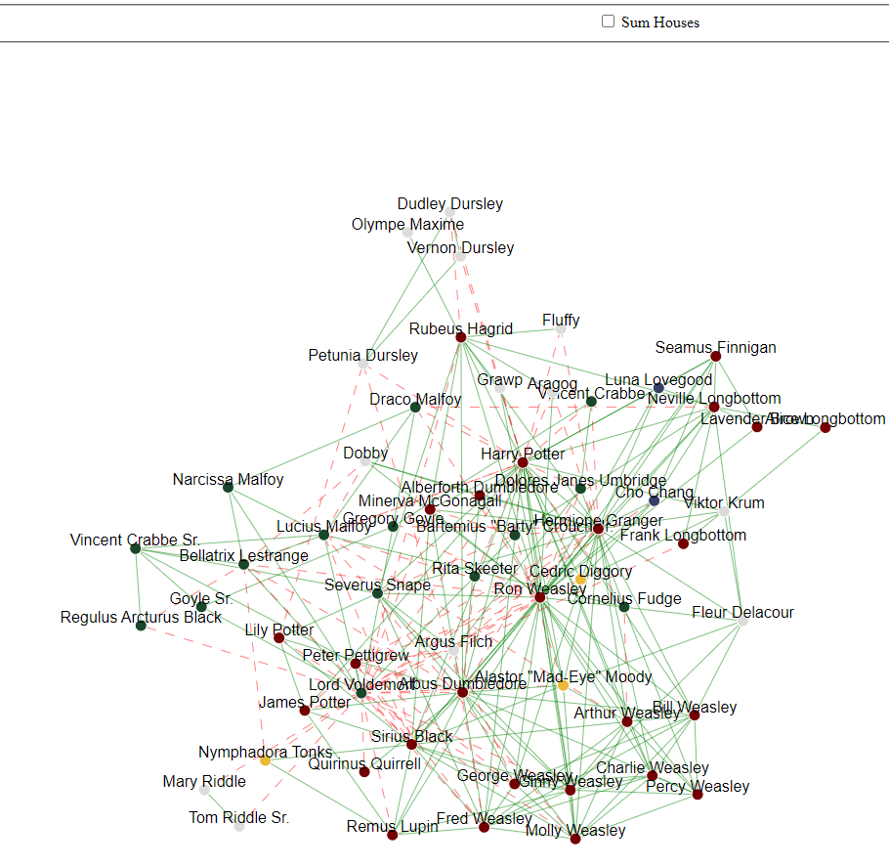**Ein Bild, das Text, Gerät enthält.
Due: 29.05.2023 8AM**

**Task 1: Network graph (12 points)**

The goal of this exercise is to implement an interactive network graph with D3. The graph data should be aggregated to each house (No House is also a house) and updated by clicking the checkbox “sum houses”.

Attached to this exercise, you will find a folder called *harrypotter.* The foldercontains an unfinished implementation of the network graph above. Your task is to finish the implementation such that opening the *index.html* shows the network graph as depicted in the left figure above, and clicking the checkbox transforms the network graph into the one showed in the right.

To finish the implementation, follow the steps described as comments in the dedicated file. Each comment starting with *TASK* indicates a position you have to add code.

The *harrypotter* folder has **5** files:

* **index.html (0 Points)**

The main entry point of the visualization.

* **index.js (12 points)**

The main JavaScript entry point. All the coding tasks are in here.

* **index.css (0 points)**

Implements CSS Rules for specific elements.

* **data.js (0 points)**

Initializes a variable called *data* and reflects the dataset we want to visualize.

* **d3.js (0 points)**

d3 library

**Task 2: Visual Perception (8 points)**

**Task 2a)** Using your own words, describe what is ***pre-attentive processing*** and why it is important for data visualization.

**Answer:** Pre-attentive processing refers to the automatic and fast processes that occur in ones brain before the conscious attention is engaged. Some visual properties are processed unconsciously very fast pre-attentively while for others the brain needs more time and conscious attention. In this process the brain can detect patterns, differences, and relationships within the data and therefore guides the subsequent attention. This is why for Data Visualization one can exploit this human characteristic for presenting the most important information and controlling where the focus of the brain should be at. It is also important to be aware of this to avoid confusing the audience or giving a different message than intended.

**Task 2b)** You are asked to evaluate the visualization of **“Biggest Covid-19 worries”** below.

* What is the information that the visualization author wanted to communicate?
* What do you think went wrong during the data encoding phase?
* Critique the visualization design, and propose an alternative representation that would be better (provide a sketch of the alternative visualization)

**Answer:**

**-** The author probably wanted to show the distribution of the biggest covid 19 worries

- The percentages shown in the graph add up to more than 100%. Maybe it was possible that people could give more than one worry but then is unclear to which population the percentages refer to. Also it is hard to compare the numbers with respect to the pie area, specifically is hard to tell if the orange area is bigger than the yellow area

- The color may indicate some kind of ordering being red the most critic and yellow the least critic

- Maybe a bar chart with other colors would be a better representation that would allow to compare this percentages more clearly.

- Here is a proposition for the graph

* **After completing your answers, export the docx-File to PDF and upload it alongside the source code files.**

**Submission: Zipped harrypotter folder including all files (index.html, index.js, index.css, data.js, d3.js) and a PDF of the completed written exercise.**

Please form a group of **2 Students**. Only 1 member of the group must submit the exercise in ILIAS.