Exercise6: Visual Perception (20 points)

**Due: 19.06.2022 8AM**

Please state the name of both, collaborating students.

Name of author 1: Jonas Stettner

Name of author 2: Ana Sanchez Acosta

**Task 1: Visual Comparison (12 points)**

**Task 1a) (8 points)**

Your task is to implement a stacked barchart **and** a grouped barchart for the given dataset.

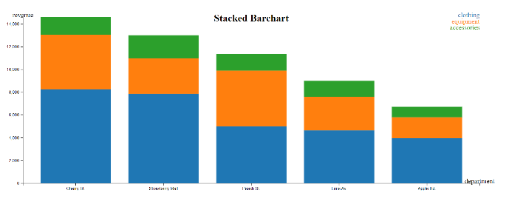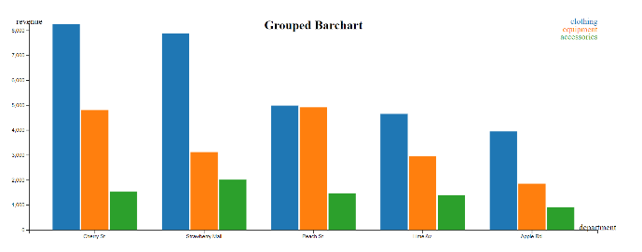

The provided data can be found in **data.js** and consists of revenue numbers for different stores, split up in different departments.

The barcharts shall include:

* A Title, displaying either *“Stacked Barchart”* or *“Grouped Barchart”*
* X & Y Scales, including labels
* Colored bars for each department
* A *legend* for the color scale
* A Tooltip showing the store, the department, and the revenue value

**Task 1b) (4 points)**

Which of the barchart implementations in Task 1a) would you choose regarding the following tasks? Explain why it is more suitable compared to the other one.

* Reading absolute revenue values
* Comparing department revenue values

In terms of scalability (having more stores and more departments), which other visualization might be a better choice? Please justify your answer.

**Task 2: Gestalt Laws (8 points)**

In the following, eight images are presented. Allocate one Gestalt Law to each image and justify your answer shortly. Multiple answer could be correct.

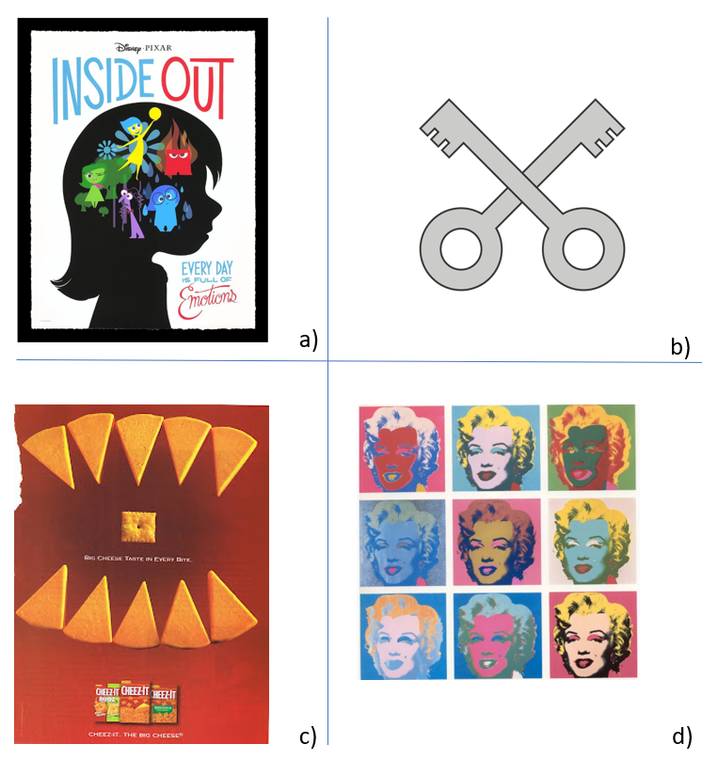



**Answer:**

**After completing your answers, export the docx-File to PDF and upload it alongside the source code files.**

**Submission: Zipped *barchart* folder including all files (index.html, index.js, index.css, data.js, d3.js) and a PDF of the completed written exercise.**

Please form a group of **2 Students**. Only 1 member of the group must submit the exercise in ILIAS. Please state the collaborators in the beginning of the document.