Exercise7 (20 points)

**Due: 26.06.2023 8AM**

**Contributor 1: Jonas Stettner**

**Contributor 2: Ana Sanchez Acosta**

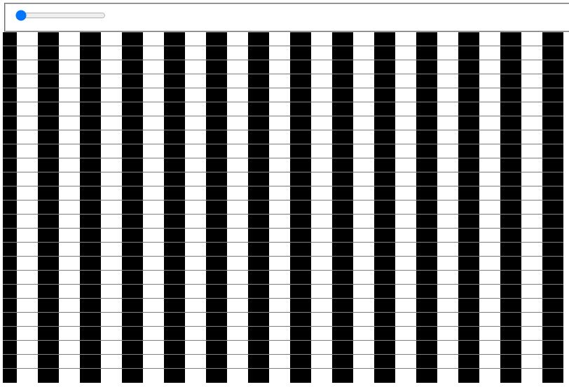

**Ein Bild, das Text enthält.
**

**Task 2: Visual Illusion (12 points)**

For this exercise, your task is to implement a visual illusion as displayed above.

The illusion shall include:

* rectangular shapes allocated and filled with black and white as displayed
* a slider element that moves the bars horizontally and creates a similar illusion

There are no prepared files for your support this time. However, you may use previously written code as orientation.

**Task 2: Color Scales (8 points)**

**Task 2a) (4 points)**

Using your own words, what is a JND? Discuss its relation to marks and information encoding.

**Answer:**

A JND, which stands for Just Noticeable Difference, can be used to measure the difference in the colors we perceive. The difference can be measured with the help of the euclidean distance, where 1 unit of this distance equals to 1 JND. If a we start with a color and a specific variable is changed until the “average” human perceives a change in this color, then difference between the starting and new color would be a JND.

This concept relies on two assumptions which are not always given.

1) Isolation: Assume there are no other elements on the screen

2) Geometric: A JND holds for all sizes and shapes of marks.

These assumptions do not always hold. The first one is violated for example by Webers Law. For the second one, can be show that many factors such as the information encoding or the size and shape of the marks can affect the JND.

**Task 2b) (4 points)**

Think of a real-world example on how to use color in a visualization.   
State **data**, **audience**, **task**, **visualization** and **marks**. Decide on its use of color (i.e. as a color scale) and justify your decisions.

**Answer:**

- **Data**: Probability of default in the portfolio of a bank.

- **Audience**: Corporate, Investors and audit company.

- **Task**: Monitor the risk of the bank’s portfolio by visualizing the probability of default and making sure that this KPI stands under certain thresholds.

- **Visualization**: A line chart which shows the development the probability of default over time.

- **Marks**: The line should be thin and have a neutral color while the marks for each datapoint should be bigger and have a different color based on the value of the probability of default. If this KPI is between the “normality” threshold the mark should be green, if it is slightly above the threshold, it should be yellow and if it is above a higher threshold, it should be red. There should also be thin reference lines across the plot showing the threshold. This way the audience will be able to see very fast if a datapoint is worth analyzing or if everything is going well. The color choice is based on the semantic perception, where green is associated with “good” and red with “trouble”. And the thin reference lines should help in case the audience is colorblind.

**After completing your answers, export the docx-File to PDF and upload it alongside the source code files.**

**Submission: Zipped folder including all necessary files and a PDF of the completed written exercise.**

Please form a group of **2 Students**. Only 1 member of the group must submit the exercise in ILIAS. Please state the collaborators in the beginning of the document.