Exercise 8 (20 points)

**Due: 03.07.2022 8AM**

**Contributor 1: Ana Sanchez Acosta**

**Contributor 2: Jonas Stettner**

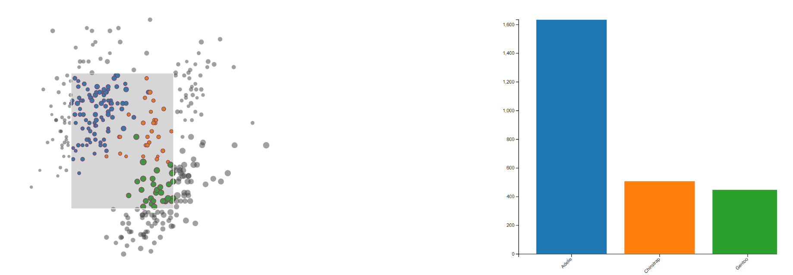

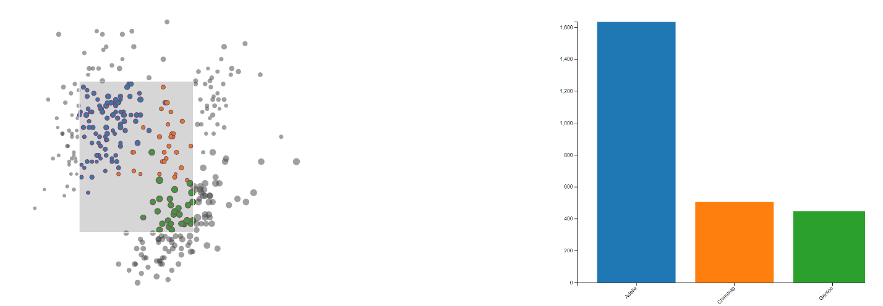

**Task 1: Linking and Brushing**

For this exercise, your task is to extend the scatterplot from exercise 4 with a brushing technique and dynamically create a Barchart based on the given selection.

The bars should display the culmen depth summed up by species based on the selected penguins.

A new selection should trigger:

* coloring the selected and not-selected points as displayed (see the index.css)
* the creation of new bars and scales

Your task is to finish the implementation such that opening the *index.html* shows the scatterplot as depicted in figure above. To finish the implementation, follow the steps described as comments within the dedicated file.

Tips:

* Use the d3-brush package to add a selection rectangle
* You can add event handlers to the brush (similar to previous events), see the possible events in the d3-brush documentation
* Based on the selection, modify the attributes of the points in the scatter plot
* Display a bar cart with the filtered data (you may either create a new one, or display/hide it)

**Task 2: Multivariate Data (6 points)**

**Task 2a) (1 points)**

Using your own words, describe what **multivariate** data is.

**Answer:**

Multivatiate data involves multiple attributes so that one data point consists of more than one measurement. For example, there could be multiple dependent variables that result in one outcome.

**Task 2b) (2 points)**

Give one example of a multivariate visualizations techniques for each of the three marks introduced by *Bertin*: **Point**, **Line** and **Area**. Which additional visualization techniques exist?

**Answer:**

Point: SPLOM

Line: PCP

Area: Mosaic plot

Other: Pixel visualization

**Task 2b) (3 points)**

1. For a parallel coordinate plot**,** why do visible patterns **depend on the order of** **dimensions**?

2. Why is this **not** the case for a **scatterplot matrix**?

3. Can you come up with one **possible criterion** to choose the **best ordering** for parallel coordinates (I.e. if multiple orderings are available, which one should I choose)?

**Answer:**

1. As variables that are placed closer together visually tend to exhibit stronger associations, it is easier to understand their relationships.

2. Each scatterplot is presented independently in its own cell, so the arrangement of variables does not impact the ability to observe relationships.

3. On could assess the strength of correlation or similarity between variables. By positioning variables with stronger correlations or similarities closer to each other in the plot, we can enhance their visual connectedness and therefore display patterns.

**After completing your answers, export the docx-File to PDF and upload it alongside the source code files.**

**Submission: Zipped folder including all necessary files and a PDF of the completed written exercise.**

Please form a group of **2 Students**. Only 1 member of the group must submit the exercise in ILIAS. Please state the collaborators in the beginning of the document.