Assignment 4: Binary Message Encoder and Decoder

This program has two parts: a binary message encoder and a binary message decoder. You will submit two separate programs for this assignment on Jupiter Ed: one for the encoder and one for the decoder.

The binary encoder turns a text message into an encoded string of 0s and 1s. The binary decoder turns a string of 0s and 1s into the corresponding text message.

Instructions
The binary encoder should prompt the user for a message, then it should print out the message encoded into binary with a space between each character. Here is some example output:

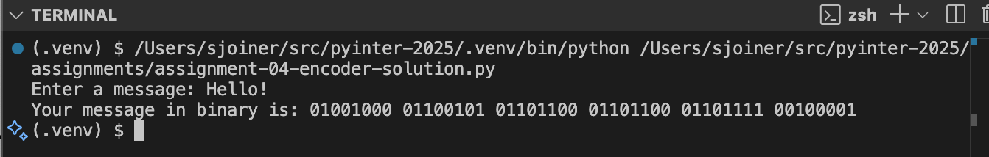

The binary decoder should prompt the user for a binary encoded message (with a space between each character), then it should print out the decoded message. Here is some example output:

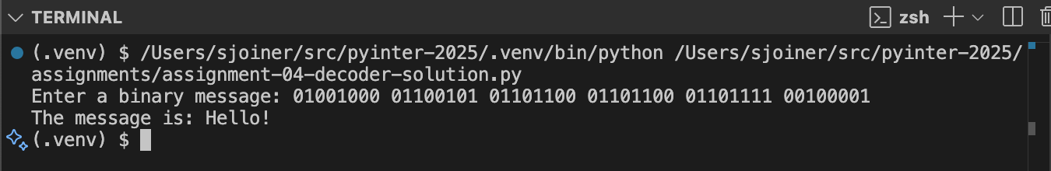

Hints

- You don’t need any fancy math to do the conversions. You should be able to do them with the functions discussed at the end of the Lecture 4 slides, e.g., format, ord, chr, etc.
- You might also need some other Python functions such as input to get the input message. Also remember your string methods such as split.
- I recommend getting the encoder working first. Then, you can use its output to test your decoder.

Here is an example of what playing the game could look like.

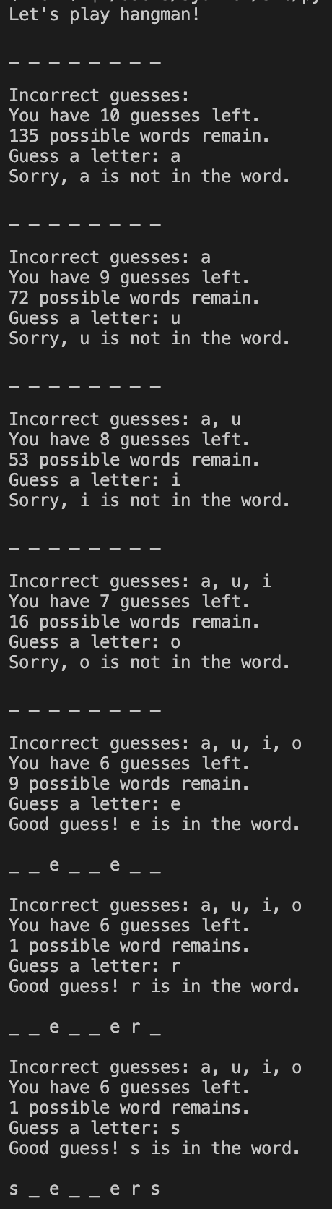 | 