Assignment 7: Onshape Introduction

For this assignment, you will (1) watch some videos, (2) complete an online course, and (3) make a simple model in Onshape.

Instructions
- Watch the following YouTube videos. I recommend creating the objects along with the videos. This will help you learn the program.
  - https://www.youtube.com/watch?v=d4QzBdcQoe0&list=PLGqRUdq5ULsMDOxmu10AGPDIOkzNYu7D7&index=2
  - https://www.youtube.com/watch?v=r_q5uQD4l5w&list=PLGqRUdq5ULsMDOxmu10AGPDIOkzNYu7D7&index=4
- Complete the following online courses.
  - Go to the Introduction to CAD learning pathway on the Onshape website: https://learn.onshape.com/learn/learning-path/introduction-to-cad
  - Complete the following courses:
    - Introduction to Parametric Feature-Based CAD
    - Introduction to Sketching
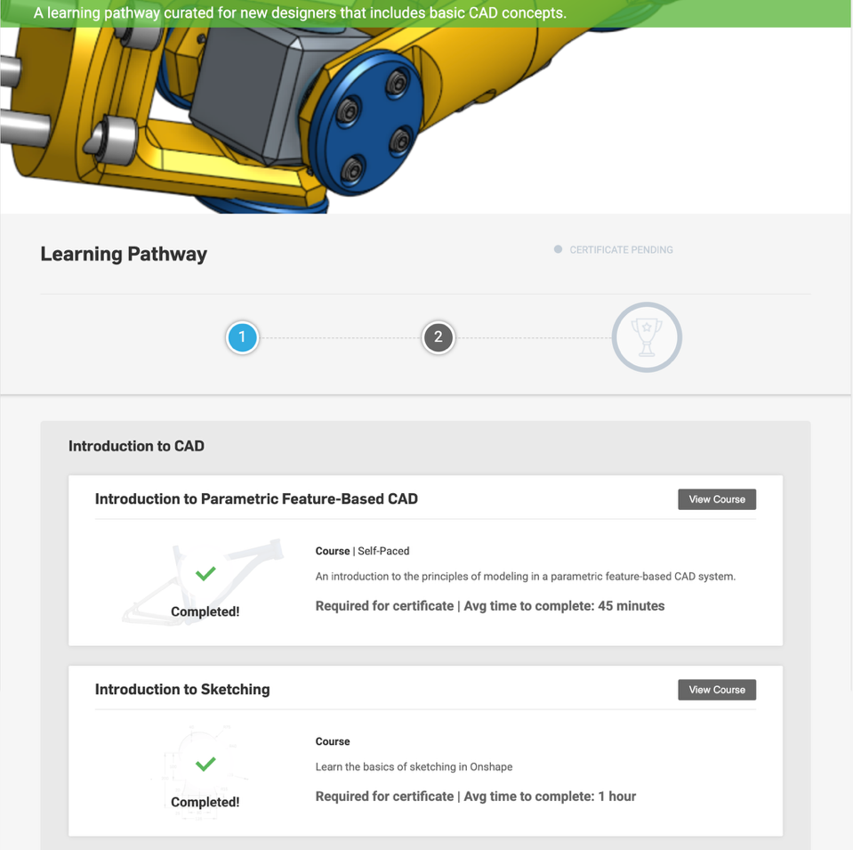

- Make the following object in Onshape and be prepared to show me your design at our next class. You may want to use 3-point arcs and the offset function to create your sketch. When you make your extrusion, use a depth of 3 mm.
