Assignment 10: Onshape Part Studios

For this assignment, you will (1) complete another an online course, and (2) model some objects based on a drawing.

Instructions
- Complete the following online course.
  - Go to the Introduction to CAD learning pathway on the Onshape website: https://learn.onshape.com/learn/learning-path/introduction-to-cad
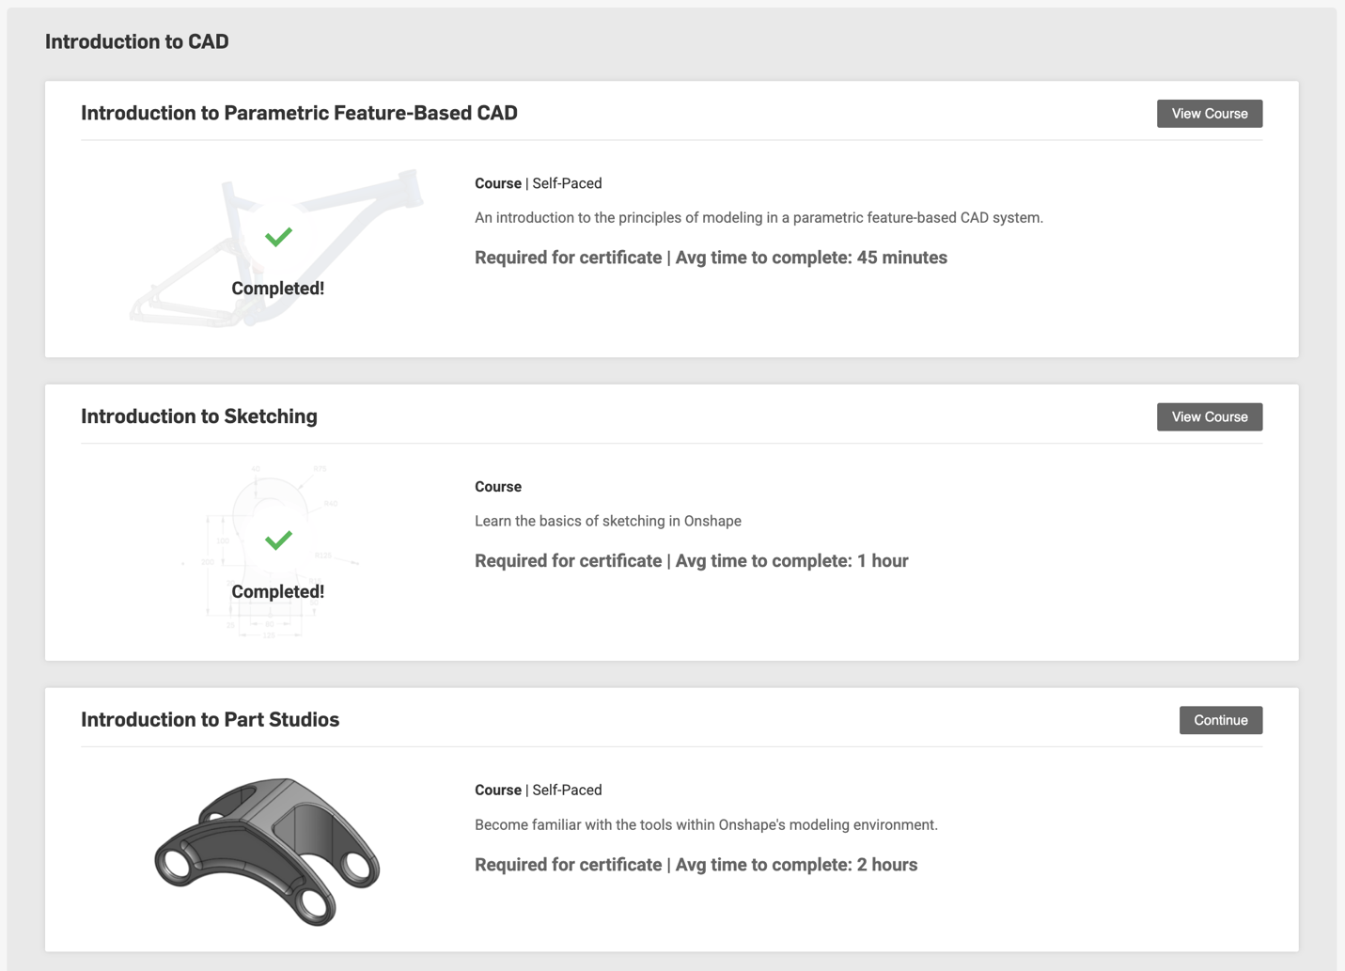
  - Complete the “Introduction to Part Studios” course. (This is the next course following the two you completed in the previous assignment.)

- Make the following two objects in Onshape and be prepared to show me your design at our next class. Compute the mass of each object so we can compare in class.

