# Compiler Design Assignment

# Gopala Krishna Chennu

# AP18110010343

# Program 2:

Implementation of Language recognizer for set of all strings ending with two symbols of same type

## Description:

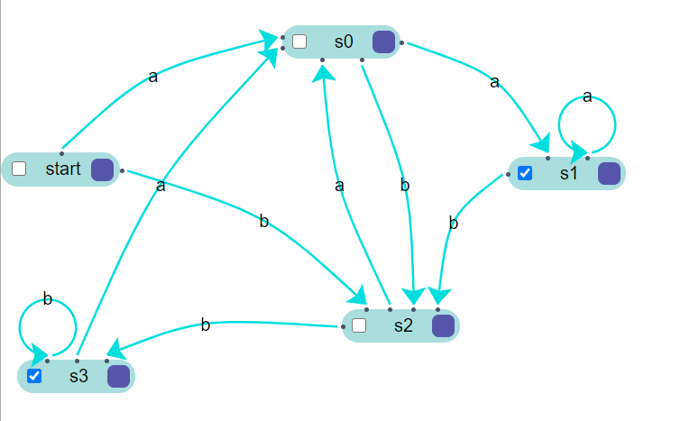The acceptable strings of the language are ε(Null string), aa, bb, abbaa, babbaa

etc. Deterministic Finite Automata for the given language is given below:

DFA M=(Q,∑,δ,Q0,F) Where

Q=Set of all states ={Q0,Q1,Q2,Q3} .

∑=Input Alphabet={a,b}, Start state is Q0

F=Set of all final States={ Q0}

And the transitions are defined in the transition diagram

## Algorithm: Language recognizer

**Input:**

*input* //input string

## Output:

Algorithm prints a message

“String accepted”: If the input is acceptable by the language, “String not accepted” otherwise,

“Invalid token”: If the input string contains symbols other than input alphabet.

## Method:

## State=0;

# while((c=input[i++])!='\0'){

# switch(s)

# {

# case 0: if(c=='a')

# s=1;

# else if(c=='b')

# s=3;

# else{

# printf("Invalid token");

# exit(0);

# }

# break;

# case 1: if(c=='a')

# s=2;

# else if(c=='b')

# s=3;

# else{

# printf("Invalid token");

# exit(0);

# }

# break;

# case 2: if(c=='a')

# s=2;

# else if(c=='b')

# s=3;

# else{

# printf("Invalid token");

# exit(0);

# }

# break;

# case 3: if(c=='a')

# s=1;

# else if(c=='b')

# s=4;

# else{

# printf("Invalid token");

# exit(0);

# }

# break;

# case 4: if(c=='a')

# s=1;

# else if(c=='b')

# s=4;

# else{

# printf("Invalid token");

# exit(0);

# }

# break;

# }

# }

# if(s==2 || s==4)

# printf("String accepted");

# else{

# printf("String not accepted");

# }

**C Code**

# #include <stdio.h>

# #include <stdlib.h>

# int main()

# {

# int s=0,i=0;

# char c,input[20];

# printf("Enter the input string:");

# scanf("%s",input);

# while((c=input[i++])!='\0'){

# switch(s)

# {

# case 0: if(c=='a')

# s=1;

# else if(c=='b')

# s=3;

# else{

# printf("Invalid token");

# exit(0);

# }

# break;

# case 1: if(c=='a')

# s=2;

# else if(c=='b')

# s=3;

# else{

# printf("Invalid token");

# exit(0);

# }

# break;

# case 2: if(c=='a')

# s=2;

# else if(c=='b')

# s=3;

# else{

# printf("Invalid token");

# exit(0);

# }

# break;

# case 3: if(c=='a')

# s=1;

# else if(c=='b')

# s=4;

# else{

# printf("Invalid token");

# exit(0);

# }

# break;

# case 4: if(c=='a')

# s=1;

# else if(c=='b')

# s=4;

# else{

# printf("Invalid token");

# exit(0);

# }

# break;

# }

# }

# if(s==2 || s==4)

# printf("String accepted");

# else{

# printf("String not accepted");

# }

# }

# Test cases:

|  |  |
| --- | --- |
| **Input** | **Expected Output** |
| aabaa | String accepted |
| aaaaaaabb | String accepted |
| aaaaaaab | String not accepted |
| aaaba | String not accepted |
| abcd | Invalid token |