**LAB -5**

**Q1.**

**<!DOCTYPE html>**

**<html lang="en">**

**<head>**

**<meta charset="UTF-8">**

**<meta name="viewport" content="width=device-width, initial-scale=1.0">**

**<style>**

**body{**

**background: #184047;**

**}**

**h2{**

**color:antiquewhite;**

**text-align: center;**

**font-size: 40px;**

**}**

**.container{**

**text-align: center;**

**margin-top: 50px;**

**}**

**input{**

**font-size: large;**

**}**

**button{**

**padding:5px;**

**background-color: green;**

**color:azure;**

**font-weight: 500;**

**font-size:15px;**

**}**

**@keyframes spin {**

**0% { transform: rotate(0deg); }**

**100% { transform: rotate(360deg); }**

**}**

**h2.spin {**

**animation: spin 3s linear infinite;**

**}**

**</style>**

**<title>Simple Web Page</title>**

**</head>**

**<body>**

**<h2 id="displayText">Hello</h2>**

**<div class="container">**

**<input type="text" id="inputText" placeholder="Type a word or phrase">**

**<button onclick="changeText()">Change Text</button>**

**</div>**

**<script>**

**function changeText() {**

**var inputElement = document.getElementById('inputText');**

**var displayElement = document.getElementById('displayText');**

**var newText = inputElement.value;**

**if (newText.trim() !== '') {**

**displayElement.innerHTML = newText;**

**displayElement.classList.add('spin');**

**}**

**}**

**</script>**

**</body>**

**</html>**

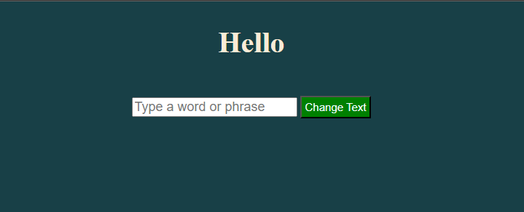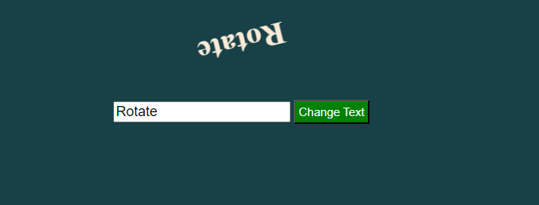

**Q2.**

**<!DOCTYPE html>**

**<html lang="en">**

**<head>**

**<meta charset="UTF-8">**

**<meta name="viewport" content="width=device-width, initial-scale=1.0">**

**<title>Counter Web Page</title>**

**<style>**

**body{**

**background: #0b3046;**

**}**

**.container{**

**text-align: center;**

**}**

**#count{**

**margin-top: 30px;**

**color:bisque**

**}**

**button{**

**background-color:green;**

**color:white;**

**padding:5px 20px;**

**margin:30px;**

**}**

**</style>**

**</head>**

**<body>**

**<div class="container">**

**<button onclick="incrementCount()">Increment Count</button>**

**<p id="count">0</p>**

**</div>**

**<script>**

**var count = 0;**

**function incrementCount() {**

**count++;**

**var countParagraph = document.getElementById('count');**

**countParagraph.innerHTML = count;**

**countParagraph.style.fontSize = count + 'em';**

**}**

**</script>**

**</body>**

**</html>**

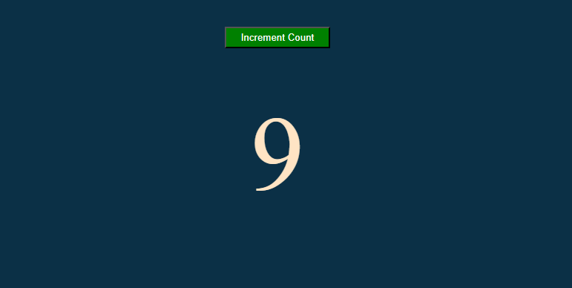

**Q3.**

**<!DOCTYPE html>**

**<html lang="en">**

**<head>**

**<meta charset="UTF-8">**

**<meta name="viewport" content="width=device-width, initial-scale=1.0">**

**<title>Counter Web Page with List</title>**

**<style>**

**body{**

**background: #0b3046;**

**}**

**#countList{**

**margin-top: 30px;**

**color:bisque**

**}**

**button{**

**background-color:green;**

**color:white;**

**padding:5px 20px;**

**margin:30px;**

**}**

**</style>**

**</head>**

**<body>**

**<button onclick="incrementCount()">Increment Count</button>**

**<ul id="countList"></ul>**

**<script>**

**var count = 0;**

**function incrementCount() {**

**count++;**

**var countList = document.getElementById('countList');**

**var listItem = document.createElement('li');**

**listItem.textContent = count;**

**listItem.style.fontSize = count + 'em';**

**countList.appendChild(listItem);**

**}**

**</script>**

**</body>**

**</html>**

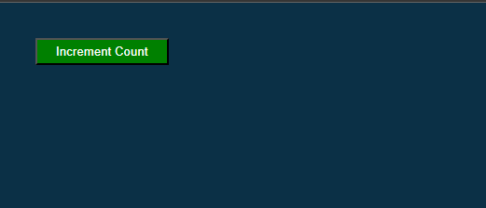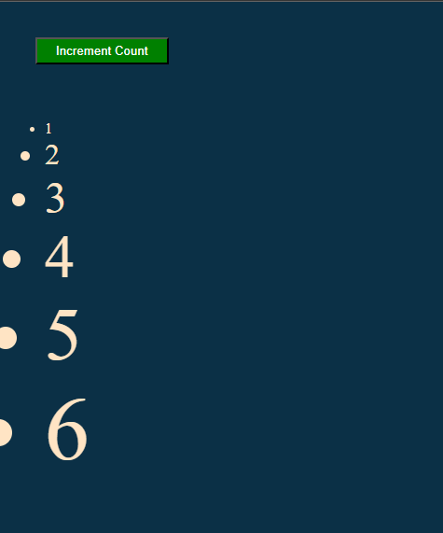

**Q4.**

**<!DOCTYPE html>**

**<html lang="en">**

**<head>**

**<meta charset="UTF-8">**

**<meta name="viewport" content="width=device-width, initial-scale=1.0">**

**<title>Table with Dynamic Rows</title>**

**<style>**

**body {**

**font-family: Arial, sans-serif;**

**text-align: center;**

**margin: 20px;**

**}**

**button {**

**padding: 10px;**

**font-size: 16px;**

**}**

**table {**

**border-collapse: collapse;**

**margin-top: 20px;**

**width: 100%;**

**}**

**th, td {**

**border: 1px solid #ddd;**

**padding: 8px;**

**text-align: center;**

**}**

**th {**

**background-color: #f2f2f2;**

**}**

**</style>**

**</head>**

**<body>**

**<button onclick="addRow()">Add Row</button>**

**<table id="myTable">**

**<tr>**

**<th>Value 1</th>**

**<th>Value 2</th>**

**</tr>**

**<tr>**

**<td>1</td>**

**<td>1</td>**

**</tr>**

**<tr>**

**<td>1</td>**

**<td>2</td>**

**</tr>**

**</table>**

**<script>**

**function addRow() {**

**var table = document.getElementById('myTable');**

**var rows = table.getElementsByTagName('tr');**

**var newRow = document.createElement('tr');**

**if (rows.length >= 2) {**

**var lastRow = rows[rows.length - 1];**

**var prevRow = rows[rows.length - 2];**

**for (var i = 0; i < lastRow.children.length; i++) {**

**var lastCellValue = parseInt(lastRow.children[i].innerText);**

**var prevCellValue = parseInt(prevRow.children[i].innerText);**

**var newCell = document.createElement('td');**

**newCell.innerText = lastCellValue + prevCellValue;**

**newRow.appendChild(newCell);**

**}**

**} else {**

**var newCell = document.createElement('td');**

**newCell.innerText = '1';**

**newRow.appendChild(newCell);**

**newCell = document.createElement('td');**

**newCell.innerText = '1';**

**newRow.appendChild(newCell);**

**}**

**table.appendChild(newRow);**

**}**

**</script>**

**</body>**

**</html>**

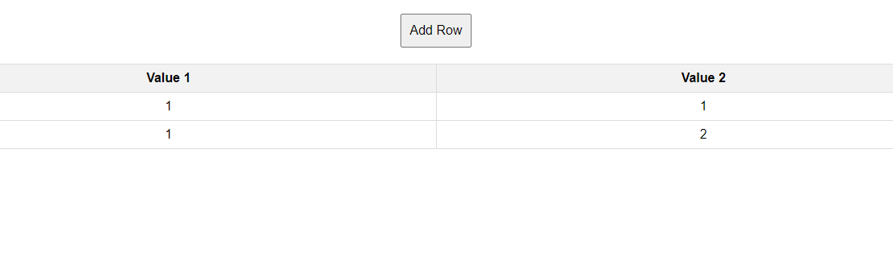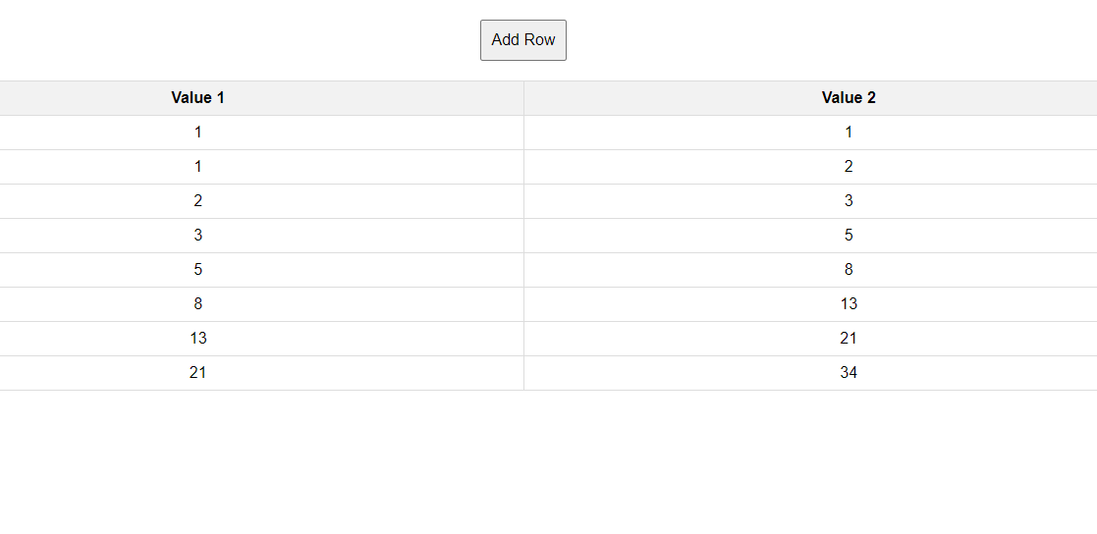

**Q5.**

**<!DOCTYPE html>**

**<html lang="en">**

**<head>**

**<meta charset="UTF-8">**

**<meta name="viewport" content="width=device-width, initial-scale=1.0">**

**<title>Simple Calculator</title>**

**<style>**

**body {**

**font-family: Arial, sans-serif;**

**text-align: center;**

**margin: 20px;**

**}**

**input {**

**padding: 8px;**

**margin: 5px;**

**}**

**button {**

**padding: 10px;**

**margin: 5px;**

**font-size: 16px;**

**}**

**#result {**

**margin-top: 10px;**

**font-size: 18px;**

**}**

**</style>**

**</head>**

**<body>**

**<input type="text" id="input1" placeholder="Enter number 1">**

**<input type="text" id="input2" placeholder="Enter number 2">**

**<br>**

**<button onclick="performOperation('+')">+</button>**

**<button onclick="performOperation('-')">-</button>**

**<button onclick="performOperation('*')">*</button>**

**<button onclick="performOperation('/')">/</button>**

**<div id="result"></div>**

**<script>**

**function performOperation(operator) {**

**var input1 = document.getElementById('input1');**

**var input2 = document.getElementById('input2');**

**var resultDisplay = document.getElementById('result');**

**var value1 = Number.parseInt(input1.value);**

**var value2 = Number.parseInt(input2.value);**

**if (!isNaN(value1) && !isNaN(value2)) {**

**var result;**

**switch (operator) {**

**case '+':**

**result = value1 + value2;**

**break;**

**case '-':**

**result = value1 - value2;**

**break;**

**case '*':**

**result = value1 * value2;**

**break;**

**case '/':**

**result = value1 / value2;**

**break;**

**default:**

**result = 'Invalid operator';**

**}**

**resultDisplay.innerText = 'Result: ' + result;**

**} else {**

**resultDisplay.innerText = 'Please enter valid numbers';**

**}**

**}**

**</script>**

**</body>**

**</html>**

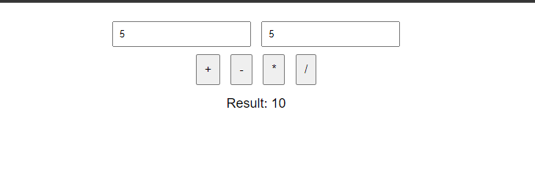

**Q6.**

**<!DOCTYPE html>**

**<html lang="en">**

**<head>**

**<meta charset="UTF-8">**

**<meta name="viewport" content="width=device-width, initial-scale=1.0">**

**<title>Document</title>**

**</head>**

**<body>**

**<button class="btn">Click me!</button>**

**<div class="body"></div>**

**<script>**

**let onclick = ()=>{**

**body = document.querySelector(".body");**

**let heading = document.createElement("h1")**

**heading.textContent ="I am H1";**

**body.appendChild(heading);**

**let para = document.createElement("p");**

**para.textContent = "I am para";**

**body.appendChild(para)**

**let ul = document.createElement('ul');**

**let li1 = document.createElement("li");**

**li1.textContent = 'one';**

**let li2 = document.createElement("li");**

**li2.textContent = 'two';**

**ul.appendChild(li1);**

**ul.appendChild(li2);**

**body.appendChild(ul);**

**}**

**document.querySelector(".btn").addEventListener("click",onclick);**

**</script>**

**</body>**

**</html>**



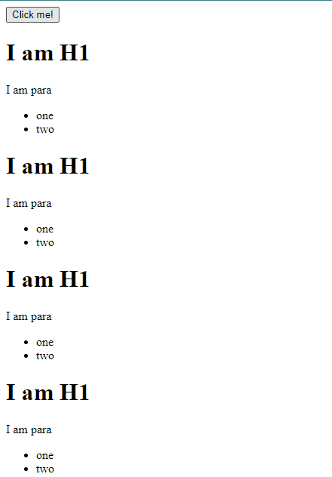

**Q7.** 