**Modified 2010 ZCTA shapefile**

Created: May 12, 2020  
Last Updated: Never

Open Data Coordinator: Kemi Eguaze, Department of Health and Mental Hygiene

**What’s In This Dataset?**

This shapefile is a resource to be used for data provided by the geographic aggregation named modified ZIP code tabulation area (MODZCTA).

It can be challenging to map data that are reported by ZIP code. A ZIP code does not actually refer to an area. It refers to a collection of points that make up a mail delivery route, which sometimes changes. Furthermore, there are some buildings that have their own ZIP code and some non-residential areas with ZIP codes.

To deal with some of the challenges of ZIP codes, [ZIP Code Tabulation Areas (ZCTAs)](https://www.census.gov/programs-surveys/geography/guidance/geo-areas/zctas.html) solidify ZIP codes into units of area. Often, data reported by ZIP code are actually mapped by ZCTA. The ZCTA geography was developed by the US Census.

DOHMH sometimes reports data by **modified** ZCTA(MODZCTA), which combines ZCTAs with populations less than 3000 to improve stability of estimates.

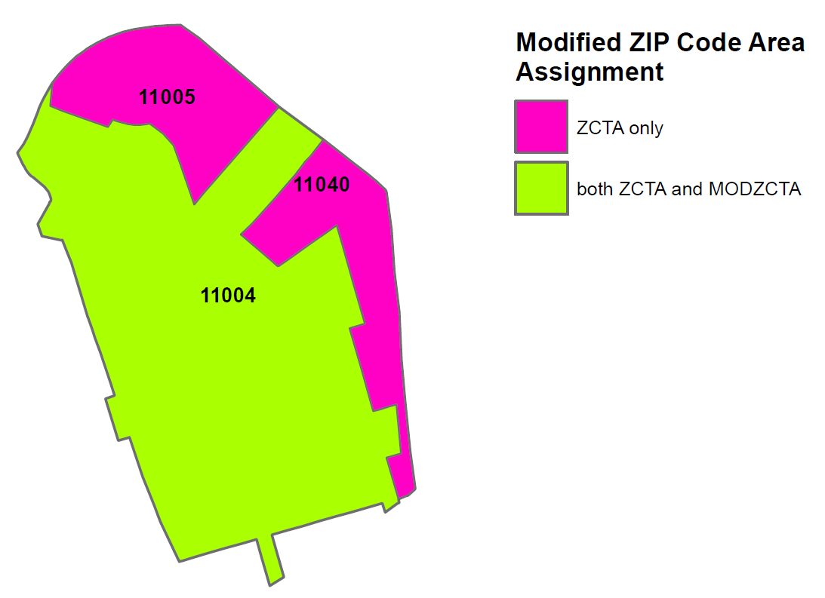**ZCTA with smaller populations are assigned to the adjacent ZCTA with a larger population:**

ZCTA 11005 and 11040 have much of their population within Nassau County with only a small portion residing in Queens County. These two ZCTAs are absorbed into the more populated ZCTA 11004.

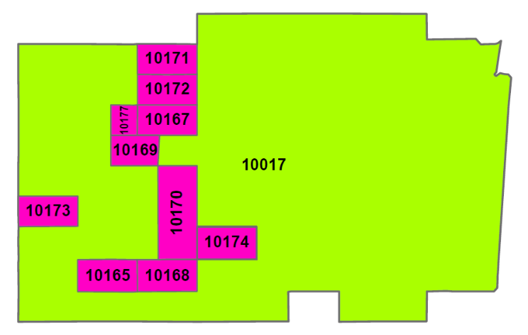

**Interior ZCTA with smaller populations are assigned to the surrounding ZCTA:**

Block level ZCTAs 10165 through 10177, which include the Berkley College Campus and Grand Central Station, are assigned to the surrounding ZCTA 10017.

The data dictionary for this shapefile includes an additional sheet for further reference: ‘ZCTA to MODZCTA (crosswalk)’, which is a crosswalk showing to which MODZCTA a ZIP code belongs. This shapefile’s ‘label’ field contains comma-delimited lists of populated zip codes that correspond with each MODZCTA area for ease of reference.

This shapefile can be used together with the “Emergency Department Visits and Admissions for Influenza-like Illness and/or Pneumonia” dataset, which uses MODZCTA resolution. This dataset can be found at <https://data.cityofnewyork.us/Health/Emergency-Department-Visits-and-Admissions-for-Inf/2nwg-uqyg>.

**Who Manages This Data?**

Gretchen Culp with the Bureau of Epidemiology Services at DOHMH.

**Get Started With This Data:**

These data can be used to:

* Map datasets aggregated to the modified ZCTA geography using a wide variety of Geographic information systems and statistical software packages including QGIS, ArcGIS, R, and many others.

**Columns (Fields, Attributes):**

**MODZCTA**: Modified ZIP Code tabulation area (ZCTA). Use this field for data joins.

**label:** Contains a comma-delimited list of all known populated zip codes corresponding to the modified ZCTA geometry

**ZCTA**: Contains the Census ZCTAs that were combined to form the MODZCTA area, as a comma-delimited list.

**pop_est**: DOHMH population estimate for each MODZCTA, aggregated from the 2018 American Community Survey (ACS) 5-year population estimates for each ZCTA.