**Title: A derivation error that affects carbon balance models exists in the current implementation of the Johnson et al. (1942) modified Arrhenius function**

**Running Title: Derivation error in modified Arrhenius model**

Author: Bridget Murphy1, Joseph R. Stinziano2,*

Affiliations: 1 Department of Biology, University of Western Ontario, London, ON, Canada;   
2 Department of Biology, University of New Mexico, Albuquerque, NM, USA

* Corresponding author; Email: [jstinziano@unm.edu](mailto:jstinziano@unm.edu); Tel: +1 (226) 678-1670

Article Type: Research Article

Word Count: 3,040

Introduction: 490

Material & Methods: 813

Results: 1154

Discussion: 557

Acknowledgments: 26

Number of Tables: 2  
Number of Figures: 6

Supplementary Files: 1

**Abstract**

Understanding biological temperature responses is crucial to predicting global carbon fluxes. The current approach to modeling temperature responses of photosynthetic capacity in large scale modeling efforts uses a modified Arrhenius equation. We rederived the modified Arrhenius equation from the source publication and uncovered a missing term that was dropped between 1942 and 2002. We compare fitted temperature response parameters between the new and old derivation of the modified Arrhenius equation. We find that most parameters are minimally affected, though small errors still exist. We then scaled the impact of these small errors to whole plant carbon balance and found that the impact of the rederivation of the Arrhenius on modelled daily carbon gain causes a meaningful deviation of ~1.8%. This suggests that the error in the derivation of the modified Arrhenius equation has impacted predictions of carbon fluxes at larger scales.

*Keywords: Arrhenius, temperature, photosynthesis, gas exchange, modeling, carbon balance*

**Introduction**

Globally, photosynthesis and autotrophic respiration are the largest biological carbon fluxes, with photosynthesis removing ~120 Gt C year-1 from the atmosphere and autotrophic respiration releasing ~60 Gt C year-1 back to the atmosphere (Amthor, 2000; Ciais et al., 2013). Given the temperature sensitivity of these large carbon fluxes, understanding how photosynthesis and respiration respond on acute, acclimatory, and adaptive timescales is crucial for predicting vegetative and carbon cycle responses to future global climates (Rogers et al., 2017; Stinziano et al. 2018). Biological temperature responses including photosynthesis and respiration are typically assumed to be exponential or peaked (Way and Yamori, 2014; Smith & Dukes, 2017; Kumarathunge et al., 2019). Exponential responses are usually modelled based on an Arrhenius-type curve (Arrhenius, 1915):

Equation 1, or equivalently,

Equation 2

where f(T) is the rate of the process at temperature T, A is a pre-exponential factor, T in K, k25 is the rate of the process at 298.15 K, Ea is the activation energy in J mol-1, R is the universal gas constant of 8.314 J mol-1 K-1, and 298.15 is the reference temperature in K. As for peaked responses, while a few options are available (Kruse et al., 2008; Hobbs et al., 2013; Heskel et al., 2016), the most commonly implemented version is the modified Arrhenius model of Johnson et al. (1942) as presented in Medlyn et al. (2002):

Equation 3

where Hd is the deactivation energy in J mol-1, and ΔS is the entropy of the process in J mol-1 K-1.

Equation 3 is used for modeling the temperature responses of photosynthetic capacity (i.e.. maximum carboxylation capacity of rubisco, Vcmax, maximum electron transport capacity, Jmax, and triose phosphate utilization capacity (TPU); see Rogers et al., 2017 for a review of models using Equation 3). These parameters are then used in ecophysiological studies to understand thermal acclimation of photosynthesis (see Kattge & Knorr, 2007; Smith & Dukes, 2017; and Kumarathunge et al., 2019 for examples). Furthermore, this equation is also used in terrestrial biosphere models to predict the future carbon cycling (e.g. Rogers et al., 2017).

Due to the ubiquity of Equation 3 in modeling photosynthetic capacity (e.g. Kattge & Knorr, 2007; Rogers et al., 2017; Smith & Dukes, 2017; Kumarathunge et al., 2019), we revisited the original Johnson et al. (1942) modified Arrhenius function to rederive Equation 3. In the process of this rederivation, we uncovered a term that was dropped sometime between Johnson et al. (1942) and Medlyn et al. (2002) which causes a systematic error in the application of Equation 3 for modeling photosynthetic capacity in individual species (e.g. Medlyn et al., 2002) to modeling global scale carbon uptake (e.g. Rogers et al., 2017). We then refit a freely available dataset (Kumarathunge et al., 2019), with both versions of the modified Arrhenius model, and fed the temperature response fits through a carbon balance model to estimate the impact of the derivation error on modelled plant carbon balance. We predicted that the derivation error would cause substantial variation in fitted temperature response parameters, and that these differences would propagate through to modelled daily carbon balance.

**Materials & methods**

**Rederivation of the modified Arrhenius equation**

Johnson et al. (1942, equation 24) describe the temperature response of the light intensity of a luciferase reaction as:

Equation 4

where I is the intensity of the luciferase reaction, c’’ is not explicitly defined in Johnson et al. (1942), but presumably represents a constant based on the derivation in the study, T is the temperature in K, R is the universal gas constant of 8.314 J mol-1 K-1, ΔH‡ is the activation energy in J mol-1, ΔH is the deactivation energy in J mol-1, and ΔS is the entropy in J mol-1 K-1. We can relativize the equation to a reference temperature by dividing Equation 4 at a hypothetical temperature by Equation 4 at a standard temperature (i.e. 25 °C):

Equation 5

Next, rearrange fractions for clarity:

Equation 6

Cancel out c’’, use exponent rules to simplify:

Equation 7

Simplify further by setting a common denominator within exponential terms:

Equation 8

Simplify exponential terms further:

Equation 9

Harmonizing the notation scheme to that typically used in plant ecophysiology:

Equation 10

Note the difference between Equations 3 and 10: the term T / 298.15 is missing from Equation 3. There are several alternative expressions of Equation 4 (e.g. Harley et al., 1986; Harley et al., 1992; Harley & Baldocchi, 1995; Lloyd, 1995), however when relativized to a common temperature, the This introduces multiple systematic errors. First, errors are introduced into the fitted parameters Ea, Hd, and ΔS. Second, k25 is scaled using the wrong equation, introducing an error in f(T). And third, acclimation equations describing Ea, Hd, and ΔS will then be in error due to errors in the fitted parameters at each temperature.

Here we focus on the impact of 1 and 2 on modeling whole-plant carbon balance.

**Data analysis**

Using A-Ci curve data compiled in Kumarathunge et al. (2019), available from the Kumarathunge et al. (2018) repository, we used the {fitacis} function from the R package {plantecophys} (Duursma, 2015), setting fitmethod = “bilinear”, Tcorrect = FALSE, and fitTPU = TRUE, to obtain Vcmax and Jmax. We then fit Equations 3 and 10 to the data, allowing Hd to be fit. To ensure that the curves could be fit (i.e. that there were enough data to fit 4 parameters), we only used data where A-Ci curves were measured at 5 or more temperatures. This reduced the number of candidate temperature responses from 729 to 403. We used the R package {minpack.lm} (Elzhov et al., 2016), using Equation 2 to obtain starting values for Ea and k25, while the other initial parameters were ΔS = 0.650 kJ mol-1, and Hd varying from 1 to 1000 kJ mol-1, followed by the {BIC} function to select the best model based on Bayesian Information Criteria. We obtained 341 and 337 successful Vcmax temperature response curve fits for Equations 3 and 10, respectively, and 241 and 242 successful Jmax temperature response curve fits for Equations 3 and 10, respectively. This resulted in a total of 547 fitted temperature response curves which we filtered further, requiring that Ea, ΔS, and Hd were all positive values and that the Vcmax and Jmax data were paired, resulting in 196 complete pairs of Vcmax and Jmax temperature responses for analysis..

**Modeling**

We modelled the impact of the equations 3 and 10 on daily net plant carbon balance under conditions of Hd = 200 kJ mol-1 and fitted Hd. Data for leaf area, root and shoot masses, as well as leaf dark respiration at 25 °C were taken for white spruce (*Picea glauca*) from Stinziano & Way (2017), while stomatal conductance model parameters were calculated with the gas exchange data reported in Stinziano & Way (2017). Mean data were taken from the control treatment at weeks 0 and 12 to provide contrasting biomass allocation patterns such that week 0 is a low respiration scenario and week 12 is a high respiration scenario. These different respiration scenarios were used to reduce bias in any conclusions regarding the impact of Equations 3 and 10 on carbon balance, as the ratio of photosynthesis to respiration may alter the sensitivity of carbon balance to the Arrhenius equation used. Root respiration for white spruce was taken from Weger and Guy (1991) and we assumed that stem respiration was equal to root respiration (Table 1).

**Table 1. Parameters used in modeling daily carbon gain.**

|  |  |  |  |
| --- | --- | --- | --- |
| Parameter | Group | Value | Reference |
| Respiration | Rdark | 2.78 μmol m-2 s-1 | Stinziano & Way, 2017 |
|  | Rday | 0.7 * Rdark | Ayub et al., 2011 |
|  | Rroot | 0.0095 μmol g-1 s-1 | Weger & Guy, 1991 |
|  | Rstem | 0.0095 μmol g-1 s-1 | Assumed |
|  | Q10 | 2.015 | Atkin & Tjoelker, 2003 |
| Γ* | 25 °C | 42.75 μmol mol-1 | Bernacchi et al., 2001 |
|  | Ea | 37.83 kJ mol-1 | Bernacchi et al., 2001 |
| Km | 25 °C | 718.4 μmol mol-1 | Bernacchi et al., 2001 |
|  | Ea | 65.51 kJ mol-1 | Bernacchi et al., 2001 |
| α |  | 0.8 | Norman & Campbell, 1998 |
| φ |  | 0.08 | Norman & Campbell, 1998 |
| Leaf Area | Low R | 0.015 m2 | Stinziano & Way, 2017 |
|  | High R | 0.025 m2 | Stinziano & Way, 2017 |
| Stem Mass | Low R | 0.496 g | Stinziano & Way, 2017 |
|  | High R | 2.523 g | Stinziano & Way, 2017 |
| Root Mass | Low R | 0.498 g | Stinziano & Way, 2017 |
|  | High R | 5.072 g | Stinziano & Way, 2017 |

**Q10: thermal sensitivity coefficient; Γ*: photorespiratory CO2 compensation point; Km: apparent Michaelis-Menten constant for rubisco carboxylation in 21% O2/air (i.e. Kc,air); α: absorbance of photosynthetically activation radiation; φ: maximum quantum efficiency of photosynthetic electron transport; Ea: activation energy; Rdark: leaf respiration in the dark; Rday: leaf respiration in the light; Rroot: root respiration; Rstem: stem respiration; Low R: low respiration scenario; High R: high respiration scenario.**

For the full model structure and equations, please see the accompanying R package {arrhenius.comparison} (“arrhenius.comparison_1.0.0.tar.gz”; Stinziano & Murphy, 2020) (see Table 2 for equations). Briefly, we linked the Medlyn et al. (2011) stomatal conductance model with the Farquhar et al. (1980) C3 photosynthesis model, assuming infinite mesophyll conductance to CO2 as these assumptions were used in fitting the data from Kumarathunge et al. (2018). Photosynthetic capacity, both maximum rubisco carboxylation capacity, Vcmax, and maximum electron transport rate, Jmax were scaled to temperature using either Equation 3 or 10, while respiration was scaled according to (Atkin & Tjoelker, 2003). Photosynthesis and respiration were summed across each modelled day to calculate daily plant carbon assimilation.

**Table 2. Equations used in modeling daily carbon uptake.**

|  |  |
| --- | --- |
| Equation | Reference |
|  | Atkin & Tjoelker, 2003 |
|  | Arrhenius, 1915 |
|  | Johnson et al., 1942; Medlyn et al., 2002 |
|  | Johnson et al., 1942; this study |
|  | Farquhar et al., 1980 |
|  | Farquhar et al., 1980; Way et al., 2011 |
| Where J is calculated as the minimum root of: | |
|  |  |
|  |  |
|  | Medlyn et al., 2011 |
|  |  |
|  |  |
|  |  |

**f(T): rate of a process at a given temperature; T: temperature in K; k25: rate of a process at 25 °C; Q10: thermal sensitivity coefficient; Ea: activation energy in kJ mol-1; ΔS: entropy parameter in kJ mol-1; Hd: deactivation energy in kJ mol-1; R: universal gas constant in 0.008314 kJ mol-1 K-1; Wc: rate of CO2-limited carboxylation in μmol m-2 s-1; Wj: rate of RuBP regeneration-limited carboxylation in μmol m-2 s-1; Vcmax: maximum rate of rubisco carboxylation capacity in μmol m-2 s-1; Jmax: maximum rate of electron transport in μmol m-2 s-1; Ci: intercellular CO2 concentration in μmol mol-1; Γ*: photorespiratory CO2 compensation point in μmol mol-1; Km: Michaelis-Menten constant for rubisco in μmol mol-1; α: absorbance of photosynthetically active radiation; φ: maximum quantum efficiency of electron transport; Qin: incident photosynthetically active radiation; Agross: gross CO2 assimilation in μmol m-2 s-1; Anet: net CO2 assimilation in μmol m-2 s-1; Rday: leaf day respiration in μmol m-2 s-1; gs: stomatal conductance to water in mol m-2 s-1; go: intercept for the Medlyn et al. 2011 model; g1: slope for the Medlyn et al. 2011 model; VPD: vapor pressure deficit in kPa; Ca: CO2 concentration at the leaf surface in μmol mol-1; Aplant: whole plant net CO2 assimilation; LA: leaf area in m-2; Rdark: leaf dark respiration in μmol m-2 s-1; Rstem: stem respiration in μmol m-2 s-1; Rroot; root respiration in μmol m-2 s-1; SM: stem mass in g; RM: root mass in g; Cbalance: whole plant daily carbon balance in g plant-1 day-1.**

Modeling was performed on 18 total days of environmental data, with three days of data from three months (17th – 19th of May, August, and October, 2019) obtained from external irradiance sensors at the Biotron Experimental Climate Change Research Centre at the University of Western Ontario and the remaining environmental data from Environment Canada historical climate data for South London (43.01°N, 81.27°W, altitude: 251 m) and the rooftop greenhouse at the University of New Mexico (35.08°N, 106.62°W, altitude: 1587 m) to capture different levels of environmental variability (Fig. 1).

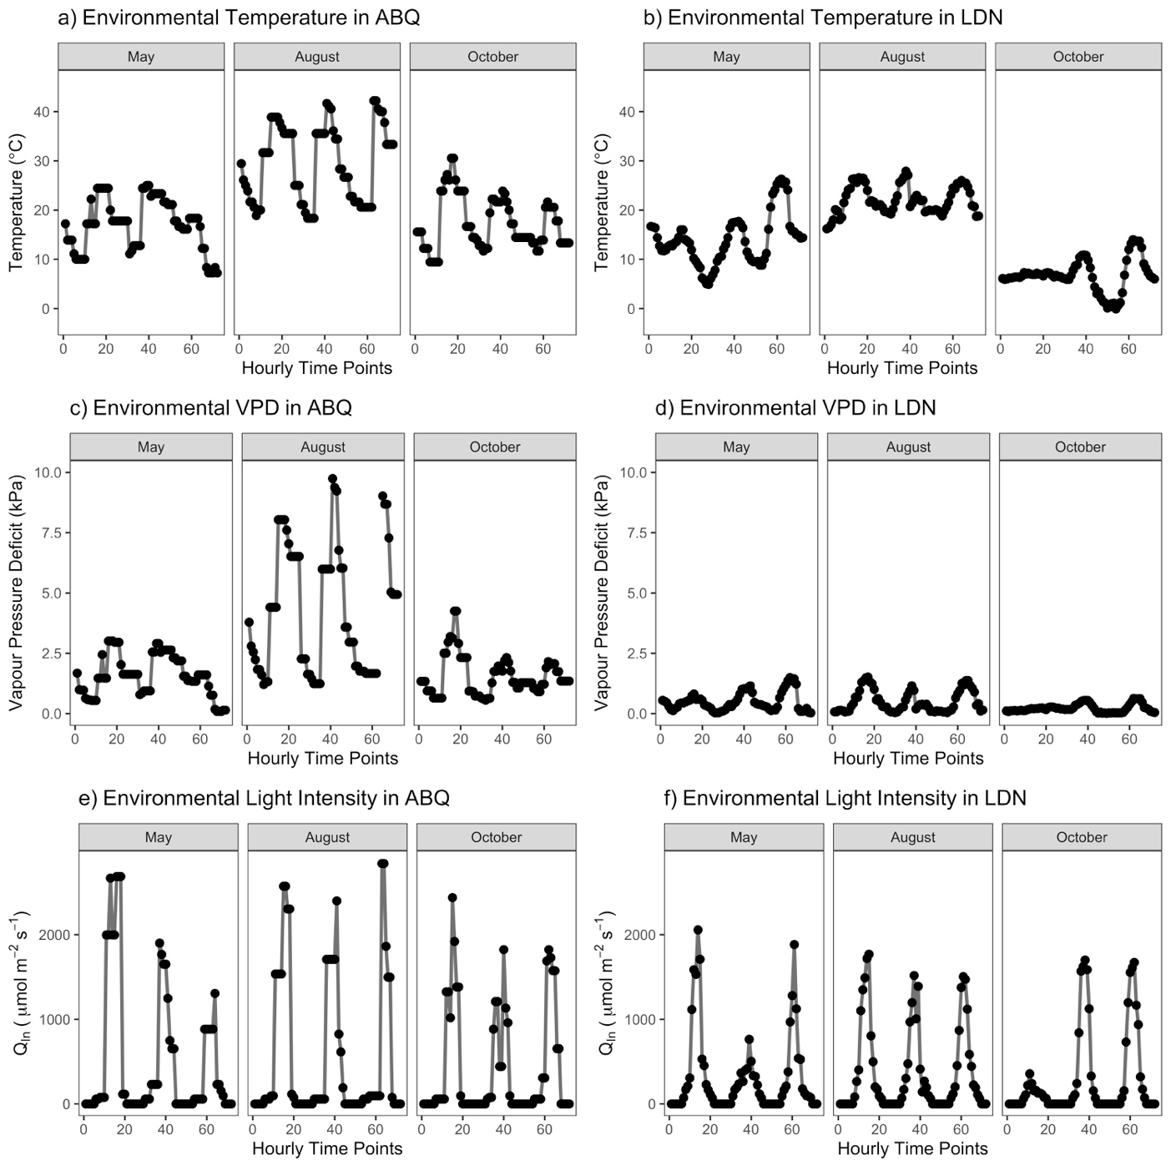

**Figure 1. Environmental data used to drive the model in Table 1 covering 3 days (17th, 18th, and 19th) of 3 months. (a,c,e) Albuquerque, NM, USA (ABQ); (b,d,e) London, ON, Canada (LDN).**

Overall, the modeling approach allows us to assess the relative differences between Equations 3 and 10 under a low- and high- respiration scenario, fixing versus fitting Hd, and across different ranges of seasonal variability.

*Statistical analysis*

Data were analyzed using the {lm} function in R v.3.6.1 (R Core Team, 2019), regressing the data obtained from Equation 10 against the data obtained from Equation 3. All code and data will be made freely available on GitHub upon publication in the {arrhenius.comparison} R package (Stinziano & Murphy, 2020).

**Results**

*Similarities of*

The performance between Equations 3 and 10 for fitting Vcmax temperature responses were essentially identical when assessed based on BIC, with a slope of 1.001 ± 0.001 (*F1,195* = 5.52 ∙ 105, *R2* = 0.9996, *P* < 2.2 ∙ 10-16; Fig X), as was the case for Jmax with a slope of 1.001 ± 0.001 (*F1,195* = 2.43 ∙ 106, *R2* = 0.9999, *P* < 2.2 ∙ 10-16; Fig X).

Estimates of Vcmax,25 were essentially identical between the Equation 3 fitting (y-axis) and the Equation 10 fitting (x-axis) with a slope of 1.002 ± 0.004 (*F1,195* = 5.84 ∙ 104, *R2* = 0.9967, *P* < 2.2 ∙ 10-16; Fig X), as was the case for Jmax,25 with a slope of 1.001 ± 0.001 (*F1,195* = 6.56 ∙ 105, *R2* = 0.9997, *P* < 2.2 ∙ 10-16; Fig X). Ea,Vcmax was generally underestimated with a slope of 0.847 ± 0.024 and a positive bias of 9.73 ± 2.59 kJ mol-1 when using Equation 3 (*F1,194* = 1202, *R2* = 0.8610, *P* < 2.2 ∙ 10-16; Fig. X), while Ea,Jmax was underestimated with a slope of 0.832 ± 0.013 and a positive bias of 5.98 ± 1.06 kJ mol-1 (*F1,194* = 3834, *R2* = 0.9518, *P* < 2.2 ∙ 10-16; Fig X). ΔSVcmax was essentially identical between Equation 3 and 10 with a slope of 1.000 ± 0.0233 (*F1,195* = 1849, *R2* = 0.9046, *P* < 2.2 ∙ 10-16; Fig. X), as was the case with ΔSJmax with a slope of 0.988 ± 0.033 (*F1,195* = 904, *R2* = 0.8226, *P* < 2.2 ∙ 10-16; Fig. X). Hd,Vcmax was also essentially identical between Equation 3 and 10 fittings with a slope of 1.002 ± 0.005 (*F1,195* = 4.12 ∙ 104, *R2* = 0.9953, *P* < 2.2 ∙ 10-16; Fig. X), although Hd,Jmax was underestimated with a slope of 0.952 ± 0.024 and a positive bias of 31.48 ± 8.93 kJ mol-1 (*F1,194* = 1592, *R2* = 0.8914, *P* < 2.2 ∙ 10-16; Fig. X).

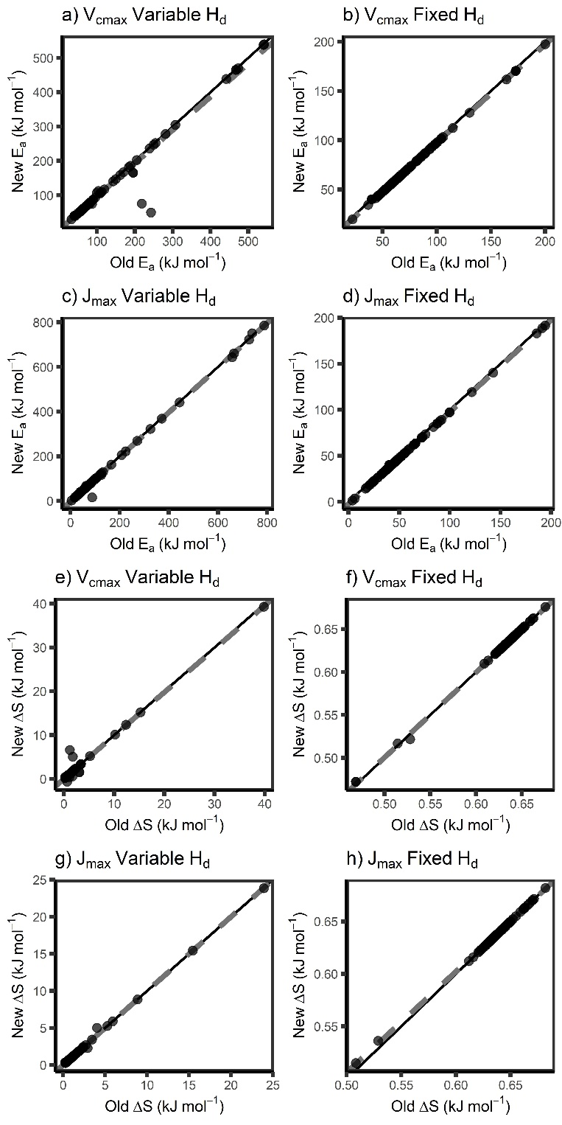

**Figure 2 – The modified Arrhenius equation with the missing term (Equation 10) gives**

**similar temperature response parameters as Equation 3 for Ea (a-d) and ΔS (e-h) for both Vcmax (a, b, e, f) and Jmax (c, d, g, h) under scenarios where Hd is allowed to vary (a, c, e, g) and is fixed to 200 kJ mol-1 (b, d, f, h). “New” indicates Equation 10, “Old” indicates Equation 3. Ea: activation energy, ΔS: entropy parameter, Hd: deactivation energy, Vcmax: maximum capacity of rubisco carboxylation, Jmax: maximum rate of electron transport. Black line indicates 1:1 line and grey dashed line indicates respective modeled slopes and intercepts.**

**Figure 3 – The modified Arrhenius equation with the missing term (Equation 10) gives**

**similar temperature response parameters as Equation 3 for k25 (a-d) and Hd (e, f) for both Vcmax (a, b, e) and Jmax (c, d, f) under scenarios where Hd is allowed to vary (a, c, e, f) and is fixed to 200 kJ mol-1 (b, d). “New” indicates Equation 10, “Old” indicates Equation 3. k25: rate of the process at 25 °C, Hd: deactivation energy, Vcmax: maximum capacity of rubisco carboxylation, Jmax: maximum rate of electron transport. Black line indicates 1:1 line and grey dashed line indicates respective modeled slopes and intercepts.**

*Impacts on modelled net carbon balance*

In general, the differences in thermal response parameters were amplified when integrated at the whole-plant level. For daily photosynthesis (A) measured at a fixed Hd of 200 kJ mol-1, the slope for the low respiration model was 0.977 ± 7.666 ∙ 10-3 and an intercept of 0.002 ± 9.366 ∙ 10-5 (approximately 2% of modeled A) (*F*1,898 = 1.625 ∙ 106, R2 = 0.9994; *P* < 2.2 ∙ 10-16) (Fig. 4b). Similarly, the high respiration model for A had a slope of 0.977 ± 7.666 ∙ 10-3 and an intercept of 0.004 ± 1.591 ∙ 10-3 (approximately 2% of modeled A) (*F*1,898 = 1.625 ∙ 106, R2 = 0.9994; *P* < 2.2 ∙ 10-16) (Fig. 4d). For daily A measured at a variable Hd, the slope for the low respiration model was 0.983 ± 9.909 ∙ 10-3 and the intercept was 0.002 ± 1.128 ∙ 10-3 (approximately 2% of modeled A) (*F*1,556 = 9.834 ∙ 105, R2 = 0.9994; *P* < 2.2 ∙ 10-16) (Fig. 4a). For the high respiration model of daily A, the slope was 0.983 ± 9.909 ∙ 10-3 and the intercept was 0.003 ± 9.909 ∙ 10-4 (approximately 2% of modeled A) (*F*1,556 = 9.834 ∙ 105, R2 = 0.9994; *P* < 2.2 ∙ 10-16) (Fig. 4c).

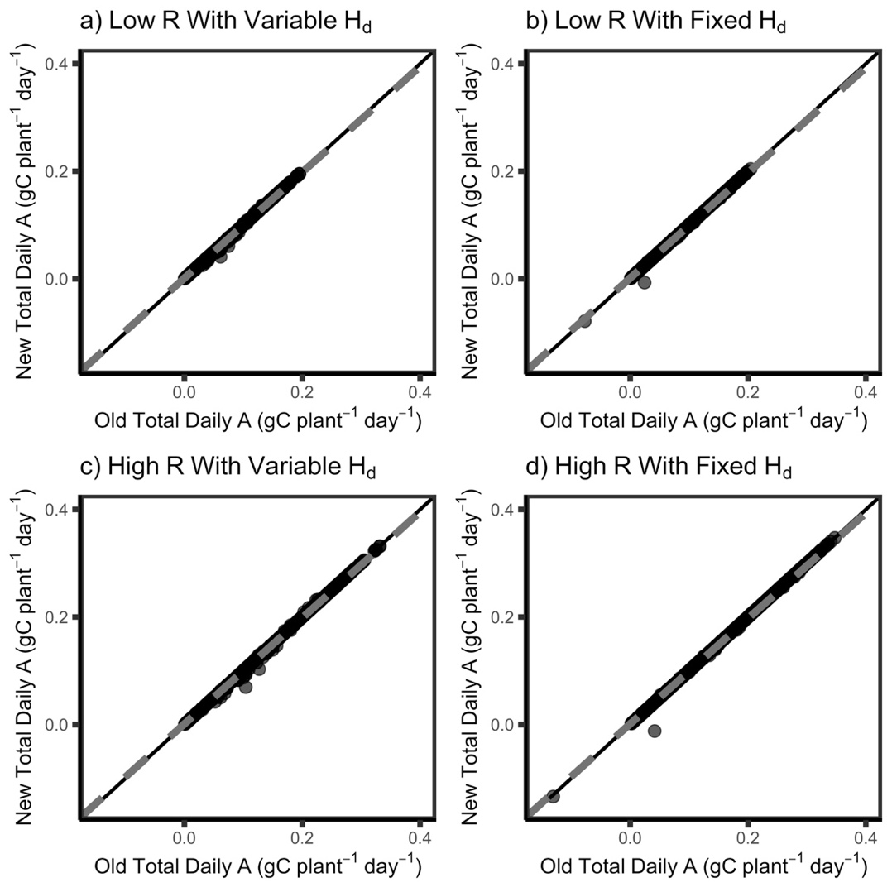

**Figure 4 – The modified Arrhenius equation with the missing term (Equation 10) gives slight differences in modeled total daily photosynthesis compared to Equation 3 for low R (a,b) and high R (c,d) under scenarios where Hd is allowed to vary (a, c) and is fixed to 200 kJ mol-1 (b,d). “New” indicates Equation 10, “Old” indicates Equation 3. A: photosynthesis, Low R: low respiration, High R: high respiration. Black line indicates 1:1 line and grey dashed line indicates respective modeled slopes and intercepts.**

The ratio of the total daily photosynthesis : respiration (A/R) was also considered when comparing models. Using a fixed Hd of 200 kJ mol-1, the low respiration model of A/R had a slope of 0.993 ± 5.634 ∙ 10-3 and the intercept was 0.025 ± 0.002 (approximately 1% of modeled A/R) (*F*1,898 = 3.109 ∙ 106, R2 = 0.9997; *P* <2.2 ∙ 10-16) (Fig. 5b). The high respiration model of A/R was similar; the slope was 0.993 ± 5.628 and the intercept was 0.014 ± 0.001 (approximately 1% of modeled A/R) (*F*1,898 = 3.115 ∙ 106, R2 = 0.9997; *P* <2.2 ∙ 10-16) (Fig. 5d). Using a variable Hd, the low respiration model of A/R had a slope of 0.994 ± 0.001 and the intercept was 0.030 ± 0.001 (approximately 1% of modeled A/R) (*F*1,556 = 6.857 ∙ 105, R2 = 0.9992; *P* <2.2 ∙ 10-16) (Fig. 5a). The high respiration model had a similar slope of 0.994 ± 0.001 and the intercept was 0.017 ± 0.003 (approximately 1% of modeled A/R) (*F*1,556 = 6.812 ∙ 105, R2 = 0.9992; *P* <2.2 ∙ 10-16) (Fig. 5c).

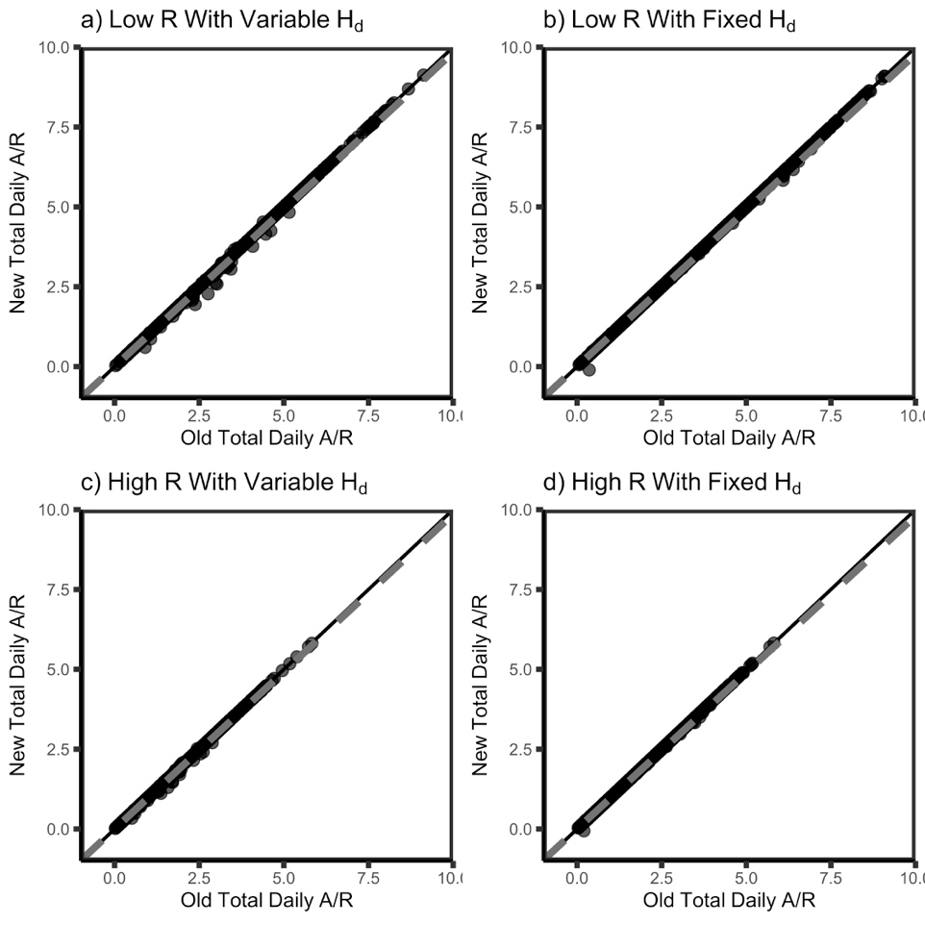

**Figure 5 – The modified Arrhenius equation with the missing term (Equation 10) gives slight differences in modeled total daily A/R compared to Equation 3 for low R (a,b) and high R (c,d) under scenarios where Hd is allowed to vary (a, c) and is fixed to 200 kJ mol-1 (b,d). “New” indicates Equation 10, “Old” indicates Equation 3. A: photosynthesis, R: respiration, Low R: low respiration, High R: high respiration. Black line indicates 1:1 line and grey dashed line indicates respective modeled slopes and intercepts.**

Lastly, total daily carbon (C) gain was also compared between models with different thermal response parameters. Using a fixed Hd of 200 kJ mol-1, the low respiration model of total C gain had a slope of 0.978 ± 7.445 ∙ 10-4 and an intercept of 0.001 ± 7.609 ∙ 10-5 (approximately 2% of modeled C gain) (*F*1,898 = 1.726 ∙ 106, R2 = 0.9995; *P* <2.2 ∙ 10-16) (Fig. 6b). Likewise, the high respiration of total C gain had a slope of 0.979 ± 7.261 ∙ 10-4 and an intercept of 0.001 ± 1.116 ∙ 10-4 (approximately 2% of modeled C gain) (*F*1,898 = 1.821 ∙ 106, R2 = 0.9995; *P* <2.2 ∙ 10-16) (Fig. 6d). This can be compared to a variable Hd; starting with the low respiration model, total C gain had a slope of 0.985 ± 9.555 ∙ 10-4 and an intercept of 0.001 ± 1.223 ∙ 10-3 (approximately 1.5% of modeled C gain) (*F*1,556 = 1.06 ∙ 106, R2 = 0.9995; *P* <2.2 ∙ 10-16) (Fig. 6a). The high respiration of total C gain also had a slope of 0.985 ± 9.110 ∙ 10-4 and an intercept of 0.001 ± 1.290 ∙ 10-4 (approximately 1.5% of modeled C gain) (*F*1,556 = 1.17 ∙ 106, R2 = 0.9995; *P* <2.2 ∙ 10-16) (Fig. 6c).

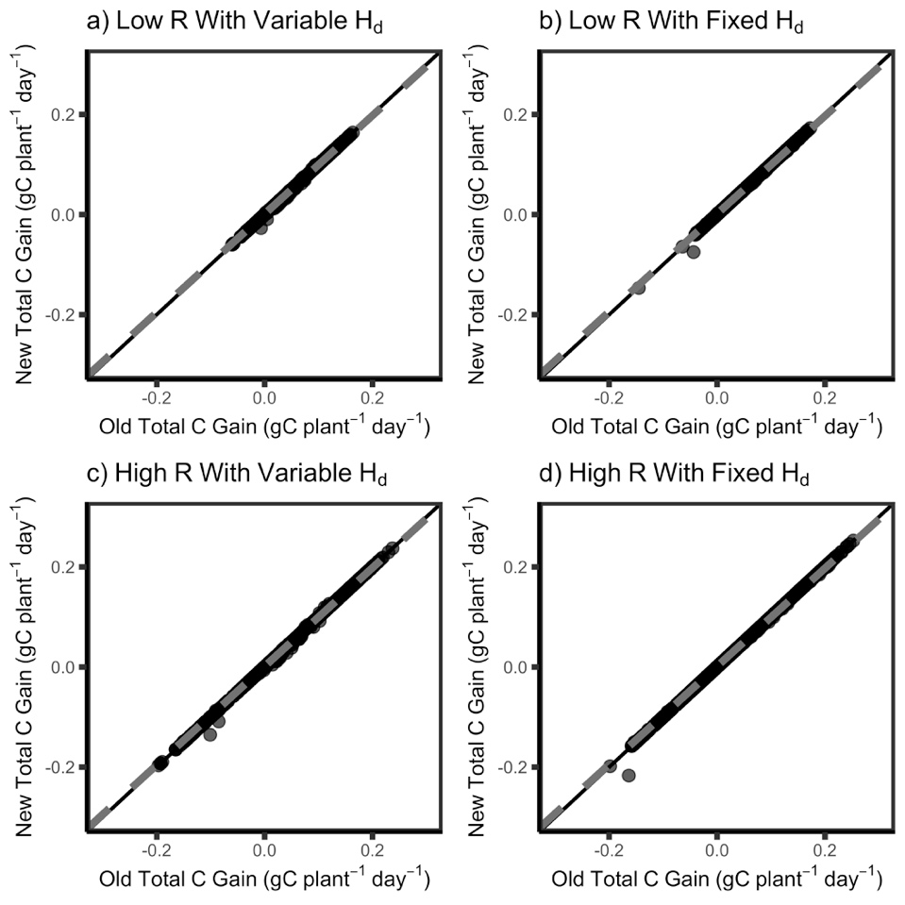

**Figure 6 – The modified Arrhenius equation with the missing term (Equation 10) gives slight differences in modeled total carbon gain compared to Equation 3 for low R (a,b) and high R (c,d) under scenarios where Hd is allowed to vary (a, c) and is fixed to 200 kJ mol-1 (b,d). “New” indicates Equation 10, “Old” indicates Equation 3. C: carbon, Low R: low respiration, High R: high respiration. Black line indicates 1:1 line and grey dashed line indicates respective modeled slopes and intercepts.**

**Discussion**

We sought to determine whether the missing term in Equation 3 had a meaningful impact on fitted temperature response parameters due to its prevalence in photosynthetic temperature response data and vegetation modeling (Kattge & Knorr, 2007; Duursma & Medlyn, 2012; Rogers et al., 2017; Smith & Dukes, 2017; Stinziano et al., 2018; Stinziano et al., 2019; Kumarathunge et al., 2019). Our present analysis suggests that there is no large impact on the fitted temperature response parameters for Vcmax and Jmax, with differences ranging between 0 and 3.8% depending on the parameter. In general, fitting Equation 10 instead of Equation 3 results in slightly reduced values for Ea and ΔS, with essentially no impact for k25 and Hd when Hd is fit. When Hd is fixed, there are no meaningful differences in the fits except for ΔS for Jmax, where Equation 10 values are ~4% lower than Equation 3 values, and intercepts in the Ea regressions of ~-2 kJ mol-1, which represents <5% differences between the two equations in most instances. These findings are promising in that one of the parameters to which modelled carbon gain is particularly sensitive, Hd (Stinziano et al., 2018), is minimally affected by the missing term. However, since temperature responses are non-linear, small changes in the shape of an accelerating curve can have a strong impact on the integral of the response (Jensen, 1906). This caused the differences in temperature response parameters to cause ~1.5 – 2.2% difference in daily C balance. The daily C balance was most affected by the missing term in Equation 3 when comparing models where Hd was fixed, leading to a 2.2% change. Overall, comparisons of low-respiration to high-respiration scenarios resulted in similar percent changes in daily C balance; however, the variation was consistently larger under high-respiration across all variables measured. Similar trends were found when comparing differences in daily photosynthesis and A/R.

Based on the above analysis, the impact of the missing term in the modified Arrhenius equation may appear negligible based on the parameter outputs. However given that carbon balance is the time integral of net CO2 assimilation, this may lead to substantial impacts over a long time period. It is thus possible that the apparently small differences we observed could accumulate to relatively large carbon flux errors across large spatial and temporal scales with fluctuating temperatures.

**Acknowledgments**

We would like to thank Wesley J. Noe at the University of New Mexico for providing climate data. This research was supported by personal funds.

**Additional Information**

A version of this manuscript was posted on bioRxiv (manuscript ID: BIORXIV/2020/921973).

**References**

Ali AA, Xu C, Rogers A, Fisher RA, Wullschleger SD, Massoud EC, Vrugt JA, Muss JD, et al. 2016. A global scale mechanistic model of photosynthetic capacity (LUNA V1.0). Geoscientific Model Development 9:587-606.

Amthor JS. 2000. Direct effect of elevated CO2 on nocturnal in situ leaf respiration in nine temperate deciduous tree species is small. Tree Physiology 20: 139–144.

Arrhenius S. 1915. Quantitative laws in biological chemistry. Bell: London.

Atkin OK, Tjoelker MG. 2003. Thermal acclimation and the dynamic response of plant respiration to temperature. Trends in Plant Science 8:343-351.

Ayub G, Smith RA, Tissue DT, Atkin OK. 2011. Impacts of drought on leaf respiration in darkness and light in *Eucalyptus saligna* exposed to industrial-age atmospheric CO2 and growth temperature. New Phytologist 190: 1003-1018.

Bernacchi CJ, Singsaas EL, Pimentel C, Portis Jr AR, Long SP. 2001. Improved temperature response functions for models of rubisco-limited photosynthesis. Plant Cell and Environment 24:253-259.

Ciais P, Sabine C, Bala G, Bopp L, Brovkin V, Canadell J, Chhabra A, DeFries R, Galloway J, Heimann M. 2013. Carbon and Other Biogeochemical Cycles. In: Heinze C, Tans P, Vesala T, eds. Climate Change 2013: The Physical Science Basis. Cambridge, UK, and New York, NY, USA: Cambridge University Press.

Duursma RA, Medlyn BE. 2012. MAESPA: a model to study interaction between water limitation, environmental drivers and vegetation function at tree and stand levels, with an example application to [CO2] x drought interactions. Geoscientific Model Development 5:919-940.

Elzhov TV, Mullen KM, Spiess A-N, Bolker B. 2016. minpack.lm: R Interface to the Levenberg-Marquardt nonlinear least-squares algorithm found in MINPACK, plus support for bounds. R package version 1.2-1. https://CRAN.R-project.org/package=minpack.lm

Farquhar GD, et al. 1980. A biochemical model of photosynthetic CO2 assimilation in leaves of C3 species. Planta 149: 78-90.

Harley PC, Sharkey TD. 1991. An improved model of C3 photosynthesis at high CO2: reversed O2 sensitivity explained by lack of glycerate re-entry into the chloroplast. Photosynthesis Research 27:169-178.

Heskel MA, O’Sullivan OS, Reich PB, Tjoelker MG, Weerasinghe LK, Penillard A, Egerton JJG, et al. 2016. Convergence in the temperature response of leaf respiration across biomes and plant functional types. Proceedings of the National Academy of Sciences USA 113: 3832-3837.

Hobbs JK, Jiao W, Ester AD, Parker EJ, Schipper LA, Arcus VL. 2013. Change in heat capacity for enzyme catalysis determines temperature dependence of enzyme catalyzed rates. ACS Chemical Biology 8:2388-2392.

Jensen JLWV. 1906. Sur les fonctions convexes et les inégalités entre les valeurs moyennes. Acta Mathematica 30: 175-193.

Johnson FH, Eyring H, Williams RW. 1942. The nature of enzyme inhibitions in bacterial luminescence: sulfanilamide, urethane, temperature and pressure. Journal of Cellular and Comparative Physiology 20:247-268.

Kattge J, Knorr W. 2007. Temperature acclimation in a biochemical model of photosynthesis: a reanalysis of data from 36 species. Plant, Cell & Environment 30:1176-1190.

Kruse J, Hopmans P, Adams MA. 2008. Temperature responses are a window to the physiology of dark respiration: differences between CO2 release and O2 reduction shed light on energy conservation. Plant, Cell Environment 31: 901-914.

Kumarathunge DP, Medlyn BE, Drake JE, Tjoelker MG, Aspinwall MJ, Battaglia M, Cano FJ, Carter KR, Molly AC, Lucas AC, et al. 2019. Acclimation and adaptation components of the temperature dependence of plant photosynthesis at the global scale. New Phytologist 222:768-784.

Kumarathunge DP, Medlyn BE, Drake JE, Tjoelker MG, Aspinwall MJ, Battaglia M, Cano FJ, Carter KR, Molly AC, Lucas AC, et al. 2018. ACi-TGlob_V1.0: a global dataset of photosynthetic CO2 response curves of terrestrial plants. doi: 10.6084/m9.figshare.7283567.v1.

Liang LL, Arcus VL, Heskel MA, O’Sullivan OS, Weerasinghe LK, Creek D, Egerton JJG, et al. 2018. Macromolecular rate theory (MMRT) provides a thermodynamics rationale to underpin the convergent temperature response in plant leaf respiration. Global Change Biology 24:1538-1547.

Medlyn BE, Duursma RA, Eamus D, Ellsworth DS, Prentice IC, Barton CVM, Crous KY, et al. 2011. Reconciling the optimal and empirical approaches to modelling stomatal conductance. Global Change Biology 17:2134-2144.

Medlyn BE, Dreyer E, Ellsworth D, Forstreuter M, Harley PC, Kirschbaum MUF, Le Roux X, et al. 2002. Temperature responses of parameters of a biochemically based model of photosynthesis. II. A review of experimental data. Plant, Cell & Environment 25:1167-1179.

Norman JM, Campbell GS. 1998. An introduction to environmental biophysics. New York NY: Springer.

R Core Team. 2019. R: A language and environment for statistical computing. R Foundation for Statistical Computing, Vienna, Austria. URL https://www.R-project.org/.

Rogers A, Medlyn BE, Dukes JS, Bonan G, von Caemmerer S, Dietze MC, Kattge J, et al. 2017. A roadmap for improving the representation of photosynthesis in Earth system models. New Phytologist 213:22-42.

Sharkey TD. 1985. Photosynthesis in intact leaves of C3 plants – physics, physiology and rate limitations. Botanical Review 51:53-105.

Smith NG, Dukes JS. 2017. Short-term acclimation to warmer temperatures accelerates leaf carbon exchange processes across plant types. Global Change Biology 23:4840-4853.

Smith NG, Keenan TF, Prentice IC, Wang H, Wright IJ, Niinemets Ü, Crous KY, Domingues TF, et al. 2019. Global photosynthetic capacity is optimized to the environment. Ecology Letters 22:506-517.

Stinziano JR, Murphy BK. 2020. arrhenius.comparison: comparing versions of the modified Arrhenius equation. R package version 1.0.0.

Stinziano JR, Way DA. 2017. Autumn photosynthetic decline and growth cessation in seedlings of white spruce are decoupled under warming and photoperiod manipulations. Plant, Cell and Environment 40:1296-1316.

Stinziano JR, Way DA, Bauerle WL. 2018. Improving models of photosynthetic thermal acclimation: which parameters are most important and how many should be modified? Global Change Biology 24:1580-1598.

Stinziano JR, Bauerle WL, Way DA. 2019. Modelled net carbon gain responses to climate change in boreal trees: impacts of photosynthetic parameter selection and acclimation. Global Change Biology 25:1445-1465.

Walker AP, Quaife T, van Bodegom PM, De Kauwe MG, Keenan TF, Joiner J, Lomas MR, MacBean, et al. 2017. The impact of alternative trait-scaling hypotheses for the maximum photosynthetic carboxylation rate (Vcmax) on global gross primary production. New Phytologist 215:1370-1386.

Way DA, Yamori W. 2014. Thermal acclimation of photosynthesis: on the importance of adjusting our definitions and accounting for thermal acclimation of respiration. Photosynthesis Research 119:89-100.

Weger HG, Guy RD. 1991. Cytochrome and alternative pathway respiration in white spruce (*Picea glauca*) roots. Effects of growth and measurement temperature. Physiologia Plantarum 83:675-681.

**Supplementary Information**

*Instructions for installing {arrhenius.comparison} in R for review purposes*

1. Download the arrhenius.comparison.tar.gz file
2. Set working directory in R to the directory that holds the arrhenius.comparison.tar.gz file using setwd()
3. Run:  
   install.packages("arrhenius.comparison_1.0.0.tar.gz", repos = NULL, type = "source")  
   library(arrhenius.comparison)