Title: A derivation error that affects carbon balance models exists in the current implementation of the modified Arrhenius function
Running Title: Derivation error in modified Arrhenius model
Author: Bridget Murphy¹, Joseph R. Stinziano^{2,*}
Affiliations: ¹ Department of Biology, University of Western Ontario, London, ON, Canada;
² Department of Biology, University of New Mexico, Albuquerque, NM, USA

* Corresponding author; Email: jstinziano@unm.edu; Tel: +1 (226) 678-1670

Article Type: Modelling/Theory
Word Count: 3,146
Introduction: 530
Description: 1321
Results: 671
Discussion: 598
Acknowledgments: 26
Number of Tables: 3
Number of Figures: 4
Supplementary Files: 1

Summary
- Understanding biological temperature responses is crucial to predicting global carbon fluxes. The current approach to modelling temperature responses of photosynthetic capacity in large scale modelling efforts uses a modified Arrhenius equation.
- We rederived the modified Arrhenius equation from the source publication from 1942 and uncovered a missing term that was dropped by 2002. We compare fitted temperature response parameters between the correct and incorrect derivation of the modified Arrhenius equation.
- We find that most parameters are minimally affected, though activation energy is impacted quite substantially. We then scaled the impact of these small errors to whole plant carbon balance and found that the impact of the rederivation of the Arrhenius on modelled daily carbon gain causes a meaningful deviation of ~18% day⁻¹.
- This suggests that the error in the derivation of the modified Arrhenius equation has impacted the accuracy of predictions of carbon fluxes at larger scales since >40% of Earth System Models contain the erroneous derivation. We recommend that the derivation error be corrected in modelling efforts moving forward.
Keywords: Arrhenius, temperature, photosynthesis, gas exchange, modelling, carbon balance
Introduction
Globally, photosynthesis and autotrophic respiration are the largest biological carbon fluxes, with photosynthesis removing ~120 Gt C year⁻¹ from the atmosphere and autotrophic respiration releasing ~60 Gt C year⁻¹ back to the atmosphere (Amthor, 2000; Ciais et al., 2013). Given the temperature sensitivity of these large carbon fluxes (Lombardozzi et al., 2015), understanding how photosynthesis and respiration respond on acute, acclimatory, and adaptive timescales is crucial for predicting vegetative and carbon cycle responses to future global climates (Rogers et al., 2017; Stinziano et al., 2018). Biological temperature responses including photosynthesis and respiration are typically assumed to be exponential or peaked (Way & Yamori, 2014; Smith & Dukes, 2017; Kumarathunge et al., 2019). Exponential responses are usually modelled based on an Arrhenius-type curve (Arrhenius, 1915):

f(T)=Akexp-EaRT Equation 1,

or equivalently,

f(T)=k25expEaT-298.15RT298.15RT Equation 2

where f(T) is the rate of the process at temperature T, k is a pre-exponential factor, E_{a} is the activation energy in J mol⁻¹, R is the universal gas constant of 8.314 J mol⁻¹ K⁻¹, T in K, k₂₅ is the rate of the process at 298.15 K, and 298.15 is the reference temperature in degrees Kelvin (K). As for peaked responses, while a few options are available (Kruse et al., 2008; Hobbs et al., 2013; Heskel et al., 2016), the most commonly implemented version is the modified Arrhenius model of Johnson et al. (1942) as presented in Medlyn et al. (2002):

f(T)=k25expEaT-298.15RT298.15RT1+exp298.15ΔS-Hd298.15R1+expTΔS-HdTR Equation 3

where H_{d} is the deactivation energy in J mol⁻¹, and ΔS is the entropy of the process in J mol⁻¹ K⁻¹.

Equation 3 (which will be referred to as M2002 from this point forward as it is conventionally referred to in the literature as the source of the equation) is used for modelling the temperature responses of photosynthetic capacity (i.e. maximum carboxylation capacity of rubisco, V_{cmax}, maximum electron transport capacity, J_{max}, and triose phosphate utilization capacity (TPU); see Table 1 for a review of which Earth System Models use M2002). These parameters are then used in ecophysiological studies to understand thermal acclimation of photosynthesis (see Kattge & Knorr, 2007; Smith & Dukes, 2017; and Kumarathunge et al., 2019 for examples). Furthermore, this equation is also used in terrestrial biosphere models to predict future carbon cycling (e.g. Rogers et al., 2017).

Due to the ubiquity of M2002 in modelling temperature responses and the thermal acclimation of photosynthetic capacity (e.g. Kattge & Knorr, 2007; Rogers et al., 2017; Smith & Dukes, 2017; Kumarathunge et al., 2019; Table 1), we revisited the original Johnson et al. (1942) modified Arrhenius function to rederive M2002. In the process of this rederivation, we uncovered a term that was completely dropped sometime between Johnson et al. (1942) and Medlyn et al. (2002) which causes a systematic error in the application of the modified Arrhenius for modelling photosynthetic capacity in individual species (e.g. Medlyn et al., 2002) to modelling global scale carbon uptake (e.g. Rogers et al., 2017; Table 1). We then refit a freely available dataset (Kumarathunge et al., 2019), with both versions of the modified Arrhenius model, and fed the temperature response fits through a carbon balance model to estimate the impact of the derivation error on modelled plant carbon balance. We predicted that the derivation error would cause substantial variation in fitted temperature response parameters, and that these differences would propagate through to modelled daily carbon balance.

Description
Rederivation of the modified Arrhenius equation
Johnson et al. (1942, equation 24) describe the temperature response of the light intensity of a luciferase reaction whereby the enzyme reversibly denatures or inactivates at high temperatures as:

$I=\frac{c^{''}T\exp\left(\frac{-ΔH‡}{RT}\right)}{1+\exp\left(\frac{ΔS}{R}\right)\exp\left(\frac{-ΔH}{RT}\right)}$ Equation 4

where I is the intensity of the luciferase reaction, c’’ is not explicitly defined in Johnson et al. (1942), but appears to represent a constant based on the derivation of Equation 4, T is the temperature in K, R is the universal gas constant of 8.314 J mol⁻¹ K⁻¹, ΔH‡ is the activation energy in J mol⁻¹, ΔH is the deactivation energy in J mol⁻¹, and ΔS is the entropy in J mol⁻¹ K⁻¹. First, we harmonize the notation with standard ecophysiological representations such that ΔH‡ becomes E_{a}, and ΔH becomes H_{d}:

f(T)=c''Texp-EaRT1+expΔSRexp-HdRT Equation 5

We can relativize the equation to a reference temperature by dividing Equation 5 at a hypothetical temperature by Equation 5 at a standard temperature (i.e. 25 °C):

$\frac{f(T)}{k_{25}}=\frac{\left[\frac{c^{''}T\exp\left(\frac{-E_{a}}{RT}\right)}{1+\exp\left(\frac{ΔS}{R}\right)\exp\left(\frac{-H_{d}}{RT}\right)}\right]}{\left[\frac{c^{''}298.15\exp\left(\frac{-E_{a}}{298.15R}\right)}{1+\exp\left(\frac{ΔS}{R}\right)\exp\left(\frac{-H_{d}}{298.15R}\right)}\right]}$ Equation 6

Next, rearrange fractions so that there is one numerator and one denominator on each line for clarity:

$\frac{f(T)}{k_{25}}=\left[\frac{c^{''}T\exp\left(\frac{-E_{a}}{RT}\right)}{c^{''}298.15\exp\left(\frac{-E_{a}}{298.15R}\right)}\right]\left[\frac{1+\exp\left(\frac{ΔS}{R}\right)\exp\left(\frac{-H_{d}}{298.15R}\right)}{1+\exp\left(\frac{ΔS}{R}\right)\exp\left(\frac{-H_{d}}{RT}\right)}\right]$ Equation 7

Cancel out the constant c’’, use exponent rules to simplify so that E_{a} is contained within a single exponential function, and the ΔS and H_{d} terms are grouped together:

f(T)k25=T298.15exp-EaRT--Ea298.15R—1+expΔSR+-Hd298.15R1+expΔSR+-HdRT Equation 8

Simplify further by setting a common denominator within exponential terms:

f(T)I=k25T298.15exp-ΔH‡298.15Ea∓+EaΔH‡TRT298.15RT1+exp298.15ΔS-HdΔH298.15R1+expTΔS-HdΔHTR Equation 9

Simplify exponential terms further to reduce the number of instances that E_{a} appears in the equation:

I=

$f(T)=k_{25}\frac{T}{298.15}\exp\left(\frac{E_{a}(T-298.15)}{298.15RT}\right)\left[\frac{1+\exp\left(\frac{298.15ΔS-H_{d}}{298.15R}\right)}{1+\exp\left(\frac{TΔS-H_{d}}{TR}\right)}\right]$ Equation 10

Note the difference between M2002 and the rederived equation 10 (which will be referred to as J1942): the term T / 298.15 is missing from M2002. There are several alternative expressions of Equation 4 (e.g. Farquhar et al., 1980; Harley et al., 1986; Harley et al., 1992; Harley & Baldocchi, 1995; Lloyd, 1995), however when relativized to a common temperature, the equations presented in Farquhar et al. (1980), Harley et al. (1992), Harley & Baldocchi (1995), and Lloyd (1995) are all identical to M2002 when relativized by temperature, while the Harley et al. (1986) equation is identical to our derivation (J1942) when relativized to a common temperature (see Appendix A for the relativizations of Farquhar et al. (1980), Harley et al. (1986), and Harley et al. (1992); Harley & Baldocchi (1995) uses an identical equation to Eq. 18 from Medlyn et al. (2002), while Lloyd (1995) uses an identical equation to Eq. 17 from Medlyn et al. (2002)).

We traced the origin of the dropped term to two papers: Hall (1979) and Farquhar et al. (1980). Both papers cite the M2002 equation as belonging to Sharpe and DeMichele (1977) when in fact it belongs to Johnson et al. (1942). In Hall (1979), the reasoning behind the dropped term is given as: “In addition their linear T term was omitted because it has little influence on the function and would have prevented Eq. 22 [the M2002 equation] from approaching Eq. 21 [Equation 1 in the present study] in the limiting conditions of low temperatures” (Hall, 1979, page 305). Considering J1942, at 5 °C the error due to the dropped term would be ~278 K / 298 K = ~0.93, and at 45 °C would be 318 K / 298 K = ~1.07, so ~7% error at those temperatures. In context of measurement precision, such an assumption of “little influence” may have been reasonable at the time. However, the reason regarding the convergence of the two equations is simply tuning the model equations to fit their expectations. Meanwhile, Farquhar et al. (1980) report that: “Eq. (36) is a simplified version of an equation developed by Sharpe and DeMichelle [sic] (1977) to describe the effect of temperature on enzyme inactivation” (Farquhar et al., 1980, page 84). In both cases, it appears that the intention was to simplify the equation, which in the process of simplifying, generated an error that was propagated for over 40 years.

The derivation error introduces multiple systematic errors. First, errors are introduced into the fitted parameters E_{a}, H_{d}, and ΔS. Second, k₂₅ is scaled using the wrong equation, introducing an error in f(T). And third, acclimation equations describing E_{a}, H_{d}, and ΔS will then be in error due to errors in the fitted parameters at each temperature. Here we focus on the impact of the dropped term on fitted temperature response parameters and modelling whole-plant carbon balance.

Data analysis
Using A-C_{i} curve data compiled in Kumarathunge et al. (2019), available from the Kumarathunge et al. (2018) repository, we used the {fitacis} function from the R package {plantecophys} (Duursma, 2015), setting fitmethod = “bilinear”, Tcorrect = FALSE, and fitTPU = TRUE, to obtain V_{cmax} and J_{max}. We then fit Equations 3 and 10 to the data, allowing H_{d} to be fit. To ensure that the curves could be fit (i.e. that there were enough data to fit 4 parameters), we only used data where A-C_{i} curves were measured at 5 or more temperatures. This reduced the number of candidate temperature responses from 729 to 403. We used the R package {minpack.lm} (Elzhov et al., 2016), using Equation 2 to obtain starting values for E_{a} and k₂₅, while the other initial parameters were ΔS = 0.650 kJ mol⁻¹ K⁻¹, and H_{d} varying from 1 to 1000 kJ mol⁻¹, followed by the {BIC} function to select the best model based on Bayesian Information Criteria. We obtained 341 and 337 successful V_{cmax} temperature response curve fits for M2002 and J1942, respectively, and 241 and 242 successful J_{max} temperature response curve fits for M2002 and J1942, respectively. This resulted in a total of 547 fitted temperature response curves which we filtered further, requiring that E_{a}, ΔS, and H_{d} were all positive values and that the V_{cmax} and J_{max} data were paired, resulting in 196 complete pairs of V_{cmax} and J_{max} temperature responses for analysis. The data covered a temperature range from 1 °C to 50 °C across all curves, with a median range of 14 °C to 42.6 °C.

Modelling
We modelled the impact of the M2002 and J1942 equations on daily net plant carbon balance. Data for leaf area, root and shoot masses, as well as leaf dark respiration at 25 °C were taken for white spruce (Picea glauca) from Stinziano & Way (2017), while stomatal conductance model parameters were calculated with the gas exchange data reported in Stinziano & Way (2017). Briefly, Stinziano and Way (2017) grew white spruce in growth chambers under a simulated autumn treatment based on temperatures and photoperiods from Trenton, ON, with weekly harvesting of biomass and gas exchange measurements across 17 weeks as a control treatment, along with a warming treatment where temperatures were +5 °C of the control, a constant summer day/night temperature with declining photoperiod, and a constant summer photoperiod with ambient changes in temperature. Here we only used data from Stinziano & Way (2017) that were from the control treatment. Mean data were taken from the control treatment at weeks 0 and 12 to provide contrasting biomass allocation patterns such that week 0 is a low respiration scenario and week 12 is a high respiration scenario. These different respiration scenarios were used to reduce bias in any conclusions regarding the impact of the M2002 and J1942 equations on carbon balance, as the ratio of photosynthesis to respiration may alter the sensitivity of net carbon balance to the Arrhenius equation used. Root respiration for white spruce was taken from Weger & Guy (1991) and we assumed that stem respiration was equal to root respiration (Table 2).

For the full model structure and equations, please see the accompanying R package {arrhenius.comparison} (“arrhenius.comparison_1.0.1.tar.gz”; Stinziano & Murphy, 2020) (see Table 3 for equations). Briefly, we linked the Medlyn et al. (2011) stomatal conductance model with the Farquhar et al. (1980) C₃ photosynthesis model, assuming infinite mesophyll conductance to CO₂ as these same assumptions were used in fitting the data from Kumarathunge et al. (2018). Photosynthetic capacity, both maximum rubisco carboxylation capacity, V_{cmax}, and maximum electron transport rate, J_{max}, were scaled to temperature using either M2002 or J1942, while respiration was scaled according to (Atkin & Tjoelker, 2003). Photosynthesis and respiration were summed across each modelled day to calculate daily plant carbon assimilation.

Modelling was performed on 18 total days of environmental data, with three days of data from three months (17th – 19th of May, August, and October, 2019) obtained from external irradiance sensors at the Biotron Experimental Climate Change Research Centre at the University of Western Ontario and the remaining environmental data from Environment Canada historical climate data for South London (43.01°N, 81.27°W, altitude: 251 m; temperature range: -0.1 – 27.9 °C) and the rooftop greenhouse at the University of New Mexico (35.08°N, 106.62°W, altitude: 1587 m; temperature range: 7.2 – 42.2 °C) to capture different levels of environmental variability (see Impacts on modelled net carbon balance for environmental data).

Overall, the modelling approach allows us to assess the relative differences between Equations 3 and 10 under a low- and high- respiration scenario across different ranges of seasonal variability.

Statistical analysis
Data were analyzed using the {lm} function in R v.3.6.2 (R Core Team, 2019), regressing the data obtained from M2002 against the data obtained from J1942 for each of V_{cmax,25}, J_{max,25}, E_{a,Vcmax}, E_{a,Jmax}, ΔS_{Vcmax}, ΔS_{Jmax}, H_{d,Vcmax}, H_{d,Jmax}, BIC values for the fits of Equations 3 and 10, daily photosynthesis, daily net carbon balance, and daily photosynthesis : daily respiration ratios. Intercepts in the regression, when significant, were interpreted as a bias in the parameter, while deviations in slope from a 1:1 relationship where interpreted as percentage over- or under- estimation of the parameter (i.e. [parameter slope – 1] ∙ 100 = % estimation error). All p-values were corrected for multiple testing using the p.adjust() function in R with Holm’s method. All code and data will be made freely available on GitHub upon publication in the {arrhenius.comparison} R package (Stinziano & Murphy, 2020).

Results
Equations M2002 and J1942 exhibited similar performance
The performance between M2002 and J1942 for fitting V_{cmax,25} temperature responses were essentially identical when assessed based on BIC, with a slope of 1.001 ± 0.001 (F_{1,195} = 5.52 ∙ 10⁵, R² = 0.9996, P < 2.2 ∙ 10⁻¹⁶; Fig. 1a), as was the case for J_{max,25} with a slope of 1.001 ± 0.001 (F_{1,195} = 2.43 ∙ 10⁶, R² = 0.9999, P < 2.2 ∙ 10⁻¹⁶; Fig. 1b). However, while fitted temperature responses based on BIC appeared identical, the largest discrepancy between fitted responses was observed when comparing J_{max,25} of both plant species scaled across 10 ˚C and 50 ˚C (Figs. 1c-f; note the differences between the blue and red hatched lines).

Estimates of V_{cmax,25} were essentially identical between the M2002 fitting (y-axis) and the J1942 fitting (x-axis) with a slope of 1.002 ± 0.004 (F_{1,195} = 5.84 ∙ 10⁴, R² = 0.9967, P < 2.2 ∙ 10⁻¹⁶; Fig. 2e), as was the case for J_{max,25} with a slope of 1.001 ± 0.001 (F_{1,195} = 6.56 ∙ 10⁵, R² = 0.9997, P < 2.2 ∙ 10⁻¹⁶; Fig. 2f). E_{a,Vcmax} was generally underestimated with a slope of 0.847 ± 0.024 and a positive bias of 9.73 ± 2.59 kJ mol⁻¹ when using M2002 (F_{1,194} = 1202, R² = 0.8610, P < 2.2 ∙ 10⁻¹⁶; Fig. 2a), while E_{a,Jmax} was underestimated with a slope of 0.832 ± 0.013 and a positive bias of 5.98 ± 1.06 kJ mol⁻¹ (F_{1,194} = 3834, R² = 0.9518, P < 2.2 ∙ 10⁻¹⁶; Fig. 2b). ΔS_{Vcmax} was essentially identical between M2002 and J1942 with a slope of 1.000 ± 0.0233 (F_{1,195} = 1849, R² = 0.9046, P < 2.2 ∙ 10⁻¹⁶; Fig. 2c), as was the case with ΔS_{Jmax} with a slope of 0.988 ± 0.033 (F_{1,195} = 904, R² = 0.8226, P < 2.2 ∙ 10⁻¹⁶; Fig. 2d), and H_{d,Vcmax} with a slope of 1.002 ± 0.005 (F_{1,195} = 4.12 ∙ 10⁴, R² = 0.9953, P < 2.2 ∙ 10⁻¹⁶; Fig. 2g). However, H_{d,Jmax} was underestimated with a slope of 0.952 ± 0.024 and a positive bias of 31.48 ± 8.93 kJ mol⁻¹ (F_{1,194} = 1592, R² = 0.8914, P < 2.2 ∙ 10⁻¹⁶; Fig. 2h).

Impacts on modelled net carbon balance
In general, the differences in thermal response parameters were amplified when integrated at the whole-plant level across a range of environmental conditions (Fig. 3). For modelled daily photosynthesis (A), the slope for the low respiration model was 0.819 ± 0.013 and the intercept was 0.018 ± 0.002 g plant⁻¹ day⁻¹ (M2002 versus J1942; approximately 18% of modelled A) (F_{1,3523} = 4.168 ∙ 10³, R² = 0.5418; P < 2.2 ∙ 10⁻¹⁶) (Fig. 4a). For the high respiration model of daily A, the slope was 0.819 ± 0.013 and the intercept was 0.031 ± 0.003 g plant⁻¹ day⁻¹ (approximately 18% of modelled A) (F_{1,3523} = 4.168 ∙ 10³, R² = 0.5418; P < 2.2 ∙ 10⁻¹⁶) (Fig. 4b). The low respiration model of total daily carbon (C) gain had a slope of 0.836 ± 0.012 and an intercept of 0.012 ± 0.001 g plant⁻¹ day⁻¹ (approximately 16% of modelled C gain) (M2002 versus J1942; F_{1,3523} = 4.539 ∙ 10³, R² = 0.5629; P <2.2 ∙ 10⁻¹⁶) (Fig. 4c). The high respiration of total C gain similarly had a slope of 0.859 ± 0.012 and an intercept of 0.011 ± 0.002 g plant⁻¹ day⁻¹ (approximately 14% of modelled C gain) (M2002 versus J1942; F_{1,3523} = 5.364 ∙ 10³, R² = 0.6035; P <2.2 ∙ 10⁻¹⁶) (Fig. 4d). The ratio of the total daily photosynthesis: respiration (A/R) was also considered when comparing models. The low respiration model of A/R had a slope of 0.982 ± 0.007 and the intercept was 0.146 ± 0.031 (approximately 2% of modelled A/R) (M2002 versus J1942; F_{1,3523} = 2.096 ∙ 10⁴, R² = 0.8561; P <2.2 ∙ 10⁻¹⁶) (Fig. 4e). The high respiration model had a similar slope of 0.982 ± 0.007 and the intercept was 0.082 ± 0.017 (approximately 2% of modelled A/R) (M2002 versus J1942; F_{1,3523} = 2.097 ∙ 10⁴, R² = 0.8562; P <2.2 ∙ 10⁻¹⁶) (Fig. 4f).

Discussion
We sought to determine whether the missing term in M2002 had a meaningful impact on fitted temperature response parameters due to its prevalence in photosynthetic temperature response data and vegetation modelling (Kattge & Knorr, 2007; Duursma & Medlyn, 2012; Rogers et al., 2017; Smith & Dukes, 2017; Stinziano et al., 2018; Stinziano et al., 2019; Kumarathunge et al., 2019). Our present analysis suggests that there is a large impact on E_{a} for both V_{cmax} and J_{max}, however there were minimal impacts on k₂₅, H_{d}, and ΔS (though note that H_{d,Jmax} was underestimated) (Fig. 2). In general, fitting M2002 instead of J1942 results in E_{a} reductions of around 15% with positive bias, even though fitted responses are visually similar (Fig. 1). These findings are promising in that one of the parameters to which modelled carbon gain is particularly sensitive, H_{d} (Stinziano et al., 2018), is minimally affected by the missing term. However, since temperature responses are non-linear, small changes in the shape of an accelerating curve can have a strong impact on the integral of the response (Jensen, 1906; e.g. changes in the shape of the temperature response of carbon assimilation can have strong impacts on total carbon fixation). Despite fit performance being nearly identical and visually similar (Fig. 1), the differences due to E_{a} values between the equations led to an 18% reduction in modelled daily photosynthesis for M2002 compared to J1942, leading to a ~14-16% reduction in modelled net daily carbon gain. Overall, comparisons of low-respiration to high-respiration scenarios resulted in similar percent changes in daily C balance with similar variation.

Not only did we compare the impact of the missing term in M2002 on different respiration scenarios, but we also modelled data across a range of environmental conditions to understand the impact on C balances of plants under different temperature regimes and how these impacts could scale up in global models. A ~15% reduction in net daily carbon gain is substantial by itself, but this difference would also be amplified over time for a single plant. Plant growth follows the compound interest law (Blackman, 1919). As leaf area increases with growth so too does the rate of photosynthesis and thus the amount of carbon available to further increase growth and metabolism, hence why relative growth rates are commonly utilized in the literature (e.g. Shipley, 1989; Causton, 1991; Tjoelker et al., 1999; Loveys et al., 2003; Poorter et al., 2012; Pommereng & Anders, 2015). A reduction of 18% in modelled daily photosynthesis caused by using the modified equation with the missing term (M2002) would become compounded long-term with plant growth and may result in underestimations of future carbon uptake. It is thus likely that the differences we observed would accumulate to even larger carbon flux errors across large spatial and temporal scales with fluctuating temperatures.

Based on the above analysis, the impact of the missing term in the modified Arrhenius equation substantially alters E_{a} and net daily carbon balance at a whole-plant level. While our models of plant carbon uptake were indicative of problems caused by using M2002, it would be worth comparing how the use of this derivation has affected the interpretation of temperature response data and whole plant carbon balances collected from previous studies. For example, in a study by Drake et al. (2019) examining gross primary production of Eucalyptus tereticornis, plant growth increased with experimental warming even when photosynthetic rates remained the same or even decreased; as plant respiration is relatively unaffected, the incorrect underestimation of daily photosynthesis using M2002 may explain this discrepancy. Future work comparing the impact of using M2002 opposed to J1942 on whole tree carbon balance and net primary production data could lead to better estimations of the temperature response of photosynthesis. Given that carbon balance is the time integral of net CO₂ assimilation, this may also lead to substantial impacts over a long time period. On a larger scale, a correction of this derivation error will also be necessary when considering Earth system models, as 17 out of 40 models in the CMIP6 simulations are affected by the derivation error (Table 1). We therefore recommend the switch from M2002 to J1942 because: 1) M2002 is the result of a derivation error circa 1979, and 2) M2002 and J1942 lead to different net daily carbon estimates due to the derivation error, which may currently be compensated by other factors in large-scale models, most notably in the Community Land Model which currently relies on the M2002 equation (Bonan, 1996; Lawrence et al., 2018) and underlies 30% of Earth System Models (Table 1).

Acknowledgments
We would like to thank Wesley J. Noe at the University of New Mexico for providing climate data. This research was supported by personal funds.

Author Contributions
Both authors contributed to all aspects of the study.

Additional Information
A version of this manuscript was posted on bioRxiv (manuscript ID: BIORXIV/2020/921973).

Tables
Table 1. List of land surface models affected by the derivation error in M2002 and the affected Earth Systems Models (ESMs) being used in the CMIP6 simulations. Note that 17 of the 40 (42.5%) CMIP6 ESMs are affected by the derivation error. Affected models are in bold.
Land Surface Model Family |  | # of ESMs | Contains M2002? | Affected ESMs | References
Atmosphere-Vegetation Interaction Model | AVIM | 2 | No | BCC-CSM2-MR,  BCC-ESM1 | Ji, 1995
Community Atmosphere-Biosphere Land Exchange Model | CABLE | 2 | Yes | ACCESS-CM2,  ACCESS-ESM1-5 | Haverd et al., 2018
Canadian Land Surface Scheme | CLASS | 1 | Yes | CanESM5 | Swart et al., 2019
Community Land Model | CLM | 12 | Yes | CAMS-CSM1-0, CESM2, CESM2-FV2, CESM2-WACCM, CESM2-WACCM-FV2, NorESM2-LM, NorESM2-MM, E3SM-1-0, FGOALS-f3-L, FGOALS-g3, TaiESM1, SAM0-UNICON | Bonan, 1996;  Lawrence et al., 2018
Goddard Institute for Space Studies Global Circulation Model | GISS-GCM | 3 | No | GISS-E2-1-G, GISS-E2-1-H, GISS-E2-2-G | Friend & Kiang, 2005
Interaction Soil Biosphere Atmosphere Carbon Cycle | ISBAcc | 3 | No | CNRM-CM6-1, CNRM-CM6-1-HR, CNRM-ESM2-1 | Calvet et al., 1998;  Joetzjer et al., 2015
Joint Scheme for Biosphere Atmosphere Coupling in Hamburg | JSBACH | 4 | No | AWI-CM-1-1-MR, MPI-ESM1-2-HR, MPI-ESM1-2-LR, NESM3 | Rogers et al., 2017;  Cao et al., 2018
Joint UK Land Environment Simulator | JULES | 3 | No | HadGEM3-GC31-LL, HadGEM-GC31-MM, UKESM | Clark et al., 2011
Land Model 4 | LM4 | 2 | No | GFDL-CM4, GFDL-ESM4 | Milly et al., 2014
Lund-Potsdam-Jena Model | LPJ | 3 | No | EC-Earth3, EC-Earth3-Veg,  IPSL-CM6A-LR | Sitch et al., 2003;  Arora et al., 2020
Simple Biosphere Model | SiB | 3 | No* | INM-CM4-8, INM-CM5-0, MRI-ESM2-0 | Sato et al., 1989;  Volodin & Lykosov, 1998;  Hosaka, 2011
Vegetation Integrative SImulator for Trace Gases | VISIT | 2 | Yes | MIROC6, MIROC-ESL2 | Ito, 2010; Arora et al., 2020
*The SiB model does not include photosynthesis.

Table 2. Parameters used in modelling daily carbon gain.
Parameter | Group | Value | Reference
Respiration | R_{dark} | 2.78 μmol m⁻² s⁻¹ | Stinziano & Way, 2017
 | R_{day} | 0.7 * R_{dark} | Ayub et al., 2011
 | R_{root} | 0.0095 μmol g⁻¹ s⁻¹ | Weger & Guy, 1991
 | R_{stem} | 0.0095 μmol g⁻¹ s⁻¹ | Assumed
 | Q₁₀ | 2.015 | Atkin & Tjoelker, 2003
Γ* | 25 °C | 42.75 μmol mol⁻¹ | Bernacchi et al., 2001
 | E_{a} | 37.83 kJ mol⁻¹ | Bernacchi et al., 2001
K_{m} | 25 °C | 718.4 μmol mol⁻¹ | Bernacchi et al., 2001
 | E_{a} | 65.51 kJ mol⁻¹ | Bernacchi et al., 2001
α |  | 0.8 | Norman & Campbell, 1998
φ |  | 0.08 | Norman & Campbell, 1998
Leaf Area | Low R | 0.015 m² | Stinziano & Way, 2017
 | High R | 0.025 m² | Stinziano & Way, 2017
Stem Mass | Low R | 0.496 g | Stinziano & Way, 2017
 | High R | 2.523 g | Stinziano & Way, 2017
Root Mass | Low R | 0.498 g | Stinziano & Way, 2017
 | High R | 5.072 g | Stinziano & Way, 2017
Q₁₀: thermal sensitivity coefficient; Γ*: photorespiratory CO₂ compensation point; K_{m}: apparent Michaelis-Menten constant for rubisco carboxylation in 21% O₂/air (i.e. K_{c,air}); α: absorbance of photosynthetically activation radiation; φ: maximum quantum efficiency of photosynthetic electron transport; E_{a}: activation energy; R_{dark}: leaf respiration in the dark; R_{day}: leaf respiration in the light; R_{root}: root respiration; R_{stem}: stem respiration; Low R: low respiration scenario; High R: high respiration scenario.

Table 3. Equations used in modelling daily carbon uptake.
Equation | Reference
$$f(T)=k_{25}Q_{10}^{\frac{T-298.15}{10}}$$ | Atkin & Tjoelker, 2003
f(T)=k25eEa(T-298.15)RT298.15RT | Arrhenius, 1915
f(T)=k25eEa(T-298.15)RT298.15RT1+e298.15ΔS-Hd298.15R1+eTΔS-HdTRRT | Medlyn et al., 2002
f(T)=k25T298.15eEa(T-298.15)RT298.15RT1+e298.15ΔS-Hd298.15R1+eTΔS-HdTRRT | Johnson et al., 1942; this study
$$W_{c}=V_{cmax}\frac{C_{i}-Γ*}{C_{i}+K_{m}}$$ | Farquhar et al., 1980
$$W_{j}=J\left(\frac{C_{i}-Γ*}{C_{i}+2Γ*}\right)$$ | Farquhar et al., 1980; Way et al., 2011
Where J is calculated as the minimum root of: $θJ^{2}-\left(0.5αϕQ_{in}+J_{max}\right)J+0.5αϕQ_{in}J_{max}=0$
$$A_{gross}=min\left(W_{c},W_{j}\right)$$
$$A_{net}=A_{gross}-R_{day}$$
$$g_{s}=g_{0}+1.6\left(1+\frac{g_{1}}{\sqrt{VPD}}\right)\left(\frac{A_{net}}{C_{a}}\right)$$ | Medlyn et al., 2011
$$C_{i}=C_{a}-1.6\frac{A_{net}}{g_{s}}$$
$$A_{plant}=A_{net}×LA-R_{dark}×LA-R_{stem}×SM-R_{root}×RM$$
$$C_{balance}=\sum{A_{plant}×3600×}\frac{12.01}{1,000,000}$$
f(T): rate of a process at a given temperature; T: temperature in K; k₂₅: rate of a process at 25 °C; Q₁₀: thermal sensitivity coefficient; E_{a}: activation energy in kJ mol⁻¹; ΔS: entropy parameter in kJ mol⁻¹; H_{d}: deactivation energy in kJ mol⁻¹; R: universal gas constant in 0.008314 kJ mol⁻¹ K⁻¹; W_{c}: rate of CO₂-limited carboxylation in μmol m⁻² s⁻¹; W_{j}: rate of RuBP regeneration-limited carboxylation in μmol m⁻² s⁻¹; V_{cmax}: maximum rate of rubisco carboxylation capacity in μmol m⁻² s⁻¹; J_{max}: maximum rate of electron transport in μmol m⁻² s⁻¹; C_{i}: intercellular CO₂ concentration in μmol mol⁻¹; Γ*: photorespiratory CO₂ compensation point in μmol mol⁻¹; K_{m}: Michaelis-Menten constant for rubisco in μmol mol⁻¹; α: absorbance of photosynthetically active radiation; φ: maximum quantum efficiency of electron transport; Q_{in}: incident photosynthetically active radiation; A_{gross}: gross CO₂ assimilation in μmol m⁻² s⁻¹; A_{net}: net CO₂ assimilation in μmol m⁻² s⁻¹; R_{day}: leaf day respiration in μmol m⁻² s⁻¹; g_{s}: stomatal conductance to water in mol m⁻² s⁻¹; g_{o}: intercept for the Medlyn et al. 2011 model; g₁: slope for the Medlyn et al. 2011 model; VPD: vapor pressure deficit in kPa; C_{a}: CO₂ concentration at the leaf surface in μmol mol⁻¹; A_{plant}: whole plant net CO₂ assimilation; LA: leaf area in m⁻²; R_{dark}: leaf dark respiration in μmol m⁻² s⁻¹; R_{stem}: stem respiration in μmol m⁻² s⁻¹; R_{root}; root respiration in μmol m⁻² s⁻¹; SM: stem mass in g; RM: root mass in g; C_{balance}: whole plant daily carbon balance in g plant⁻¹ day⁻¹.

Figure Captions

Figure 1. Relative performance and fit for Equations 3 (M2002) and 10 (J1942) for temperature responses of V_{cmax 25} and J_{max 25} based on a,b) Bayesian Information Criterion (BIC), and c-f) visual inspection of curve fits across 10-50 ˚C for c,d) Elymus canadensis and 20-50 ˚C of e,f) Betula alleghaniensis. Red dashed lines indicate curves fitted with the M2002 equation and blue dotted lines indicate curves fitted with the J1942 equation. Parameters for c-f) are as follows: c) M2002: k₂₅: 46.4 μmol m⁻² s⁻¹, E_{a}: 29.0 kJ mol⁻¹, ΔS: 0.692 kJ mol⁻¹ K⁻¹, H_{d}: 221.4 kJ mol⁻¹; J1942: k₂₅: 46.4 μmol m⁻² s⁻¹, E_{a}: 29.0 kJ mol⁻¹, ΔS: 0.655 kJ mol⁻¹ K⁻¹, H_{d}: 209.0 kJ mol⁻¹; d) M2002: k₂₅: 68.9 μmol m⁻² s⁻¹, E_{a}: 0.0 kJ mol⁻¹, ΔS: 0.746 kJ mol⁻¹ K⁻¹, H_{d}: 240.5 kJ mol⁻¹; J1942: k₂₅: 69.5 μmol m⁻² s⁻¹, E_{a}: 0.0 kJ mol⁻¹, ΔS: 0.625 kJ mol⁻¹ K⁻¹, H_{d}: 201.0 kJ mol⁻¹; e) M2002: k₂₅: 37.6 μmol m⁻² s⁻¹, E_{a}: 57.7 kJ mol⁻¹, ΔS: 0.579 kJ mol⁻¹ K⁻¹, H_{d}: 185.4 kJ mol⁻¹; J1942: k₂₅: 37.0 μmol m⁻² s⁻¹, E_{a}: 57.7 kJ mol⁻¹, ΔS: 0.557 kJ mol⁻¹ K⁻¹, H_{d}: 178.1 kJ mol⁻¹; f) M2002: k₂₅: 66.7 μmol m⁻² s⁻¹, E_{a}: 23.0 kJ mol⁻¹, ΔS: 0.761 kJ mol⁻¹ K⁻¹, H_{d}: 246.6 kJ mol⁻¹; J1942: k₂₅: 65.5 μmol m⁻² s⁻¹, E_{a}: 23.0 kJ mol⁻¹, ΔS: 0.668 kJ mol⁻¹ K⁻¹, H_{d}: 216.1 kJ mol⁻¹.

Figure 2. The modified Arrhenius equation missing the term (M2002) compared to J1942 fits different values for E_{a} (a,b), but mostly similar values for ΔS (c,d), k₂₅ (e,f) and H_{d} (f, g) for both V_{cmax} (a, c, e, g) and J_{max} (c, d, f, h). E_{a}: activation energy, ΔS: entropy parameter, k₂₅: rate of the process at 25 °C, H_{d}: deactivation energy, V_{cmax}: maximum capacity of rubisco carboxylation, J_{max}: maximum rate of electron transport. Black line indicates 1:1 line and grey dashed line indicates respective modelled slopes and intercepts.

Figure 3. Hourly environmental data used to drive the model in Table 3 covering 3 days (17th, 18th, and 19th) of 3 months. (a,c,e) Albuquerque, NM, USA (ABQ); (b,d,e) London, ON, Canada (LDN). Environmental parameters include: a,b) temperature; c,d) vapour pressure deficit; and e,f) irradiance (Q_{in}).

Figure 4. The modified Arrhenius equation without the missing term (M2002) gives differences in modelled daily carbon fluxes compared to J1942 for low R (a,c,e) and high R (b,d,f) under scenarios where H_{d} is allowed to vary. Modelled carbon fluxes include: a,b) Total daily photosynthesis; c,d) total daily C gain; and e,f) total daily A/R. A: photosynthesis, R respiration, Low R: low respiration, High R: high respiration. Black line indicates 1:1 line and grey dashed line indicates respective modelled slopes and intercepts.

Figures

Figure 1. Relative performance and fit for Equations 3 (M2002) and 10 (J1942) for temperature responses of V_{cmax 25} and J_{max 25} based on a,b) Bayesian Information Criterion (BIC), and c-f) visual inspection of curve fits across 10-50 ˚C for c,d) Elymus canadensis and 20-50 ˚C of e,f) Betula alleghaniensis. Red dashed lines indicate curves fitted with the M2002 equation and blue dotted lines indicate curves fitted with the J1942 equation. Parameters for c-f) are as follows: c) M2002: k₂₅: 46.4 μmol m⁻² s⁻¹, E_{a}: 29.0 kJ mol⁻¹, ΔS: 0.692 kJ mol⁻¹ K⁻¹, H_{d}: 221.4 kJ mol⁻¹; J1942: k₂₅: 46.4 μmol m⁻² s⁻¹, E_{a}: 29.0 kJ mol⁻¹, ΔS: 0.655 kJ mol⁻¹ K⁻¹, H_{d}: 209.0 kJ mol⁻¹; d) M2002: k₂₅: 68.9 μmol m⁻² s⁻¹, E_{a}: 0.0 kJ mol⁻¹, ΔS: 0.746 kJ mol⁻¹ K⁻¹, H_{d}: 240.5 kJ mol⁻¹; J1942: k₂₅: 69.5 μmol m⁻² s⁻¹, E_{a}: 0.0 kJ mol⁻¹, ΔS: 0.625 kJ mol⁻¹ K⁻¹, H_{d}: 201.0 kJ mol⁻¹; e) M2002: k₂₅: 37.6 μmol m⁻² s⁻¹, E_{a}: 57.7 kJ mol⁻¹, ΔS: 0.579 kJ mol⁻¹ K⁻¹, H_{d}: 185.4 kJ mol⁻¹; J1942: k₂₅: 37.0 μmol m⁻² s⁻¹, E_{a}: 57.7 kJ mol⁻¹, ΔS: 0.557 kJ mol⁻¹ K⁻¹, H_{d}: 178.1 kJ mol⁻¹; f) M2002: k₂₅: 66.7 μmol m⁻² s⁻¹, E_{a}: 23.0 kJ mol⁻¹, ΔS: 0.761 kJ mol⁻¹ K⁻¹, H_{d}: 246.6 kJ mol⁻¹; J1942: k₂₅: 65.5 μmol m⁻² s⁻¹, E_{a}: 23.0 kJ mol⁻¹, ΔS: 0.668 kJ mol⁻¹ K⁻¹, H_{d}: 216.1 kJ mol⁻¹.

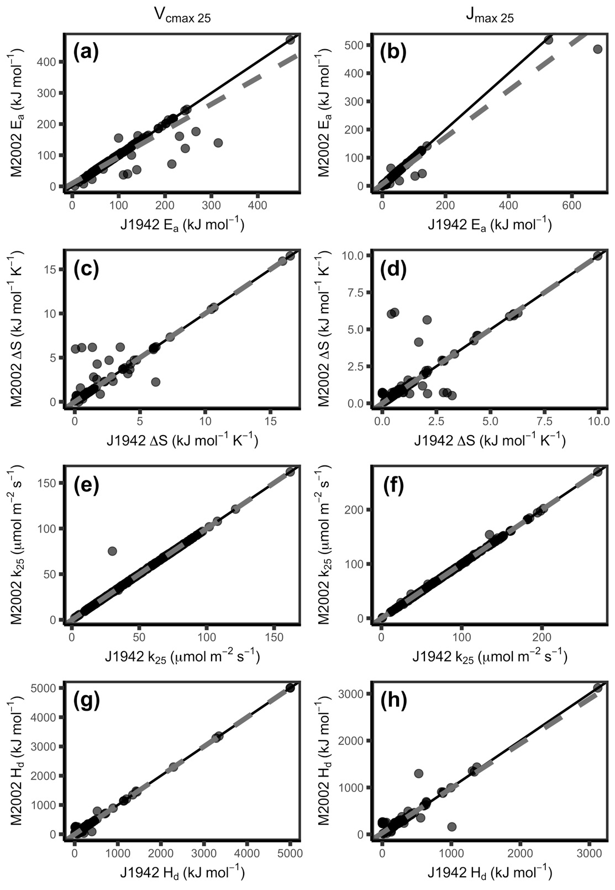
Figure 2. The modified Arrhenius equation missing the term (M2002) compared to J1942 fits different values for E_{a} (a,b), but mostly similar values for ΔS (c,d), k₂₅ (e,f) and H_{d} (f, g) for both V_{cmax} (a, c, e, g) and J_{max} (c, d, f, h). E_{a}: activation energy, ΔS: entropy parameter, k₂₅: rate of the process at 25 °C, H_{d}: deactivation energy, V_{cmax}: maximum capacity of rubisco carboxylation, J_{max}: maximum rate of electron transport. Black line indicates 1:1 line and grey dashed line indicates respective modelled slopes and intercepts.
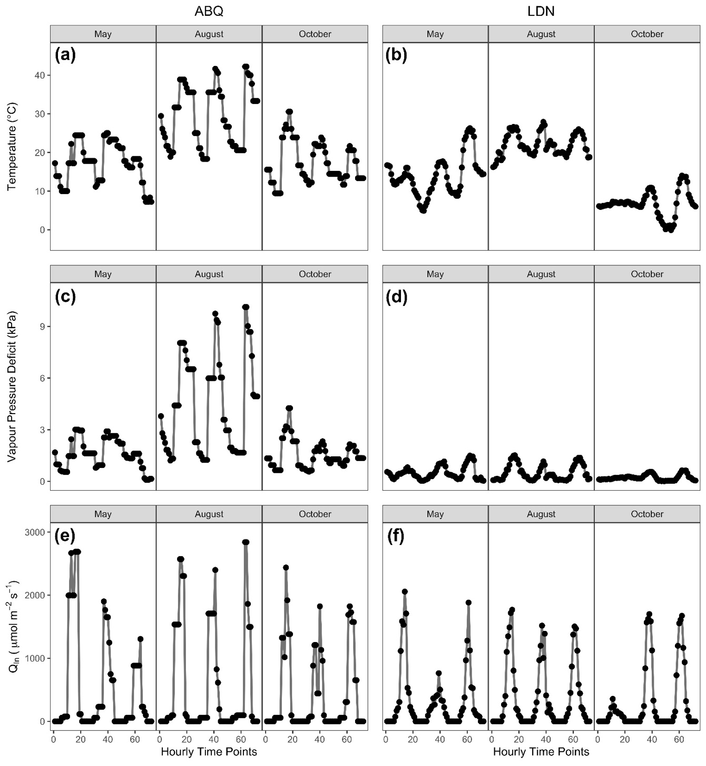
Figure 3. Hourly environmental data used to drive the model in Table 3 covering 3 days (17th, 18th, and 19th) of 3 months. (a,c,e) Albuquerque, NM, USA (ABQ); (b,d,e) London, ON, Canada (LDN). Environmental parameters include: a,b) temperature; c,d) vapour pressure deficit; and e,f) irradiance (Q_{in}).

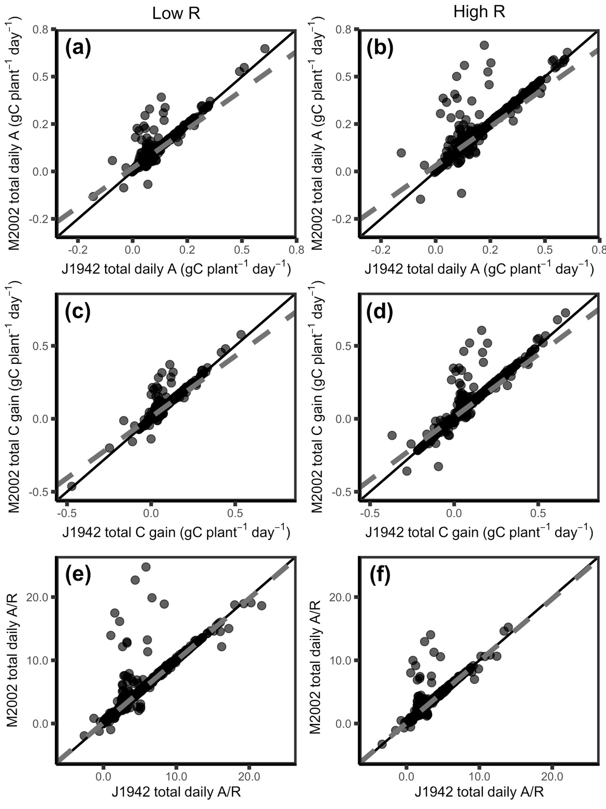
Figure 4. The modified Arrhenius equation without the missing term (M2002) gives differences in modelled daily carbon fluxes compared to J1942 for low R (a,c,e) and high R (b,d,f) under scenarios where H_{d} is allowed to vary. Modelled carbon fluxes include: a,b) Total daily photosynthesis; c,d) total daily C gain; and e,f) total daily A/R. A: photosynthesis, R respiration, Low R: low respiration, High R: high respiration. Black line indicates 1:1 line and grey dashed line indicates respective modelled slopes and intercepts.

References
Amthor JS. 2000. Direct effect of elevated CO₂ on nocturnal in situ leaf respiration in nine temperate deciduous tree species is small. Tree Physiology 20: 139–144.
Arora VK, Katavouta A, Williams RG, Jones CD, Brovkin V, Friedlingstein P, Schwinger J, et al. 2020. Carbon-concentration and carbon-climate feedbacks in CMIP6 models, and their comparison to CMIP5 models. Biogeosciences doi: 10.5194/bg-2019-473.
Arrhenius S. 1915. Quantitative laws in biological chemistry. Bell: London.
Atkin OK, Tjoelker MG. 2003. Thermal acclimation and the dynamic response of plant respiration to temperature. Trends in Plant Science 8:343-351.
Ayub G, Smith RA, Tissue DT, Atkin OK. 2011. Impacts of drought on leaf respiration in darkness and light in Eucalyptus saligna exposed to industrial-age atmospheric CO₂ and growth temperature. New Phytologist 190: 1003-1018.
Bernacchi CJ, Singsaas EL, Pimentel C, Portis Jr AR, Long SP. 2001. Improved temperature response functions for models of rubisco-limited photosynthesis. Plant Cell and Environment 24:253-259.
Blackman, VH. 1919. The compound interest and plant growth. Annals of Botany 33: 353-360.
Bonan GB. 1996. A Land Surface Model (LSM Version 1.0) for Ecological, Hydrological, and Atmospheric Studies: Technical Description and User's Guide (No. NCAR/TN-417+STR). University Corporation for Atmospheric Research. doi:10.5065/D6DF6P5X
Calvet J-C, Noilhan J, Roujean J-L, Bessemoulin P, Cabelguenne M, Olioso A, Wigneron J-P. 1998. An interactive vegetation SVAT model tested against data from six contrasting sites. Agricultural and Forest Meteorology 92:73-95
Cao J, Wang B, Yang Y-M, Ma L, Li J, Sun B, Bao Y, He J, Zhou X, Wu L. 2018. The NUIST Earth System Model (NESM) version 3: description and preliminary evaluation. Geoscientific Model Development 11:2975-2993.
Causton, DR. 1991. Plant-growth analysis: the variability of relative growth rate within a sample. Annals of Botany 67(2): 137-144.
Ciais P, Sabine C, Bala G, Bopp L, Brovkin V, Canadell J, Chhabra A, DeFries R, Galloway J, Heimann M. 2013. Carbon and Other Biogeochemical Cycles. In: Heinze C, Tans P, Vesala T, eds. Climate Change 2013: The Physical Science Basis. Cambridge, UK, and New York, NY, USA: Cambridge University Press.
Clark DB, Mercado LM, Sitch S, Jones CD, Gedney N, Best MJ, Pryor M, et al. 2011. The Joint UK Land Environment Simulator (JULES), model description – part 2: carbon fluxes and vegetation dynamics. Geoscientific Model Development 4:701-722.
Drake JE, Tjoelker MG, Aspinwall MJ, Reich PB, Pfautsch S, Barton CVM. 2019. The partitioning of gross primary production for young Eucalyptus tereticornis trees under experimental warming and altered water availability. New Phytologist 222: 1298-1312
Duursma RA. 2015. Plantecophys – an R package for analysing and modelling leaf gas exchange data. PLoS ONE 10:e0143346.
Duursma RA, Medlyn BE. 2012. MAESPA: a model to study interaction between water limitation, environmental drivers and vegetation function at tree and stand levels, with an example application to [CO₂] x drought interactions. Geoscientific Model Development 5:919-940.
Elzhov TV, Mullen KM, Spiess A-N, Bolker B. 2016. minpack.lm: R Interface to the Levenberg-Marquardt nonlinear least-squares algorithm found in MINPACK, plus support for bounds. R package version 1.2-1. https://CRAN.R-project.org/package=minpack.lm
Farquhar GD, von Caemmerer S, Berry JA. 1980. A biochemical model of photosynthetic CO₂ assimilation in leaves of C₃ species. Planta 149: 78-90.
Friend AD, Kiang NY. 2005. Land surface model development for the GISS GCM: effects of improved canopy physiology on simulated climate. Journal of Climate 18:2883-2902.
Hall AE. 1979. A model of leaf photosynthesis and respiration for predicting carbon dioxide assimilation in different environments. Oecologia 43: 299-316.
Harley PC, Baldocchi DD. 1995. Scaling carbon dioxide and water vapour exchange from leaf to canopy in a deciduous forest. I. Leaf model parameterization. Plant, Cell and Environment 18:1146-1156.
Harley PC, Thomas RB, Reynolds JF, Strain BR. 1992. Modelling photosynthesis of cotton grown in elevated CO₂. Plant, Cell and Environment 15:271-282.
Harley PC, Tenhunen JD, Lange OL. 1986. Use of an analytical model to study limitations on net photosynthesis in Arbutus unedo under field conditions. Oecologia 70:393-401.
Haverd V, Smith B, Nieradzik L, Briggs PR, Woodgate W, Trudinger CM, Canadell JG, Cuntz M. 2018. A new version of the CABLE land surface model (Subversion revision r4601) incorporating land use and land cover change, woody vegetation demography, and a novel optimization-based approach to plant coordination of photosynthesis. Geoscientific Model Development 11:2995-3026.
Heskel MA, O’Sullivan OS, Reich PB, Tjoelker MG, Weerasinghe LK, Penillard A, Egerton JJG, et al. 2016. Convergence in the temperature response of leaf respiration across biomes and plant functional types. Proceedings of the National Academy of Sciences USA 113: 3832-3837.
Hobbs JK, Jiao W, Ester AD, Parker EJ, Schipper LA, Arcus VL. 2013. Change in heat capacity for enzyme catalysis determines temperature dependence of enzyme catalyzed rates. ACS Chemical Biology 8:2388-2392.
Hosaka M. 2011. A new MRI land surface model HAL. AGU Fall Meeting Abstracts GC43B-0901.
Ito A. 2020. Changing ecophysiological processes and carbon budget in East Asian ecosystems under near-future changes in climate: implications for long-term monitoring from a process-based model. Journal of Plant Research 123:577-588.
Jensen JLWV. 1906. Sur les fonctions convexes et les inégalités entre les valeurs moyennes. Acta Mathematica 30: 175-193.
Ji J. 1995. A climate-vegetation interaction model: simulating physical and biological processes at the surface. Journal of Biogeography 22:445-451.
Joetzjer E, Delire C, Douville H, Ciais P, Decharme B, Carrer D, Verbeeck H, De Weirdt M, Bonal D. 2015. Improving the ISBA_{CC} land surface model simulation of water and carbon fluxes and stocks over the Amazon forest. Geoscientific Model Development 8:1709-1727.
Johnson FH, Eyring H, Williams RW. 1942. The nature of enzyme inhibitions in bacterial luminescence: sulfanilamide, urethane, temperature and pressure. Journal of Cellular and Comparative Physiology 20:247-268.
Kattge J, Knorr W. 2007. Temperature acclimation in a biochemical model of photosynthesis: a reanalysis of data from 36 species. Plant, Cell and Environment 30:1176-1190.
Kruse J, Hopmans P, Adams MA. 2008. Temperature responses are a window to the physiology of dark respiration: differences between CO₂ release and O₂ reduction shed light on energy conservation. Plant, Cell and Environment 31: 901-914.
Kumarathunge DP, Medlyn BE, Drake JE, Tjoelker MG, Aspinwall MJ, Battaglia M, Cano FJ, Carter KR, Molly AC, Lucas AC, et al. 2019. Acclimation and adaptation components of the temperature dependence of plant photosynthesis at the global scale. New Phytologist 222:768-784.
Kumarathunge DP, Medlyn BE, Drake JE, Tjoelker MG, Aspinwall MJ, Battaglia M, Cano FJ, Carter KR, Molly AC, Lucas AC, et al. 2018. ACi-TGlob_V1.0: a global dataset of photosynthetic CO₂ response curves of terrestrial plants. doi: 10.6084/m9.figshare.7283567.v1.
Lawrence D, Fisher R, Koven C, Oleson K, Swenson S, Vertenstein M, et al. 2018. Technical Description of version 5.0 of the Community Land Model (CLM). National Center for Atmospheric Research. http://www.cesm.ucar.edu/models/cesm2/land/
Lloyd J, Grace J, Miranda AC, Meir P, Wong SC, Miranda HS, Wright IR, Gash JHC, McIntyre J. 1995. A simple calibrated model of Amazon rainforest productivity based on leaf biochemical properties. Plant, Cell and Environment 18:1129-1145.
Lombardozzi DL, Bonan GB, Smith NG, Dukes JS, Fisher RA. 2015. Temperature acclimation of photosynthesis and respiration: a key uncertainty in the carbon cycle-climate feedback. Geophysical Research Letters 42:8624-8631.
Loveys BR, Atkinson LJ, Sherlock DJ, Roberts RL, Fitter AH, Atkin OK. 2003. Thermal acclimation of leaf and root respiration: An investigation comparing inherently fast- and slow-growing plant species. Global Change Biology 9(6): 895-910.
Medlyn BE, Duursma RA, Eamus D, Ellsworth DS, Prentice IC, Barton CVM, Crous KY, et al. 2011. Reconciling the optimal and empirical approaches to modelling stomatal conductance. Global Change Biology 17:2134-2144.
Medlyn BE, Dreyer E, Ellsworth D, Forstreuter M, Harley PC, Kirschbaum MUF, Le Roux X, et al. 2002. Temperature responses of parameters of a biochemically based model of photosynthesis. II. A review of experimental data. Plant, Cell and Environment 25:1167-1179.

Milly PCD, Malyshev SL, Shevliakova E, Dunne KA, Findell KL, Gleeson T, Liang Z, et al. 2014. An enhanced model of land water and energy for global hydrologic and Earth-system studies. Journal of Hydrometeorology 15:1739-1761.
Norman JM, Campbell GS. 1998. An introduction to environmental biophysics. New York NY: Springer.

Pommerening A, Muszta, A. 2015. Methods of modelling relative growth rate. Forest Ecosystems 2:5.
Poorter H, Niklas KJ, Reich PB, Oleksyn J, Poot P, Mommer L. 2012. Biomass allocation to leaves, stem, and roots: meta-analyses of interspecific variation and environmental control. New Phytologist 193: 30-50.
R Core Team. 2019. R: A language and environment for statistical computing. R Foundation for Statistical Computing, Vienna, Austria. URL https://www.R-project.org/.
Rogers A, Medlyn BE, Dukes JS, Bonan G, von Caemmerer S, Dietze MC, Kattge J, et al. 2017. A roadmap for improving the representation of photosynthesis in Earth system models. New Phytologist 213:22-42.
Sato N, Sellers PJ, Randall DA, Schneider EK, Shukla J, Kinter JL, Hou Y-T, Albertazzi E. 1989. Implementing the Simple Biosphere Model (SiB) in a general circulation model: methodologies and results. NASA Technical Report NASA-CR-185509.
Sharpe PJH, DeMichele DW. 1977. Reaction kinetics of poikilotherm development. Journal of Theoretical Biology 64: 649-670.
Shipley, B. 1989. The use of above-ground maximum relative growth-rate as an accurate predictor of whole-plant maximum relative growth-rate. Functional Ecology 3(6): 771-775.
Sitch S, Smith B, Prentice IC, Arneth A, Bondeau A, Cramer W, Kaplan JO, et al. 2003. Evaluation of ecosystem dynamics, plant geography and terrestrial carbon cycling in the LPJ dynamic global vegetation model. Global Change Biology 9:161-185.
Smith NG, Dukes JS. 2017. Short-term acclimation to warmer temperatures accelerates leaf carbon exchange processes across plant types. Global Change Biology 23:4840-4853.
Stinziano JR, Murphy BK. 2020. arrhenius.comparison: comparing versions of the modified Arrhenius equation. R package version 1.0.0.
Stinziano JR, Way DA. 2017. Autumn photosynthetic decline and growth cessation in seedlings of white spruce are decoupled under warming and photoperiod manipulations. Plant, Cell and Environment 40:1296-1316.
Stinziano JR, Way DA, Bauerle WL. 2018. Improving models of photosynthetic thermal acclimation: which parameters are most important and how many should be modified? Global Change Biology 24:1580-1598.
Stinziano JR, Bauerle WL, Way DA. 2019. Modelled net carbon gain responses to climate change in boreal trees: impacts of photosynthetic parameter selection and acclimation. Global Change Biology 25:1445-1465.
Swart NC, Cole JNS, Kharin VV, Lazare M, Scinocca JF, Gillett NP, Anstey J, et al. 2019. The Canadian Earth System Model version 5 (CanESM5.0.3). Geoscientific Model Development 12:4823-4873.
Tjoelker M, Oleksyn J, Reich P. 1999. Acclimation of respiration to temperature and CO₂ in seedlings of boreal tree species in relation to plant size and relative growth rate. Global Change Biology 49(6): 679-691.
Volodin EM, Lykosov VN. 1998. Parameterization of heat and moisture transfer in the soil-vegetation system for use in atmospheric general circulation models: 1. Formulation and simulations based on local observational data. Izvestiya Atmospheric and Oceanic Physics 34:405-416.
Way DA, Yamori W. 2014. Thermal acclimation of photosynthesis: on the importance of adjusting our definitions and accounting for thermal acclimation of respiration. Photosynthesis Research 119:89-100.
Weger HG, Guy RD. 1991. Cytochrome and alternative pathway respiration in white spruce (Picea glauca) roots. Effects of growth and measurement temperature. Physiologia Plantarum 83:675-681.

