**Modeling Results – Murphy & Stinziano**

HD 200kPa

WEEK 1

*Total Daily C Gain*

Summary Statistics:

* F-stat = 1.726e+06, DF = 1,898, p-value<2.2e-16, R-squared = 0.995
* Slope = 0.978097 and intercept = 0.001426

*Total Daily Photosynthesis*

Summary Statistics:

* F-stat = 1.625e+06, DF = 1,898, p-value<2.2e-16, R-squared = 0.9994
* Slope = 0.977255 and intercept = 0.002224

*Total Daily A/R*

Summary Statistics:

* F-stat = 3.109e+06, DF = 1,898, p<2.2e-16, R-squared = 0.9997
* Slope = 0.9933 and intercept = 0.0255

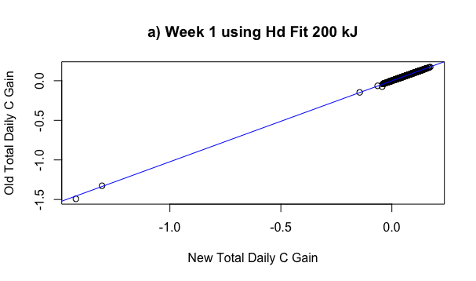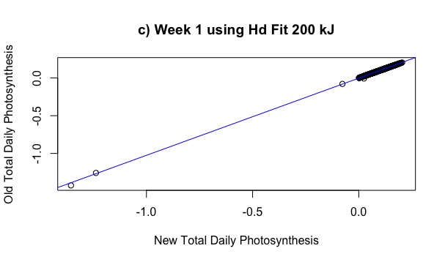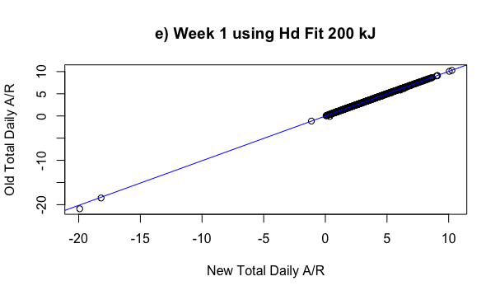

WEEK 12

*Total Daily C Gain*

Summary Statistics:

* F-stat: 1.821e+06, DF = 1, 898, p<2.2e-16, R2=0.9995
* Slope = 0.979928 and intercept = 0.001377

*Total Daily Photosynthesis*

Summary Statistics:

* F-stat: 1.625e+06, DF = 1,898, p<2.2e-16, R2 =0.9994
* Slope = 0.977255 and intercept = 0.003779

*Total Daily A/R*

* F-stat = 3.115e+06, DF = 1,898, p<2.2e-16, R2 = 0.9997
* Slope = 0.99336 and intercept = 0.01436

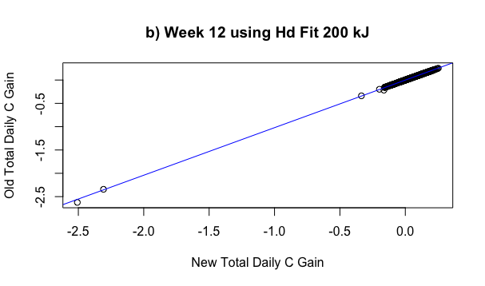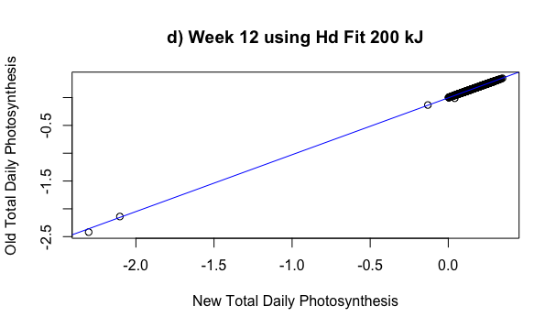

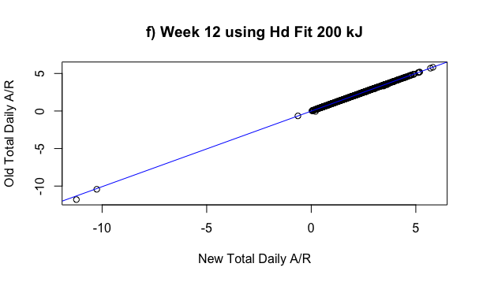

HD Fitted

WEEK 1

*Total Daily C Gain*

Summary Statistics:

* F-statistic = 1.06e+06, DF = 1,556, p-value < 2.2e-16, R2=0.9995
* Slope = 0.983546 and intercept = 0.001233

*Total Daily Photosynthesis*

Summary Statistics:

* F-statistic = 9.834e+05, DF = 1,556, p-value <2.2e-16, R2=0.9994
* Slope = 0.982618 and intercept = 0.001859

*Total Daily A/R*

Summary Statistics:

* F-statistic = 6.857e+05, DF = 1,556, p-value < 2.2e-16, R2=0.9992
* Slope = 0.99428 and intercept = 0.02961

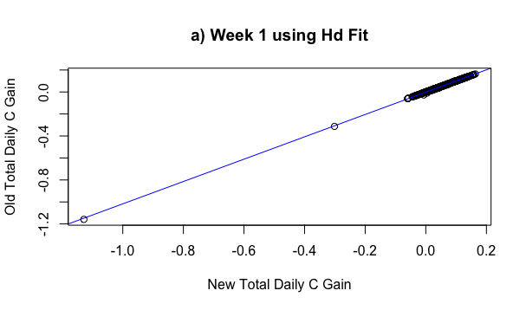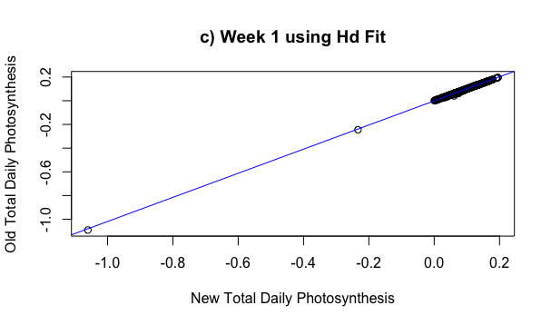

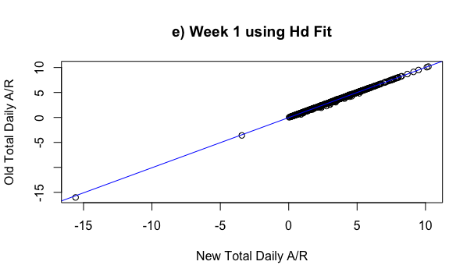

WEEK 12

*Total Daily C Gain*

Summary Statistics:

* F-statistic = 1.17e+06, DF = 1,556, p-value = <2.2e-16, R-squared = 0.995
* Slope = 0.985405 and intercept = 0.001282

*Total Daily Photosynthesis*

Summary Statistics:

* F-statistic = 9.834e+05, DF = 1,556, p-value = <2.2e-16, R-squared = 0.994
* Slope = 0.982618 and intercept = 0.003158

*Total Daily A/R*

Summary Statistics:

* F-statistic = 6.812e+05, DF = 1,556, p-value<2.2e-16, R-squared = 0.9992
* Slope = 0.99430 and intercept = 0.01671

