**Title: A derivation error that affects carbon balance models exists in the current implementation of the Johnson et al. (1942) modified Arrhenius function**

**Running Title: Derivation error in modified Arrhenius model**

Author: Bridget Murphy1, Joseph R. Stinziano2,*

Affiliations: 1 Department of Biology, University of Western Ontario, London, ON, Canada;   
2 Department of Biology, University of New Mexico, Albuquerque, NM, USA

* Corresponding author; Email: jstinziano@unm.edu; Tel: +1 (226) 678-1670

Article Type: Modeling/Theory

Word Count: 3,147

Introduction: 530

Material & Methods: 1323

Results: 671

Discussion: 597

Acknowledgments: 26

Number of Tables: 2  
Number of Figures: 4

Supplementary Files: 1

**Summary**

* Understanding biological temperature responses is crucial to predicting global carbon fluxes. The current approach to modeling temperature responses of photosynthetic capacity in large scale modeling efforts uses a modified Arrhenius equation.
* We rederived the modified Arrhenius equation from the source publication from 1942 and uncovered a missing term that was completely dropped by 2002. We compare fitted temperature response parameters between the new and old derivation of the modified Arrhenius equation.
* We find that most parameters are minimally affected, though activation energy is impacted quite substantially. We then scaled the impact of these small errors to whole plant carbon balance and found that the impact of the rederivation of the Arrhenius on modelled daily carbon gain causes a meaningful deviation of ~18% day-1.
* This suggests that the error in the derivation of the modified Arrhenius equation has impacted the accuracy of predictions of carbon fluxes at larger scales. We recommend that the derivation error be corrected in modeling efforts moving forward.

*Keywords: Arrhenius, temperature, photosynthesis, gas exchange, modeling, carbon balance*

**Introduction**

Globally, photosynthesis and autotrophic respiration are the largest biological carbon fluxes, with photosynthesis removing ~120 Gt C year-1 from the atmosphere and autotrophic respiration releasing ~60 Gt C year-1 back to the atmosphere (Amthor, 2000; Ciais et al., 2013). Given the temperature sensitivity of these large carbon fluxes (Lombardozzi et al., 2015), understanding how photosynthesis and respiration respond on acute, acclimatory, and adaptive timescales is crucial for predicting vegetative and carbon cycle responses to future global climates (Rogers et al., 2017; Stinziano et al. 2018). Biological temperature responses including photosynthesis and respiration are typically assumed to be exponential or peaked (Way and Yamori, 2014; Smith & Dukes, 2017; Kumarathunge et al., 2019). Exponential responses are usually modelled based on an Arrhenius-type curve (Arrhenius, 1915):

Equation 1,

or equivalently,

Equation 2

where f(T) is the rate of the process at temperature T, A is a pre-exponential factor, T in K, k25 is the rate of the process at 298.15 K, Ea is the activation energy in J mol-1, R is the universal gas constant of 8.314 J mol-1 K-1, and 298.15 is the reference temperature in K. As for peaked responses, while a few options are available (Kruse et al., 2008; Hobbs et al., 2013; Heskel et al., 2016), the most commonly implemented version is the modified Arrhenius model of Johnson et al. (1942) as presented in Medlyn et al. (2002):

Equation 3

where Hd is the deactivation energy in J mol-1, and ΔS is the entropy of the process in J mol-1 K-1.

Equation 3 is used for modeling the temperature responses of photosynthetic capacity (i.e. maximum carboxylation capacity of rubisco, Vcmax, maximum electron transport capacity, Jmax, and triose phosphate utilization capacity (TPU); see Rogers et al., 2017 for a review of models using Equation 3). These parameters are then used in ecophysiological studies to understand thermal acclimation of photosynthesis (see Kattge & Knorr, 2007; Smith & Dukes, 2017; and Kumarathunge et al., 2019 for examples). Furthermore, this equation is also used in terrestrial biosphere models to predict the future carbon cycling (e.g. Rogers et al., 2017).

Due to the ubiquity of Equation 3 in modeling temperature responses and the thermal acclimation of photosynthetic capacity (e.g. Kattge & Knorr, 2007; Rogers et al., 2017; Smith & Dukes, 2017; Kumarathunge et al., 2019), we revisited the original Johnson et al. (1942) modified Arrhenius function to rederive Equation 3. In the process of this rederivation, we uncovered a term that was completely dropped sometime between Johnson et al. (1942) and Medlyn et al. (2002) which causes a systematic error in the application of Equation 3 for modeling photosynthetic capacity in individual species (e.g. Medlyn et al., 2002) to modeling global scale carbon uptake (e.g. Rogers et al., 2017). We then refit a freely available dataset (Kumarathunge et al., 2019), with both versions of the modified Arrhenius model, and fed the temperature response fits through a carbon balance model to estimate the impact of the derivation error on modelled plant carbon balance. We predicted that the derivation error would cause substantial variation in fitted temperature response parameters, and that these differences would propagate through to modelled daily carbon balance.

**Materials & methods**

**Rederivation of the modified Arrhenius equation**

Johnson et al. (1942, equation 24) describe the temperature response of the light intensity of a luciferase reaction as:

Equation 4

where I is the intensity of the luciferase reaction, c’’ is not explicitly defined in Johnson et al. (1942), but appears to represent a constant based on the derivation of Equation 4, T is the temperature in K, R is the universal gas constant of 8.314 J mol-1 K-1, ΔH‡ is the activation energy in J mol-1, ΔH is the deactivation energy in J mol-1, and ΔS is the entropy in J mol-1 K-1. We can relativize the equation to a reference temperature by dividing Equation 4 at a hypothetical temperature by Equation 4 at a standard temperature (i.e. 25 °C):

Equation 5

Next, rearrange fractions for clarity:

Equation 6

Cancel out c’’, use exponent rules to simplify:

Equation 7

Simplify further by setting a common denominator within exponential terms:

Equation 8

Simplify exponential terms further:

Equation 9

Harmonizing the notation scheme to that typically used in plant ecophysiology:

Equation 10

Note the difference between Equations 3 and 10: the term T / 298.15 is missing from Equation 3. There are several alternative expressions of Equation 4 (e.g. Farquhar et al., 1980; Harley et al., 1986; Harley et al., 1992; Harley & Baldocchi, 1995; Lloyd, 1995), however when relativized to a common temperature, the equations presented in Farquhar et al. (1980), Harley et al. (1992), Harley & Baldocchi (1995), and Lloyd (1995) are all identical to Eq. 3 when relativized by temperature, while the Harley et al. (1986) equation is identical to our derivation when relativized to a common temperature (see Appendix A for the relativizations of Farquhar et al. (1980), Harley et al. (1986), and Harley et al. (1992); Harley & Baldocchi (1995) uses an identical equation to Eq. 18 from Medlyn et al. (2002), while Lloyd (1995) uses an identical equation to Eq. 17 from Medlyn et al. (2002)). This derivation error introduces multiple systematic errors. First, errors are introduced into the fitted parameters Ea, Hd, and ΔS. Second, k25 is scaled using the wrong equation, introducing an error in f(T). And third, acclimation equations describing Ea, Hd, and ΔS will then be in error due to errors in the fitted parameters at each temperature. Here we focus on the impact of the dropped term on fitted temperature response parameters and modeling whole-plant carbon balance.

**Data analysis**

Using A-Ci curve data compiled in Kumarathunge et al. (2019), available from the Kumarathunge et al. (2018) repository, we used the {fitacis} function from the R package {plantecophys} (Duursma, 2015), setting fitmethod = “bilinear”, Tcorrect = FALSE, and fitTPU = TRUE, to obtain Vcmax and Jmax. We then fit Equations 3 and 10 to the data, allowing Hd to be fit. To ensure that the curves could be fit (i.e. that there were enough data to fit 4 parameters), we only used data where A-Ci curves were measured at 5 or more temperatures. This reduced the number of candidate temperature responses from 729 to 403. We used the R package {minpack.lm} (Elzhov et al., 2016), using Equation 2 to obtain starting values for Ea and k25, while the other initial parameters were ΔS = 0.650 kJ mol-1 K-1, and Hd varying from 1 to 1000 kJ mol-1, followed by the {BIC} function to select the best model based on Bayesian Information Criteria. We obtained 341 and 337 successful Vcmax temperature response curve fits for Equations 3 and 10, respectively, and 241 and 242 successful Jmax temperature response curve fits for Equations 3 and 10, respectively. This resulted in a total of 547 fitted temperature response curves which we filtered further, requiring that Ea, ΔS, and Hd were all positive values and that the Vcmax and Jmax data were paired, resulting in 196 complete pairs of Vcmax and Jmax temperature responses for analysis. The data covered a temperature range from 1 °C to 50 °C across all curves, with a median range of 14 °C to 42.6 °C.

**Modeling**

We modelled the impact of the Equations 3 and 10 on daily net plant carbon balance. Data for leaf area, root and shoot masses, as well as leaf dark respiration at 25 °C were taken for white spruce (*Picea glauca*) from Stinziano & Way (2017), while stomatal conductance model parameters were calculated with the gas exchange data reported in Stinziano & Way (2017). Briefly, Stinziano and Way (2017) grew white spruce in growth chambers under a simulated autumn treatment based on temperatures and photoperiods from Trenton, ON, with weekly harvesting of biomass and gas exchange measurements across 17 weeks as a control treatment, along with a warming treatment where temperatures were +5 °C of the control, a constant summer day/night temperature with declining photoperiod, and a constant summer photoperiod with ambient changes in temperature. Here we only used data from Stinziano & Way (2017) that were from the control treatment. Mean data were taken from the control treatment at weeks 0 and 12 to provide contrasting biomass allocation patterns such that week 0 is a low respiration scenario and week 12 is a high respiration scenario. These different respiration scenarios were used to reduce bias in any conclusions regarding the impact of Equations 3 and 10 on carbon balance, as the ratio of photosynthesis to respiration may alter the sensitivity of net carbon balance to the Arrhenius equation used. Root respiration for white spruce was taken from Weger and Guy (1991) and we assumed that stem respiration was equal to root respiration (Table 1).

**Table 1. Parameters used in modeling daily carbon gain.**

|  |  |  |  |
| --- | --- | --- | --- |
| Parameter | Group | Value | Reference |
| Respiration | Rdark | 2.78 μmol m-2 s-1 | Stinziano & Way, 2017 |
|  | Rday | 0.7 * Rdark | Ayub et al., 2011 |
|  | Rroot | 0.0095 μmol g-1 s-1 | Weger & Guy, 1991 |
|  | Rstem | 0.0095 μmol g-1 s-1 | Assumed |
|  | Q10 | 2.015 | Atkin & Tjoelker, 2003 |
| Γ* | 25 °C | 42.75 μmol mol-1 | Bernacchi et al., 2001 |
|  | Ea | 37.83 kJ mol-1 | Bernacchi et al., 2001 |
| Km | 25 °C | 718.4 μmol mol-1 | Bernacchi et al., 2001 |
|  | Ea | 65.51 kJ mol-1 | Bernacchi et al., 2001 |
| α |  | 0.8 | Norman & Campbell, 1998 |
| φ |  | 0.08 | Norman & Campbell, 1998 |
| Leaf Area | Low R | 0.015 m2 | Stinziano & Way, 2017 |
|  | High R | 0.025 m2 | Stinziano & Way, 2017 |
| Stem Mass | Low R | 0.496 g | Stinziano & Way, 2017 |
|  | High R | 2.523 g | Stinziano & Way, 2017 |
| Root Mass | Low R | 0.498 g | Stinziano & Way, 2017 |
|  | High R | 5.072 g | Stinziano & Way, 2017 |

**Q10: thermal sensitivity coefficient; Γ*: photorespiratory CO2 compensation point; Km: apparent Michaelis-Menten constant for rubisco carboxylation in 21% O2/air (i.e. Kc,air); α: absorbance of photosynthetically activation radiation; φ: maximum quantum efficiency of photosynthetic electron transport; Ea: activation energy; Rdark: leaf respiration in the dark; Rday: leaf respiration in the light; Rroot: root respiration; Rstem: stem respiration; Low R: low respiration scenario; High R: high respiration scenario.**

For the full model structure and equations, please see the accompanying R package {arrhenius.comparison} (“arrhenius.comparison_1.0.1.tar.gz”; Stinziano & Murphy, 2020) (see Table 2 for equations). Briefly, we linked the Medlyn et al. (2011) stomatal conductance model with the Farquhar et al. (1980) C3 photosynthesis model, assuming infinite mesophyll conductance to CO2 as these assumptions were used in fitting the data from Kumarathunge et al. (2018). Photosynthetic capacity, both maximum rubisco carboxylation capacity, Vcmax, and maximum electron transport rate, Jmax were scaled to temperature using either Equation 3 or 10, while respiration was scaled according to (Atkin & Tjoelker, 2003). Photosynthesis and respiration were summed across each modelled day to calculate daily plant carbon assimilation.

**Table 2. Equations used in modeling daily carbon uptake.**

|  |  |
| --- | --- |
| Equation | Reference |
|  | Atkin & Tjoelker, 2003 |
|  | Arrhenius, 1915 |
|  | Medlyn et al., 2002 |
|  | Johnson et al., 1942; this study |
|  | Farquhar et al., 1980 |
|  | Farquhar et al., 1980; Way et al., 2011 |
| Where J is calculated as the minimum root of: | |
|  |  |
|  |  |
|  | Medlyn et al., 2011 |
|  |  |
|  |  |
|  |  |

**f(T): rate of a process at a given temperature; T: temperature in K; k25: rate of a process at 25 °C; Q10: thermal sensitivity coefficient; Ea: activation energy in kJ mol-1; ΔS: entropy parameter in kJ mol-1; Hd: deactivation energy in kJ mol-1; R: universal gas constant in 0.008314 kJ mol-1 K-1; Wc: rate of CO2-limited carboxylation in μmol m-2 s-1; Wj: rate of RuBP regeneration-limited carboxylation in μmol m-2 s-1; Vcmax: maximum rate of rubisco carboxylation capacity in μmol m-2 s-1; Jmax: maximum rate of electron transport in μmol m-2 s-1; Ci: intercellular CO2 concentration in μmol mol-1; Γ*: photorespiratory CO2 compensation point in μmol mol-1; Km: Michaelis-Menten constant for rubisco in μmol mol-1; α: absorbance of photosynthetically active radiation; φ: maximum quantum efficiency of electron transport; Qin: incident photosynthetically active radiation; Agross: gross CO2 assimilation in μmol m-2 s-1; Anet: net CO2 assimilation in μmol m-2 s-1; Rday: leaf day respiration in μmol m-2 s-1; gs: stomatal conductance to water in mol m-2 s-1; go: intercept for the Medlyn et al. 2011 model; g1: slope for the Medlyn et al. 2011 model; VPD: vapor pressure deficit in kPa; Ca: CO2 concentration at the leaf surface in μmol mol-1; Aplant: whole plant net CO2 assimilation; LA: leaf area in m-2; Rdark: leaf dark respiration in μmol m-2 s-1; Rstem: stem respiration in μmol m-2 s-1; Rroot; root respiration in μmol m-2 s-1; SM: stem mass in g; RM: root mass in g; Cbalance: whole plant daily carbon balance in g plant-1 day-1.**

Modeling was performed on 18 total days of environmental data, with three days of data from three months (17th – 19th of May, August, and October, 2019) obtained from external irradiance sensors at the Biotron Experimental Climate Change Research Centre at the University of Western Ontario and the remaining environmental data from Environment Canada historical climate data for South London (43.01°N, 81.27°W, altitude: 251 m; temperature range: -0.1 – 27.9 °C) and the rooftop greenhouse at the University of New Mexico (35.08°N, 106.62°W, altitude: 1587 m; temperature range: 7.2 – 42.2 °C) to capture different levels of environmental variability (Fig. 1).

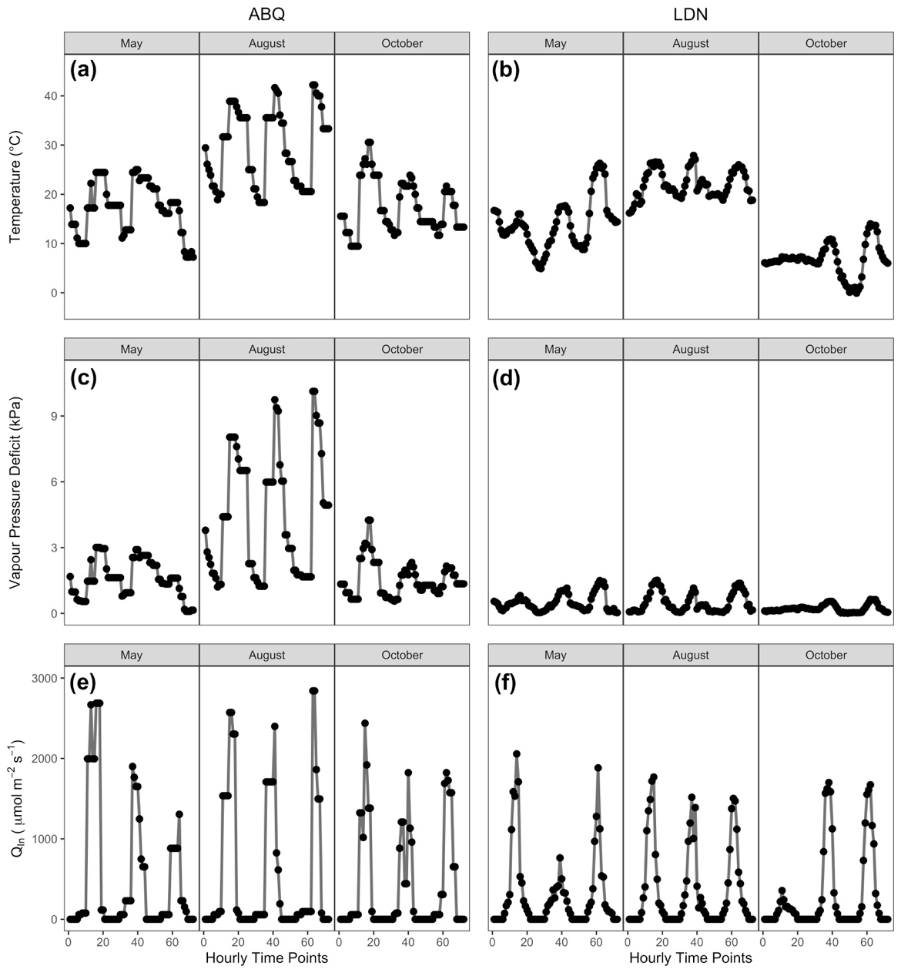

**Fig. 1. Environmental data used to drive the model in Table 1 covering 3 days (17th, 18th, and 19th) of 3 months. (a,c,e) Albuquerque, NM, USA (ABQ); (b,d,e) London, ON, Canada (LDN). Environmental parameters include: a,b) temperature; c,d) vapour pressure deficit; and e,f) irradiance (Qin).**

Overall, the modeling approach allows us to assess the relative differences between Equations 3 and 10 under a low- and high- respiration scenario across different ranges of seasonal variability.

*Statistical analysis*

Data were analyzed using the {lm} function in R v.3.6.2 (R Core Team, 2019), regressing the data obtained from Equation 3 against the data obtained from Equation 10 for each of Vcmax,25, Jmax,25, Ea,Vcmax, Ea,Jmax, ΔSVcmax­, ΔSJmax, Hd,Vcmax, Hd,Jmax, BIC values for the fits of Equations 3 and 10, daily photosynthesis, daily net carbon balance, and daily photosynthesis : daily respiration ratios. Intercepts in the regression, when significant, were interpreted as a bias in the parameter, while deviations in slope from a 1:1 relationship where interpreted as percentage over- or under- estimation of the parameter (i.e. [parameter slope – 1] ∙ 100 = % estimation error). All p-values were corrected for multiple testing using the p.adjust() function in R with Holm’s method. All code and data will be made freely available on GitHub upon publication in the {arrhenius.comparison} R package (Stinziano & Murphy, 2020).

**Results**

*Equations 3 and 10 exhibited similar performance*

The performance between Equations 3 and 10 for fitting Vcmax temperature responses were essentially identical when assessed based on BIC, with a slope of 1.001 ± 0.001 (*F1,195* = 5.52 ∙ 105, *R2* = 0.9996, *P* < 2.2 ∙ 10-16; Fig 2a), as was the case for Jmax with a slope of 1.001 ± 0.001 (*F1,195* = 2.43 ∙ 106, *R2* = 0.9999, *P* < 2.2 ∙ 10-16; Fig. 2b). However, while some fitted temperature responses appeared identical, there were some cases where the fitted shape differed (Figs. 2c-f).

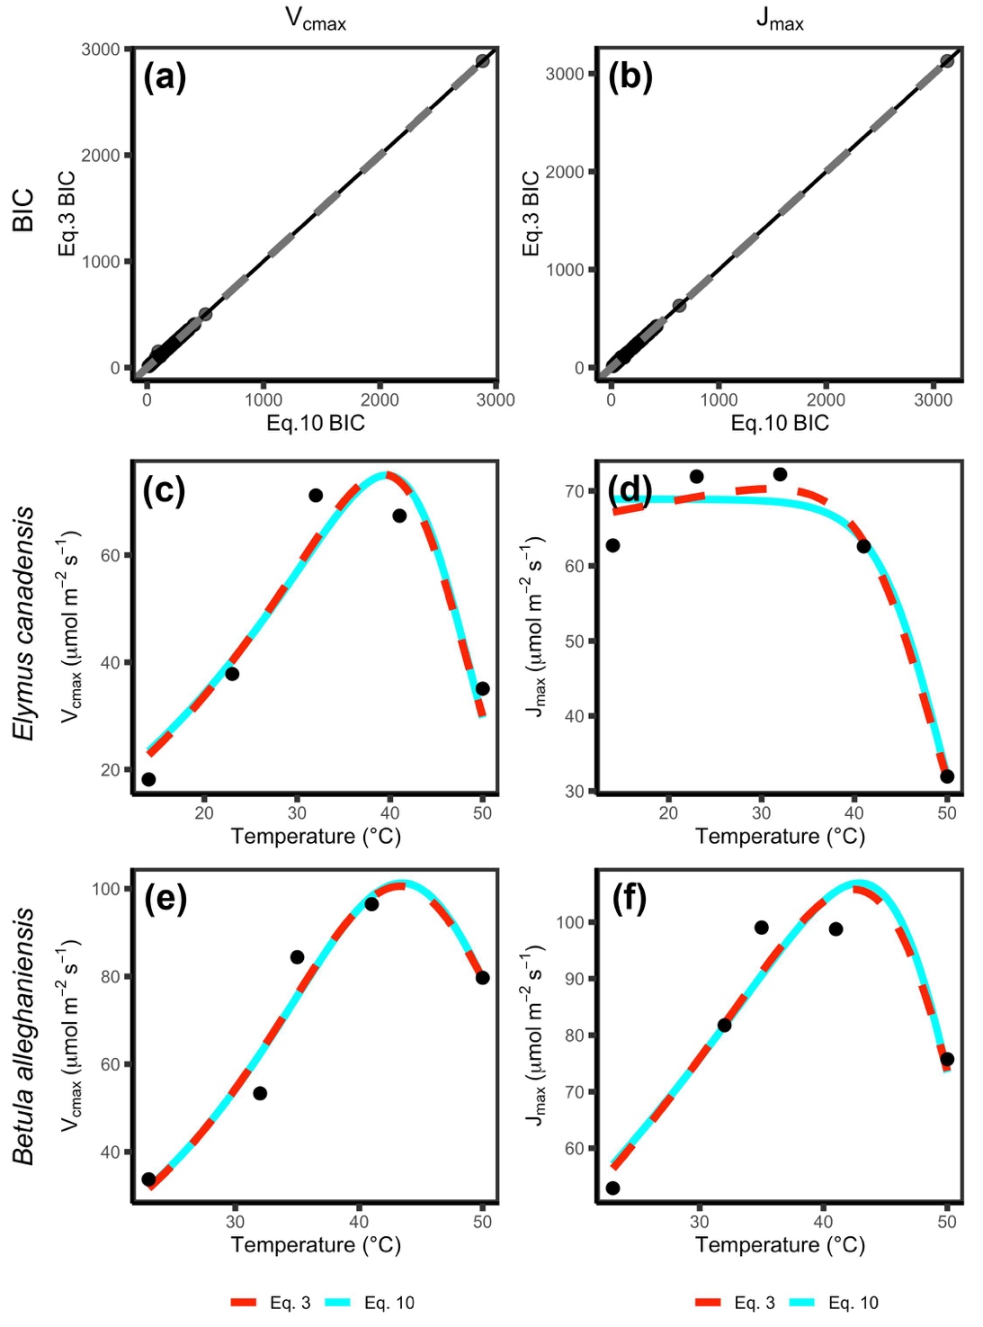

**Figure 2. Relative performance and fit for Equations 3 and 10 for temperature responses of Vcmax and Jmax based on a,b) Bayesian Information Criterion (BIC), and c-f) visual inspection of curve fits.**

Estimates of Vcmax,25 were essentially identical between the Equation 3 fitting (y-axis) and the Equation 10 fitting (x-axis) with a slope of 1.002 ± 0.004 (*F1,195* = 5.84 ∙ 104, *R2* = 0.9967, *P* < 2.2 ∙ 10-16; Fig 3e), as was the case for Jmax,25 with a slope of 1.001 ± 0.001 (*F1,195* = 6.56 ∙ 105, *R2* = 0.9997, *P* < 2.2 ∙ 10-16; Fig 3f). Ea,Vcmax was generally underestimated with a slope of 0.847 ± 0.024 and a positive bias of 9.73 ± 2.59 kJ mol-1 when using Equation 3 (*F1,194* = 1202, *R2* = 0.8610, *P* < 2.2 ∙ 10-16; Fig. 3a), while Ea,Jmax was underestimated with a slope of 0.832 ± 0.013 and a positive bias of 5.98 ± 1.06 kJ mol-1 (*F1,194* = 3834, *R2* = 0.9518, *P* < 2.2 ∙ 10-16; Fig. 3b). ΔSVcmax was essentially identical between Equation 3 and 10 with a slope of 1.000 ± 0.0233 (*F1,195* = 1849, *R2* = 0.9046, *P* < 2.2 ∙ 10-16; Fig. 3c), as was the case with ΔSJmax with a slope of 0.988 ± 0.033 (*F1,195* = 904, *R2* = 0.8226, *P* < 2.2 ∙ 10-16; Fig. 3d), and Hd,Vcmax with a slope of 1.002 ± 0.005 (*F1,195* = 4.12 ∙ 104, *R2* = 0.9953, *P* < 2.2 ∙ 10-16; Fig. 3g). However, Hd,Jmax was underestimated with a slope of 0.952 ± 0.024 and a positive bias of 31.48 ± 8.93 kJ mol-1 (*F1,194* = 1592, *R2* = 0.8914, *P* < 2.2 ∙ 10-16; Fig. 3h).

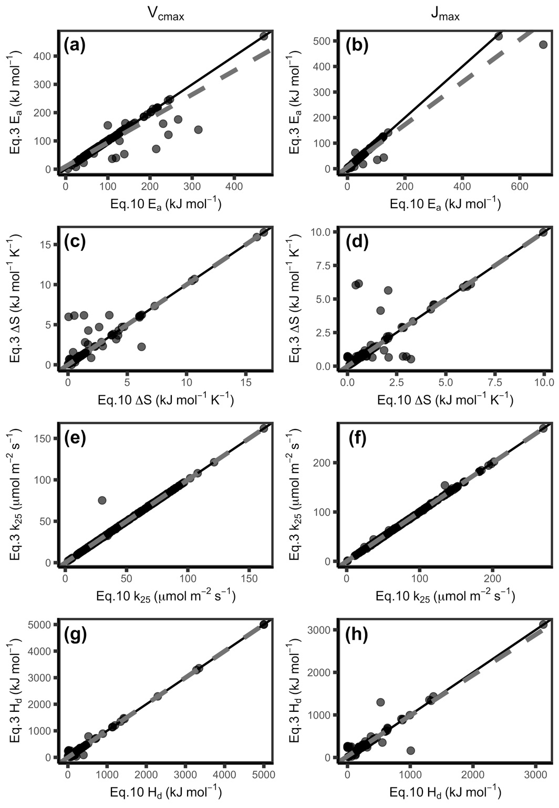

**Fig. 3. The modified Arrhenius equation missing the term (Equation 3) compared to Equation 10 fits different values for Ea (a,b), but mostly similar values for ΔS (c,d), k25 (e,f) and Hd (f, g) for both Vcmax (a, c, e, g) and Jmax (c, d, f, h). Ea: activation energy, ΔS: entropy parameter, k25: rate of the process at 25 °C, Hd: deactivation energy, Vcmax: maximum capacity of rubisco carboxylation, Jmax: maximum rate of electron transport. Black line indicates 1:1 line and grey dashed line indicates respective modeled slopes and intercepts.**

*Impacts on modelled net carbon balance*

In general, the differences in thermal response parameters were amplified when integrated at the whole-plant level. For modelled daily photosynthesis (A), the slope for the low respiration model was 0.819 ± 0.013 and the intercept was 0.018 ± 0.002 g plant-1 day-1 (Eq. 3 versus Eq. 10; approximately 18% of modeled A) (*F*1,3523 = 4.168 ∙ 103, R2 = 0.5418; *P* < 2.2 ∙ 10-16) (Fig. 4**a**). For the high respiration model of daily A, the slope was 0.819 ± 0.013and the intercept was 0.031 ± 0.003 g plant-1 day-1 (approximately 18% of modeled A) (*F*1,3523 = 4.168 ∙ 103, R2 = 0.5418; *P* < 2.2 ∙ 10-16) (Fig. 4**b**). The low respiration model of total daily carbon (C) gain had a slope of 0.836 ± 0.012 and an intercept of 0.012 ± 0.001 g plant-1 day-1 (approximately 16% of modeled C gain) (Eq. 3 versus Eq. 10; *F*1,3523 = 4.539 ∙ 103, R2 = 0.5629; *P* <2.2 ∙ 10-16) (Fig. 4**c**). The high respiration of total C gain similarly had a slope of 0.859 ± 0.012 and an intercept of 0.011 ± 0.002 g plant-1 day-1 (approximately 14% of modeled C gain) (Eq. 3 versus Eq. 10; *F*1,3523 = 5.364 ∙ 103, R2 = 0.6035; *P* <2.2 ∙ 10-16) (Fig. 4**d**). The ratio of the total daily photosynthesis: respiration (A/R) was also considered when comparing models. The low respiration model of A/R had a slope of 0.982 ± 0.007 and the intercept was 0.146 ± 0.031 (approximately 2% of modeled A/R) (Eq. 3 versus Eq. 10; *F*1,3523 = 2.096 ∙ 104, R2 = 0.8561; *P* <2.2 ∙ 10-16) (Fig. 4**e**). The high respiration model had a similar slope of 0.982 ± 0.007 and the intercept was 0.082 ± 0.017 (approximately 2% of modeled A/R) (Eq. 3 versus Eq. 10; *F*1,3523 = 2.097 ∙ 104, R2 = 0.8562; *P* <2.2 ∙ 10-16) (Fig. 4**f**).

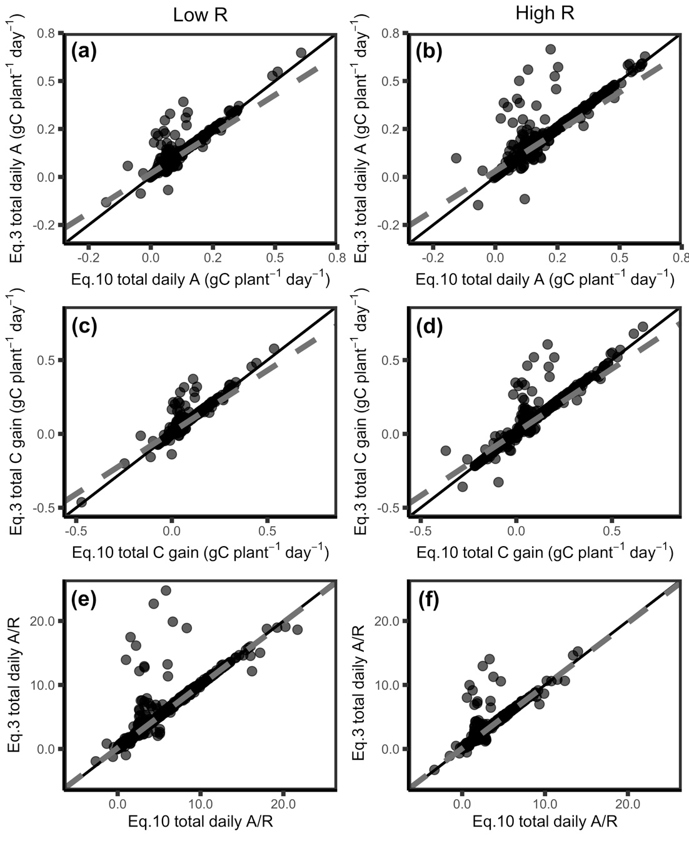

**Fig. 4. The modified Arrhenius equation without the missing term (Equation 3) gives differences in modeled daily carbon fluxes compared to Equation 10 for low R (a,c,e) and high R (b,d,f) under scenarios where Hd is allowed to vary. Modeled carbon fluxes include: a,b) Total daily photosynthesis; c,d) total daily C gain; and e,f) total daily A/R. A: photosynthesis, R respiration, Low R: low respiration, High R: high respiration. Black line indicates 1:1 line and grey dashed line indicates respective modeled slopes and intercepts.**

**Discussion**

We sought to determine whether the missing term in Equation 3 had a meaningful impact on fitted temperature response parameters due to its prevalence in photosynthetic temperature response data and vegetation modeling (Kattge & Knorr, 2007; Duursma & Medlyn, 2012; Rogers et al., 2017; Smith & Dukes, 2017; Stinziano et al., 2018; Stinziano et al., 2019; Kumarathunge et al., 2019). Our present analysis suggests that there is a large impact on Ea for both Vcmax and Jmax, however there were minimal impacts on k25, Hd, and ΔS (though note that Hd for Jmax was underestimated) (Fig. 3). In general, fitting Equation 3 instead of Equation 10 results in Ea reductions of around 15% with positive bias. These findings are promising in that one of the parameters to which modelled carbon gain is particularly sensitive, Hd (Stinziano et al., 2018), is minimally affected by the missing term. However, since temperature responses are non-linear, small changes in the shape of an accelerating curve can have a strong impact on the integral of the response (Jensen, 1906; i.e. changes in the shape of the temperature response of carbon assimilation can have strong impacts on total carbon fixation). Despite fit performance being nearly identical, the differences due to Ea values between the equations led to an 18% reduction in modeled daily photosynthesis for Equation 3 compared to Equation 10, leading ~14-16% reduction in modeled net daily carbon gain. Overall, comparisons of low-respiration to high-respiration scenarios resulted in similar percent changes in daily C balance with similar variation.

Not only did we compare the impact of the missing term in Equation 3 on different respiration scenarios, but we also modelled data across a range of environmental conditions to understand the impact on C balances of plants under different temperature regimes and how these impacts could scale up in global models. A ~15% reduction in net daily carbon gain is substantial by itself, but this difference would also be amplified over time for a single plant. Plant growth follows the compound interest law (Blackman, 1919). As leaf area increases with growth so does the rate of photosynthesis and thus the amount of carbon available to further increase growth and metabolism, hence why relative growth rates are commonly utilized in the literature (Loveys et al. 2003; Poorter et al., 2012; Causton, 1991; Tjoelker et al., 1999; Pommereng & Anders, 2015; Shipley, 1989). A reduction of 18% in modelled daily photosynthesis caused by using the modified equation with the missing term (Eq. 3) would become compounded long-term with plant growth and may result in underestimations of future carbon uptake. It is thus likely that the differences we observed would accumulate to even larger carbon flux errors across large spatial and temporal scales with fluctuating temperatures.

Based on the above analysis, the impact of the missing term in the modified Arrhenius equation substantially alters Ea and net daily carbon balance at a whole-plant level. Given that carbon balance is the time integral of net CO2 assimilation, this may lead to substantial impacts over a long time period. Despite the robust use of Equation 3 (e.g. Kattge & Knorr, 2007; Oikawa et al., 2016; Rogers et al., 2017; Smith & Dukes, 2017; Mercado et al., 2018; Kumarathunge et al., 2019), Equation 3 is still incorrect. We therefore recommend the switch from Equation 3 to Equation 10 because: 1) Equation 3 is the result of a derivation error, and 2) Equations 3 and 10 lead to different net daily carbon estimates due to the derivation error, which may currently be compensated by other factors in large-scale models.

**Acknowledgments**

We would like to thank Wesley J. Noe at the University of New Mexico for providing climate data. This research was supported by personal funds.

**Author Contributions**

Both authors contributed to all aspects of the study.

**Additional Information**

A version of this manuscript was posted on bioRxiv (manuscript ID: BIORXIV/2020/921973).

**References**

Amthor JS. 2000. Direct effect of elevated CO2 on nocturnal in situ leaf respiration in nine temperate deciduous tree species is small. Tree Physiology 20: 139–144.

Arrhenius S. 1915. Quantitative laws in biological chemistry. Bell: London.

Atkin OK, Tjoelker MG. 2003. Thermal acclimation and the dynamic response of plant respiration to temperature. Trends in Plant Science 8:343-351.

Ayub G, Smith RA, Tissue DT, Atkin OK. 2011. Impacts of drought on leaf respiration in darkness and light in *Eucalyptus saligna* exposed to industrial-age atmospheric CO2 and growth temperature. New Phytologist 190: 1003-1018.

Bernacchi CJ, Singsaas EL, Pimentel C, Portis Jr AR, Long SP. 2001. Improved temperature response functions for models of rubisco-limited photosynthesis. Plant Cell and Environment 24:253-259.

Blackman, VH. 1919. The compound interest and plant growth. Annals of Botany 33: 353-360.

Causton, DR. 1991. Plant-growth analysis: the variability of relative growth rate within a sample. Annals of Botany 67(2): 137-144.

Ciais P, Sabine C, Bala G, Bopp L, Brovkin V, Canadell J, Chhabra A, DeFries R, Galloway J, Heimann M. 2013. Carbon and Other Biogeochemical Cycles. In: Heinze C, Tans P, Vesala T, eds. Climate Change 2013: The Physical Science Basis. Cambridge, UK, and New York, NY, USA: Cambridge University Press.

Duursma RA, Medlyn BE. 2012. MAESPA: a model to study interaction between water limitation, environmental drivers and vegetation function at tree and stand levels, with an example application to [CO2] x drought interactions. Geoscientific Model Development 5:919-940.

Elzhov TV, Mullen KM, Spiess A-N, Bolker B. 2016. minpack.lm: R Interface to the Levenberg-Marquardt nonlinear least-squares algorithm found in MINPACK, plus support for bounds. R package version 1.2-1. https://CRAN.R-project.org/package=minpack.lm

Farquhar GD, et al. 1980. A biochemical model of photosynthetic CO2 assimilation in leaves of C3 species. Planta 149: 78-90.

Harley PC, Baldocchi DD. 1995. Scaling carbon dioxide and water vapour exchange from leaf to canopy in a deciduous forest. I. Leaf model parameterization. Plant, Cell & Environment 18:1146-1156.

Harley PC, Thomas RB, Reynolds JF, Strain BR. 1992. Modelling photosynthesis of cotton grown in elevated CO2. Plant, Cell & Envirnment 15:271-282.

Harley PC, Tenhunen JD, Lange OL. 1986. Use of an analytical model to study limitations on net photosynthesis in *Arbutus unedo* under field conditions. Oecologia 70:393-401.

Heskel MA, O’Sullivan OS, Reich PB, Tjoelker MG, Weerasinghe LK, Penillard A, Egerton JJG, et al. 2016. Convergence in the temperature response of leaf respiration across biomes and plant functional types. Proceedings of the National Academy of Sciences USA 113: 3832-3837.

Hobbs JK, Jiao W, Ester AD, Parker EJ, Schipper LA, Arcus VL. 2013. Change in heat capacity for enzyme catalysis determines temperature dependence of enzyme catalyzed rates. ACS Chemical Biology 8:2388-2392.

Jensen JLWV. 1906. Sur les fonctions convexes et les inégalités entre les valeurs moyennes. Acta Mathematica 30: 175-193.

Johnson FH, Eyring H, Williams RW. 1942. The nature of enzyme inhibitions in bacterial luminescence: sulfanilamide, urethane, temperature and pressure. Journal of Cellular and Comparative Physiology 20:247-268.

Kattge J, Knorr W. 2007. Temperature acclimation in a biochemical model of photosynthesis: a reanalysis of data from 36 species. Plant, Cell & Environment 30:1176-1190.

Kruse J, Hopmans P, Adams MA. 2008. Temperature responses are a window to the physiology of dark respiration: differences between CO2 release and O2 reduction shed light on energy conservation. Plant, Cell Environment 31: 901-914.

Kumarathunge DP, Medlyn BE, Drake JE, Tjoelker MG, Aspinwall MJ, Battaglia M, Cano FJ, Carter KR, Molly AC, Lucas AC, et al. 2019. Acclimation and adaptation components of the temperature dependence of plant photosynthesis at the global scale. New Phytologist 222:768-784.

Kumarathunge DP, Medlyn BE, Drake JE, Tjoelker MG, Aspinwall MJ, Battaglia M, Cano FJ, Carter KR, Molly AC, Lucas AC, et al. 2018. ACi-TGlob_V1.0: a global dataset of photosynthetic CO2 response curves of terrestrial plants. doi: 10.6084/m9.figshare.7283567.v1.

Lloyd J, Grace J, Miranda AC, Meir P, Wong SC, Miranda HS, Wright IR, Gash JHC, McIntyre J. 1995. A simple calibrated model of Amazon rainforest productivity based on leaf biochemical properties. Plant, Cell & Environment 18:1129-1145.

Lombardozzi DL, Bonan GB, Smith NG, Dukes JS, Fisher RA. 2015. Temperature acclimation of photosynthesis and respiration: a key uncertainty in the carbon cycle-climate feedback. Geophysical Research Letters 42:8624-8631.

Loveys BR, Atkinson LJ, Sherlock DJ, Roberts RL, Fitter AH, Atkin OK. 2003. Thermal acclimation of leaf and root respiration: An investigation comparing inherently fast- and slow-growing plant species. Global Change Biology 9(6): 895-910.

Medlyn BE, Duursma RA, Eamus D, Ellsworth DS, Prentice IC, Barton CVM, Crous KY, et al. 2011. Reconciling the optimal and empirical approaches to modelling stomatal conductance. Global Change Biology 17:2134-2144.

Medlyn BE, Dreyer E, Ellsworth D, Forstreuter M, Harley PC, Kirschbaum MUF, Le Roux X, et al. 2002. Temperature responses of parameters of a biochemically based model of photosynthesis. II. A review of experimental data. Plant, Cell & Environment 25:1167-1179.

Mercado LM, Medlyn BE, Huntingford C, Oliver RJ, Clark DB, Sitch S, Zelazowski P, Kattge J, Harper AB, Cox PM. 2018. Large sensitivity in land carbon storage due to geographical and temporal variation in the thermal response of photosynthetic capacity. New Phytologist 218:1462-1477.

Norman JM, Campbell GS. 1998. An introduction to environmental biophysics. New York NY: Springer.

Oikawa PY, Jenerette GD, Knox SH, Sturtevant C, Verfaillie J, Dronova I, Poindexter CM, Eichelmann E, Baldocchi DD. 2016. Evaluation of a hierarchy of models reveals importance of substrate limitation for predicting carbon dioxide and methane exchange in restored wetlands. Journal of Geophysical Research – Biogeosciences 122:145-167.

Pommerening A, Muszta, A. 2015. Methods of modelling relative growth rate. Forest Ecosystems 2:5.

Poorter H, Niklas KJ, Reich PB, Oleksyn J, Poot P, Mommer L. 2012. Biomass allocation to leaves, stem, and roots: meta-analyses of interspecific variation and environmental control. New Phytologist 193: 30-50.

R Core Team. 2019. R: A language and environment for statistical computing. R Foundation for Statistical Computing, Vienna, Austria. URL https://www.R-project.org/.

Rogers A, Medlyn BE, Dukes JS, Bonan G, von Caemmerer S, Dietze MC, Kattge J, et al. 2017. A roadmap for improving the representation of photosynthesis in Earth system models. New Phytologist 213:22-42.

Shipley, B. The use of above-ground maximum relative growth-rate as an accurate predictor of whole-plant maximum relative growth-rate. Functional Ecology 3(6): 771-775.

Smith NG, Dukes JS. 2017. Short-term acclimation to warmer temperatures accelerates leaf carbon exchange processes across plant types. Global Change Biology 23:4840-4853.

Stinziano JR, Murphy BK. 2020. arrhenius.comparison: comparing versions of the modified Arrhenius equation. R package version 1.0.0.

Stinziano JR, Way DA. 2017. Autumn photosynthetic decline and growth cessation in seedlings of white spruce are decoupled under warming and photoperiod manipulations. Plant, Cell and Environment 40:1296-1316.

Stinziano JR, Way DA, Bauerle WL. 2018. Improving models of photosynthetic thermal acclimation: which parameters are most important and how many should be modified? Global Change Biology 24:1580-1598.

Stinziano JR, Bauerle WL, Way DA. 2019. Modelled net carbon gain responses to climate change in boreal trees: impacts of photosynthetic parameter selection and acclimation. Global Change Biology 25:1445-1465.

Tjoelker M, Oleksyn J, Reich P. 1999. Acclimation of respiration to temperature and CO2 in seedlings of boreal tree species in relation to plant size and relative growth rate. Global Change Biology 49(6): 679-691.

Way DA, Yamori W. 2014. Thermal acclimation of photosynthesis: on the importance of adjusting our definitions and accounting for thermal acclimation of respiration. Photosynthesis Research 119:89-100.

Weger HG, Guy RD. 1991. Cytochrome and alternative pathway respiration in white spruce (*Picea glauca*) roots. Effects of growth and measurement temperature. Physiologia Plantarum 83:675-681.

**Appendix A – Alternate derivations of the modified Arrhenius equation**

Below are the temperature relativizations of Farquhar et al. (1980), Harley et al. (1986), and Harley et al. (1992) showing that Farquhar et al. (1980) and Harley et al. (1992) can be transformed to be identical to Equation 3 in the manuscript, while Harley et al. (1986) can be transformed to be identical to Equation 10 in the manuscript.

*Farquhar et al. (1980)*

From Eq. 36 in Farquhar et al. (1980):

Equation A1

Relativizing to 25 °C:

Equation A2

Simplifying:

Equation A3

Equation A4

where E is activation energy (Ea), S is deactivation entropy (ΔS), and H is deactivation energy (Hd).

*Harley et al. (1986)*

From Eq. 7 in Harley et al. (1986):

Equation A5

Relativizing to 25 °C:

Equation A6

Simplifying:

Equation A7

Equation A8

where ΔHa is activation energy (Ea), and ΔH­d is deactivation energy (Hd).

*Harley et al. (1992)*

From Eq. 9 in Harley et al. (1992):

Equation A9

Relativizing to 25 °C:

Equation A10

Simplifying:

Equation A11

Equation A12

where ΔHa is activation energy (Ea), and ΔH­d is deactivation energy (Hd).

**Supplementary Information**

*Instructions for installing {arrhenius.comparison} in R for review purposes*

1. Download the arrhenius.comparison.tar.gz file
2. Set working directory in R to the directory that holds the arrhenius.comparison.tar.gz file using setwd()
3. Run:  
   install.packages("arrhenius.comparison_1.0.0.tar.gz", repos = NULL, type = "source")  
   library(arrhenius.comparison)